**5/10/2024**

ping:

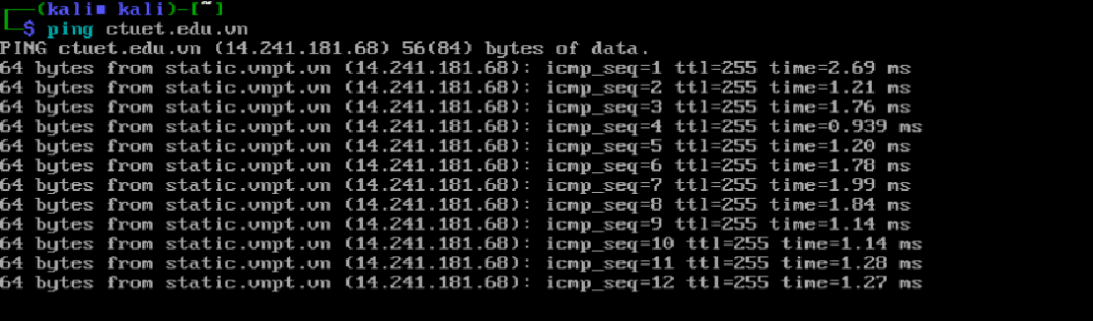

fping

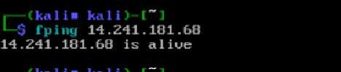

Nmap: 