BUỔI 2 :

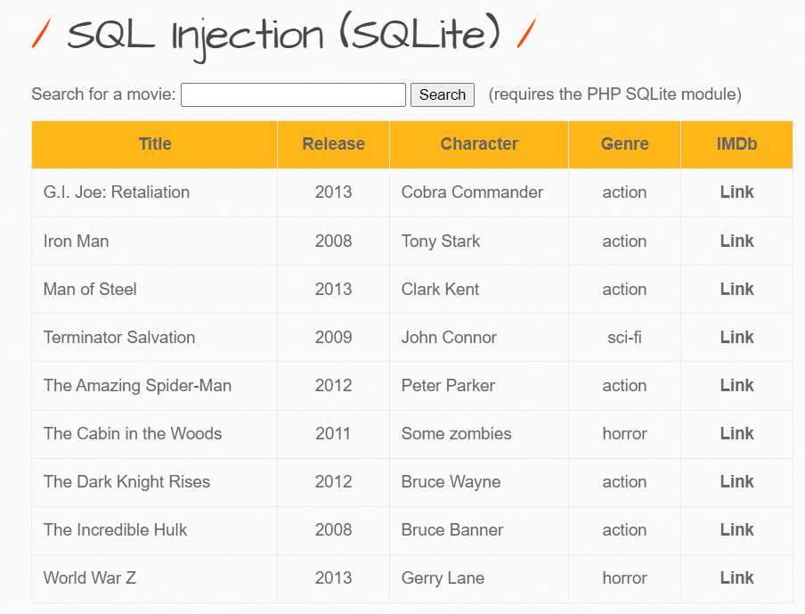`

BUỔI 3 :



