Bành Trọng Khiêm

HTTT2211035

Th2

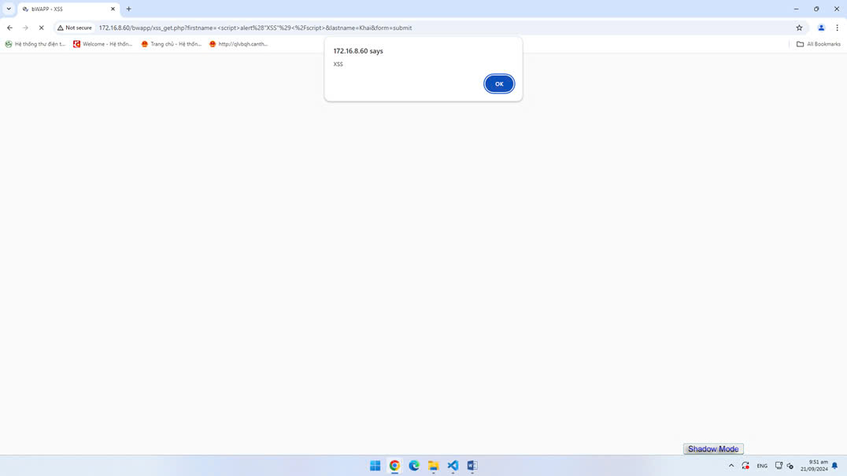

TH3



