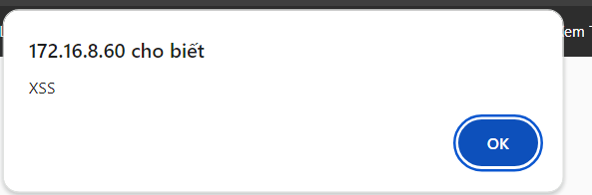http://172.16.8.60/bWapp/xss_get.php?firstname=%3Cscript%3Ealert%28%22XSS%22%29%3C%2Fscript%3E&lastname=A&form=submit

