ĐINH THỊ THU CÚC HTTT2311047
LAB 1
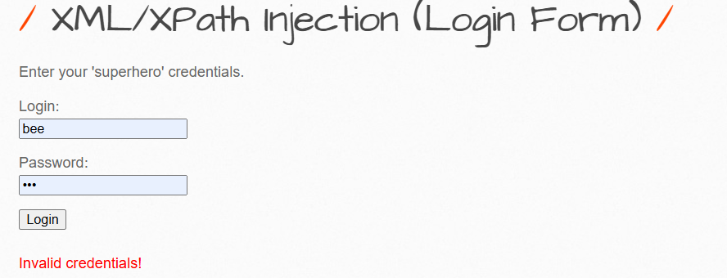

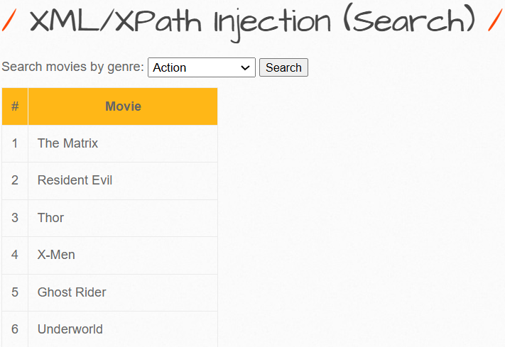

LAB 2
LAB 3
LAB 4
LAB 5

