B1: Create Private Key
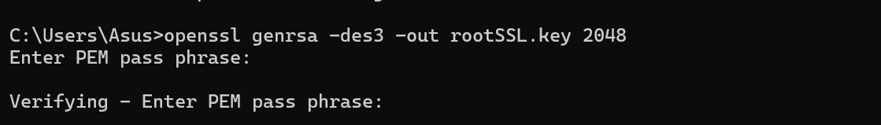
B2: Create Certificate File
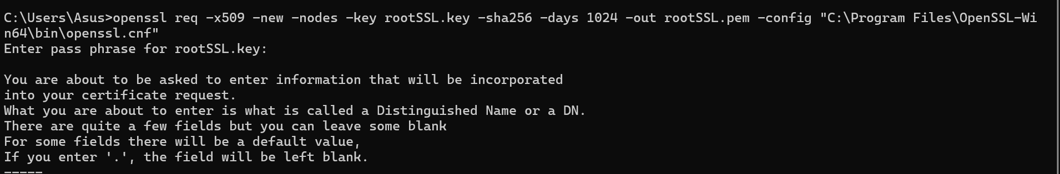
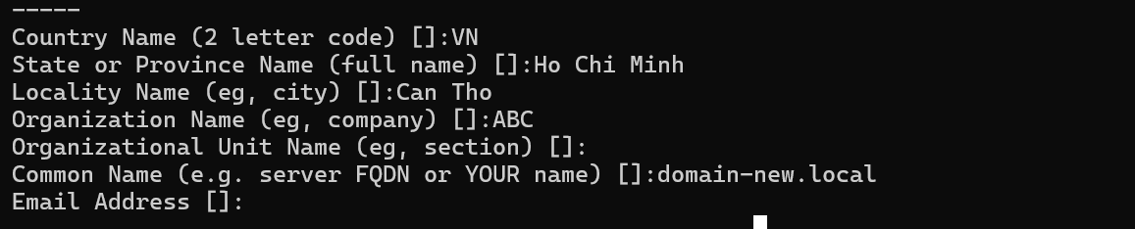
B3: Create a local domain. Thêm dòng sau vào file hosts trong thư mục c:\windows\system32\drivers\etc\
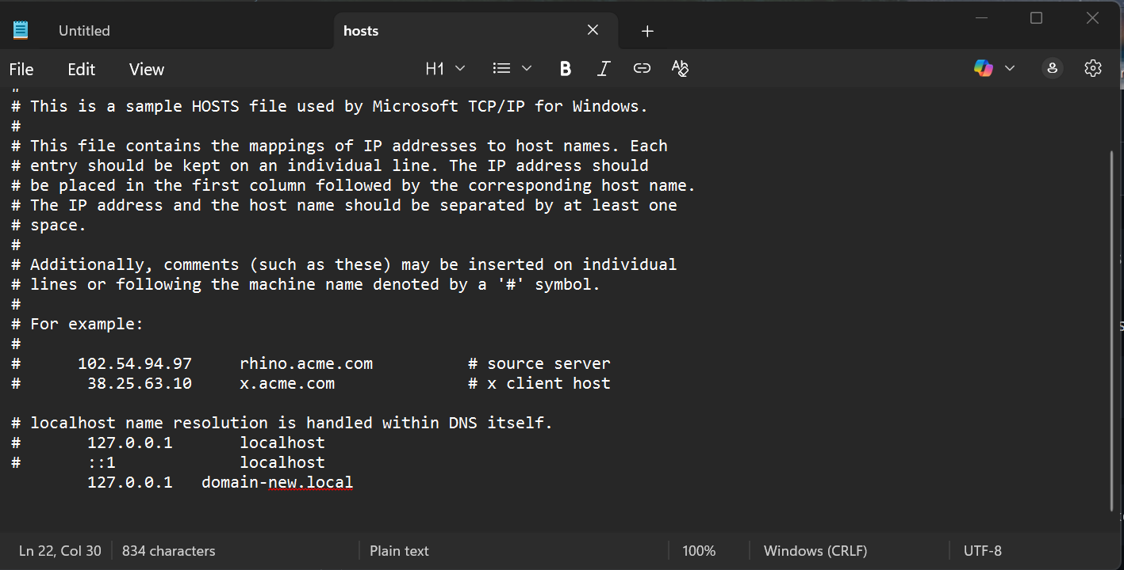
B4: Create a Private Key for the New Domain.
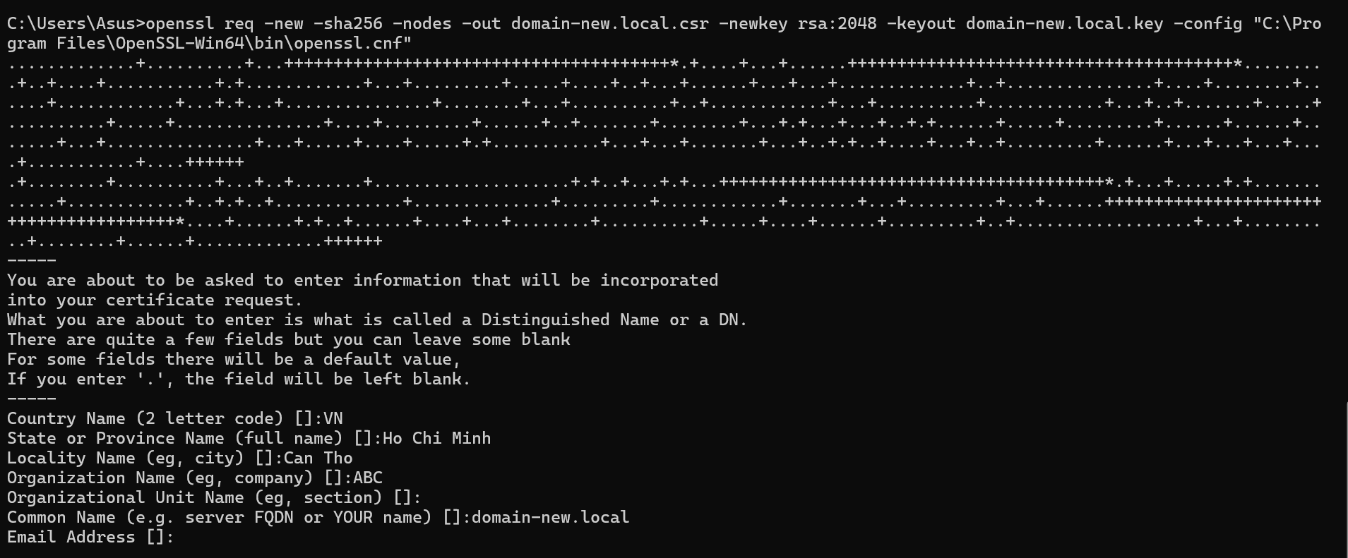
B5: Issue the New Certificate Using the Root SSL Certificate
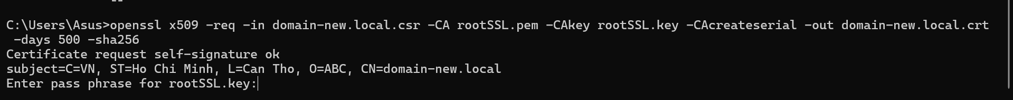
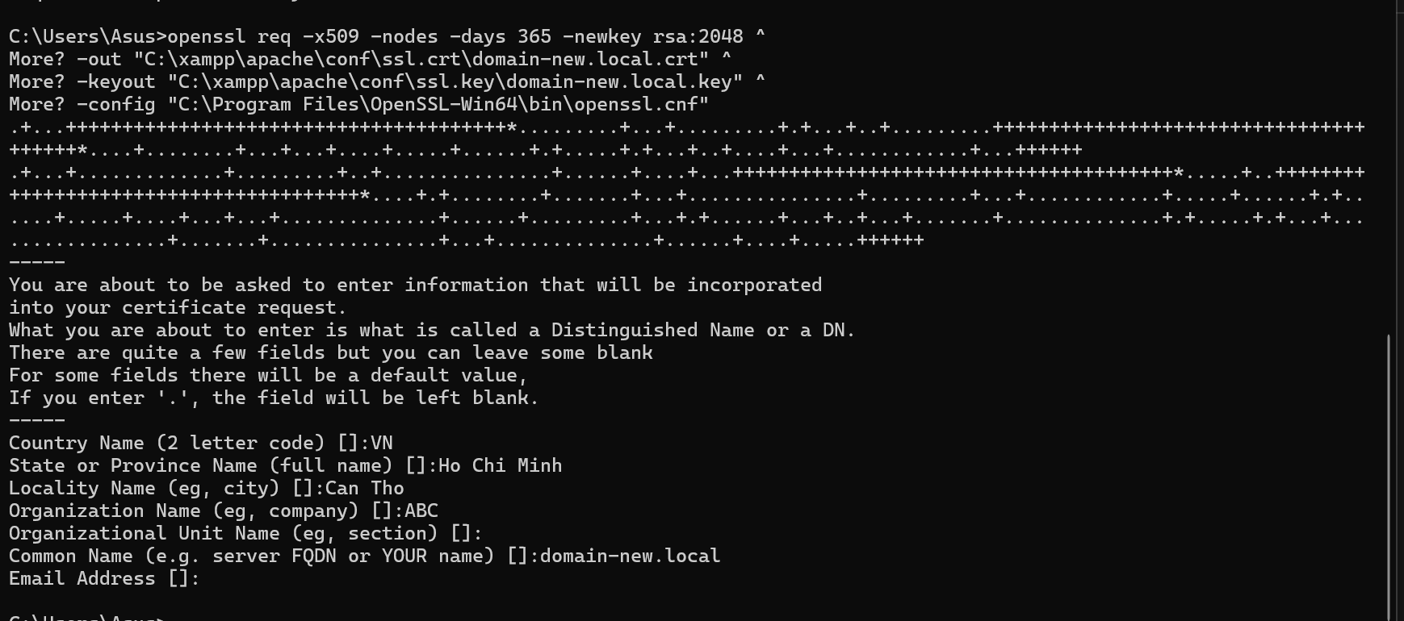

B6: Thêm đoạn sau vào xampp/apache/conf/extra/httpd-vhosts.conf
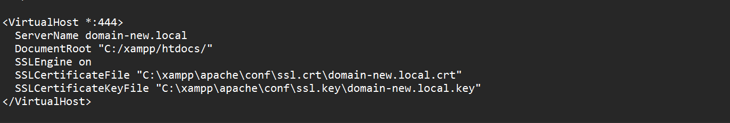
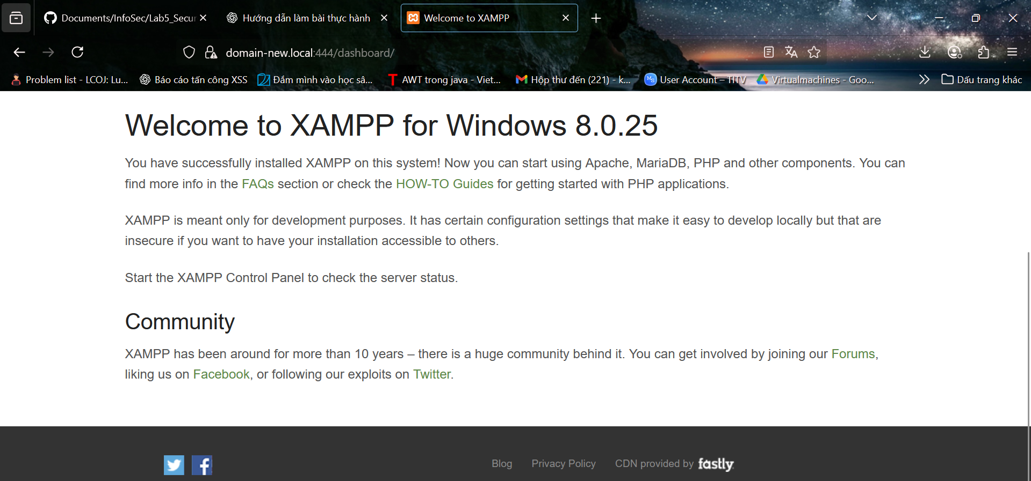
B7: Get Windows to Trust the Certificate Authority
- Windows + R
- MMC Enter
- File > Add/Remove Snap-in
- Click “Certificates” and “Add”
- Select “Computer Account” and click “Next”
- Select “Local Computer” then click “Finish”
- Click “OK” to go back to the MMC window
- Double-click “Certificates (local computer)” to expand the view
- Select “Trusted Root Certification Authorities”, right-click “Certificates” and select “All Tasks” then “Import”
- Click “Next” then Browse and locate the “rootSSL.pem”
- Select “Place all certificates in the following store” and select the “Trusted Root Certification Authorities store”. Click “Next” then click “Finish” to complete the wizard

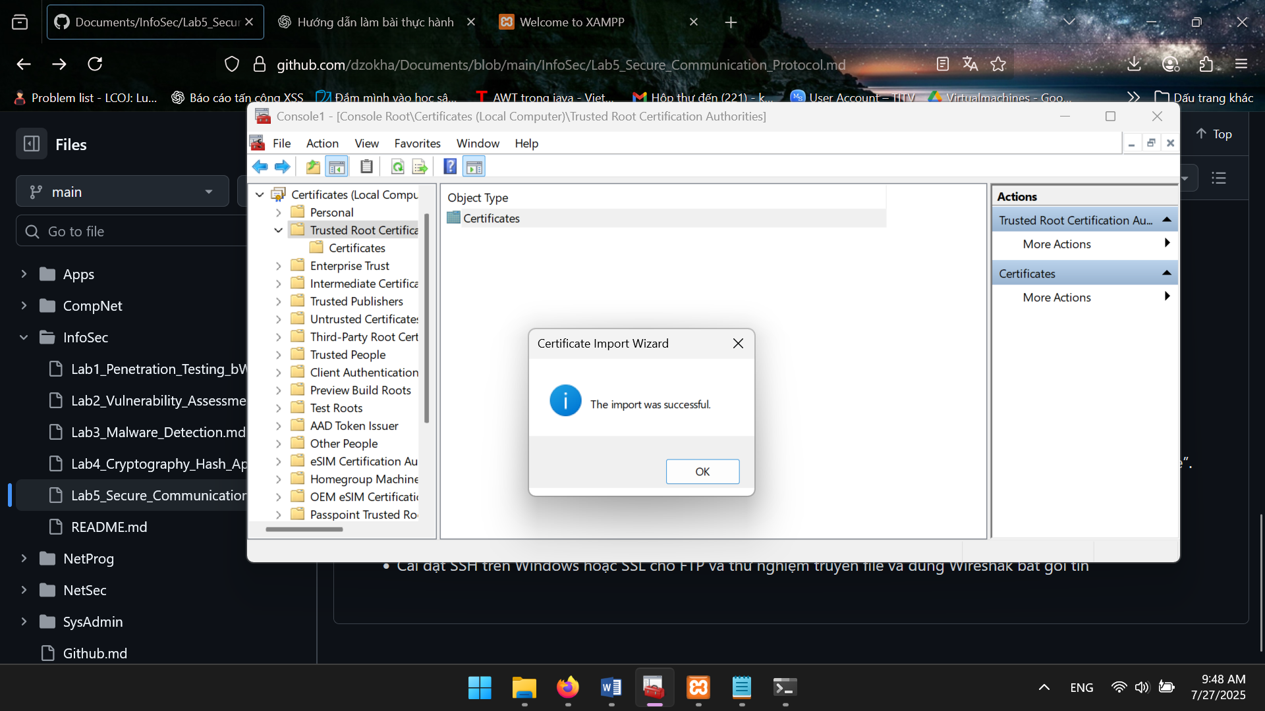
• Cài đặt FTP trên Windows và thử nghiệm truyền file và dùng Wireshark bắt gói tin

A. Bật FTP server trên Windows:
- Nhấn Windows + R → gõ optionalfeatures
- Tìm mục Internet Information Services (IIS)
  - Tick: FTP Server
  - Tick luôn Web Management Tools
- Bấm OK → chờ máy cài xong
