**3.5.4. Cài đặt Windows 10**

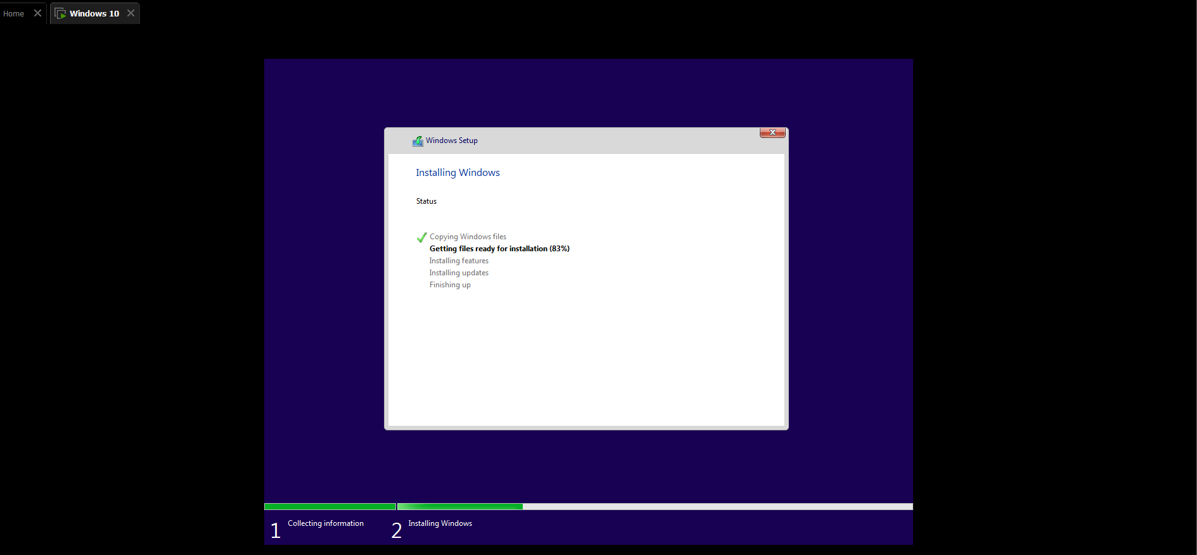

**11.2. Configuring Windows Firewall**

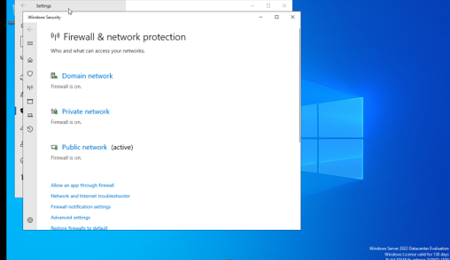

**11.3. Windows Firewall with Advanced Security (WFAS)**

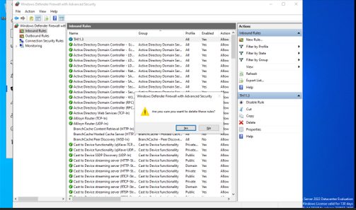

**11.7. Windows Defender Credential Guard**

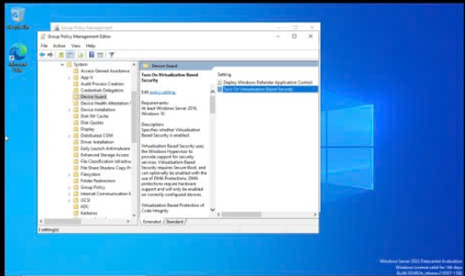

**11.8. Windows Defender Exploit Guard**

