Võ Quang Vinh-CNTT2211007

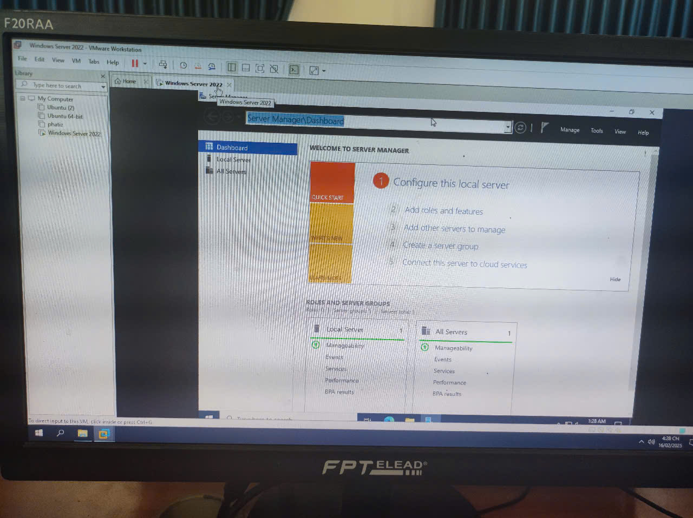

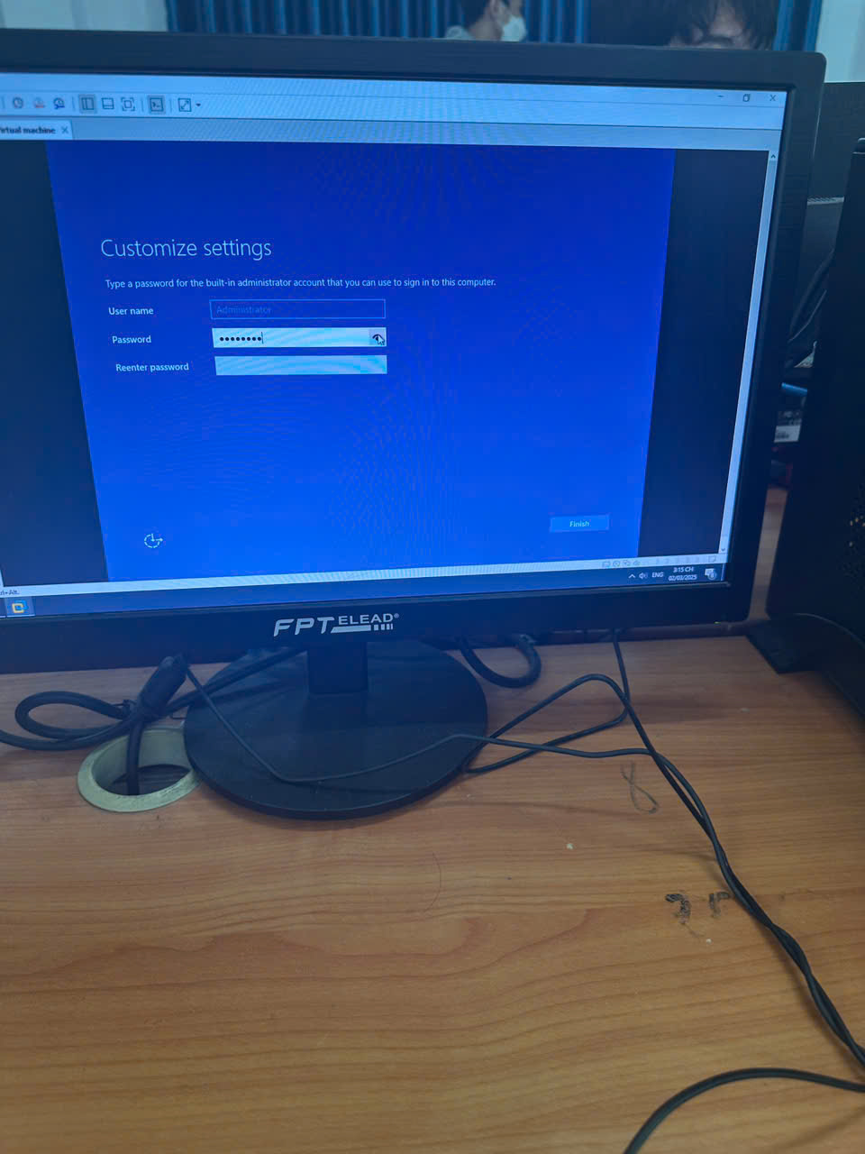

**Võ Quang Vinh-CNTT2211007**

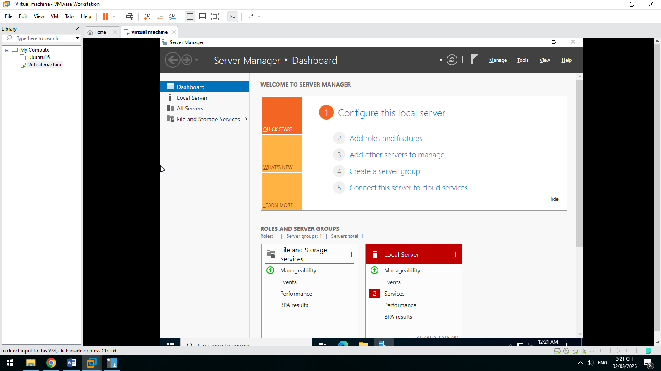

**1.DNS SERVER**

**4.1. Installing and Configuring the DNS Service**



**4.2. Configuring a Zone for Dynamic Updates**

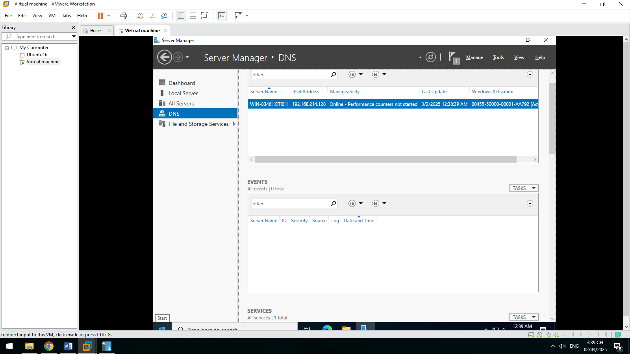

**4.3.Creating a Delegated DNS Zone**

Võ Quang Vinh-CNTT2211007





**1.DNS SERVER**

**4.1. Installing and Configuring the DNS Service**



**4.2. Configuring a Zone for Dynamic Updates**



**4.3.Creating a Delegated DNS Zone**

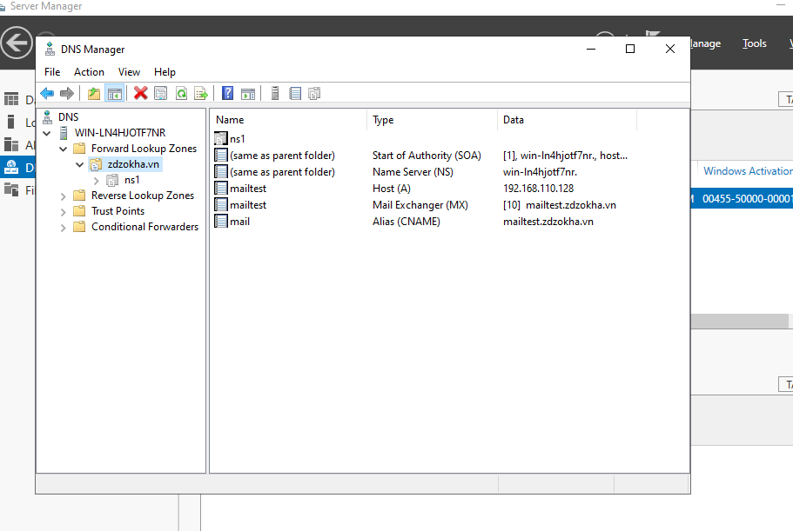

# **5. Active Directory**

**5.1. Promoting a Domain Controller**

