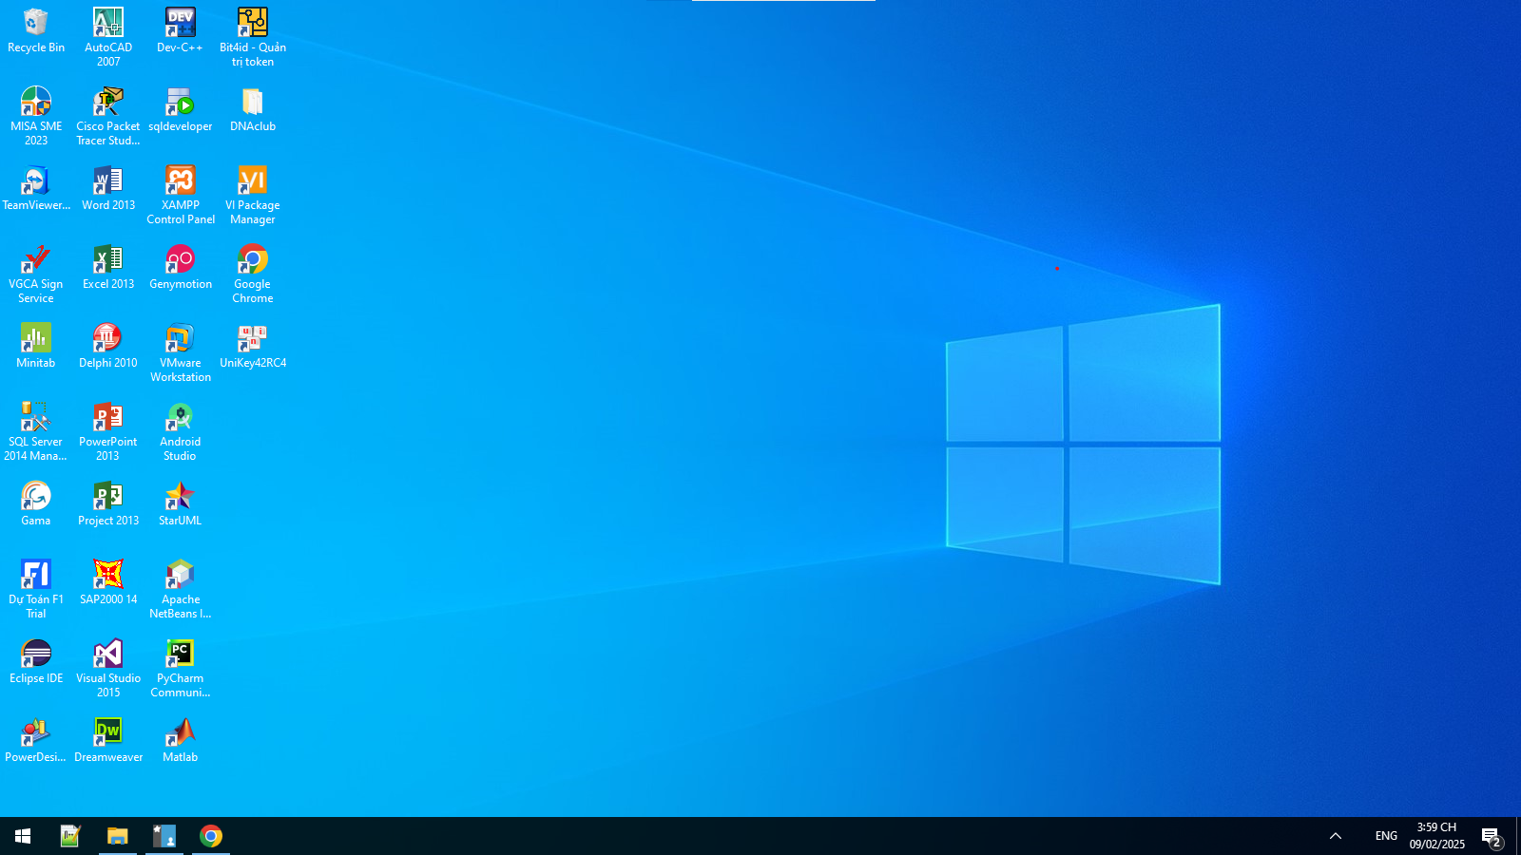

**4. DNS Server**

**4.1. Installing and Configuring the DNS Service**

**4.2. Configuring a Zone for Dynamic Updates**

**4.3. Creating a Delegated DNS Zone**

**4.4. Manually Creating DNS Records**

