Phan An Khang

Buoi 2

Configuring a Zone for Dynamic Updates

WIN-3HC85Q1KHP1

192.168.83.128

Creating a Delegated DNS Zone

Manually Creating DNS Records

Password DSRM: P@ssw0rd

Promoting a Domain Controller

**Viewing the Active Directory Event Log**

**Configuring DNS Integration with Active Directory**

**Creating an OU Structure**

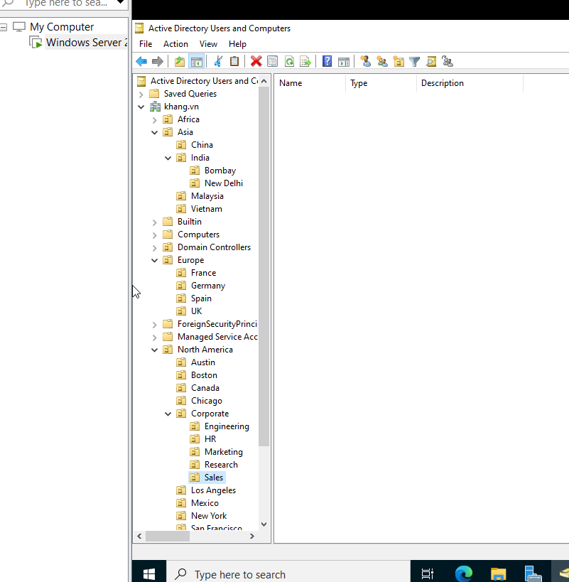

**5.7. Modifying OU Structure**

**5.8. Using the Delegation of Control Wizard**

**5.9. Delegating Custom Tasks**

**5.10. Creating Active Directory Objects**

**5.12. Managing Object Properties**

**5.13. Moving Active Directory Objects**

**5.14. Resetting an Existing Computer Account**

**5.15. Creating and Publishing a Printer**

**5.16. Creating and Publishing a Shared Folder**

**6. DHCP**

**6.1. Installing the DHCP Service**

## 6.2. Authorizing a DHCP Server

**6.3. Unauthorizing a DHCP Server**

**6.4. Creating a New Scope**

## 6.5. Creating a Superscope

**6.6. Creating a New Multicast Scope**

**6.7. Enabling DHCP-DNS Integration**

**6.8. Configuring DHCP Filtering**

**6.9. Enabling DHCP Name Protection**

## 10.1. Creating a Group Policy Object Using the GPMC

## 10.2. Linking Existing GPOs to Active Directory

**10.3. Filtering Group Policy Using Security Groups**

## 10.4. Delegating Administrative Control of Group Policy

## 10.5. Configuring Automatic Certificate Enrollment in Group Policy

**10.6. Configuring Folder Redirection in Group Policy**

## 10.7. Creating a Software Deployment Share

## 11.1. Windows Defender Security Center

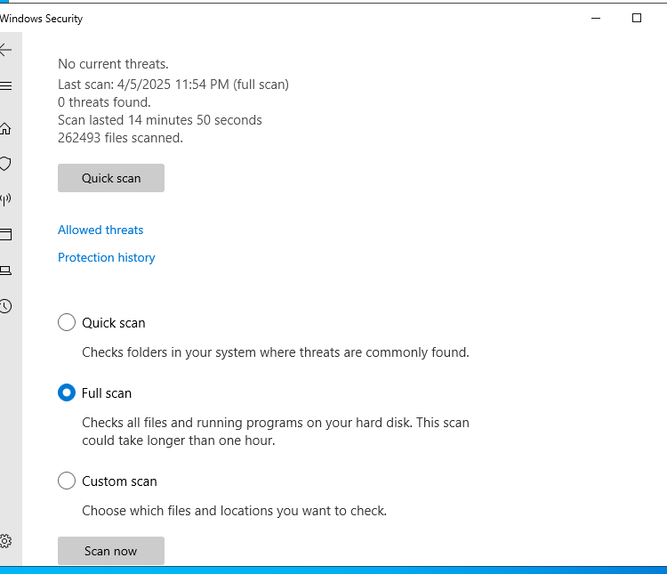

## 11.2. Configuring Windows Firewall

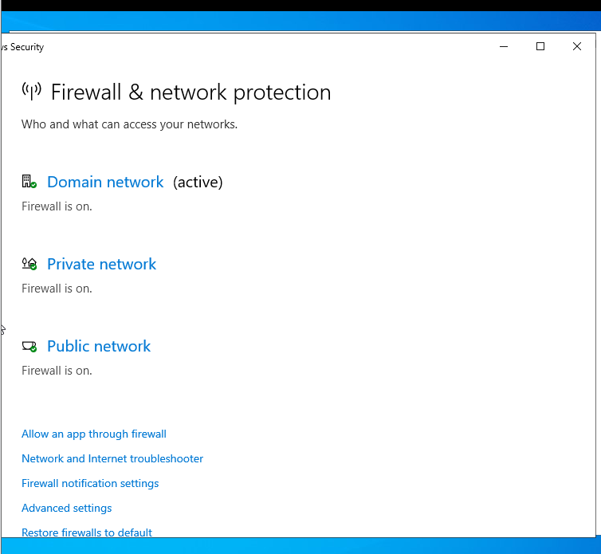

## 11.3. Windows Firewall with Advanced Security (WFAS)

