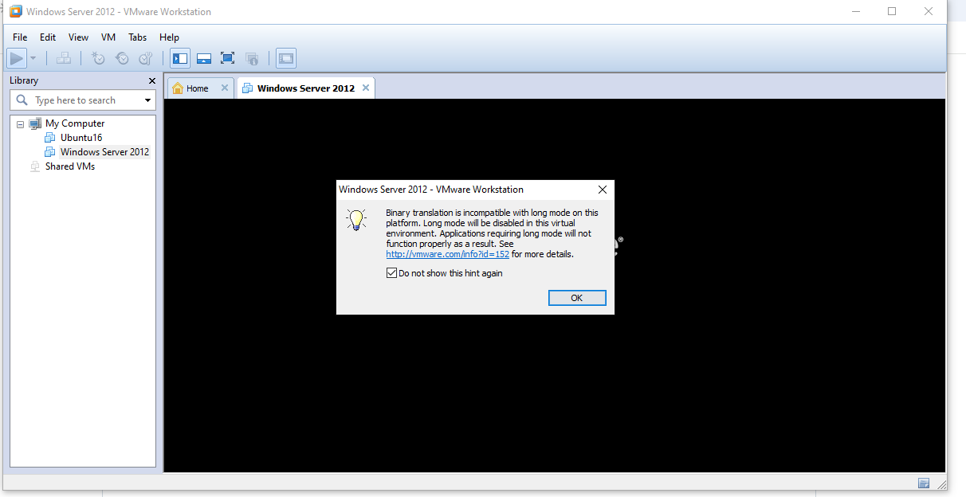

Nhân

# DNS Server

## 4.1 Installing and Configuring the DNS Service

## 4.2 Configuring a Zone for Dynamic Updates

**4.3 Creating a Delegated DNS Zone**

**4.4 Manually Creating DNS Records**

1. **Active Directory**

## 5.1 Promoting a Domain Controller

**5.2. Viewing the Active Directory Event Log**

**5.5. Configuring DNS Integration with Active Directory**

**5.6. Creating an OU Structure**

**5.7. Modifying OU Structure**

**5.8. Using the Delegation of Control Wizard**

**5.9. Delegating Custom Tasks**

**5.10. Creating Active Directory Objects**

**5.11. Creating a User Template**

**5.12. Managing Object Properties**

**5.13. Moving Active Directory Objects**

**5.14. Resetting an Existing Computer Account**

**5.16. Creating and Publishing a Shared Folder**

1. **DHCP**
   1. **Installing the DHCP Service**

