**QUẢN TRỊ VÀ BẢO TRÌ HỆ THỐNG**

**Họ và tên: LÊ QUỐC ĐẠI**

**MSSV: CNTT2211047**

# **4. DNS Server**

## **4.1. Installing and Configuring the DNS Service**

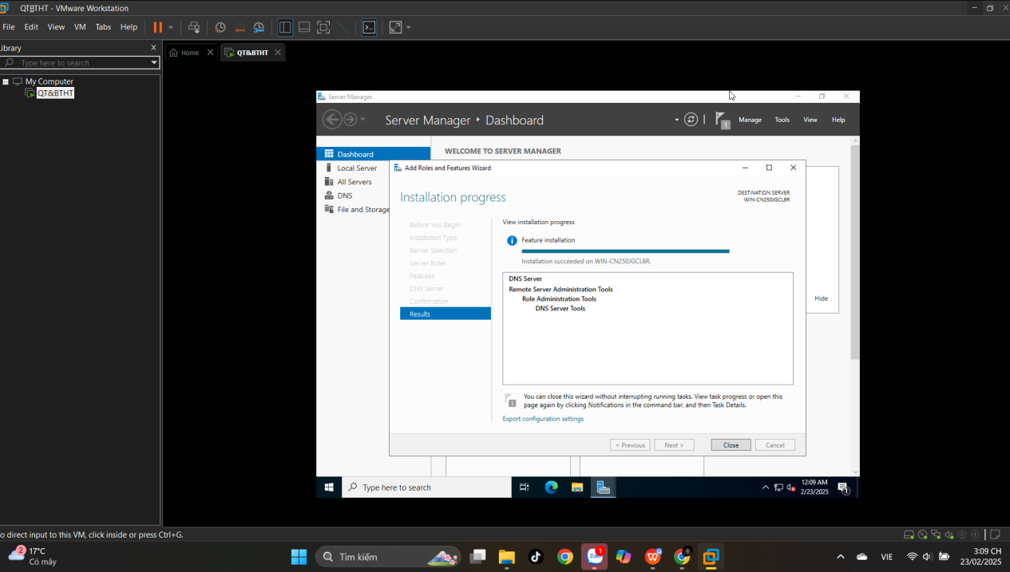

## **4.2. Configuring a Zone for Dynamic Updates**

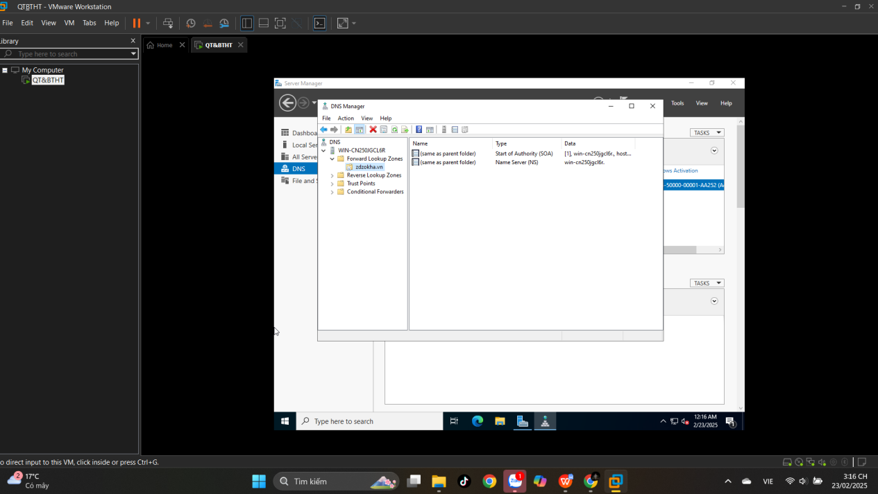

## **4.3. Creating a Delegated DNS Zone**

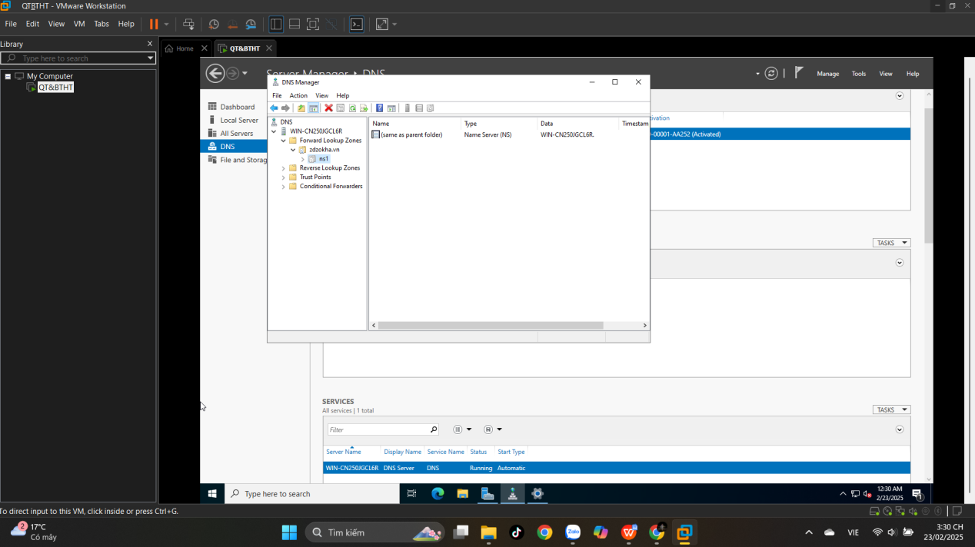

## **4.4. Manually Creating DNS Records**

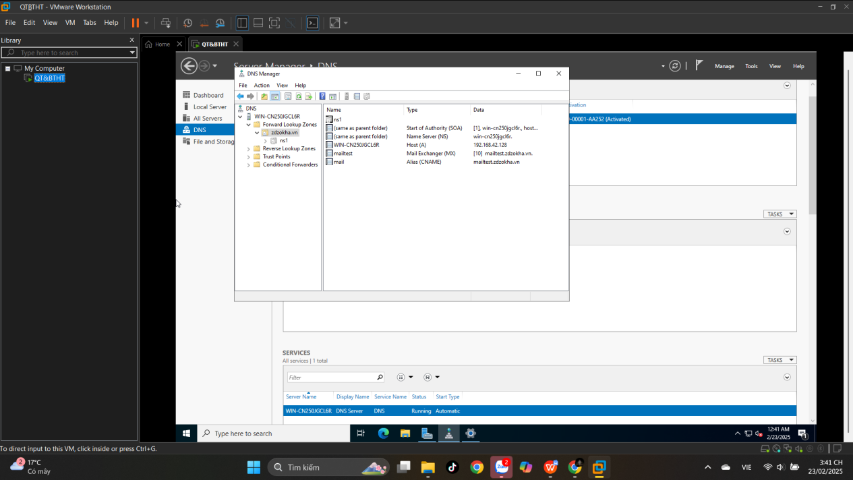

# **5. Active Directory**

## **5.1. Promoting a Domain Controller**

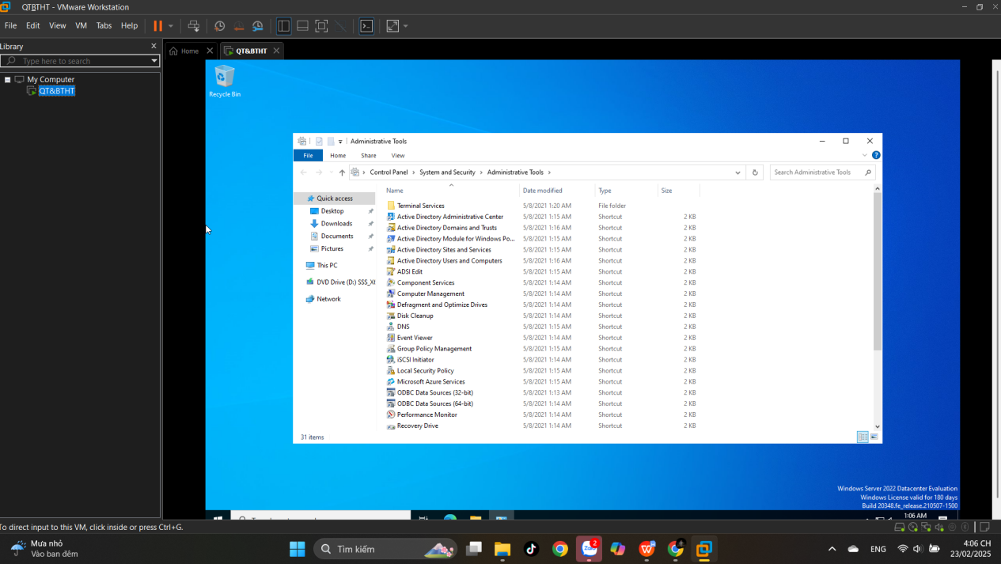

## **5.2. Viewing the Active Directory Event Log**

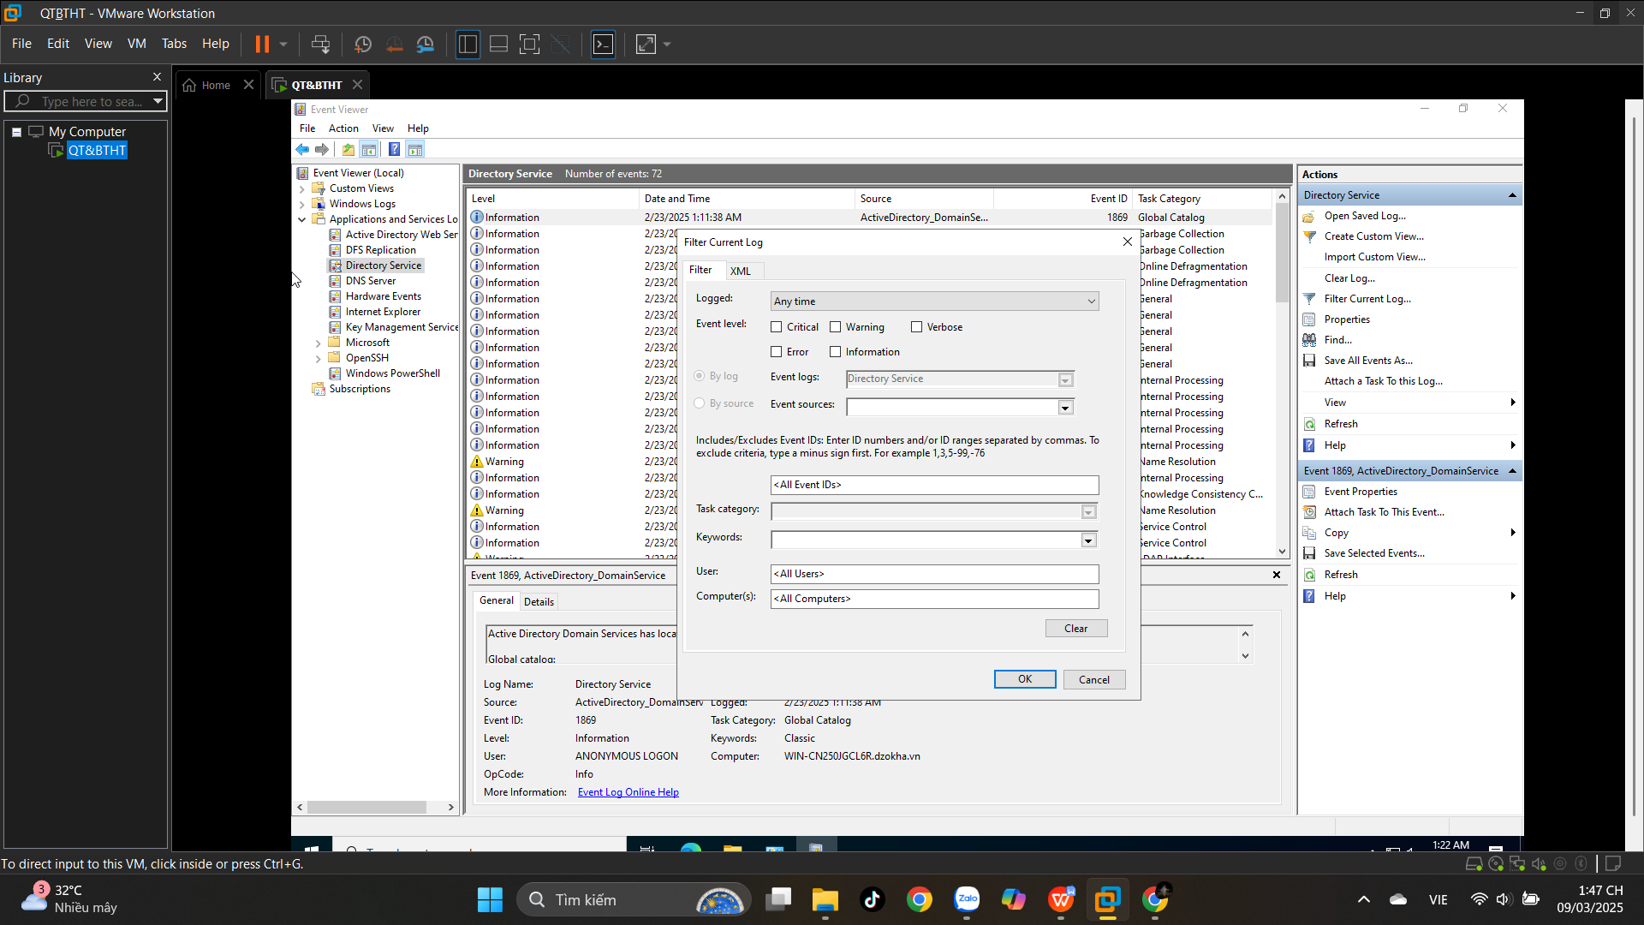

## **5.5. Configuring DNS Integration with Active Directory**

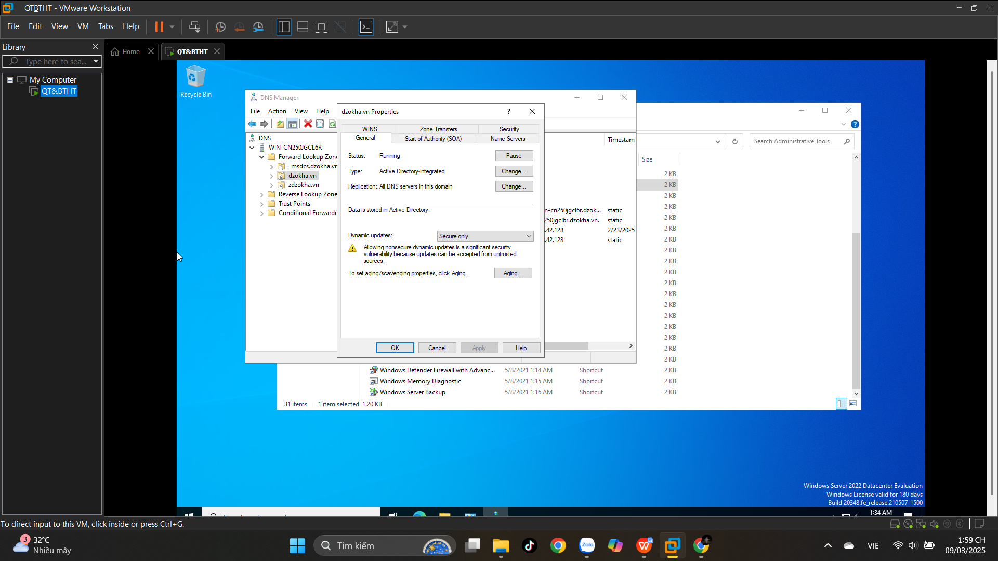

**5.6. Creating an OU Structure**

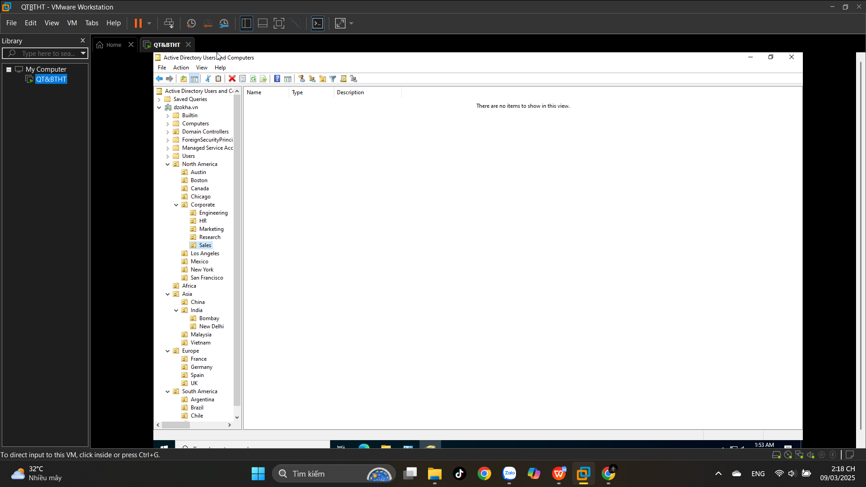

**5.7. Modifying OU Structure**

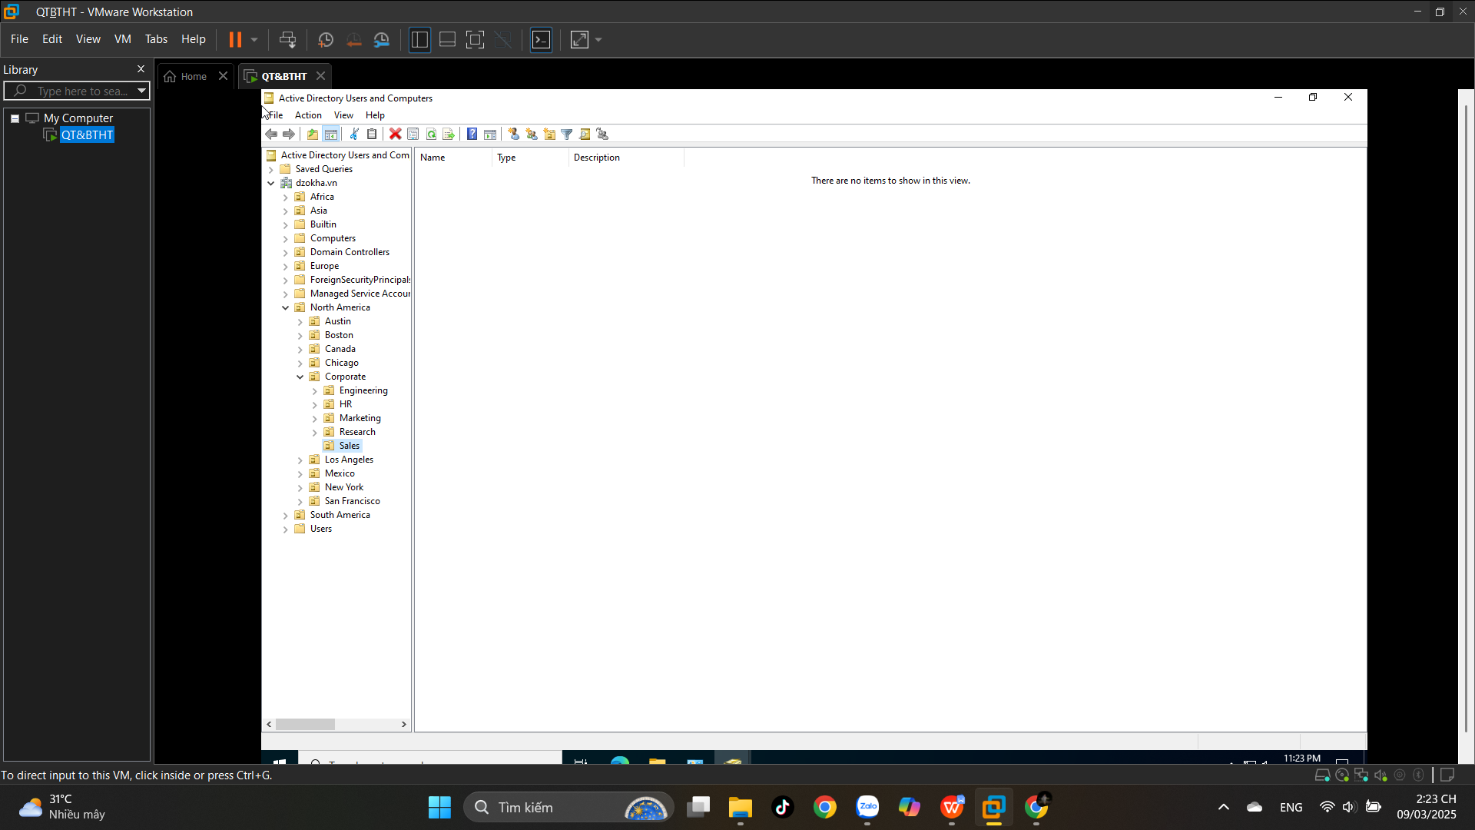

## **5.8. Using the Delegation of Control Wizard**

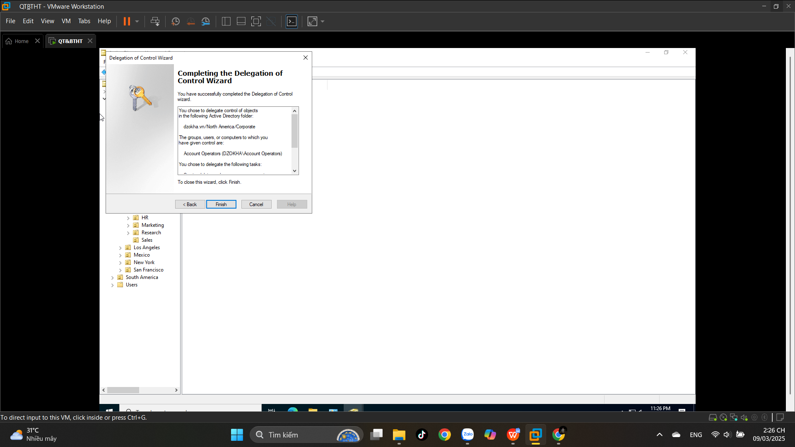

**5.9. Delegating Custom Tasks**

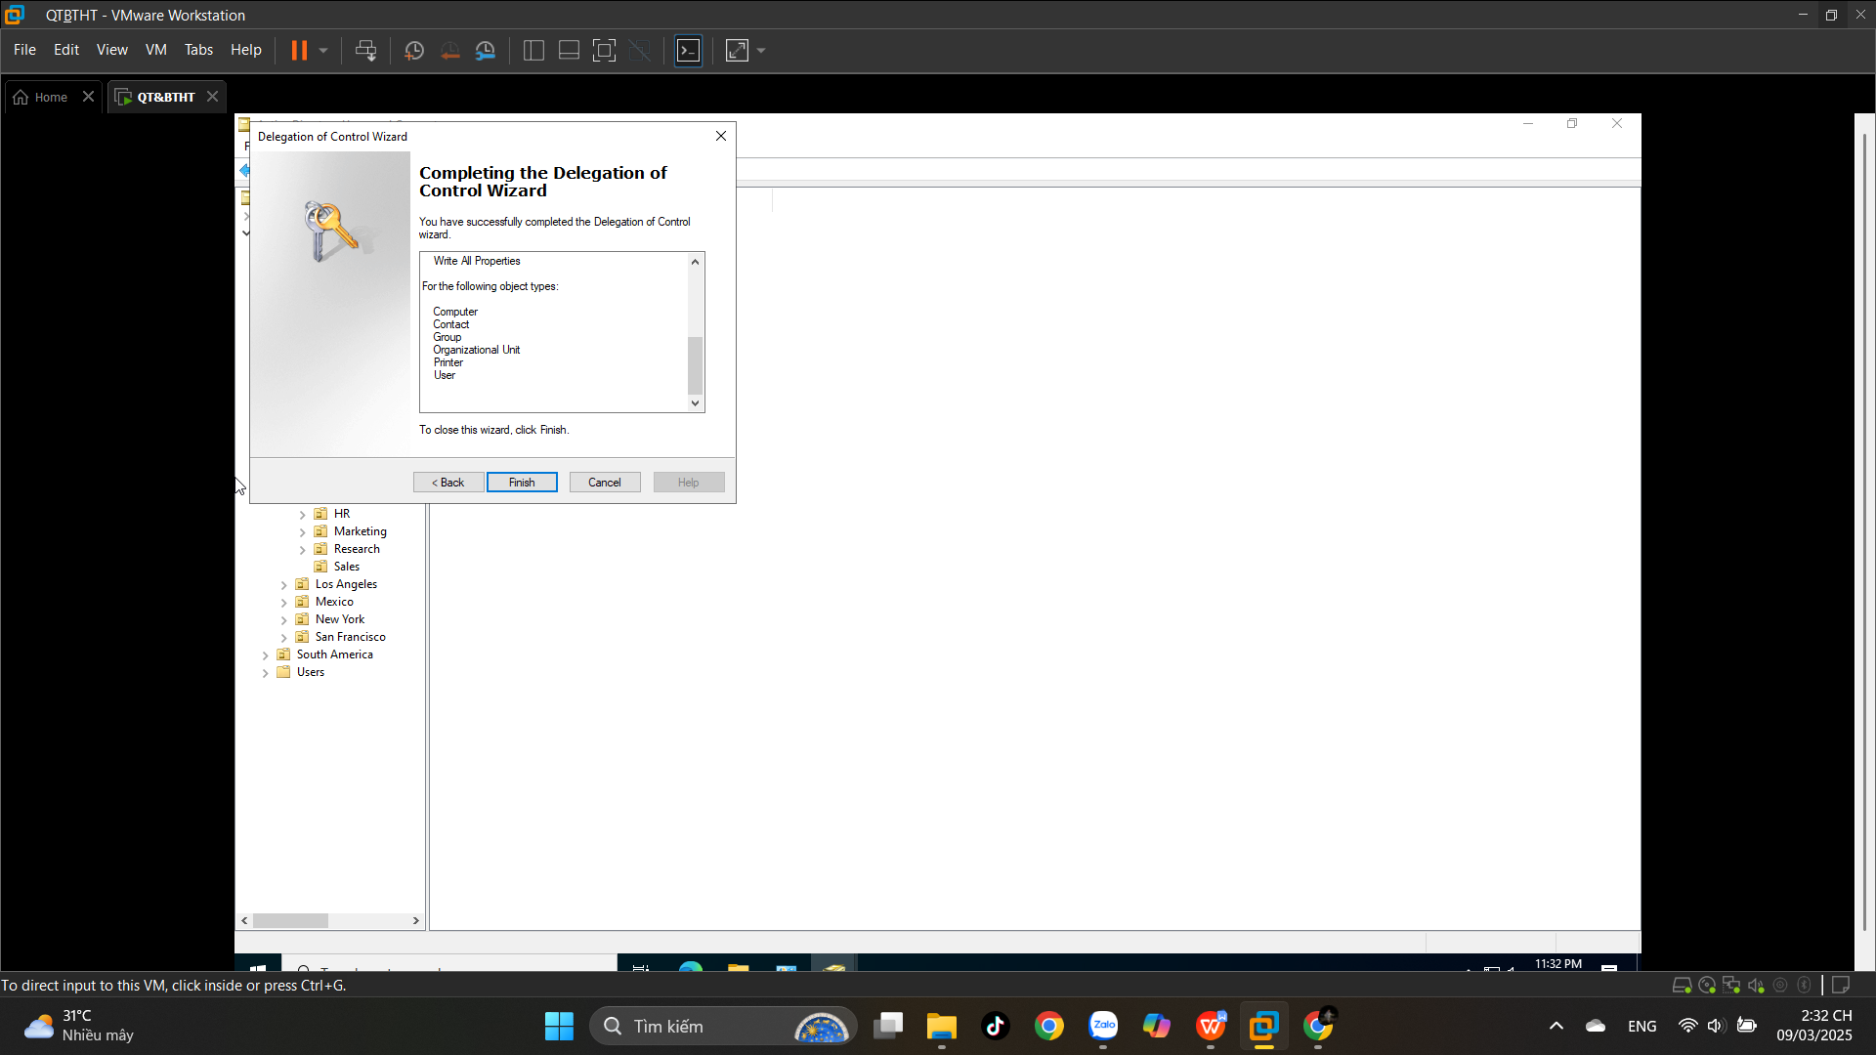

## **5.10. Creating Active Directory Objects**

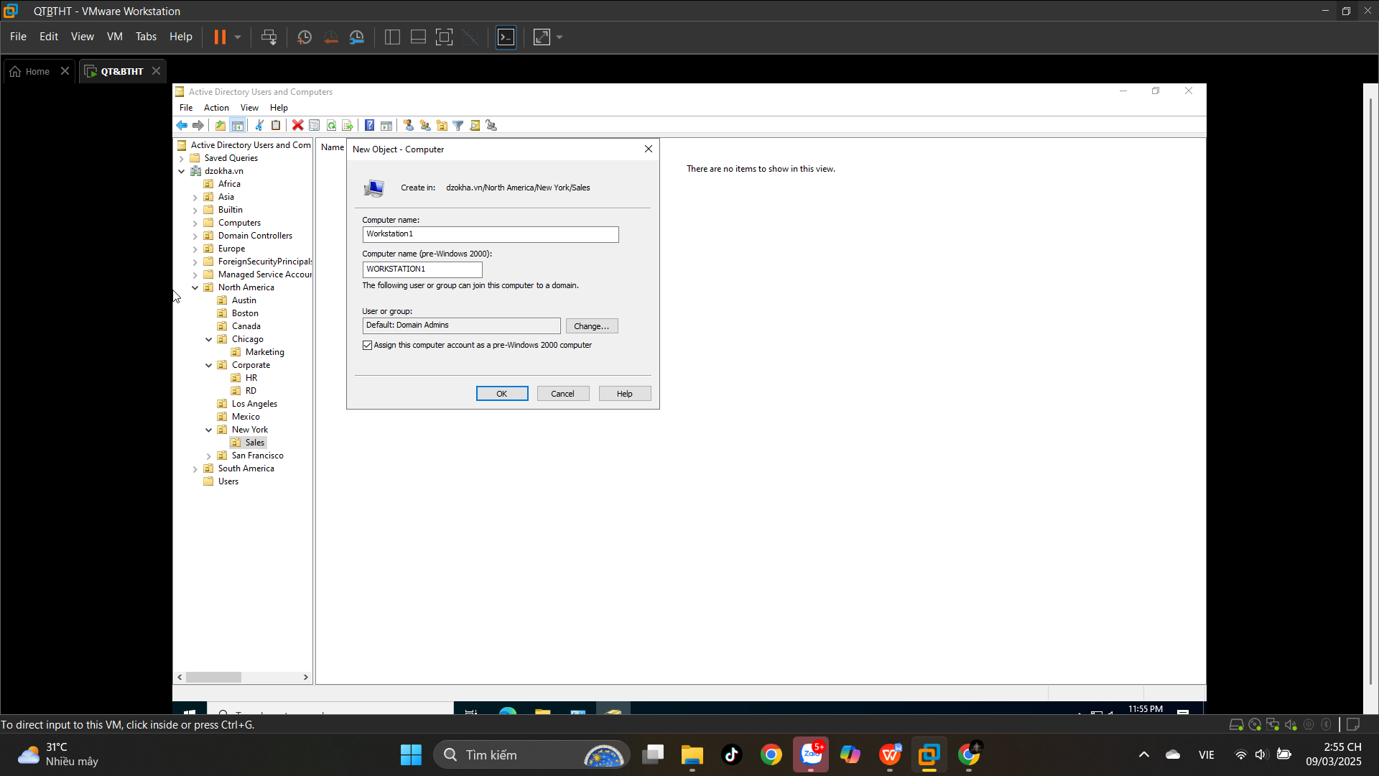

## **5.11. Creating a User Template**

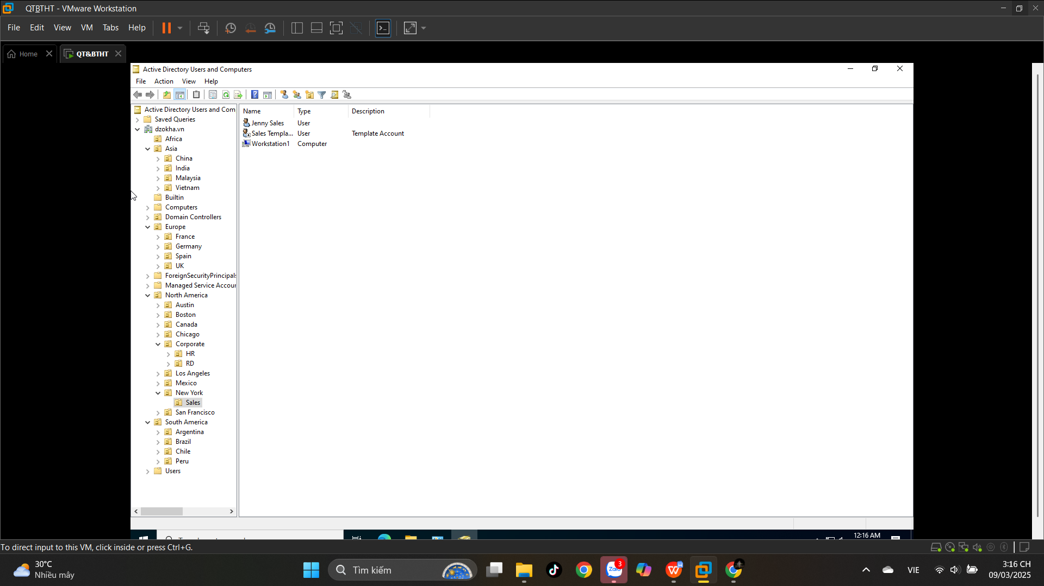

**5.12. Managing Object Properties**

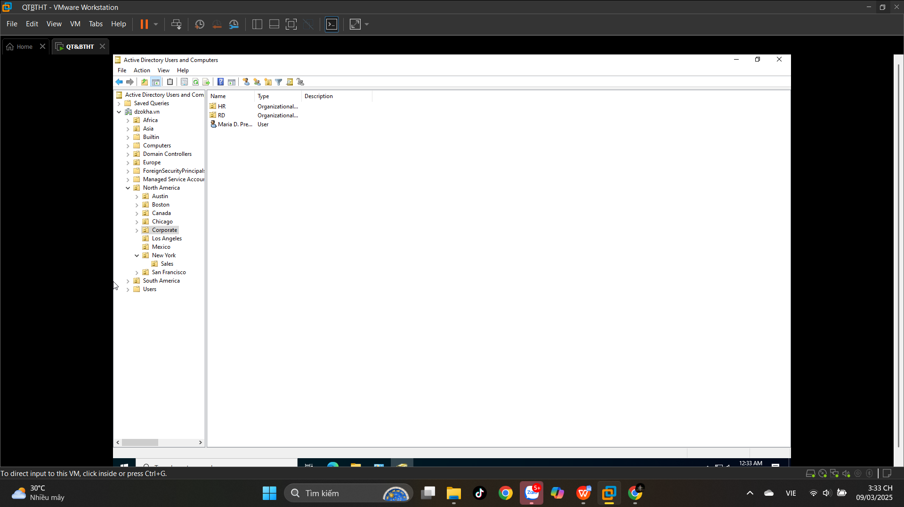

**5.13. Moving Active Directory Objects**

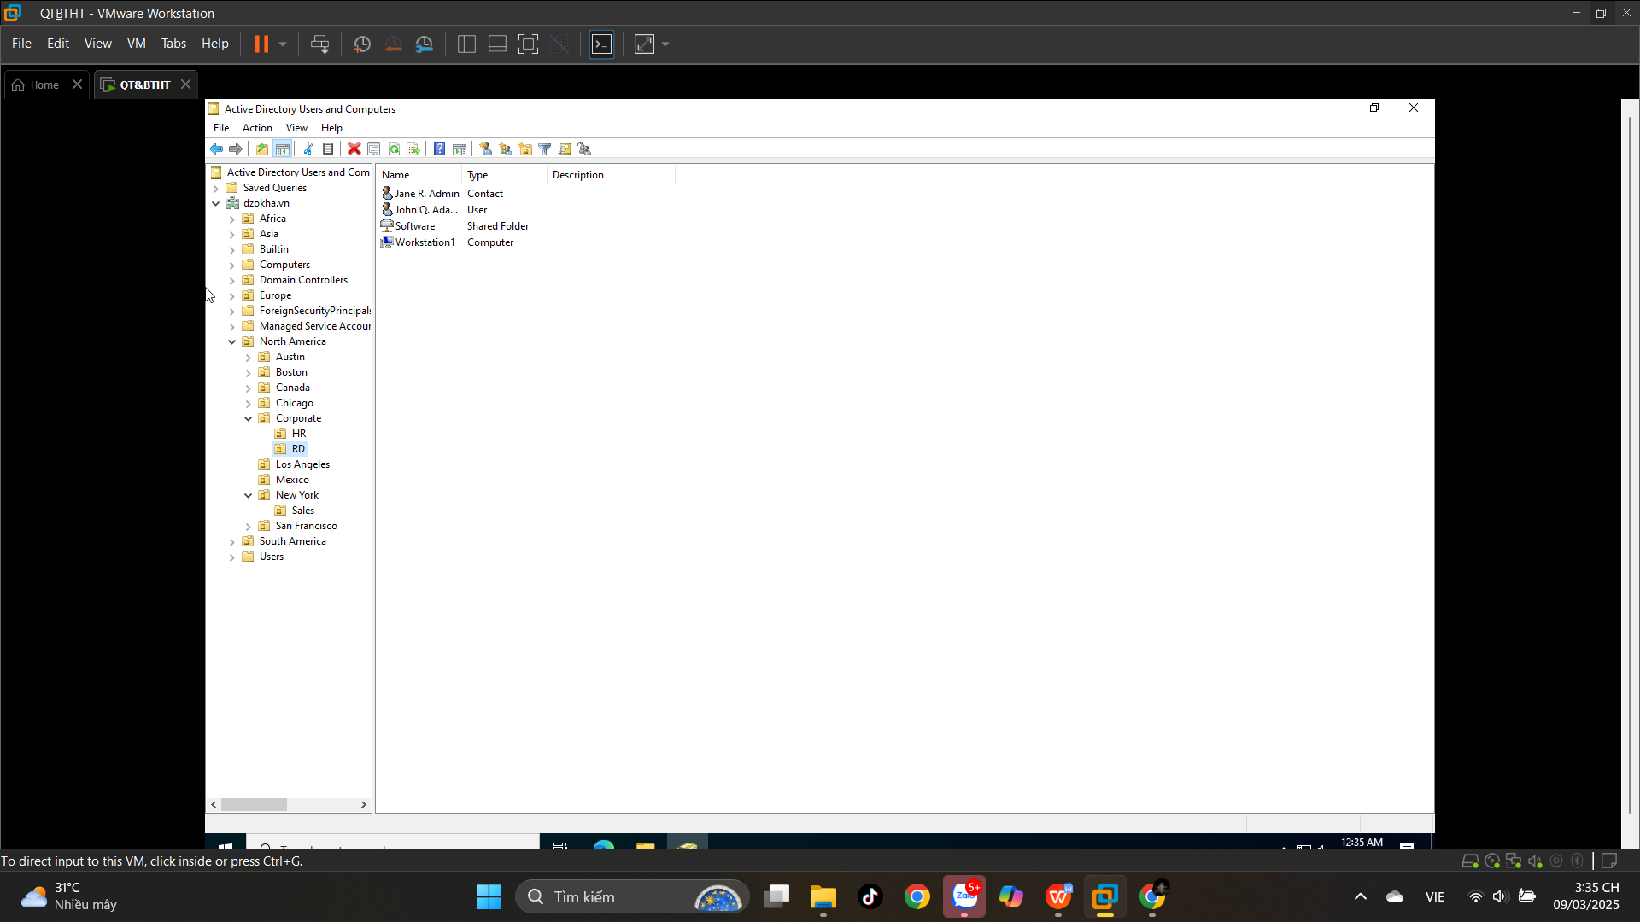

## **5.14. Resetting an Existing Computer Account**

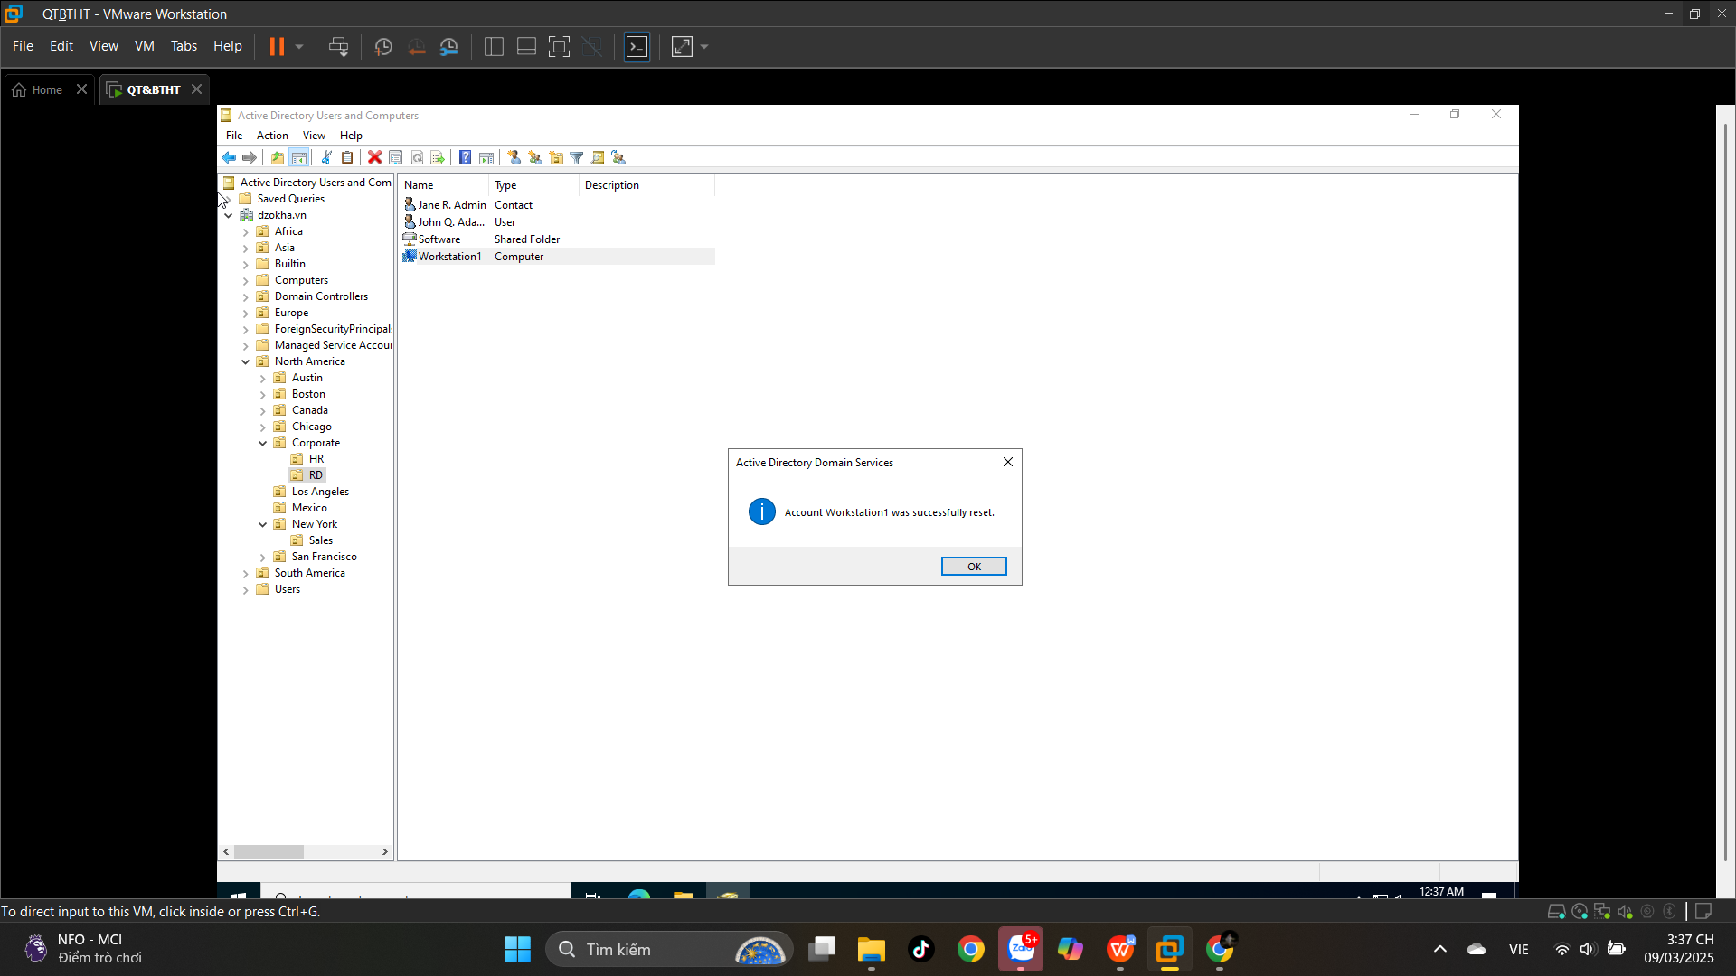

## **5.16. Creating and Publishing a Shared Folder**

