TÔN TRƯỜNG PHÁT CNTT2211060

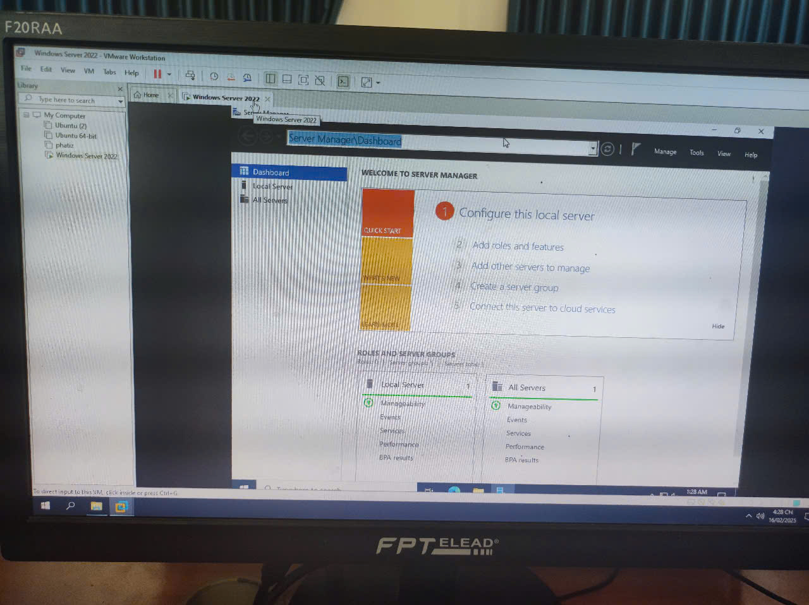

1.DNS SEVER

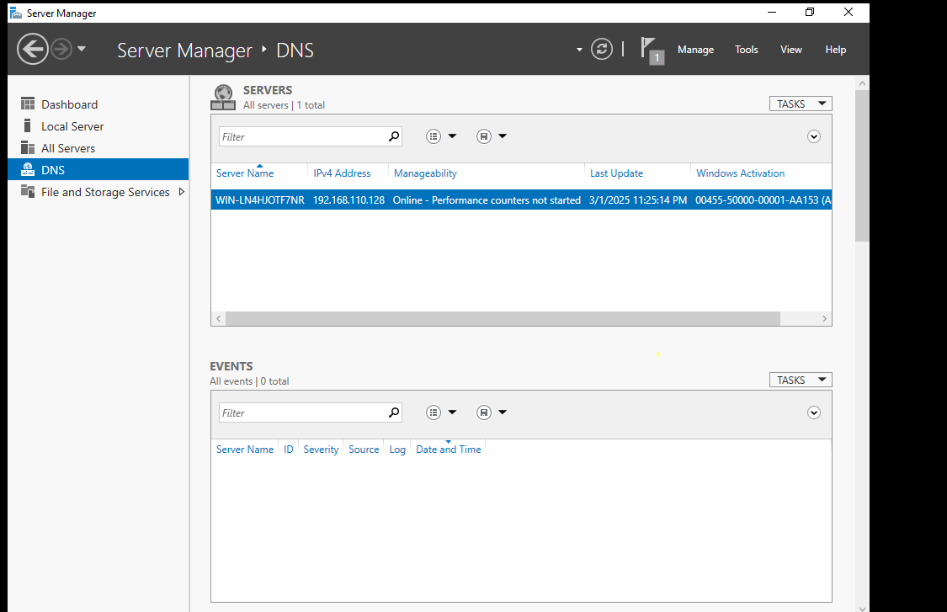

## 2. Configuring a Zone for Dynamic Updates

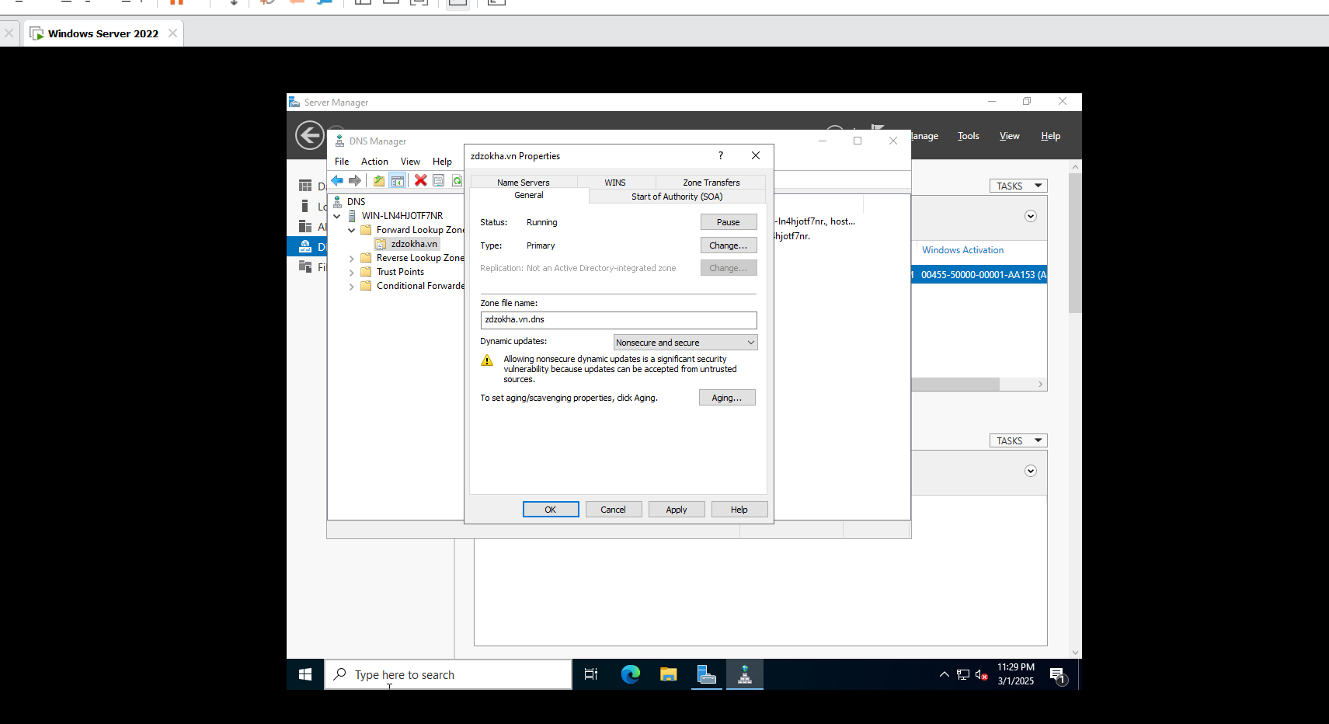

3. Creating a Delegated DNS Zone

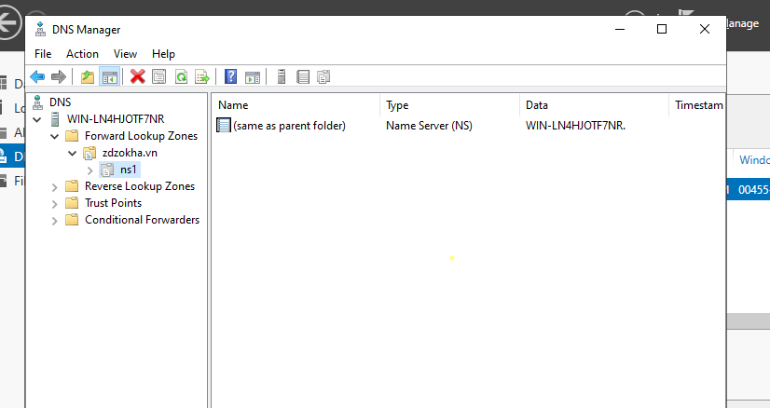

## 4Manually Creating DNS Records

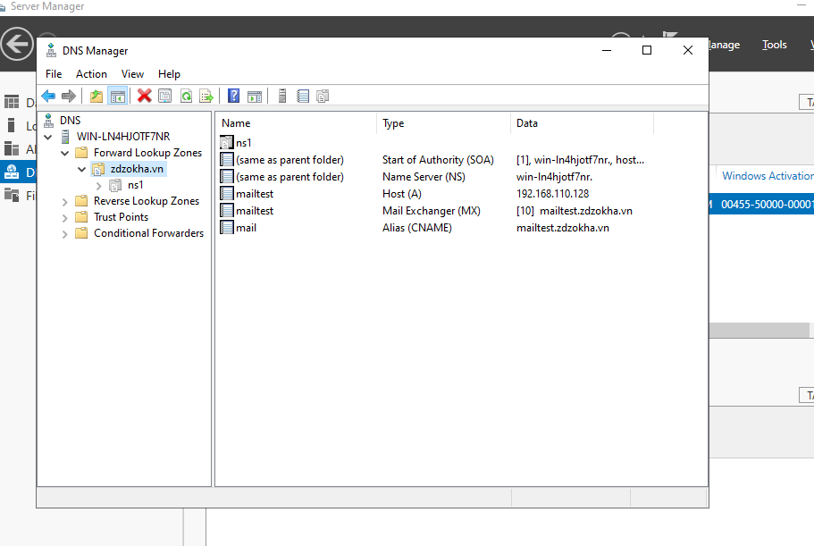

# 5. Active Directory

## 5.1. Promoting a Domain Controller

