**DNS Server**

**Installing and Configuring the DNS Service**

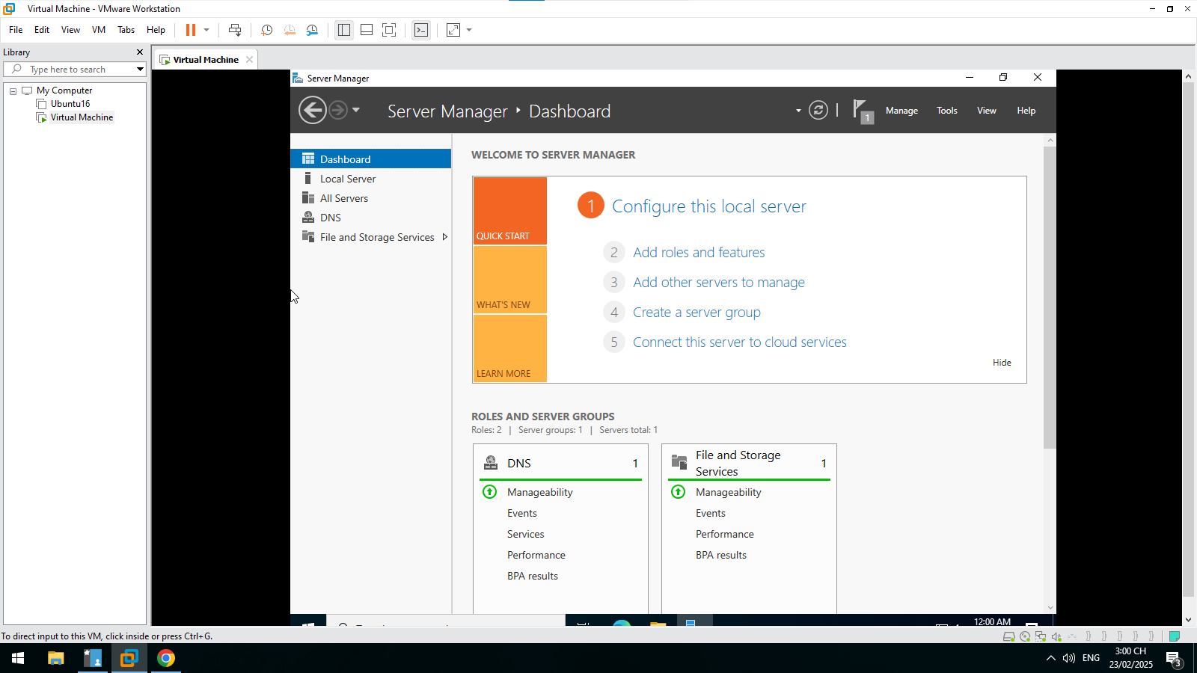

**Configuring a Zone for Dynamic Updates**

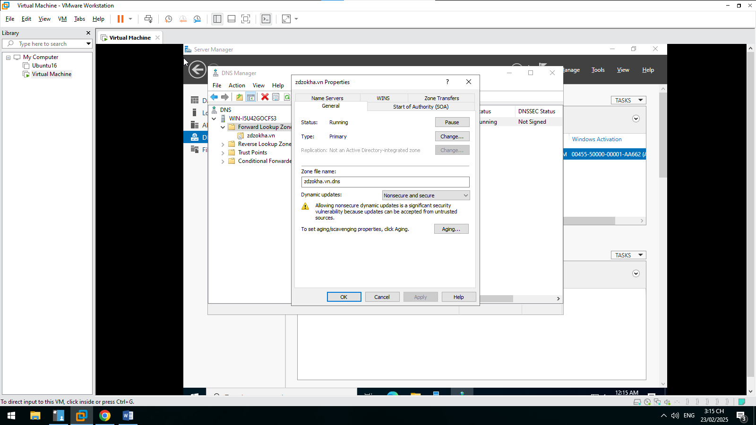

**Creating a Delegated DNS Zone**

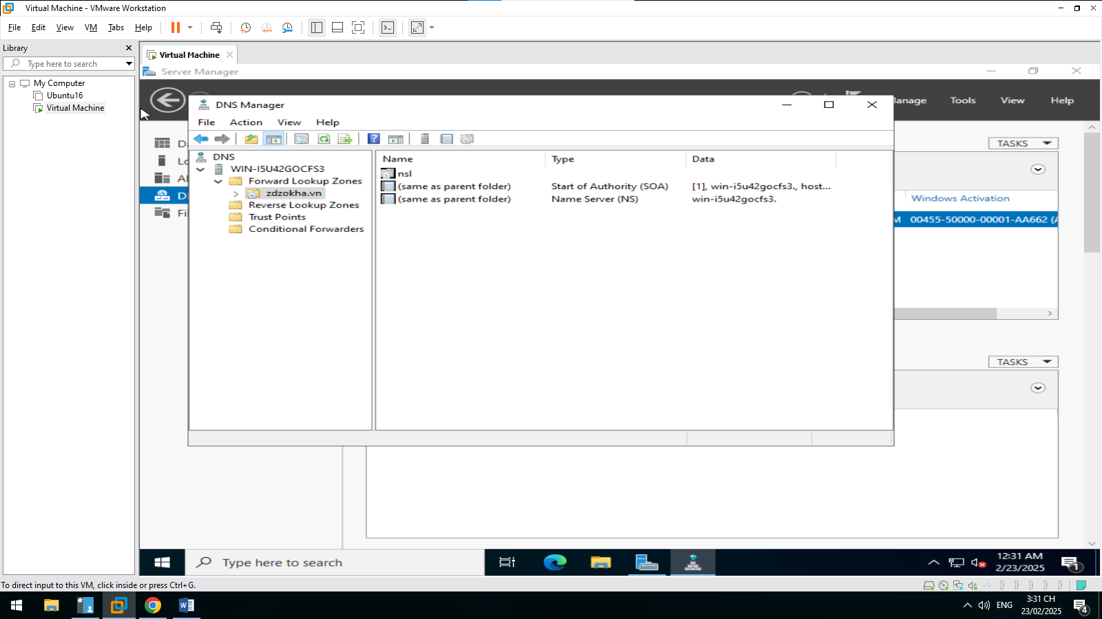

**Manually Creating DNS Records**

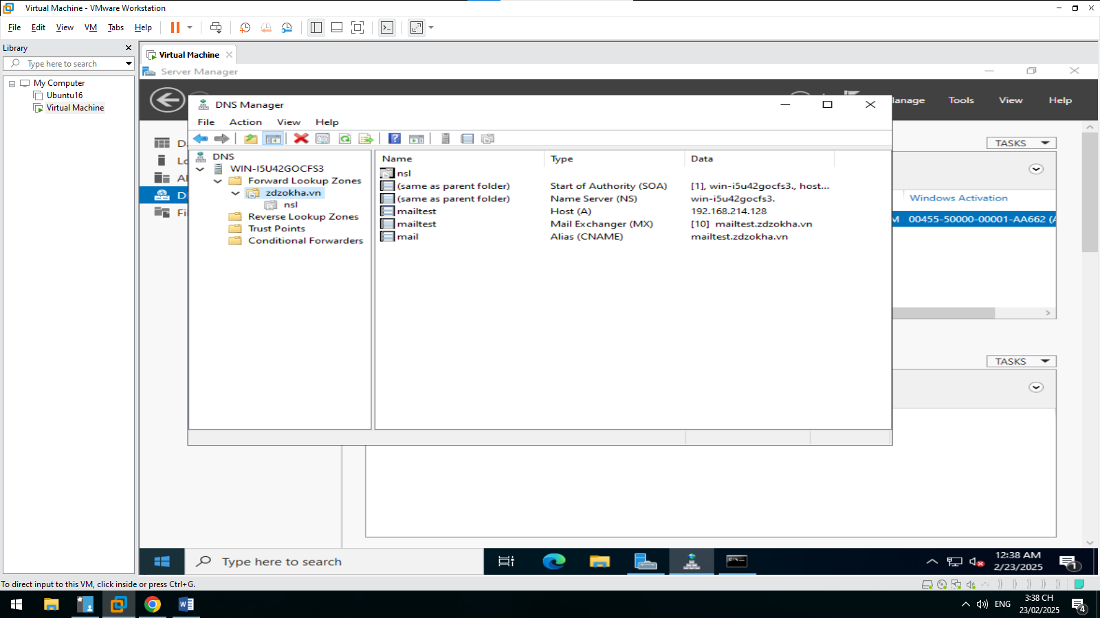

**Active Directory**

**Promoting a Domain Controller**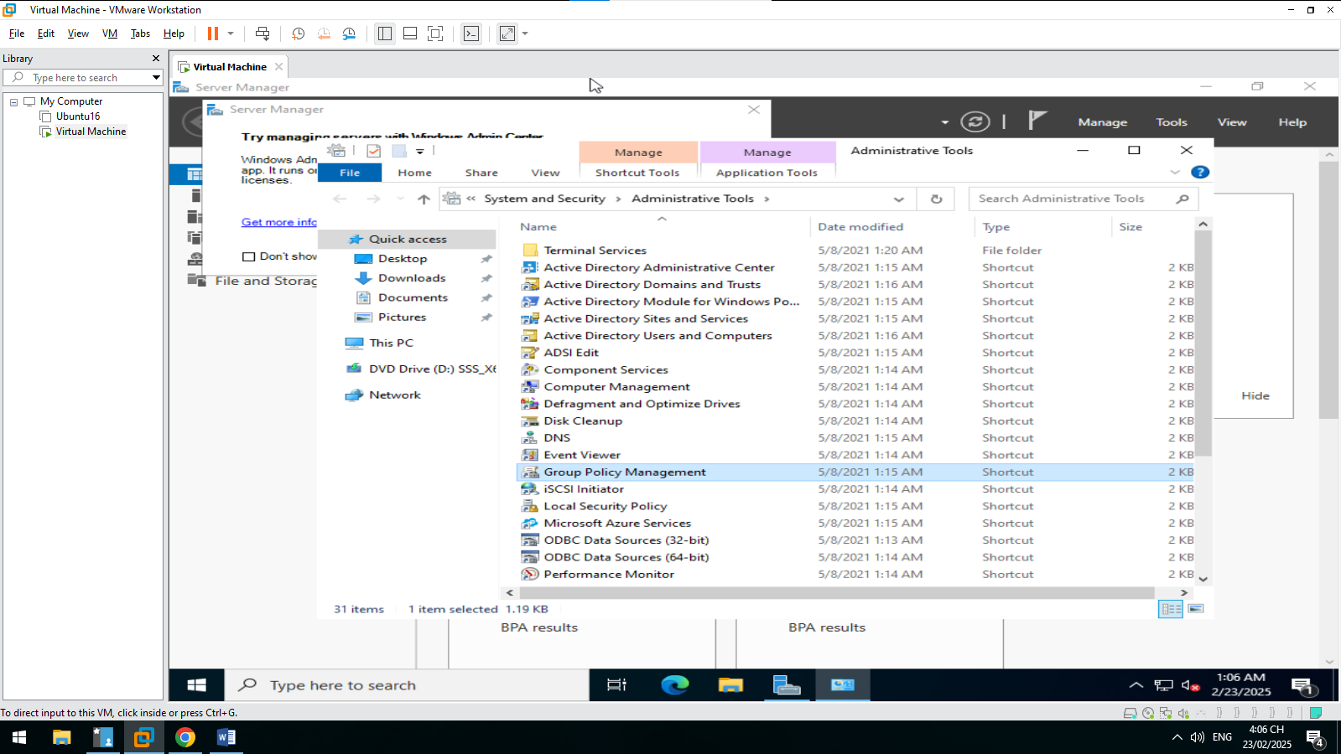

**Viewing the Active Directory Event Log**

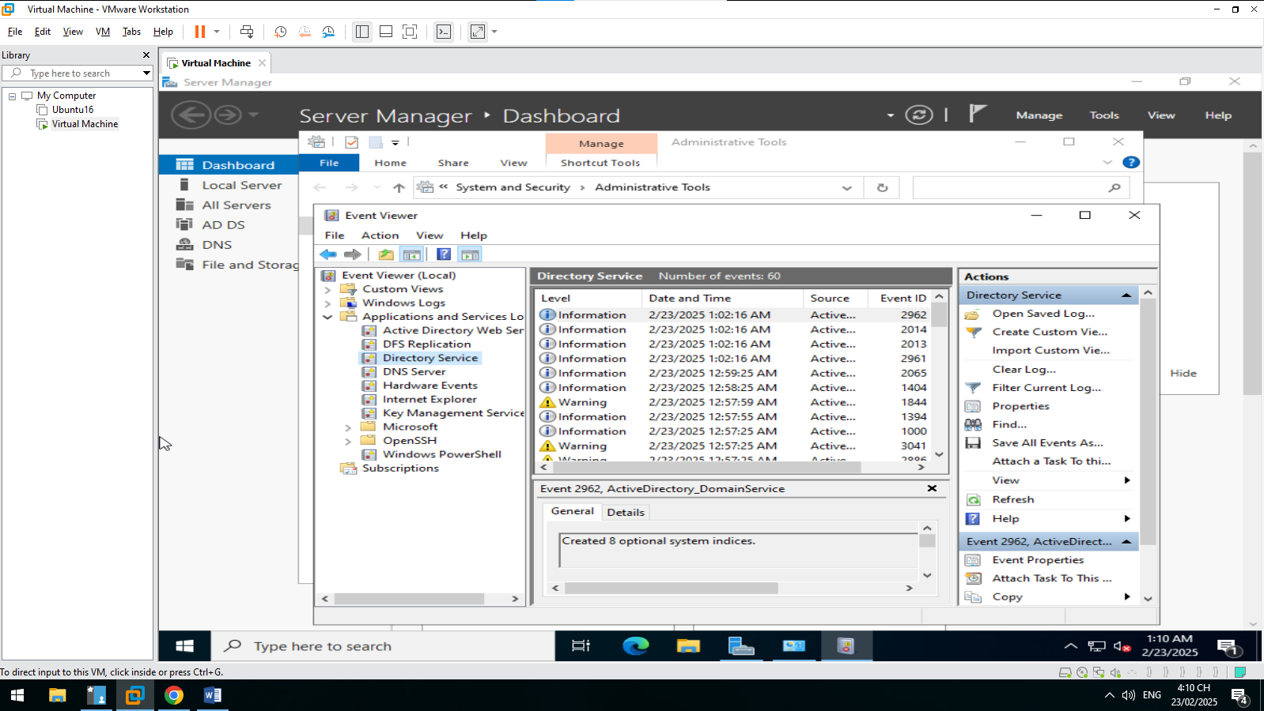

**Configuring DNS Integration with Active Directory**

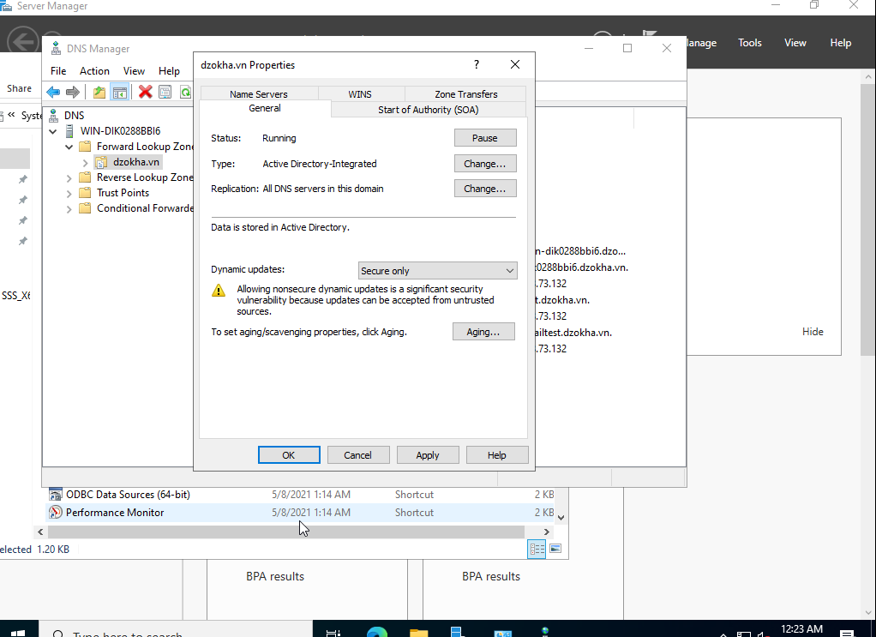

**Creating an OU Structure**

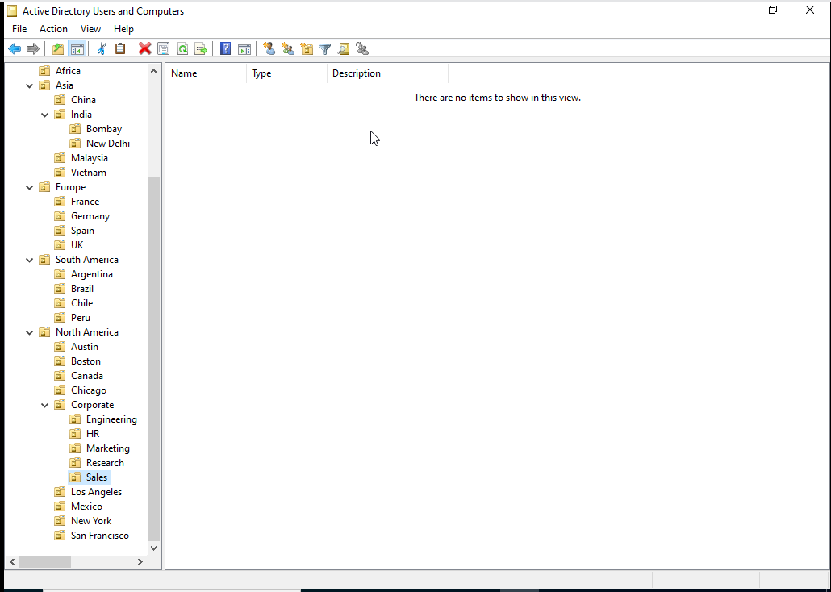

**Modifying OU Structure**

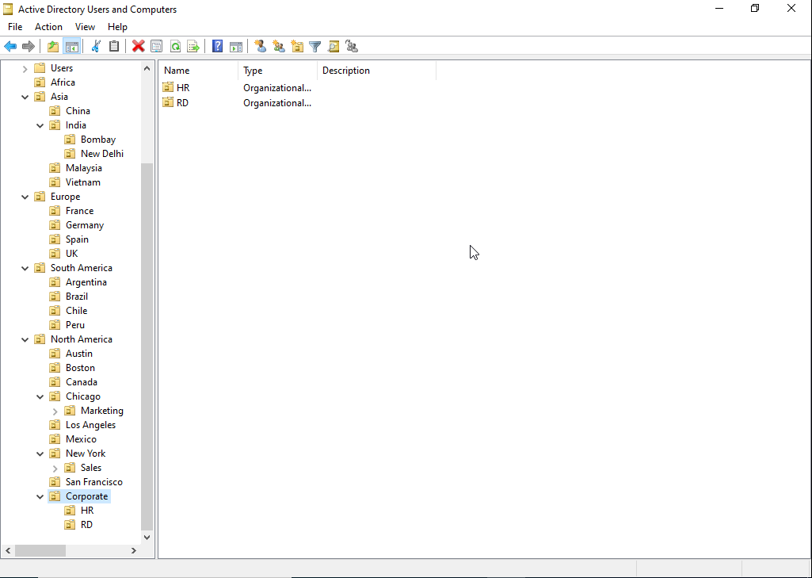

**Using the Delegation of Control Wizard**

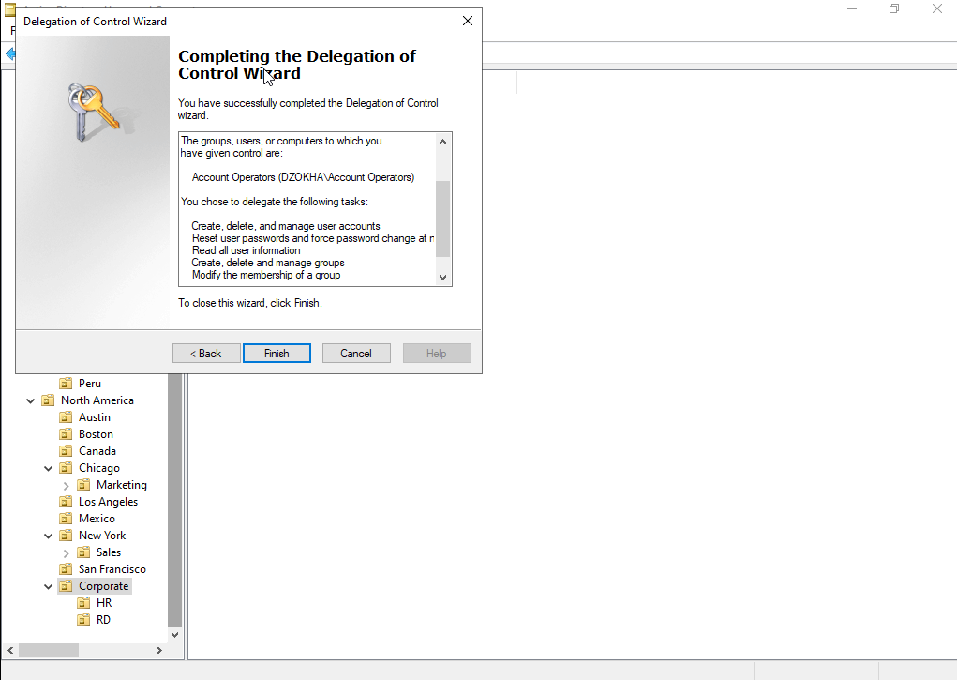

**Delegating Custom Tasks**

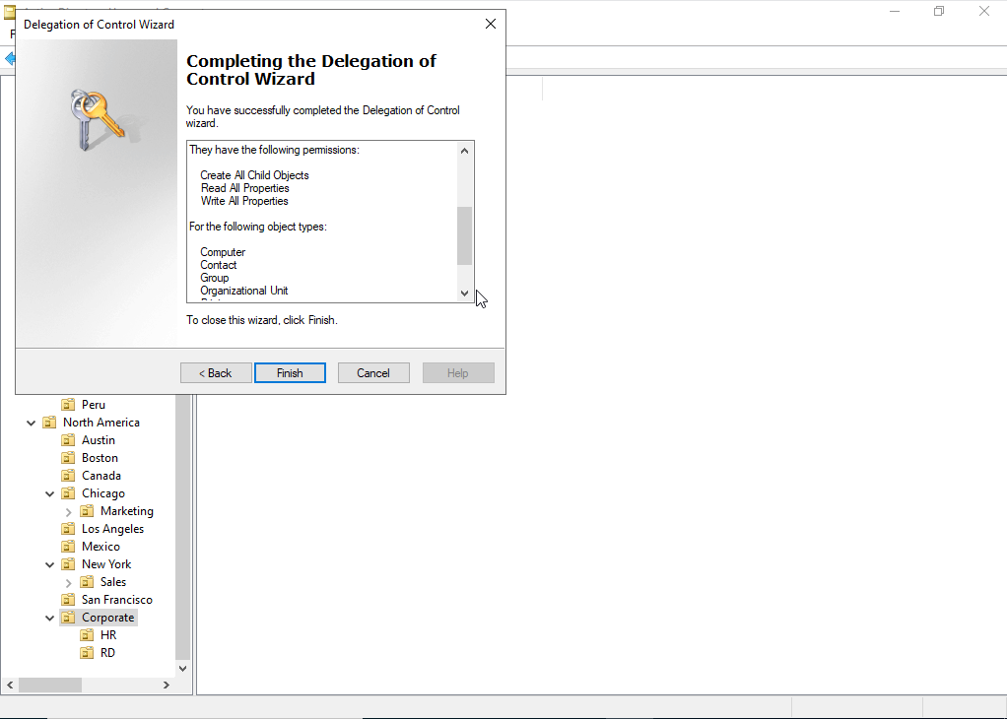

**Creating Active Directory Objects**

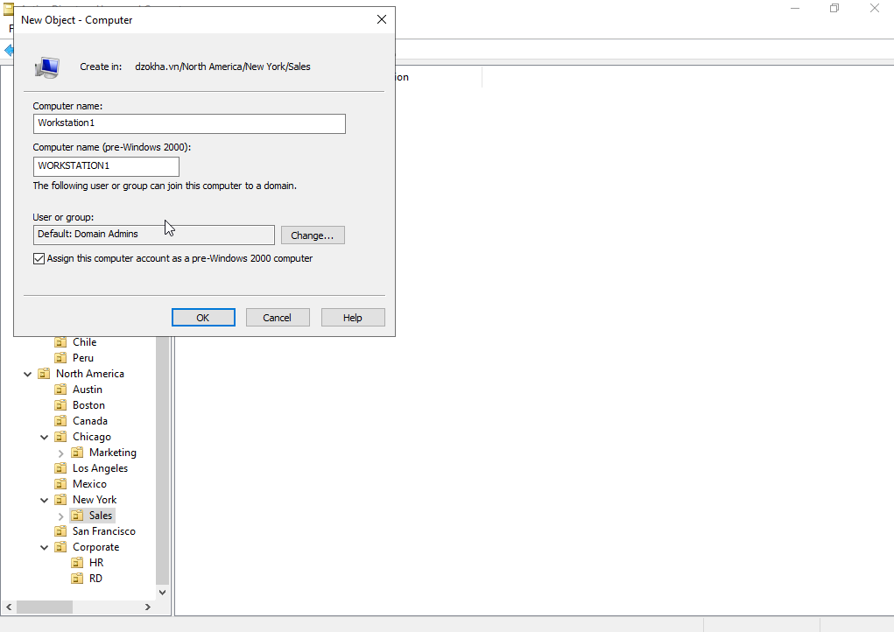

**Creating a User Template**

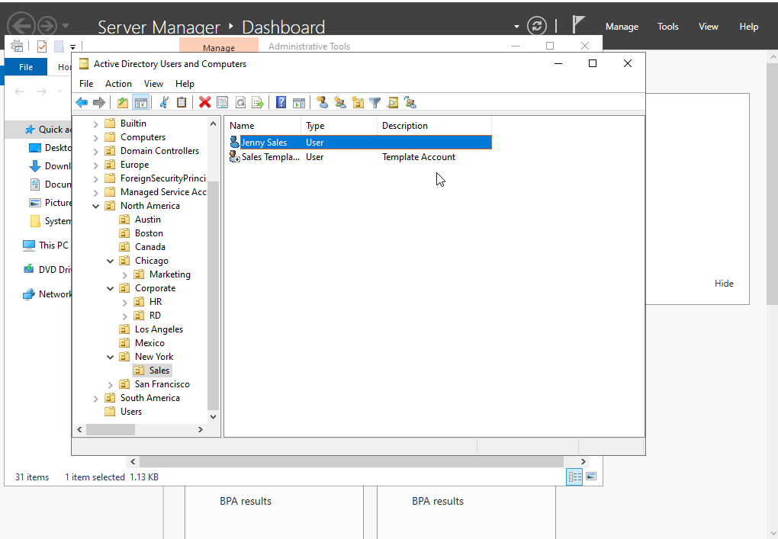

**Managing Object Properties**

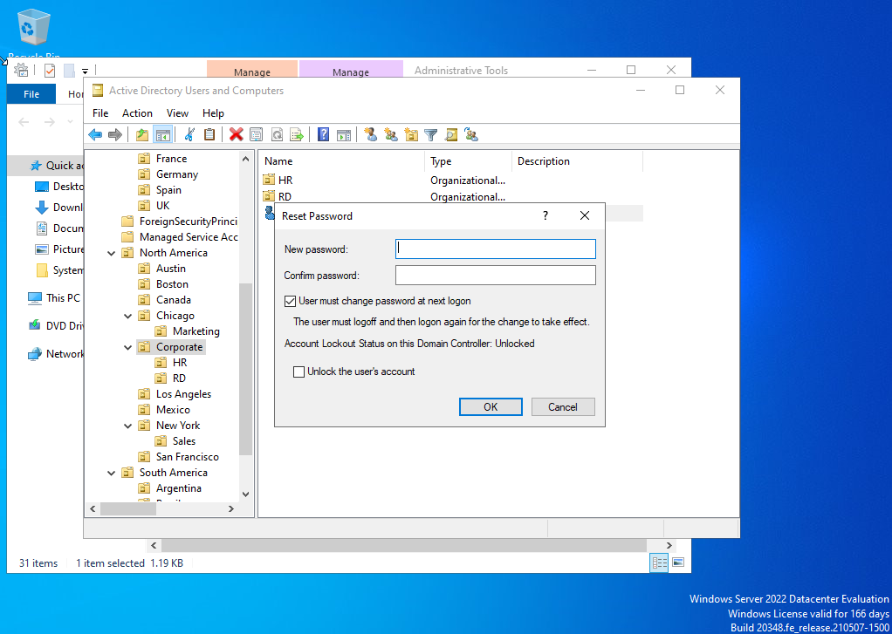

**Moving Active Directory Objects**

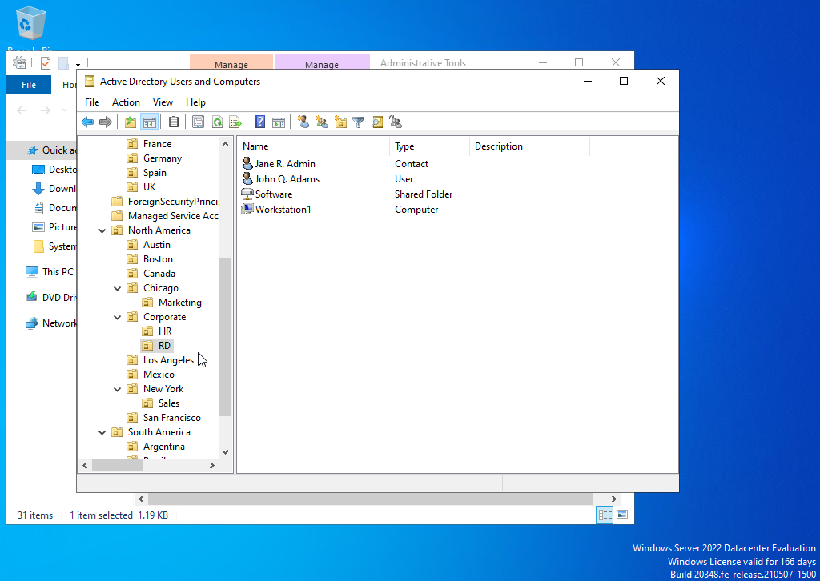

**Resetting an Existing Computer Account**

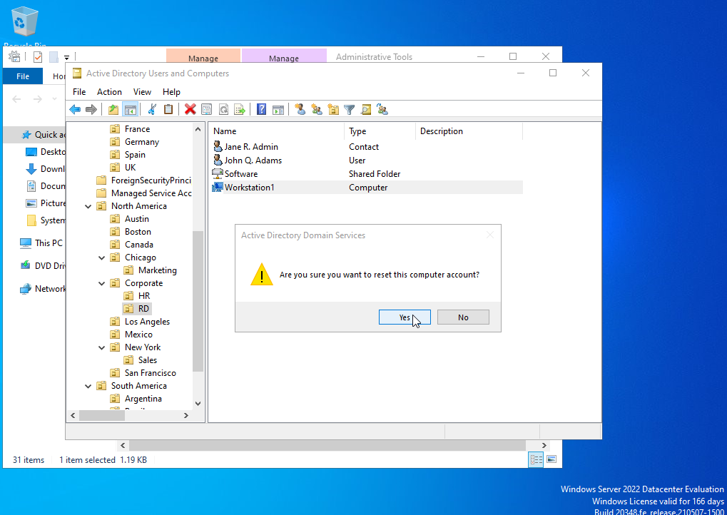

**Creating and Publishing a Shared Folder**

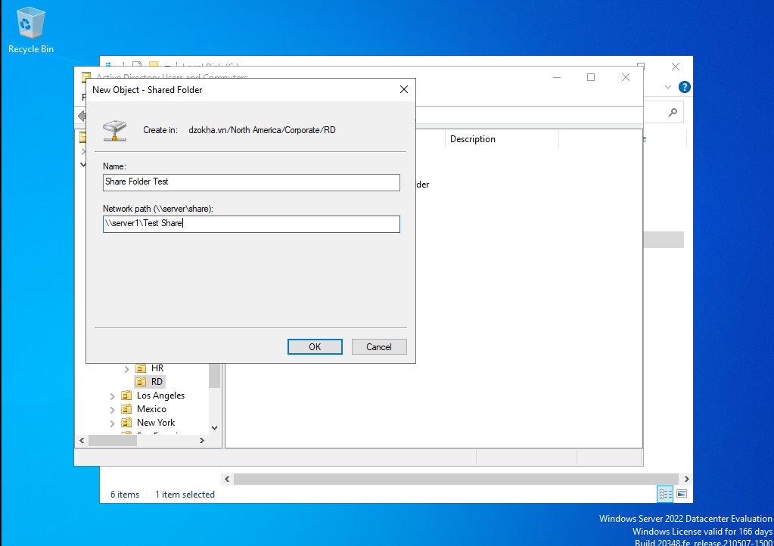

**Ứng dụng máy chủ**

**Cài dịch vụ IIS**

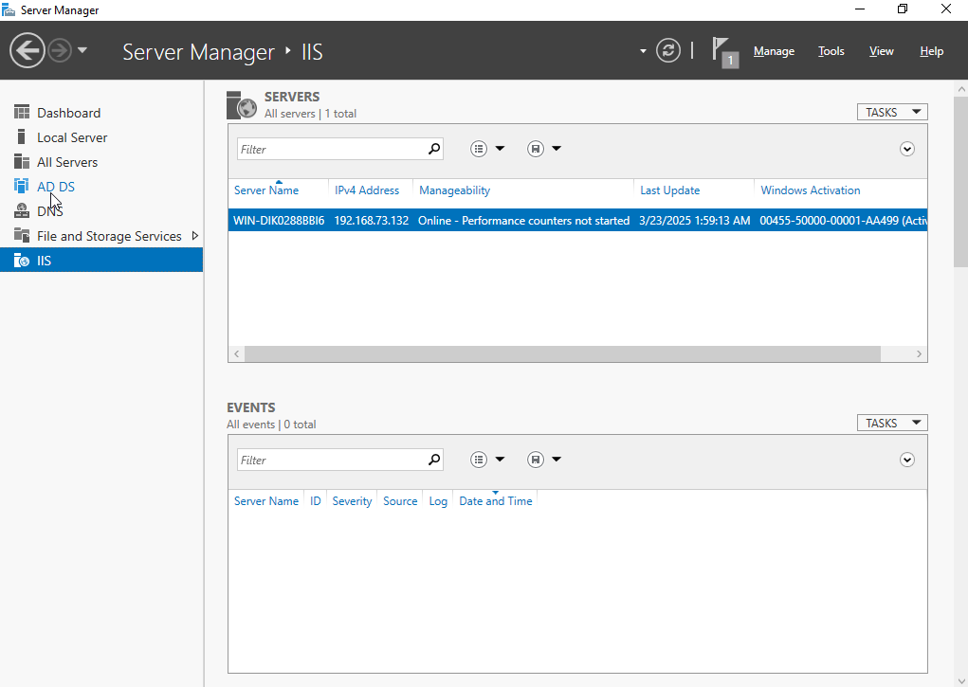

**Group Policy**

**Creating a Group Policy Object Using the GPMC**

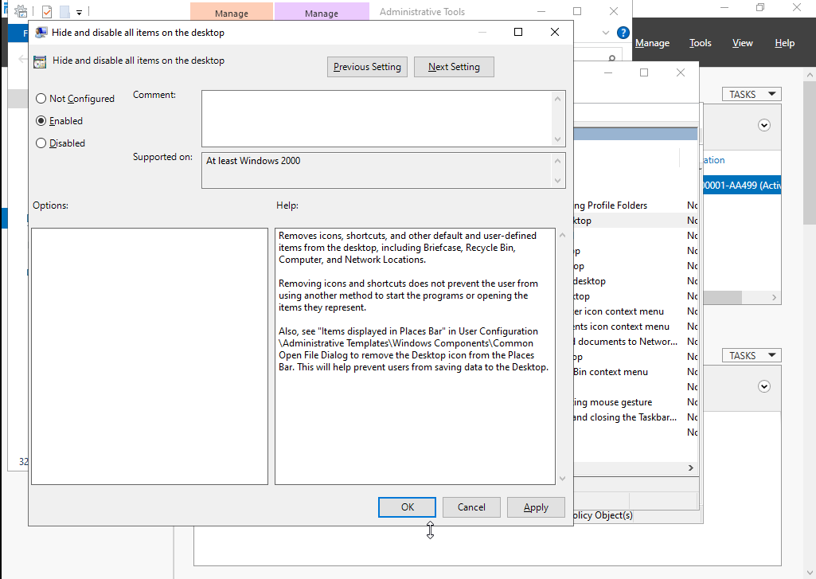

**Linking Existing GPOs to Active Directory**

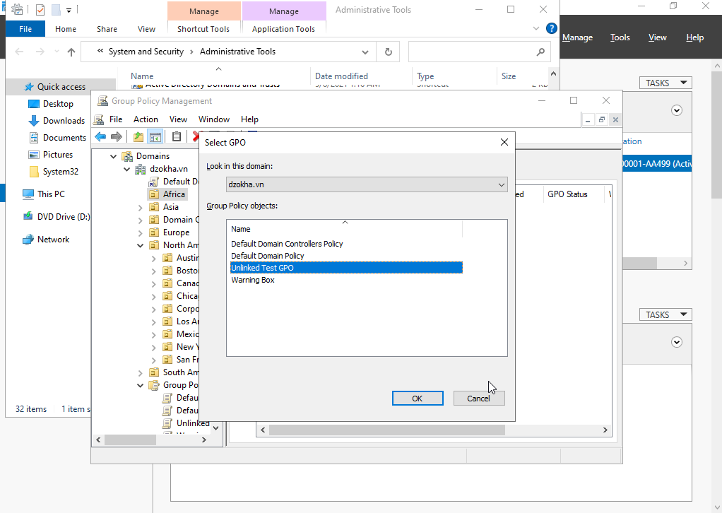

**Filtering Group Policy Using Security Groups**

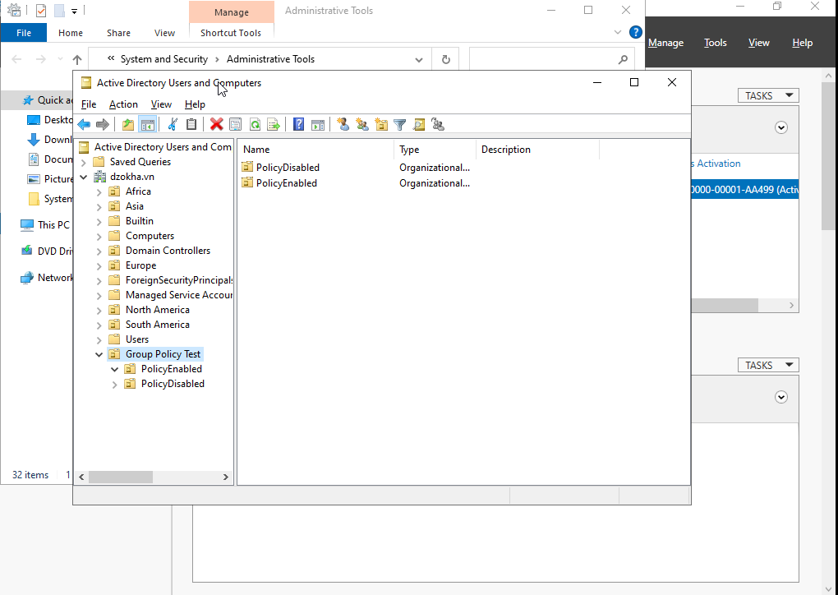

**Creating a New Scope**

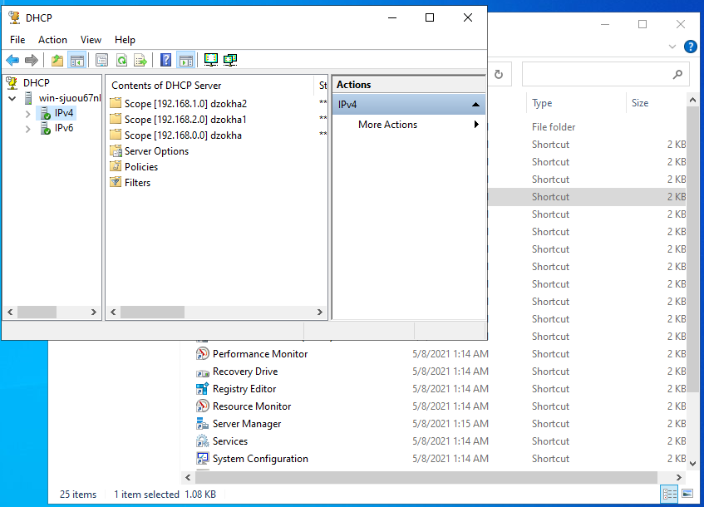

**Creating a Superscope**

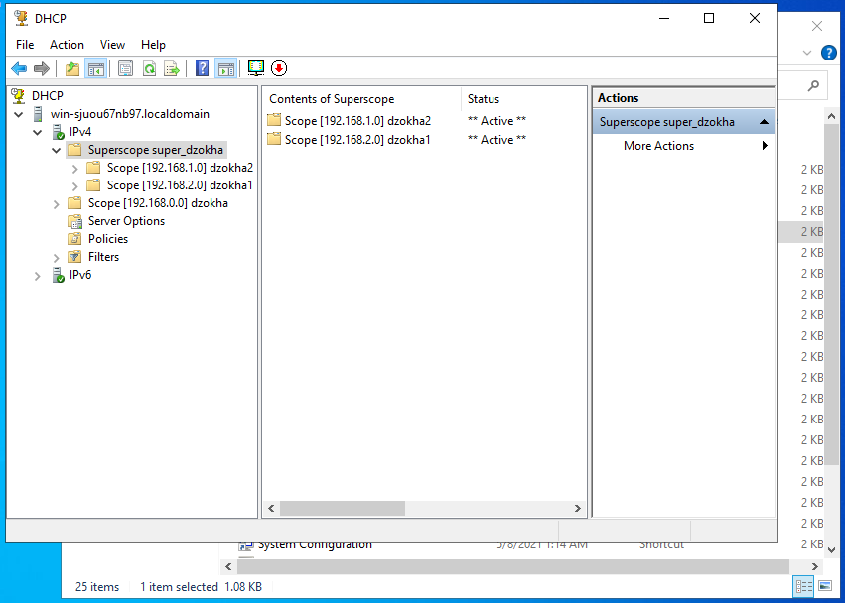

**Creating a New Multicast Scope**

