# **DNS Server**

## **Installing and Configuring the DNS Service**

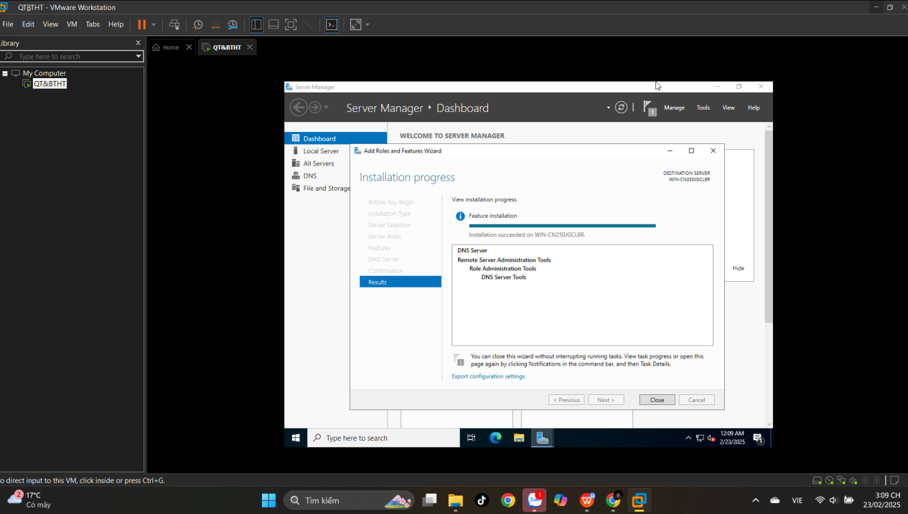

## **Configuring a Zone for Dynamic Updates**

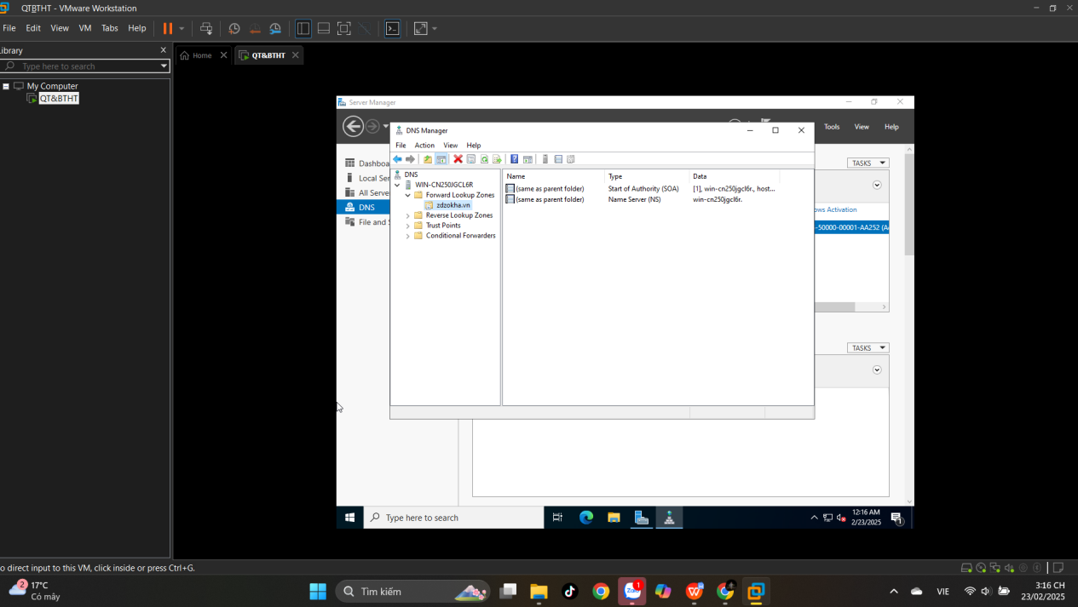

**Creating a Delegated DNS Zone**

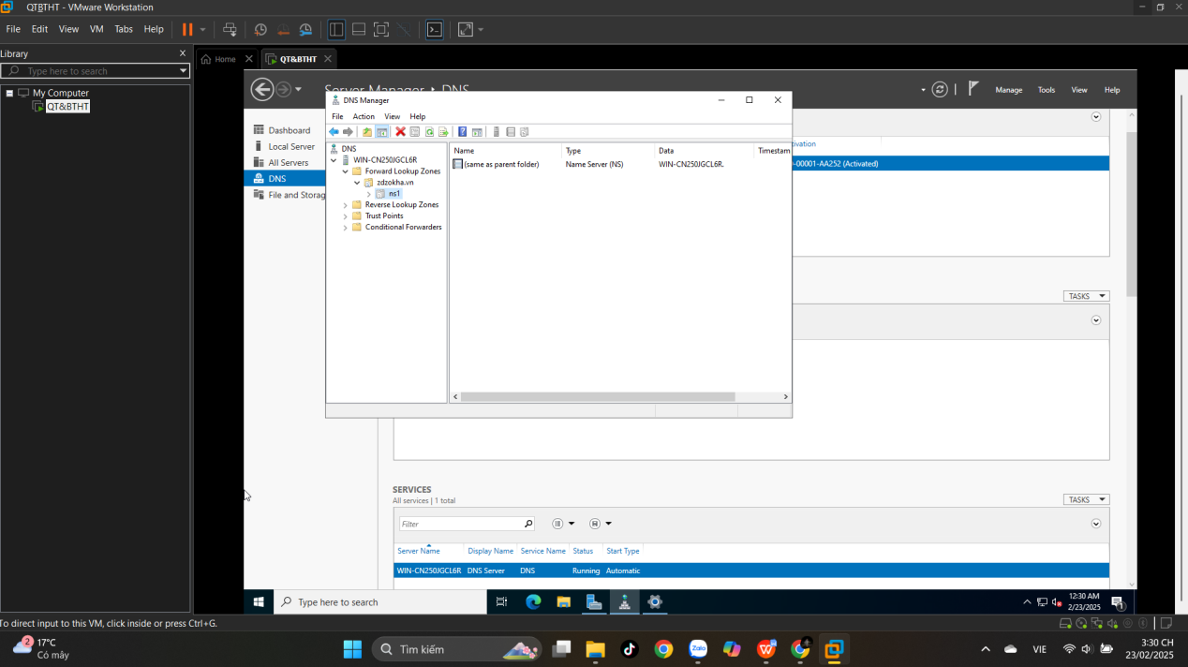

**Manually Creating DNS Records**

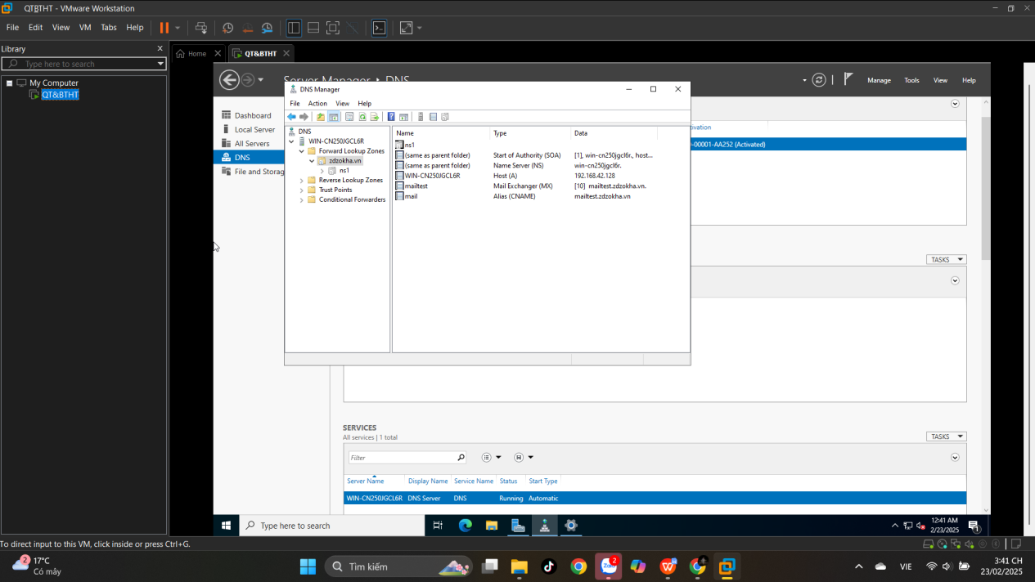

**Active Directory**

## **Promoting a Domain Controller**

