1. **Group Policy**
   1. **Creating a Group Policy Object Using the GPMC**

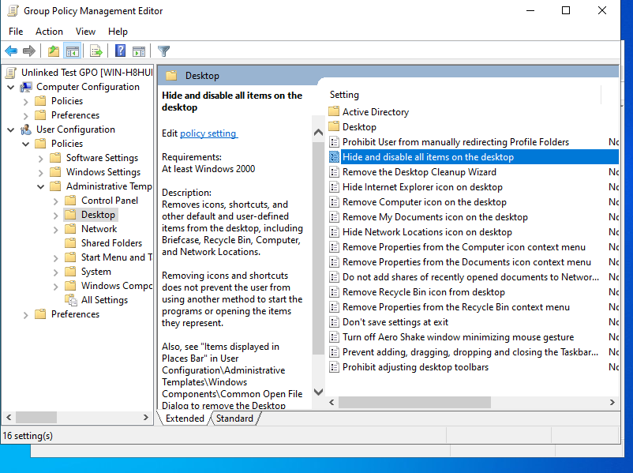

* 1. **Linking Existing GPOs to Active Directory**

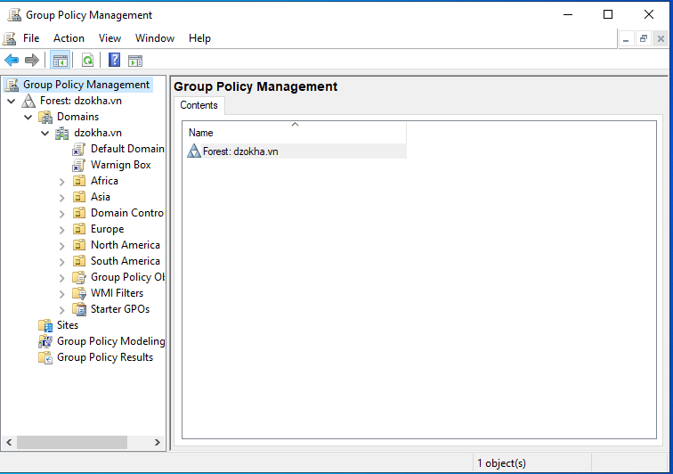

* 1. **Filtering Group Policy Using Security Groups**

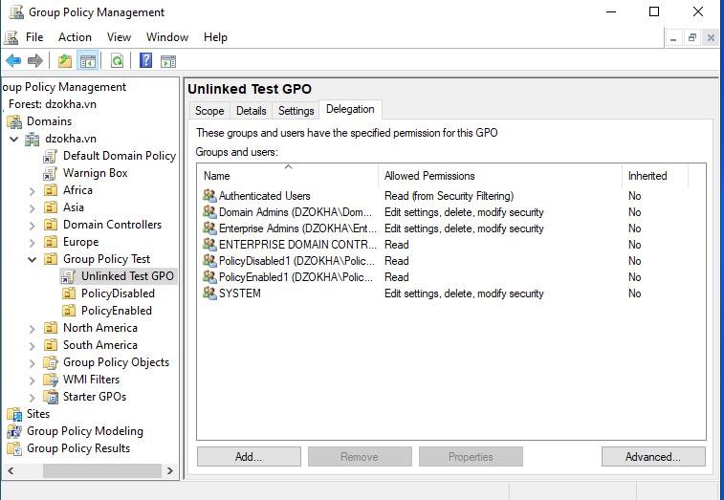

* 1. **Delegating Administrative Control of Group Policy**

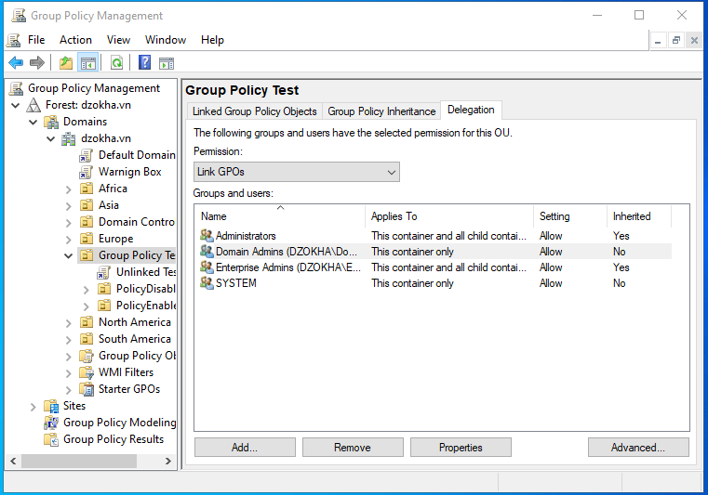

* 1. **Configuring Automatic Certificate Enrollment in Group Policy**

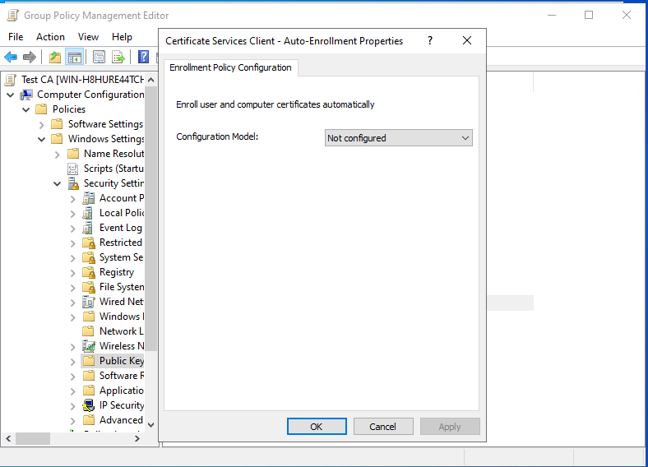

* 1. **Configuring Folder Redirection in Group Policy**

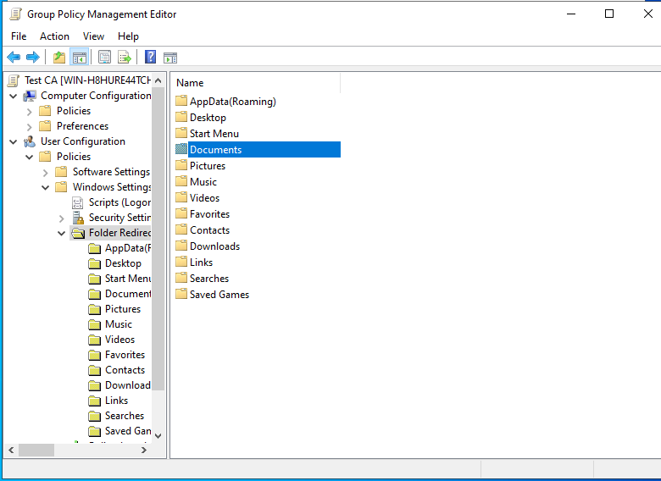

# **Configuring Security**

## **11.1 Windows Defender Security Center**

## 

**11.2 Configuring Windows Firewall**

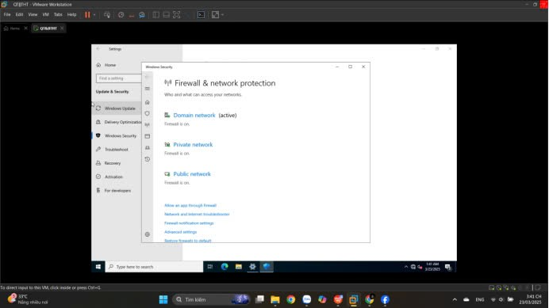

**11.3 Windows Firewall with Advanced Security (WFAS)**

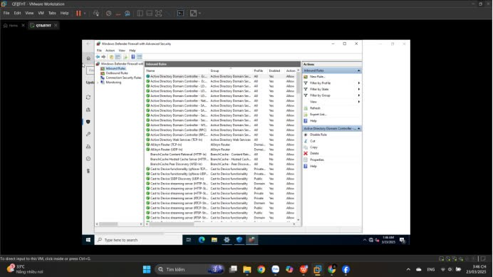

**11.4 Installing Windows Defender Application Guard**

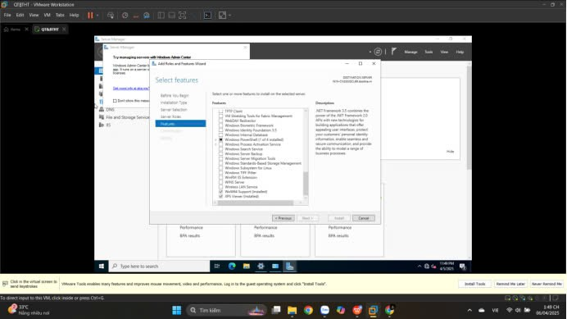

**11.5. Using Windows Defender Application Guard**

**11.6. Windows Defender Application Guard Enterprise**

**11.7. Windows Defender Credential Guard**

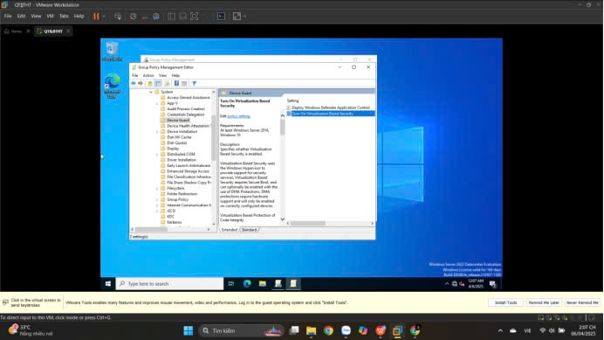

**11.8. Windows Defender Exploit Guard**

