**THB2**

1. **DNS SERVER**
2. 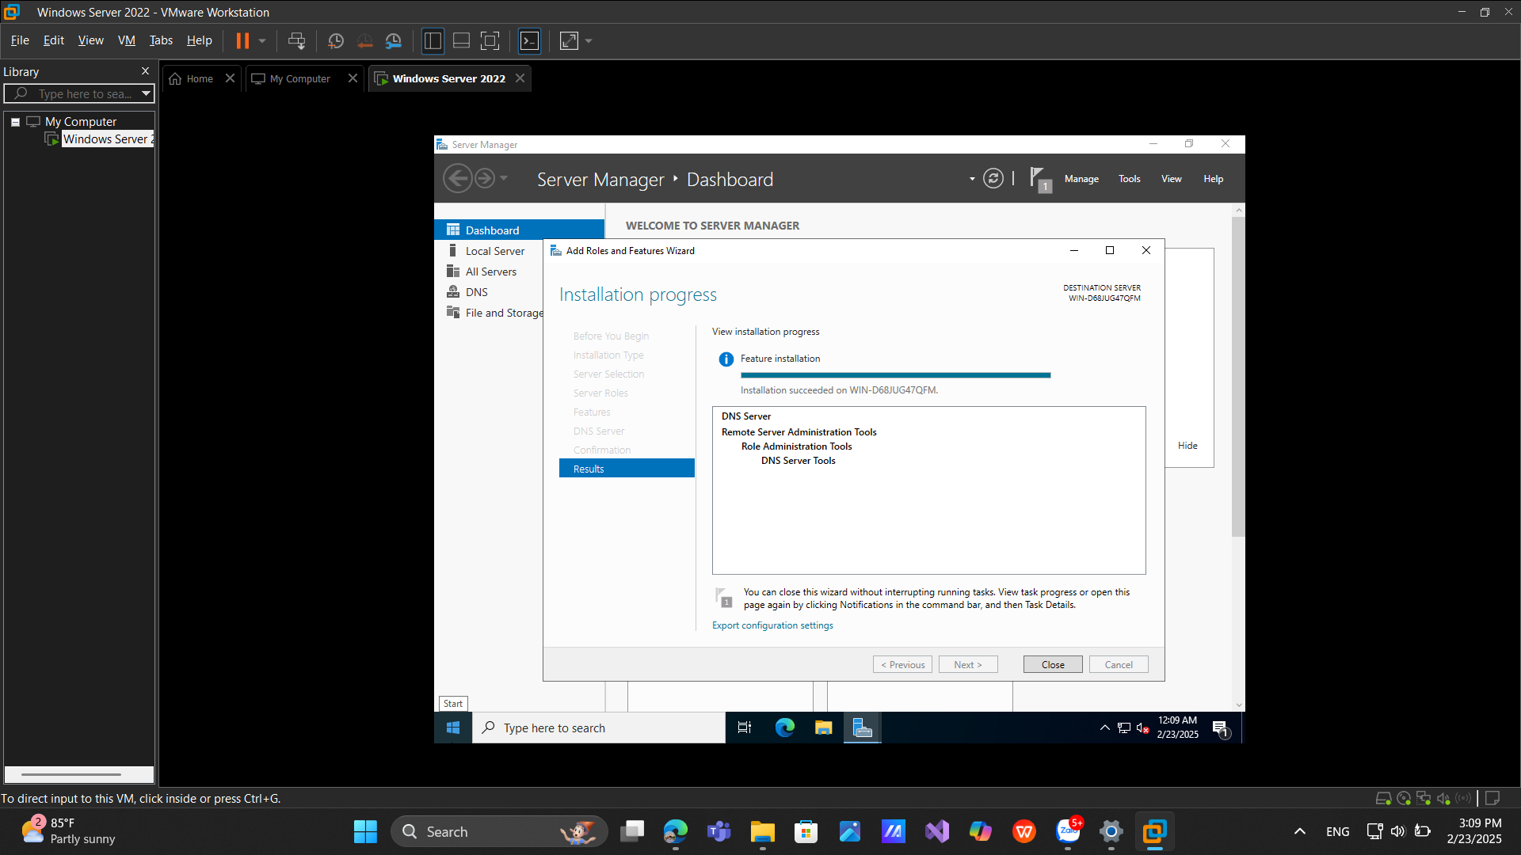**Installing and Configuring the DNS Service**
3. 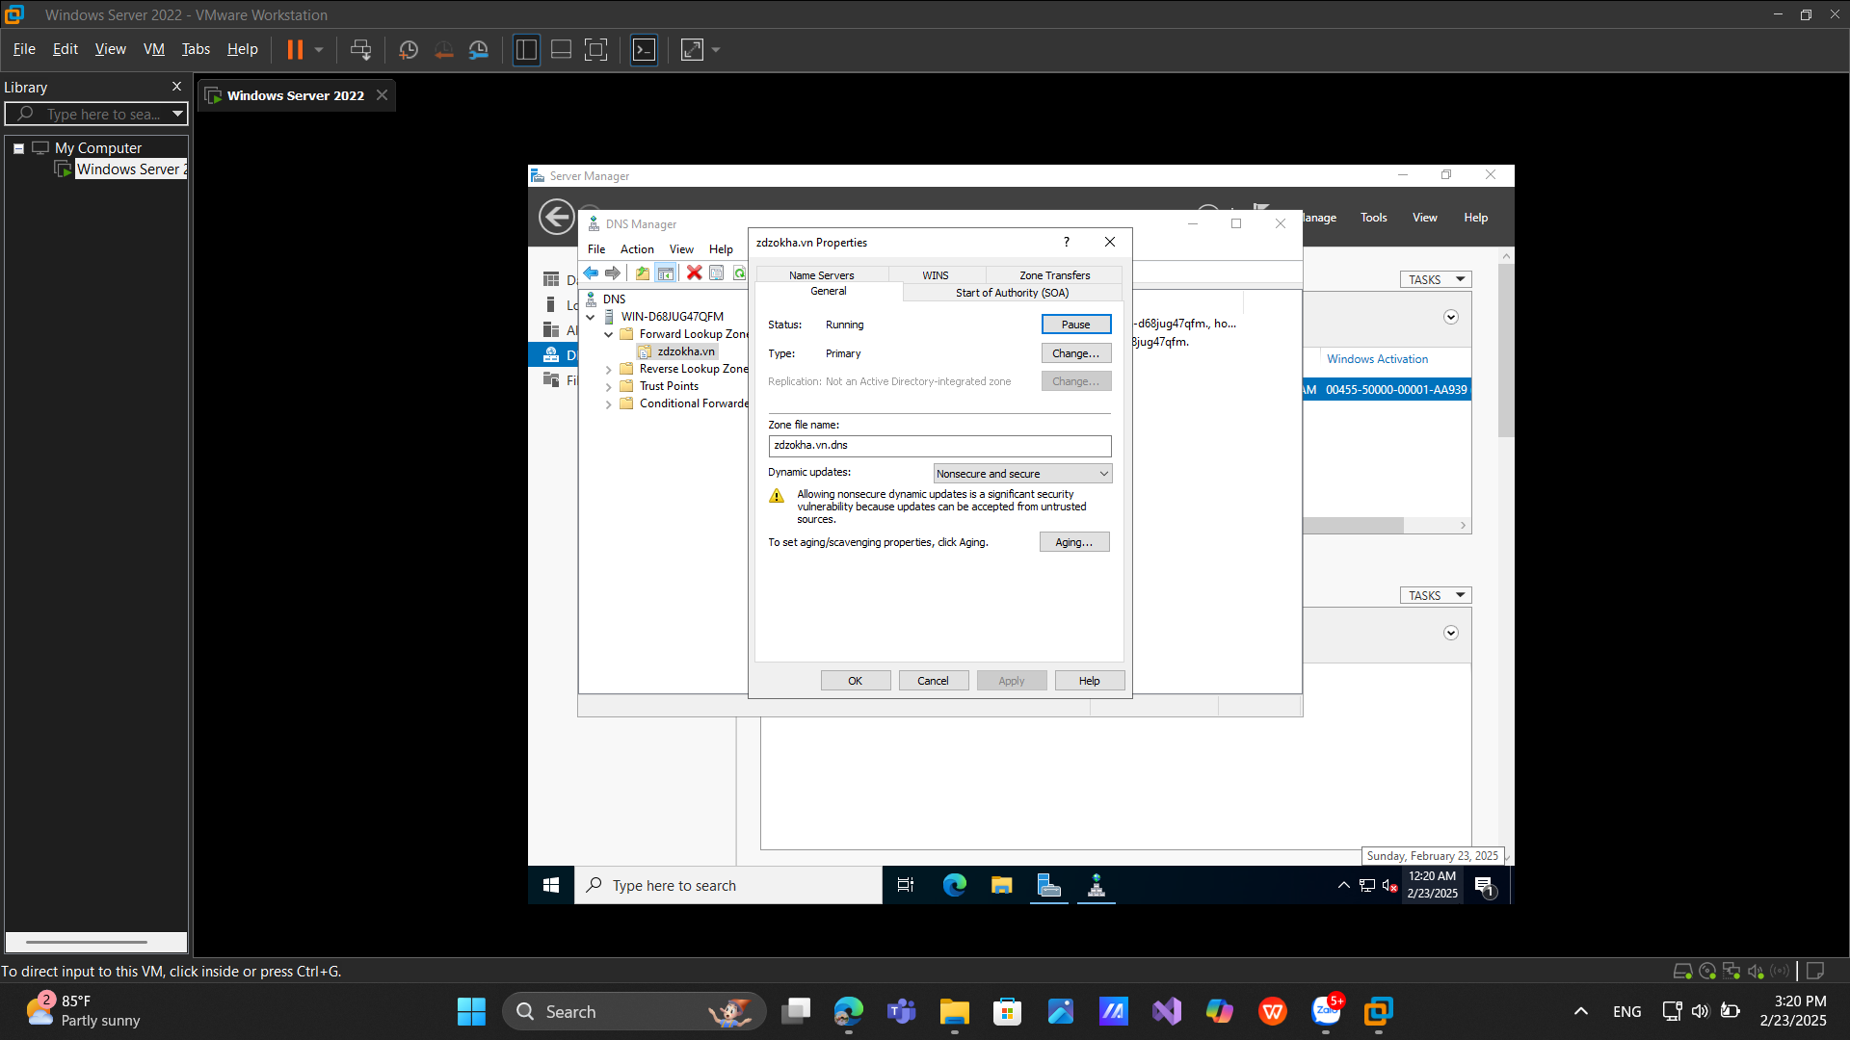**Configuring a Zone for Dynamic Updates**
4. **Creating a Delegated DNS Zone**

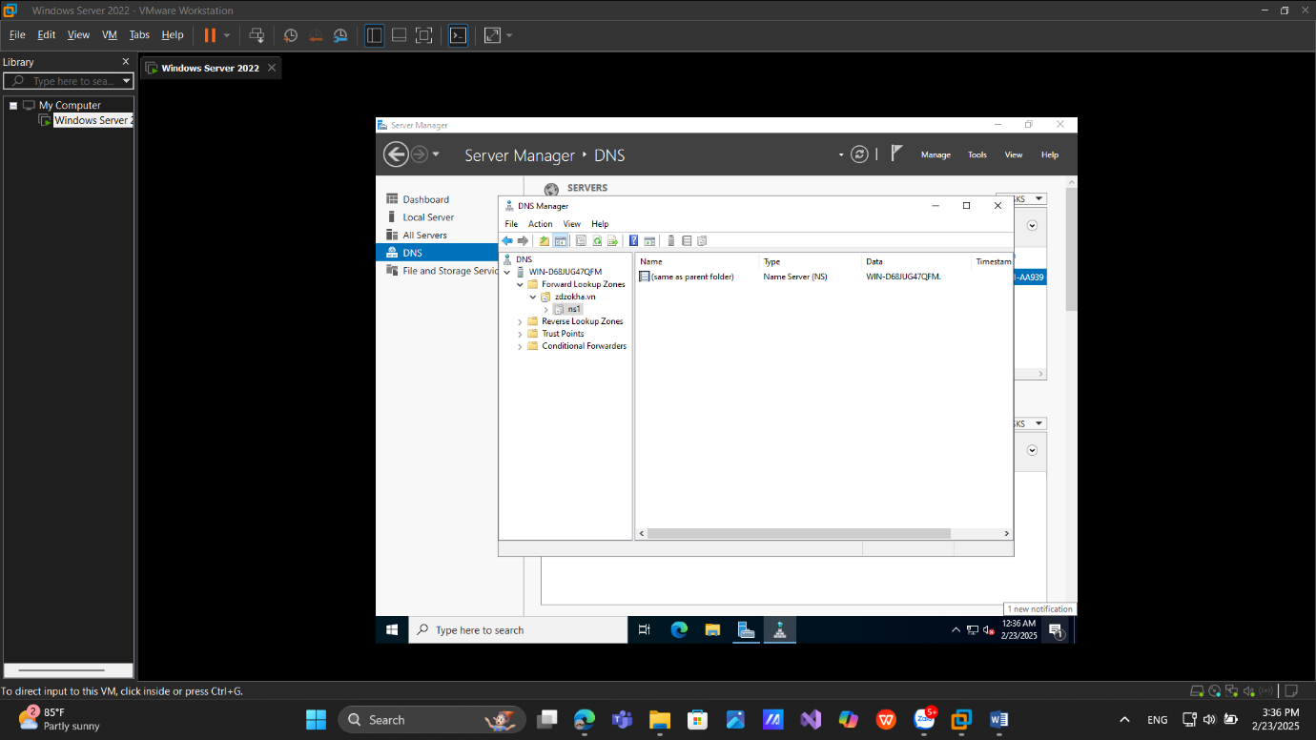

1. **Manually Creating DNS Records**

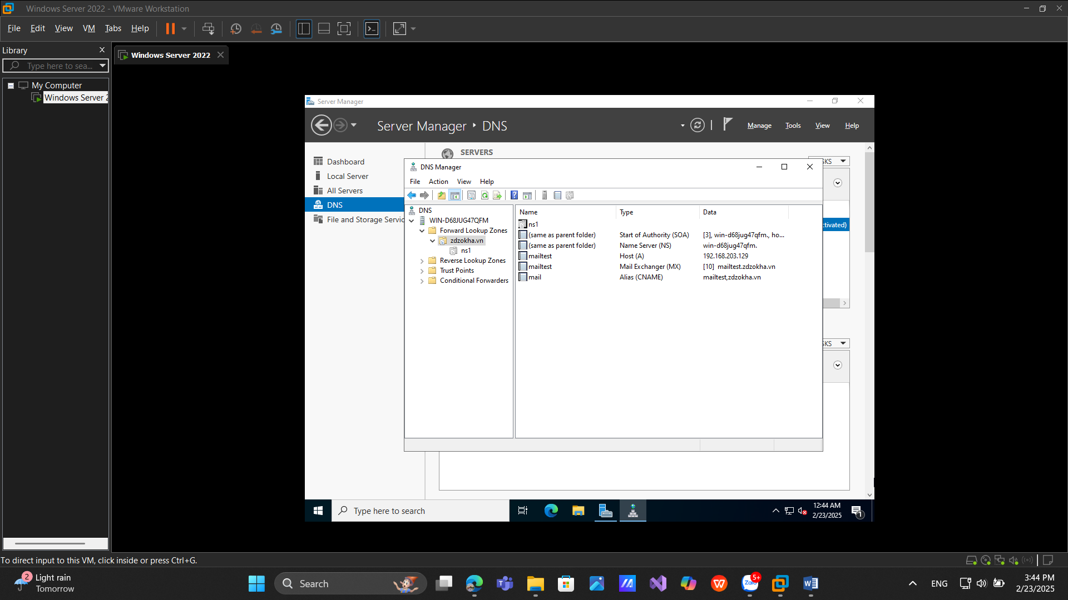

# **2. Active Directory**

**a.** **Promoting a Domain Controller**

