

**Installing and Configuring the DNS Service**

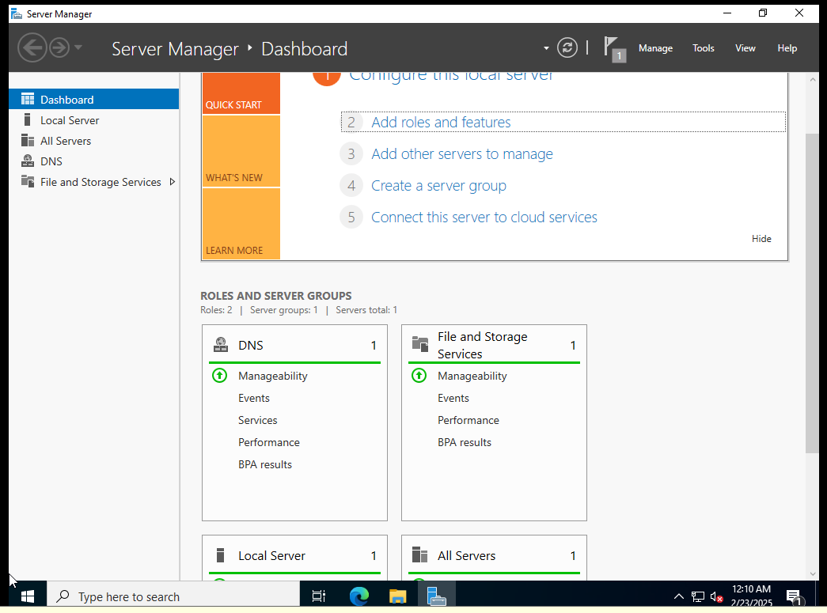

## Configuring a Zone for Dynamic Updates

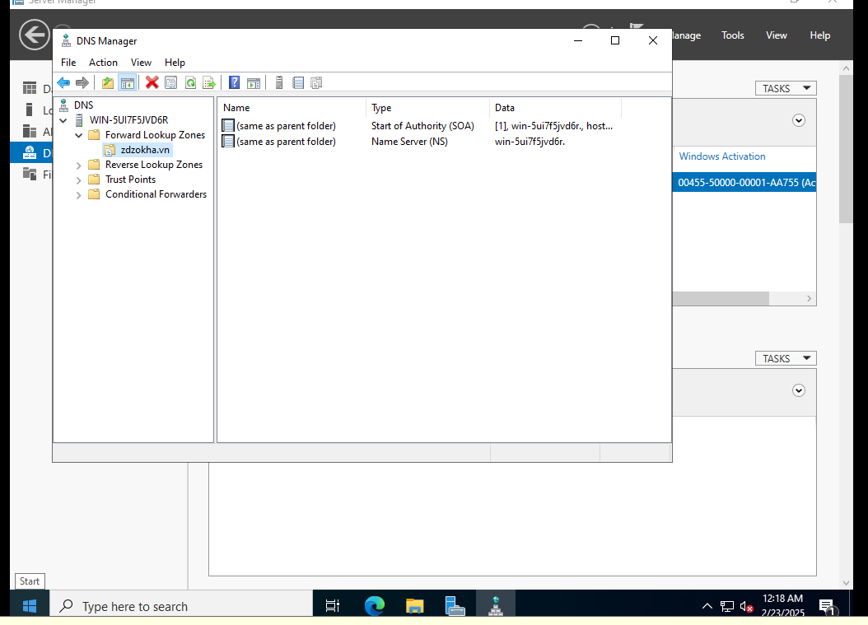

## Creating a Delegated DNS Zone

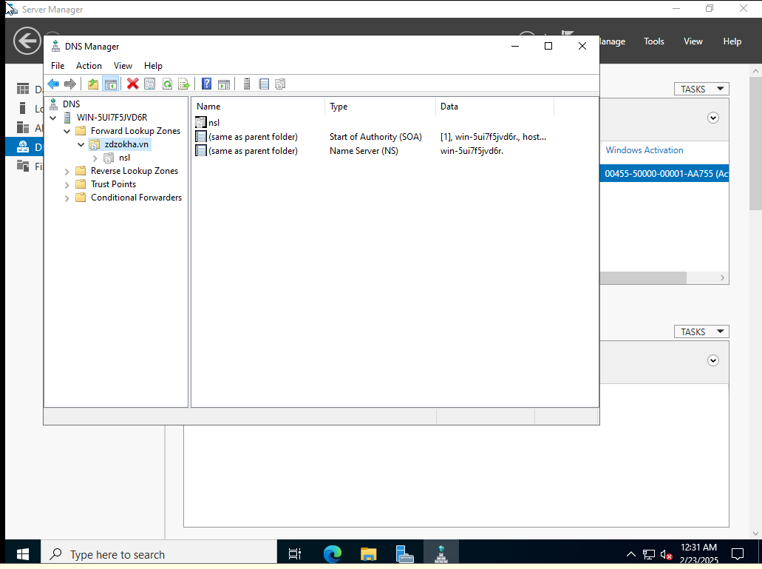

## Manually Creating DNS Records

