**TH_QTBTHTTT**

1. **DNS SERVER**
2. 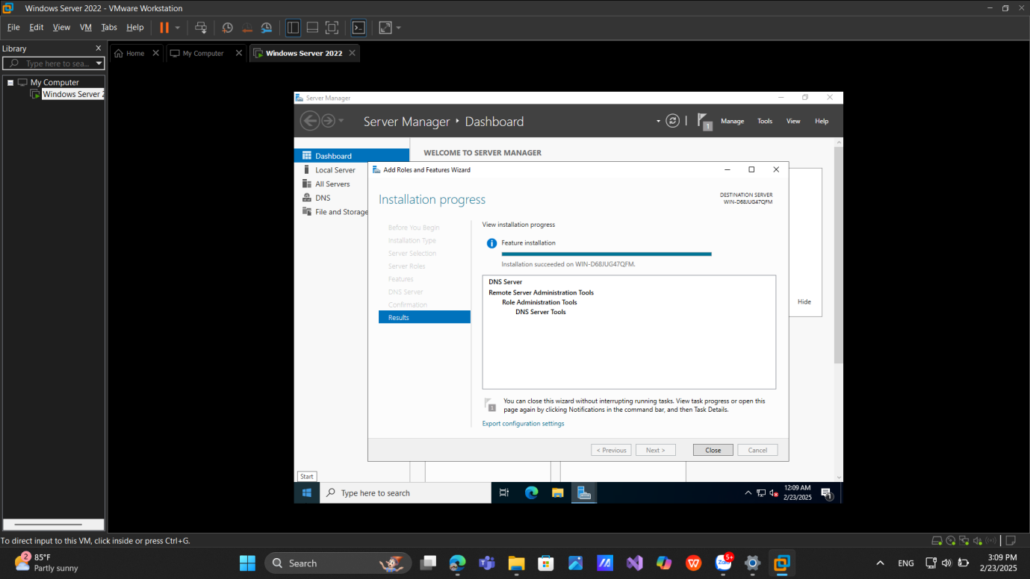**Installing and Configuring the DNS Service**
3. 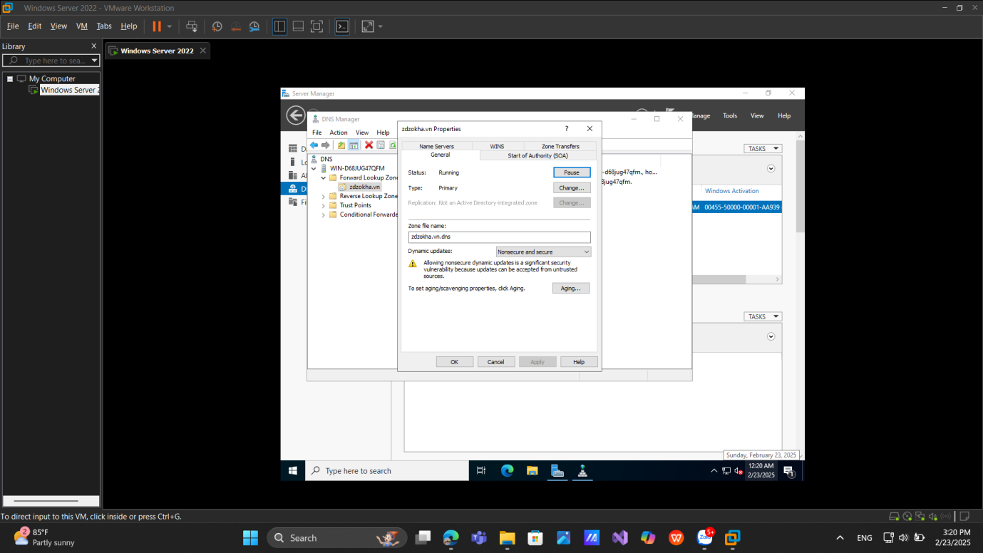**Configuring a Zone for Dynamic Updates**
4. **Creating a Delegated DNS Zone**

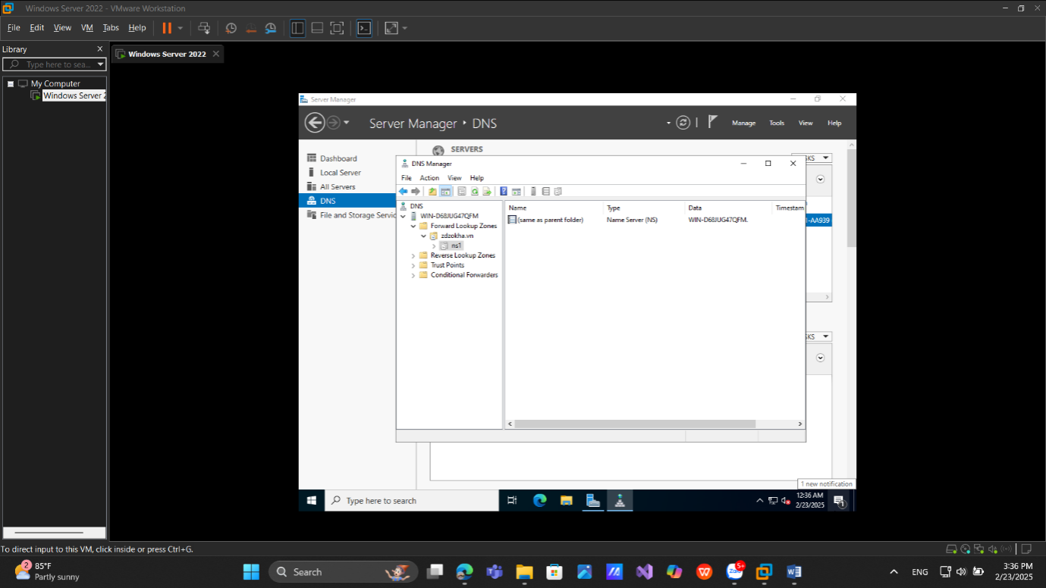

1. **Manually Creating DNS Records**

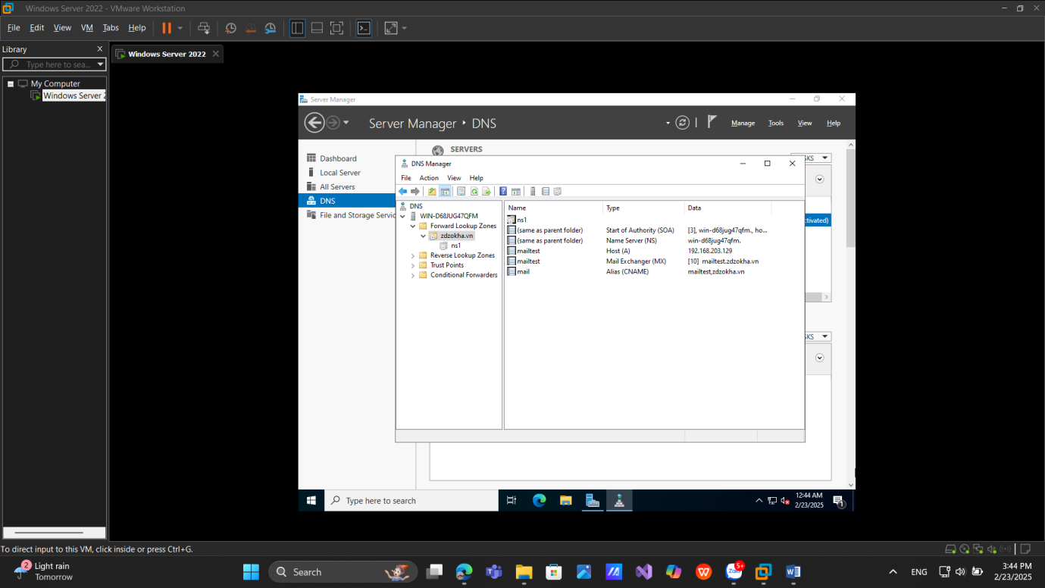

# **2. Active Directory**

**a.** **Promoting a Domain Controller**

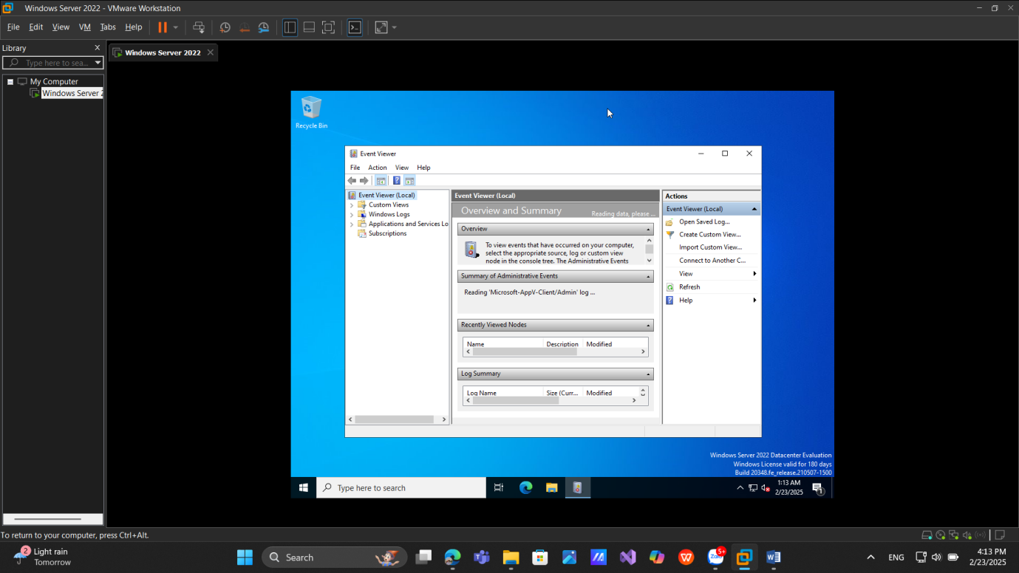

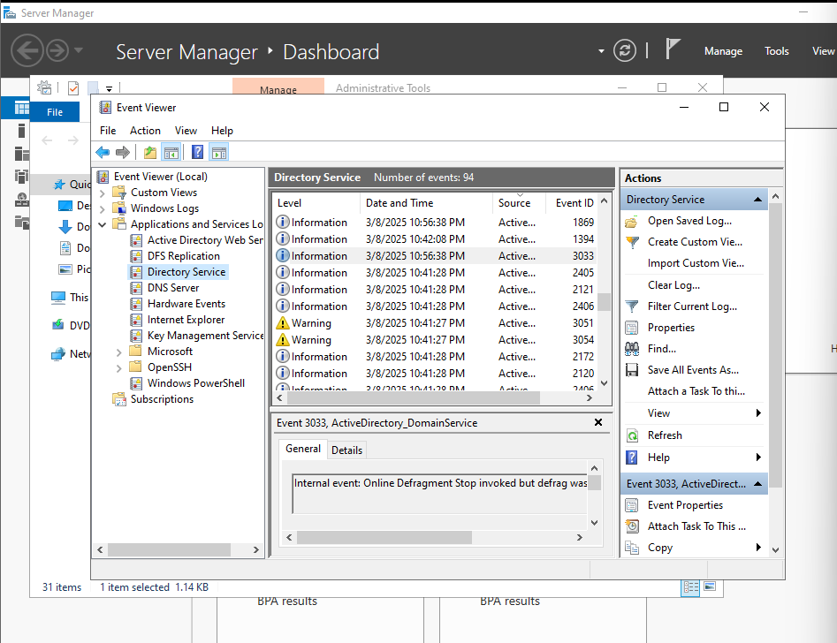**b. Viewing the Active Directory Event Log**

**c. Cài đặt Windows 10:**

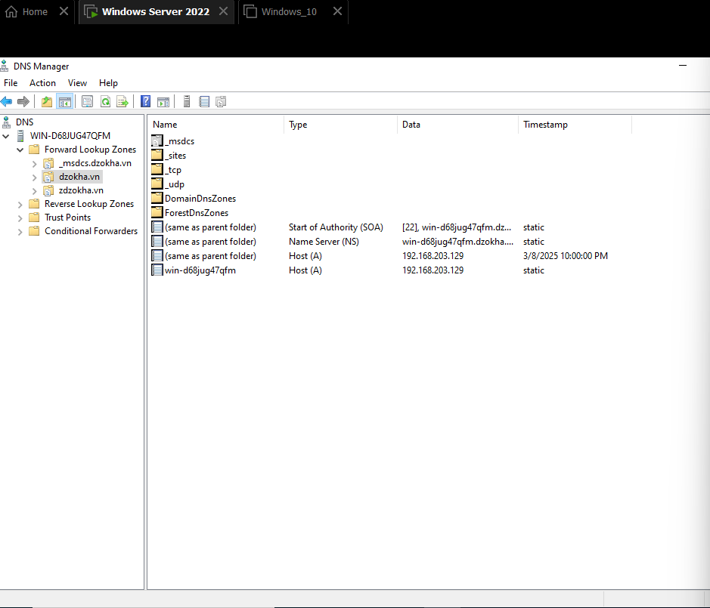**d. Creating an OU Structure**

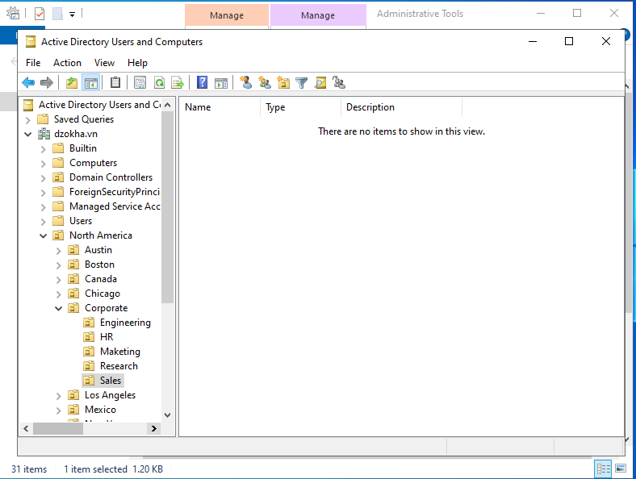

1. **Modifying OU Structure**

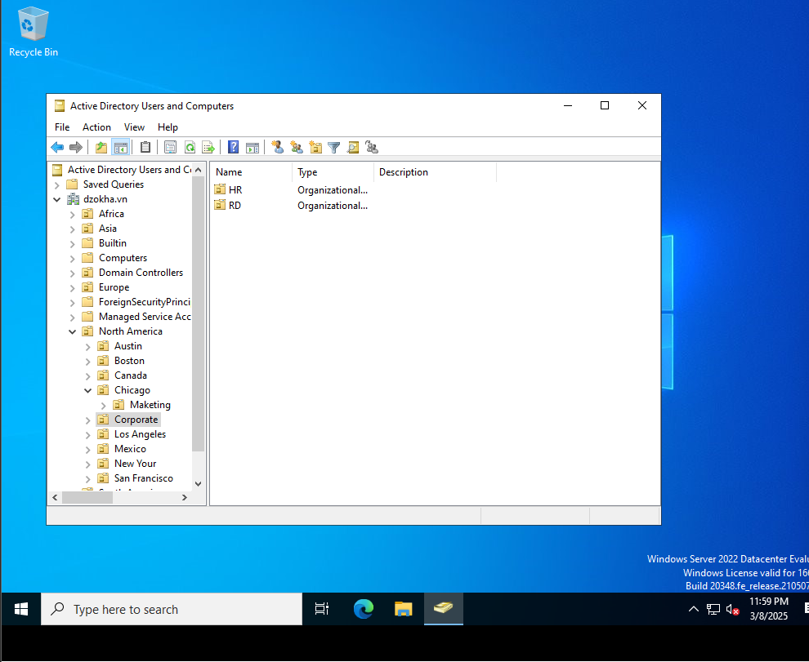

1. **Using the Delegation of Control Wizard**

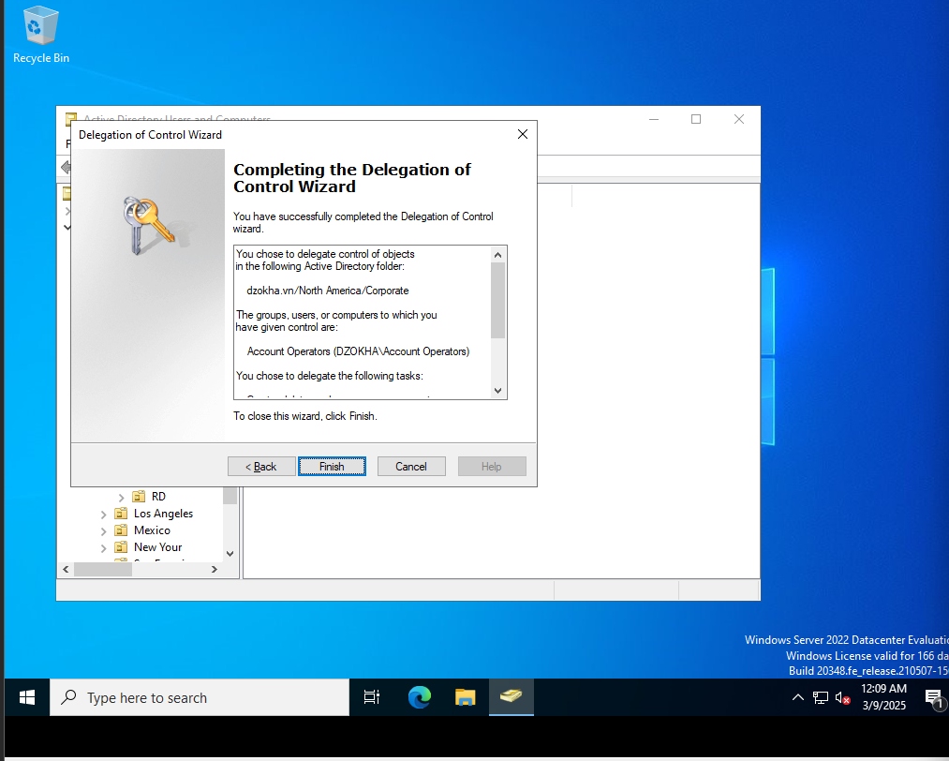

1. **Delegating Custom Tasks**

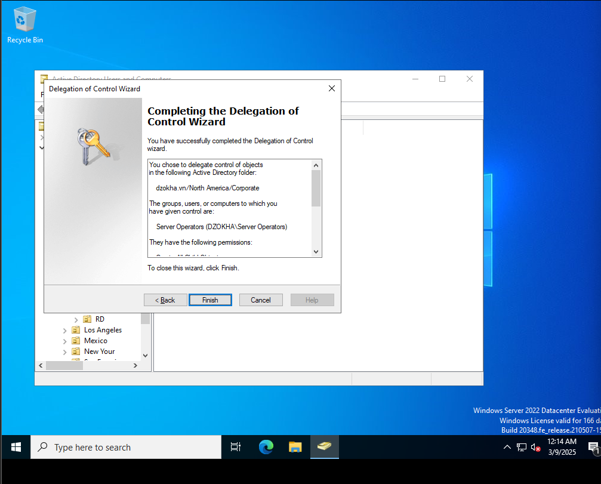

**f. Creating Active Directory Objects**

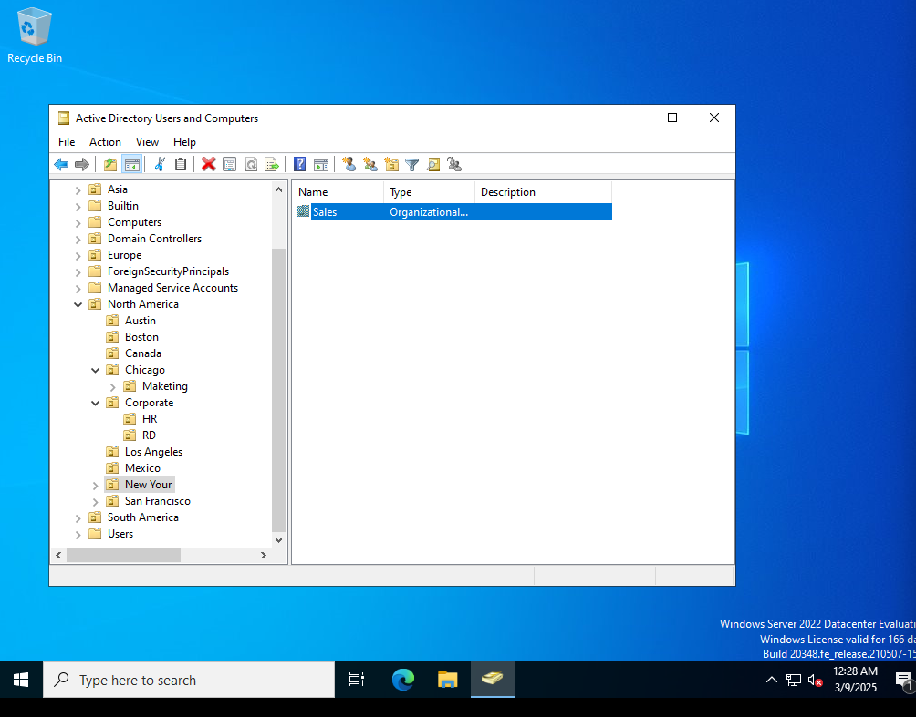

**j. Creating a User Template**

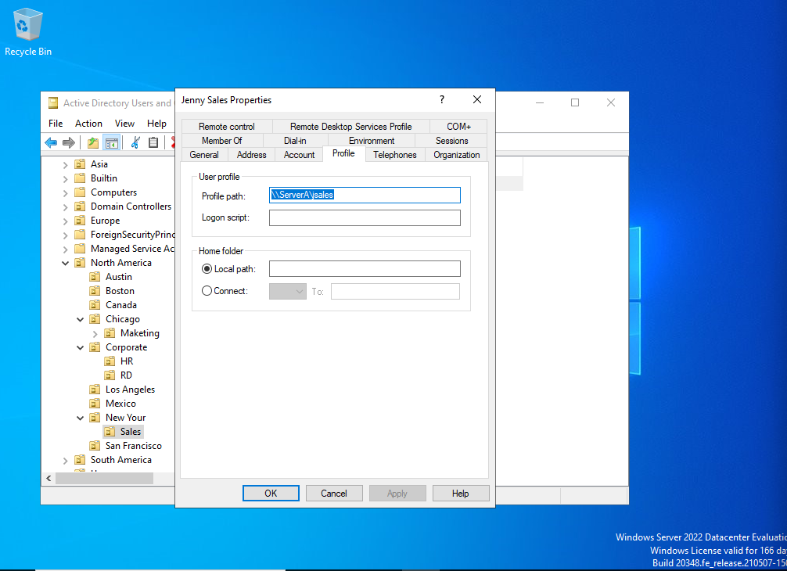

1. **Managing Object Properties**

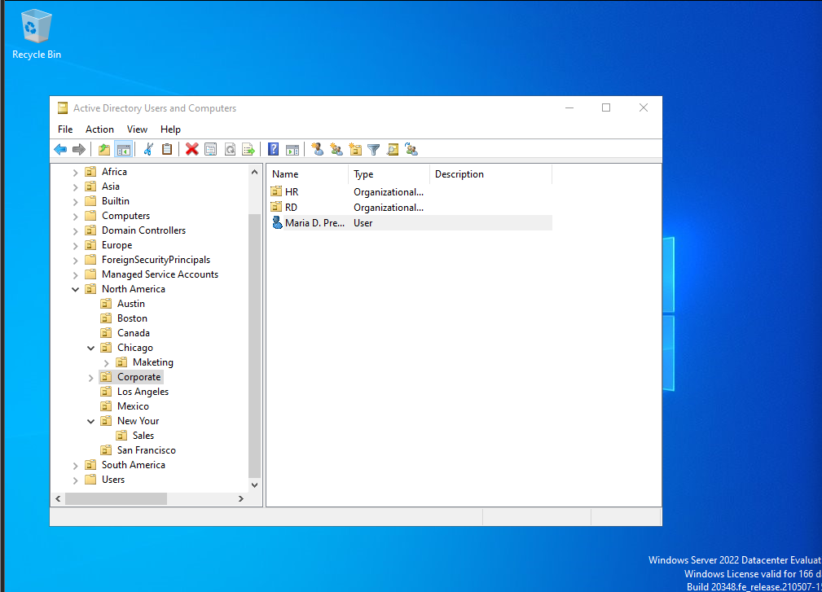

1. **Moving Active Directory Objects**

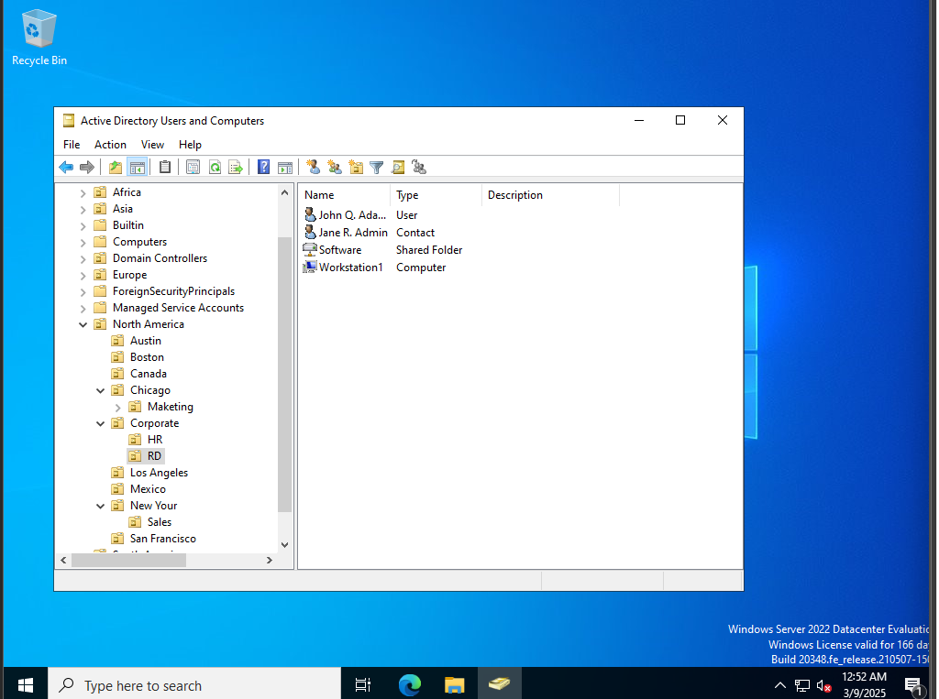

1. **Resetting an Existing Computer Account**

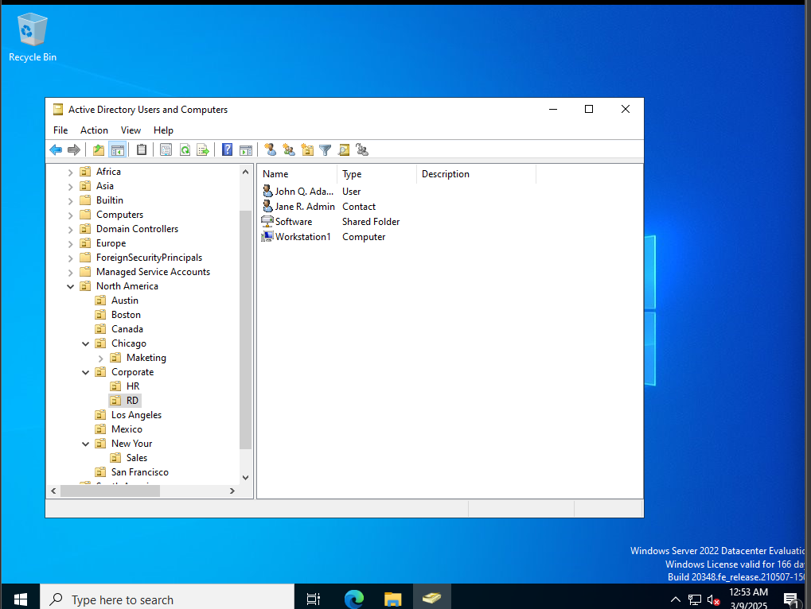

1. **Creating and Publishing a Printer**

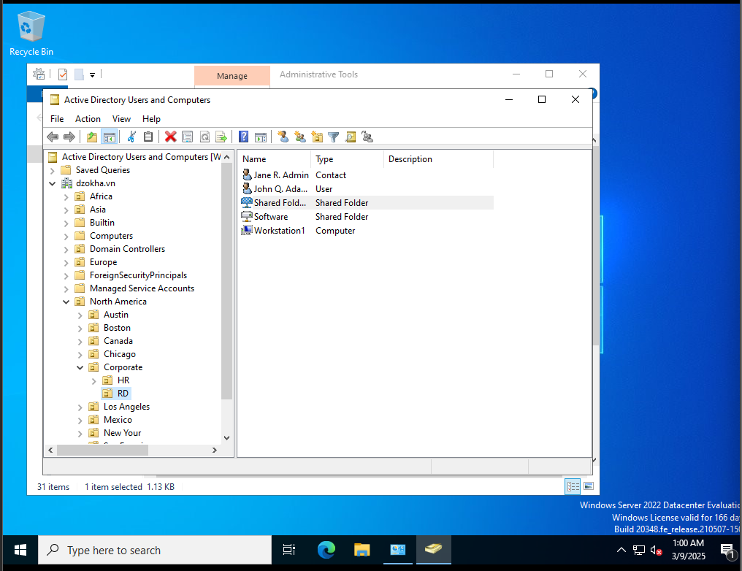

**3.3 Thiết lập DHCP**

**3.3.1. Installing the DHCP Service**

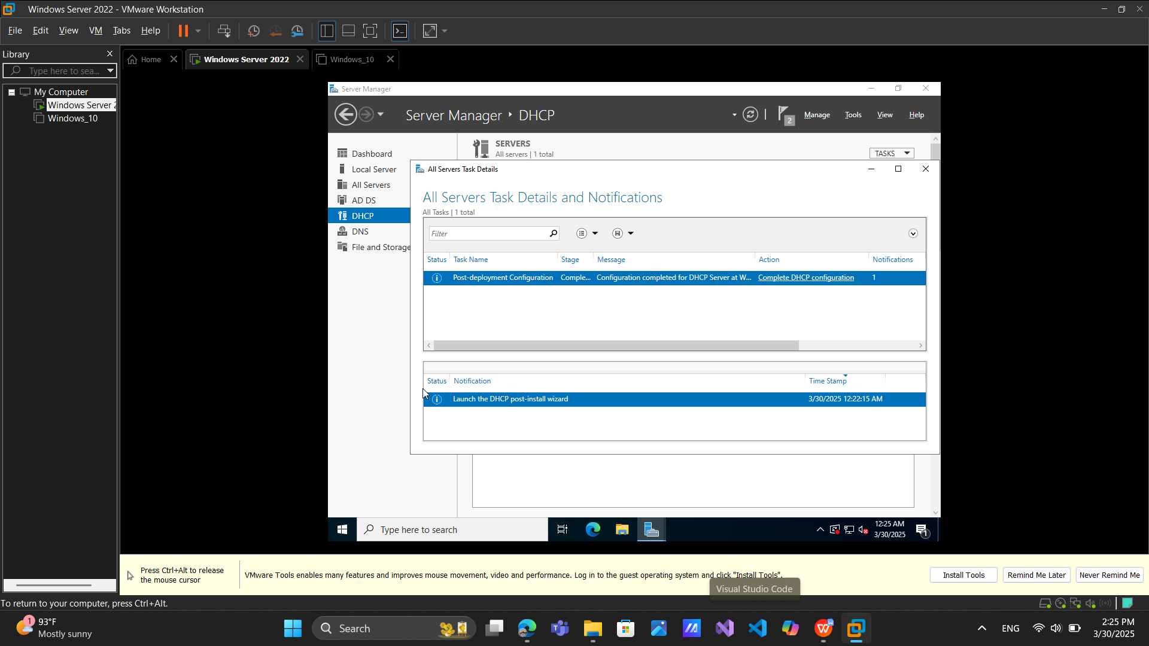

**3.3.2 Authorizing a DHCP Server**

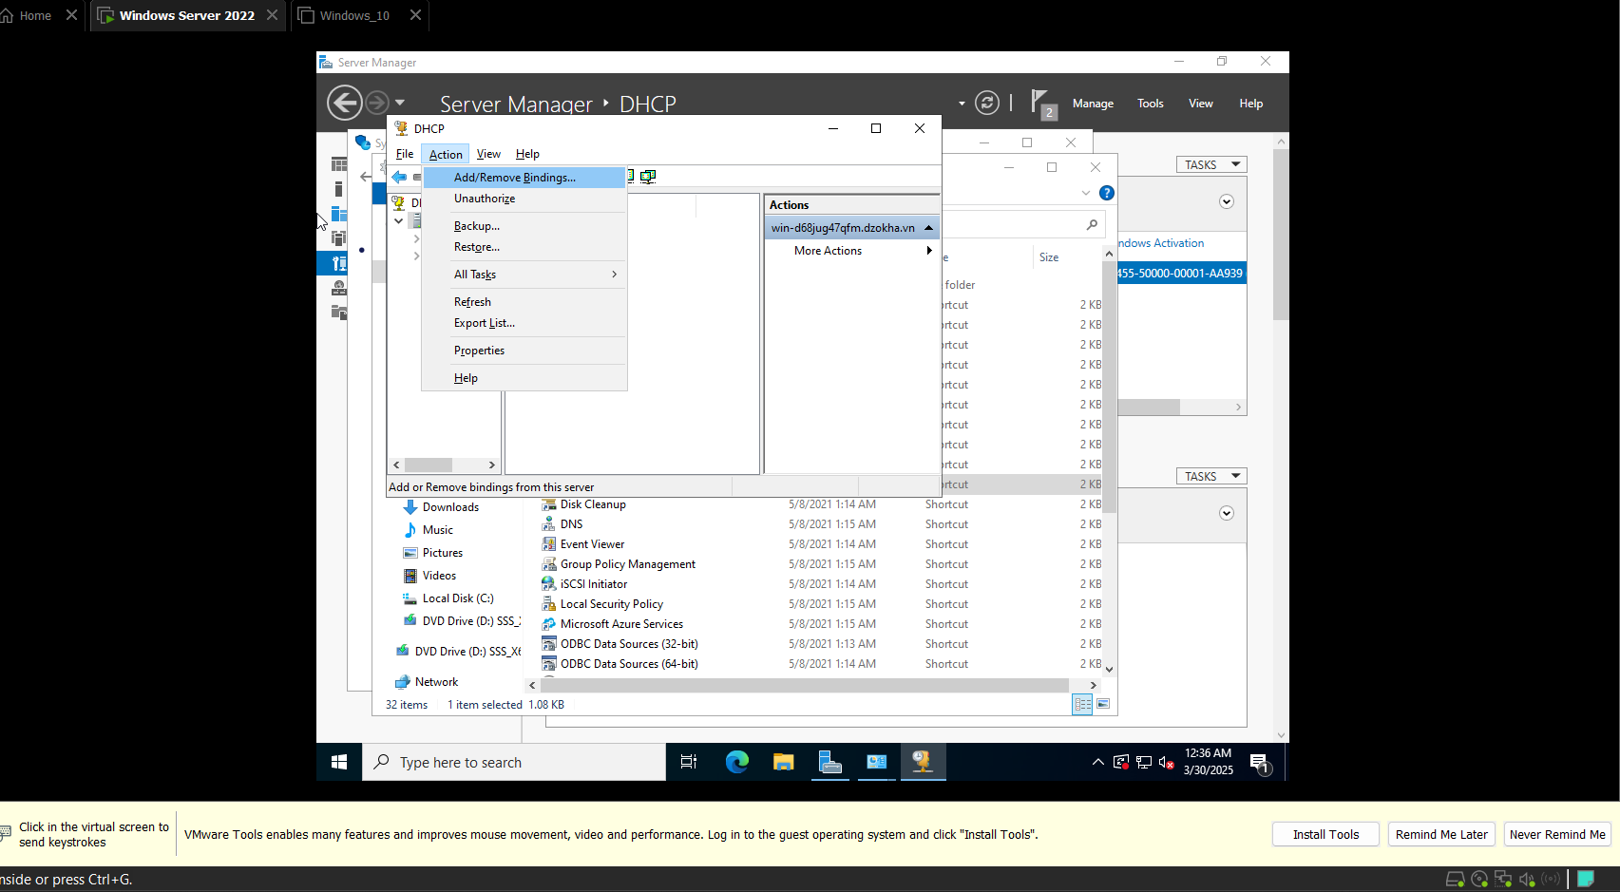

**3.3.3 Unauthorizing a DHCP Server**

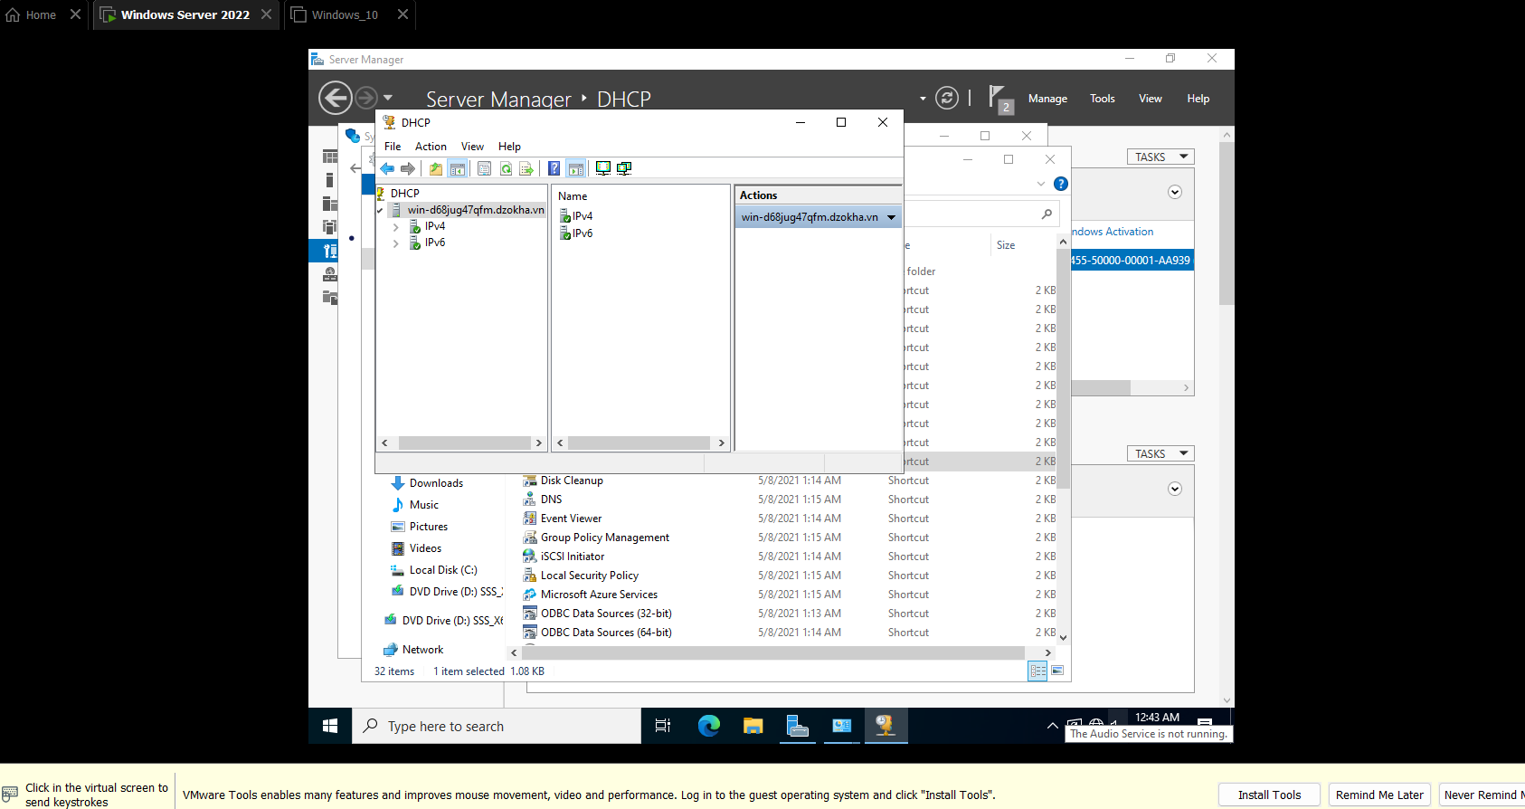

**3.3.4. Creating a New Scope**

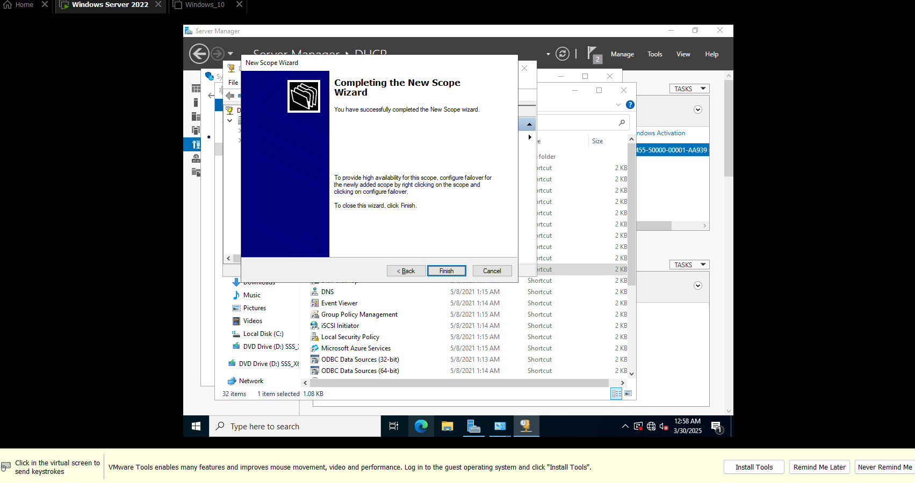

**3.3.5. Creating a Superscope**