**Installing and Configuring the DNS Service**

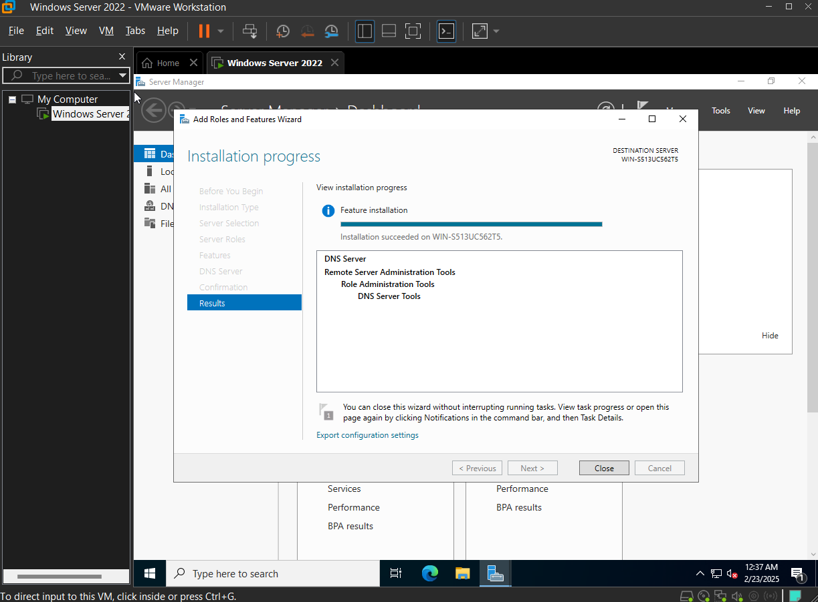

**Configuring a Zone for Dynamic Updates**

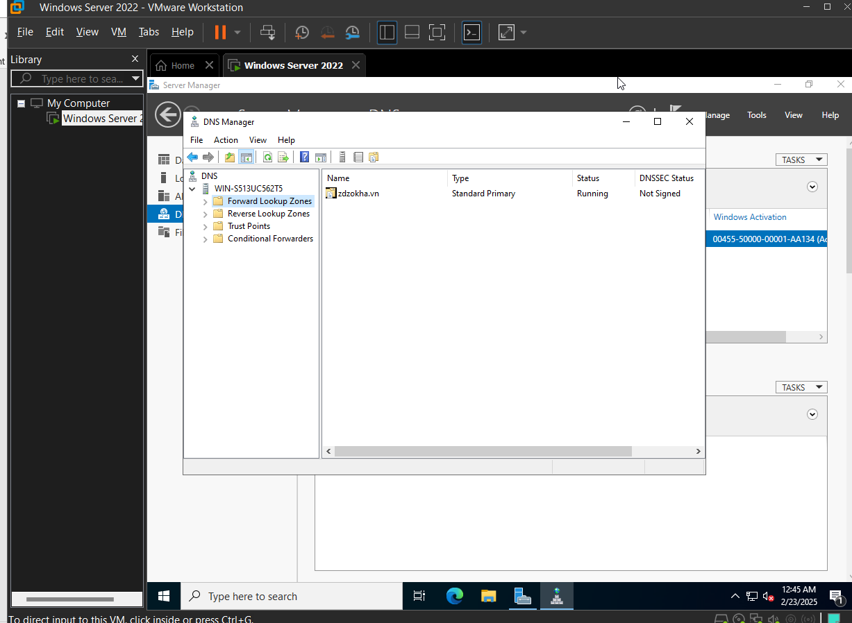

**Creating a Delegated DNS Zone**

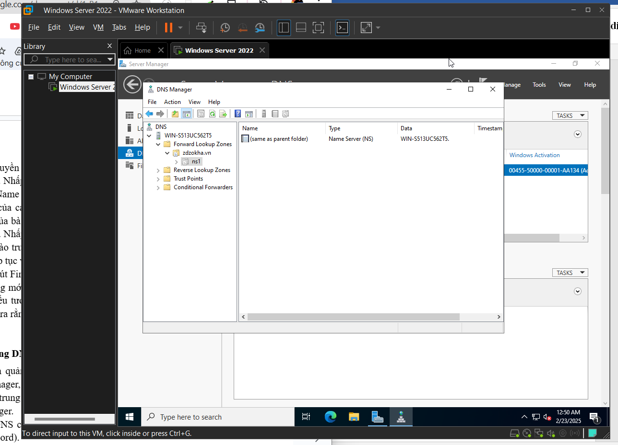

**Manually Creating DNS Records**

