# **DNS Server**

## **4.1 Installing and Configuring the DNS Service**

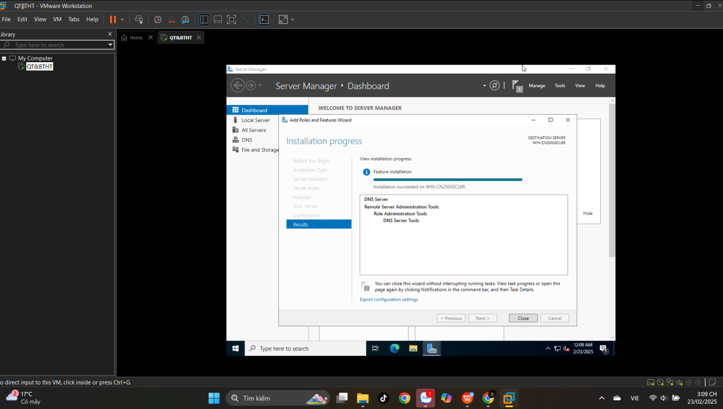

## **4.2 Configuring a Zone for Dynamic Updates**

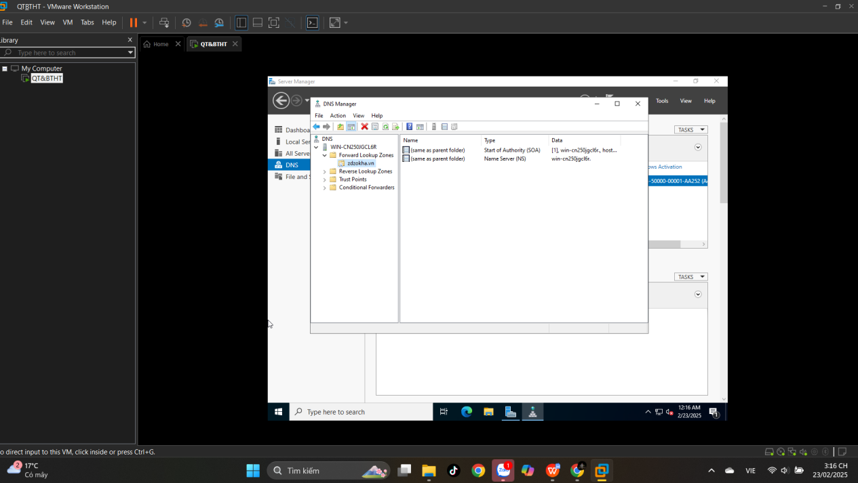

**4.3 Creating a Delegated DNS Zone**

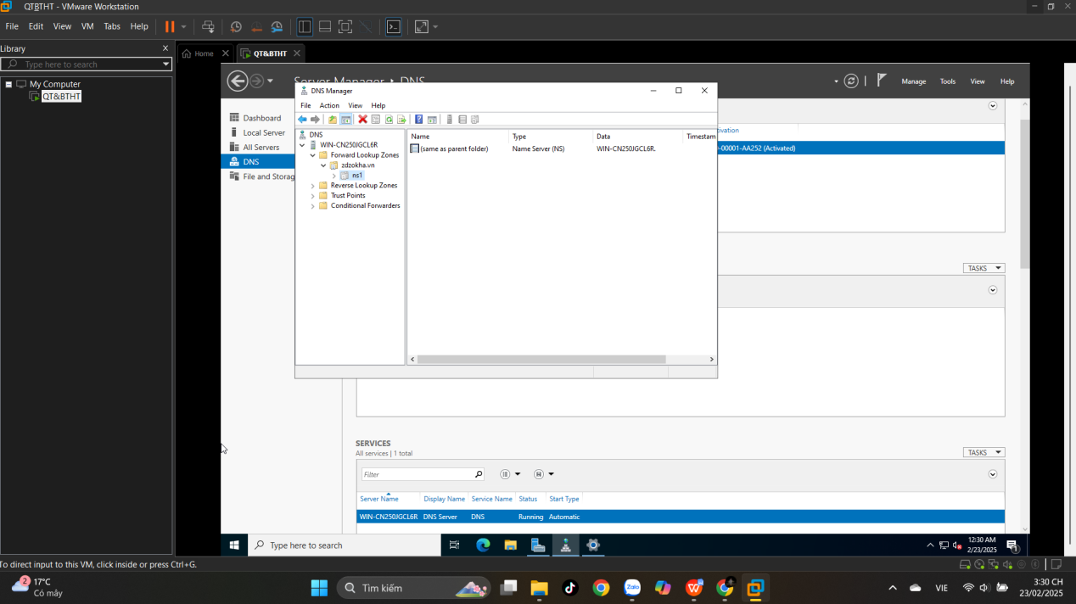

**4.4 Manually Creating DNS Records**

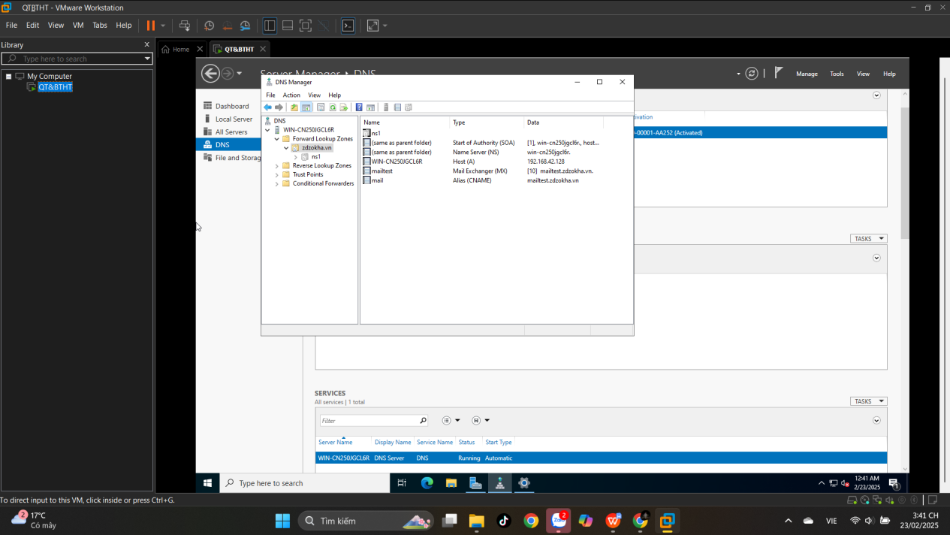

1. **Active Directory**

## **5.1 Promoting a Domain Controller**

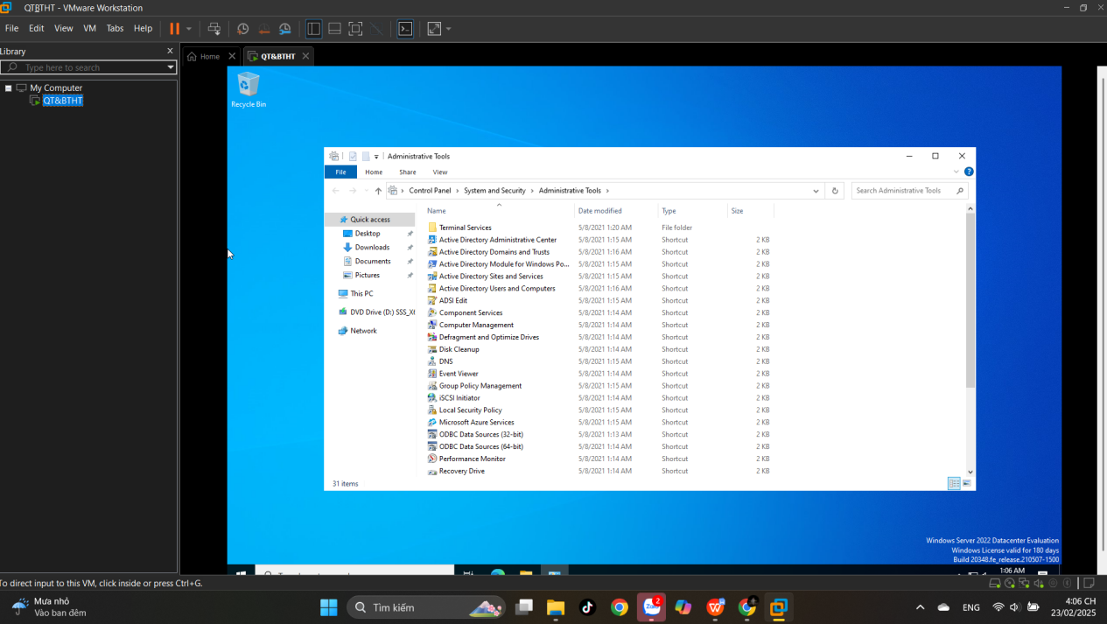

**5.2. Viewing the Active Directory Event Log**

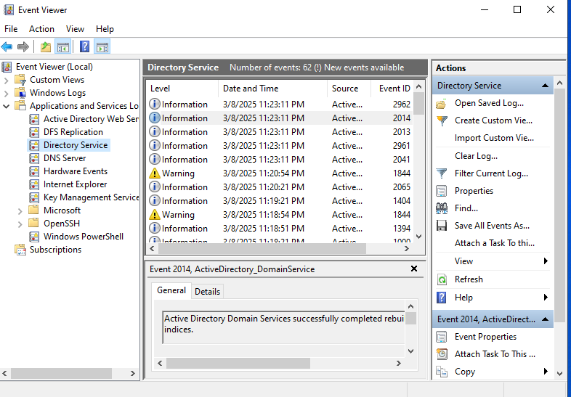

**5.5. Configuring DNS Integration with Active Directory**

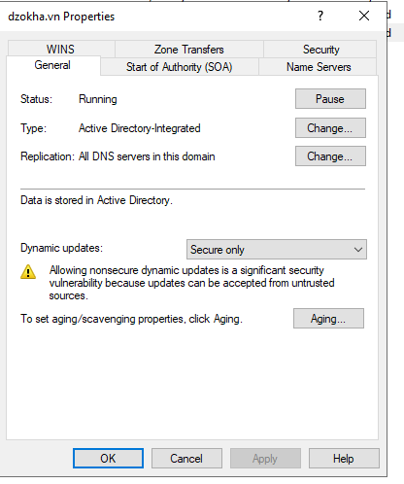

**5.6. Creating an OU Structure**

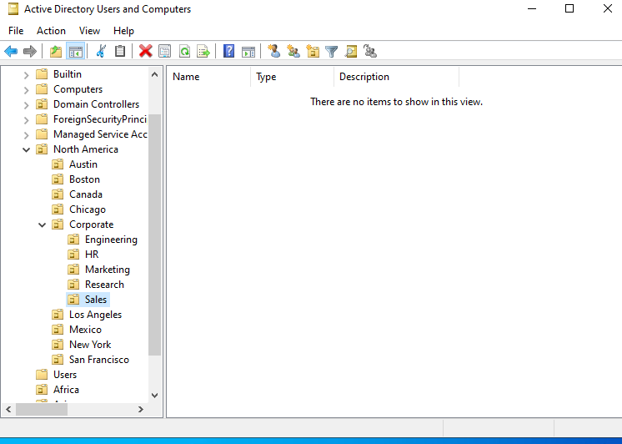

**5.7. Modifying OU Structure**

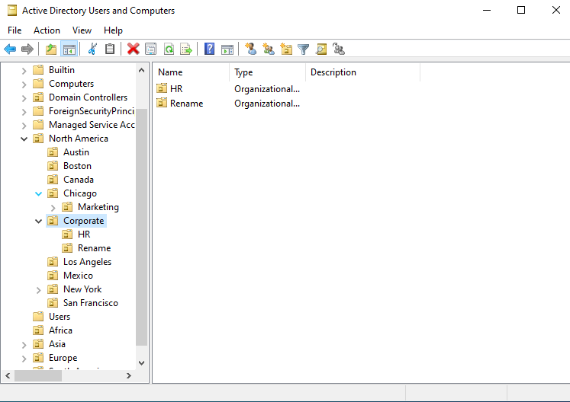

**5.8. Using the Delegation of Control Wizard**

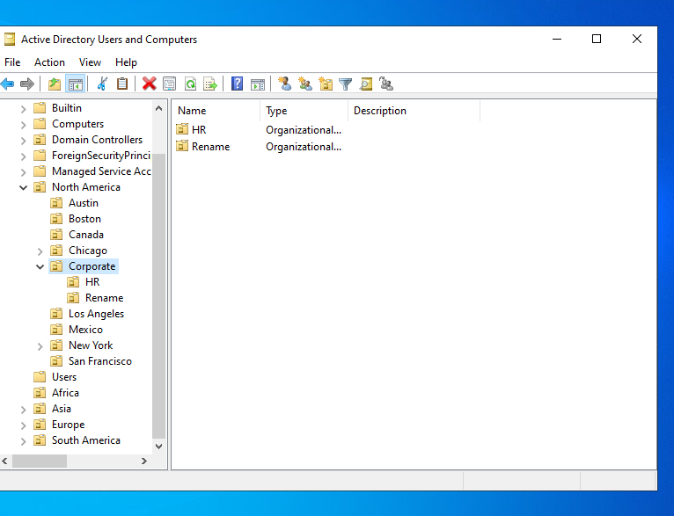

**5.9. Delegating Custom Tasks**

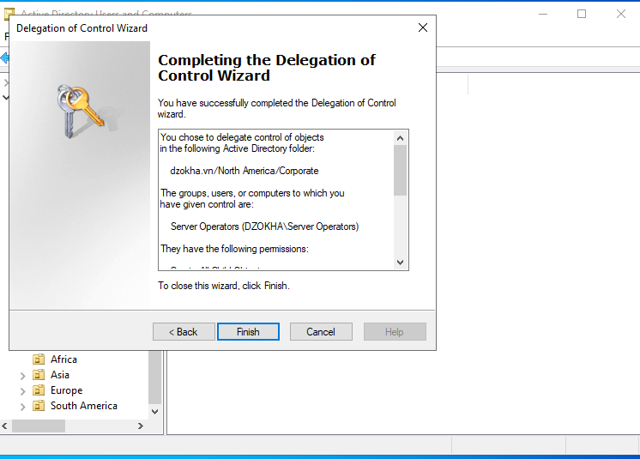

**5.10. Creating Active Directory Objects**

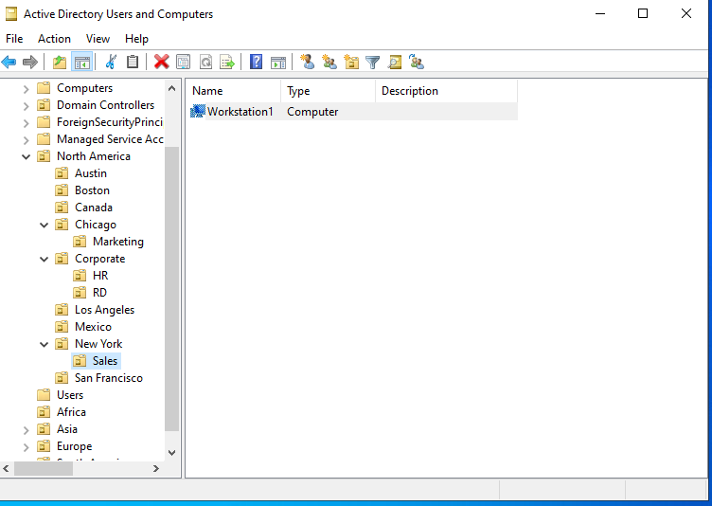

**5.11. Creating a User Template**

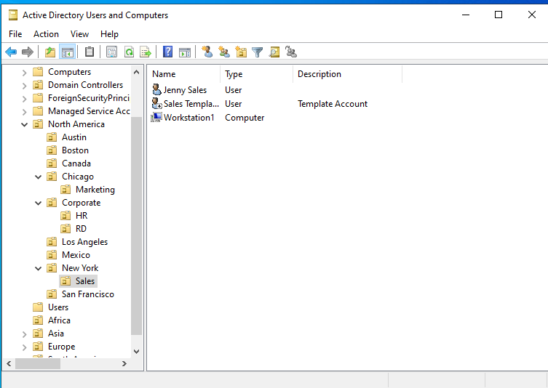

**5.12. Managing Object Properties**

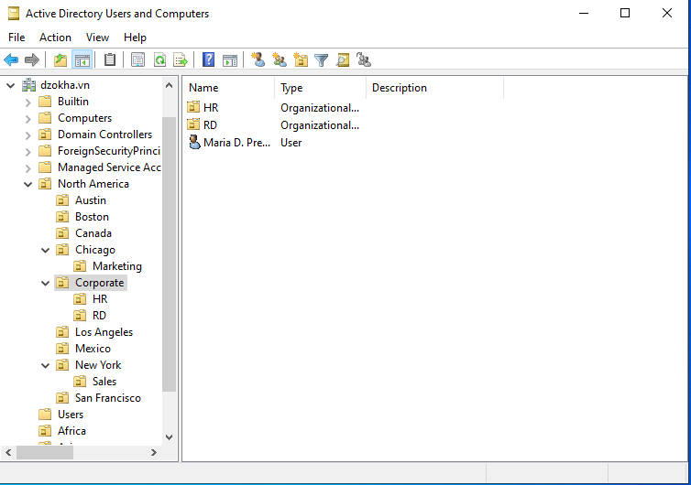

**5.13. Moving Active Directory Objects**

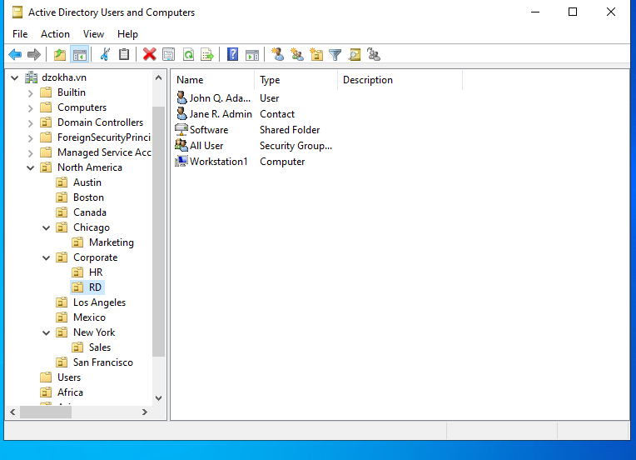

**5.14. Resetting an Existing Computer Account**

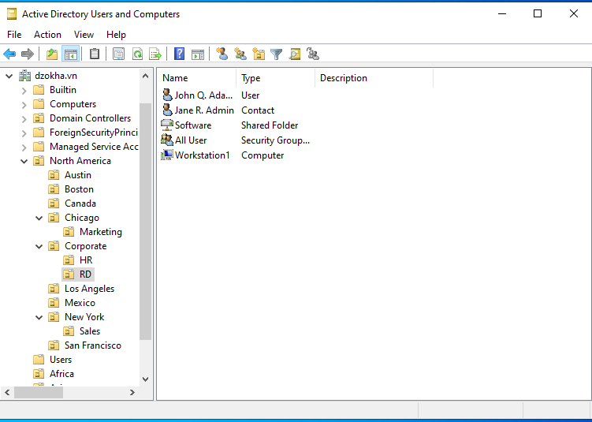

**5.16. Creating and Publishing a Shared Folder**

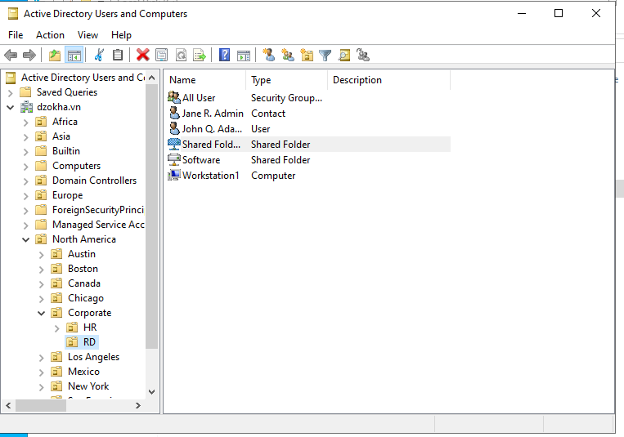

1. **DHCP**
   1. **Installing the DHCP Service**

