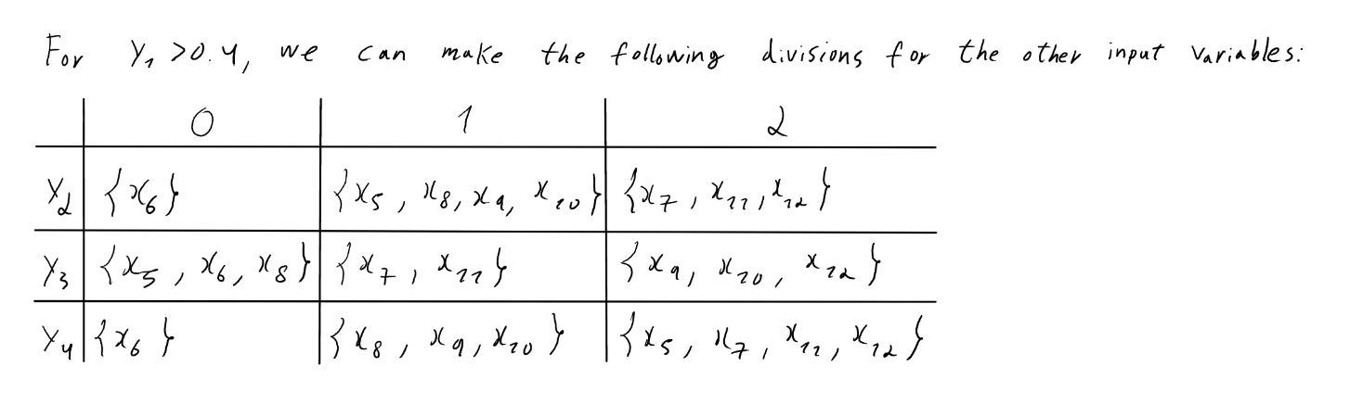
I. Pen-and-paper
1.)

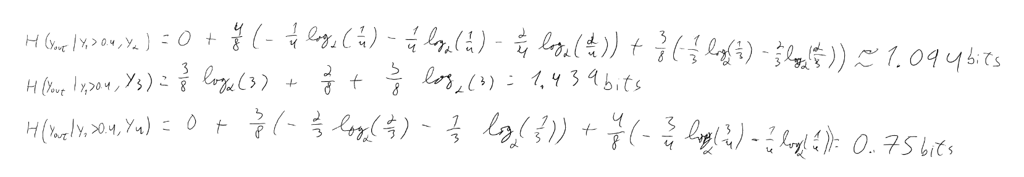

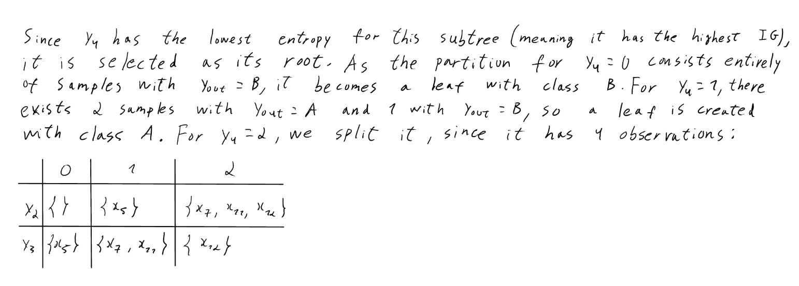

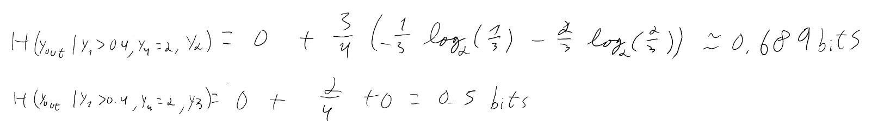

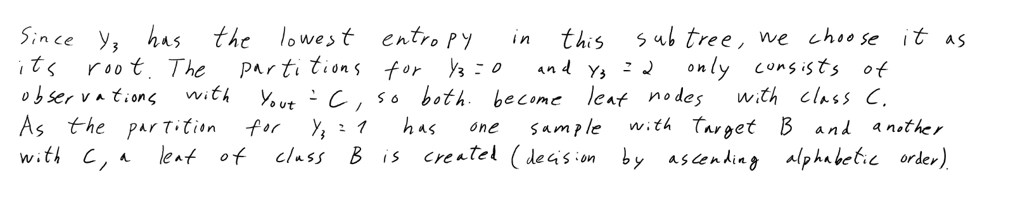

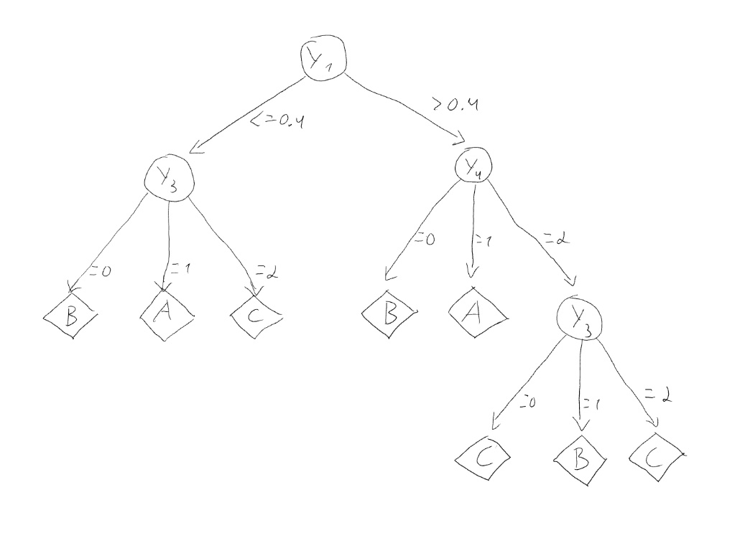

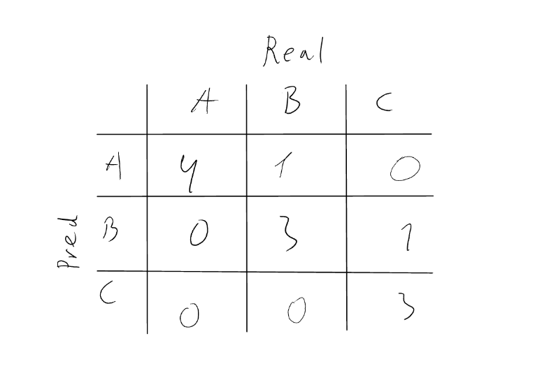
2.)

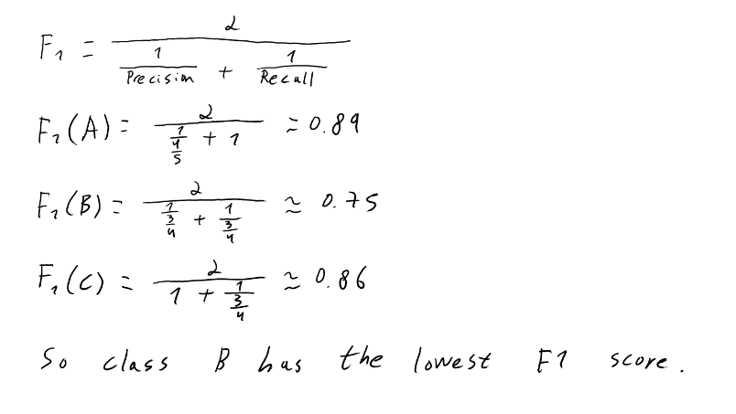
3.)

y_{out} = A |  |  |  | y_{out} = B |  |  |  | y_{out} = C
y₁ | Frequency | Rel. Freq |  | y₁ | Frequency | Rel. Freq |  | y₁ | Frequency | Rel. Freq
[0,0.2[ | 2 | 0.4 |  | [0,0.2[ | 1 | 0.25 |  | [0,0.2[ | 0 | 0
[0.2,0.4[ | 1 | 0.2 |  | [0.2,0.4[ | 0 | 0 |  | [0.2,0.4[ | 2 | 0.4
[0.4,0.6[ | 0 | 0 |  | [0.4,0.6[ | 1 | 0.25 |  | [0.4,0.6[ | 2 | 0.4
[0.6,0.8[ | 2 | 0.4 |  | [0.6,0.8[ | 0 | 0 |  | [0.6,0.8[ | 0 | 0
[0.8,1] | 0 | 0 |  | [0.8,1] | 2 | 0.5 |  | [0.8,1] | 1 | 0.2
4.)
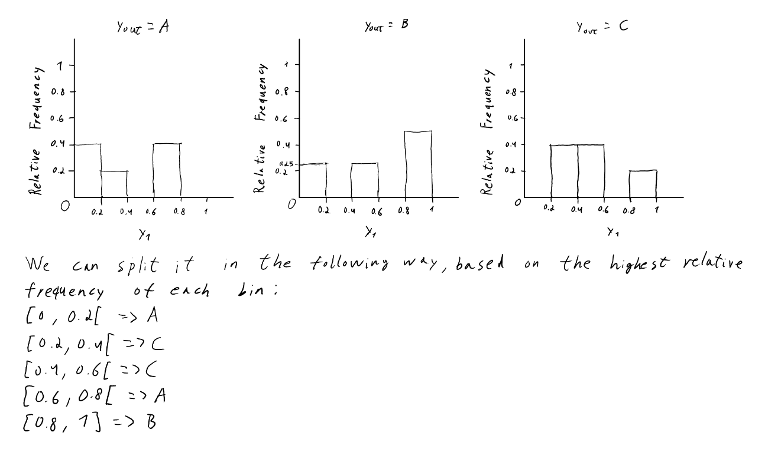

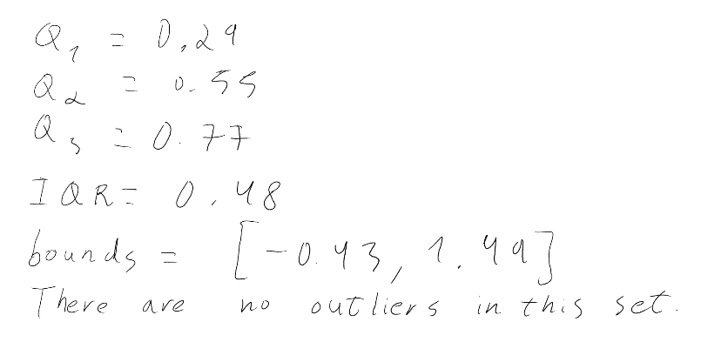
5.)

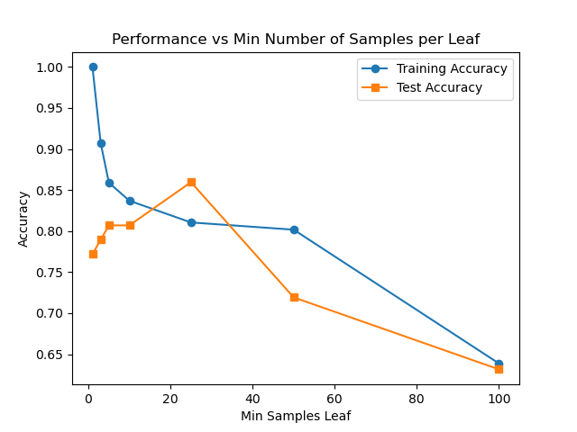
II. Programming
1.)

2.) From the plot, we can see that when using a very small minimum sample leaf, the decision tree reaches a very high training accuracy with a lower test accuracy, meaning that the model can predict very well on inputs that it has already seen, but very sensitive to new inputs (it’s overfitting). On the other hand, when minimum sample leaf is large, the model predicts poorly since its hyperparameter makes the tree shallow: it couldn’t capture good patterns (underfitting). The tree performed its best with intermediate minimum sample leaf (10 to 25): both accuracies were relatively close, creating a good balance between variance and bias, marking the best values for this hyperparameter to maximize the model’s generalization capacity.
3.) i) The combination of the hyperparameters max depth = 4 and min split = 11 gave the best validation set accuracy (80.7%) while also a good test set accuracy (78.9%). This model’s generalization capacity is also high, as both accuracies are considerably close to each other.

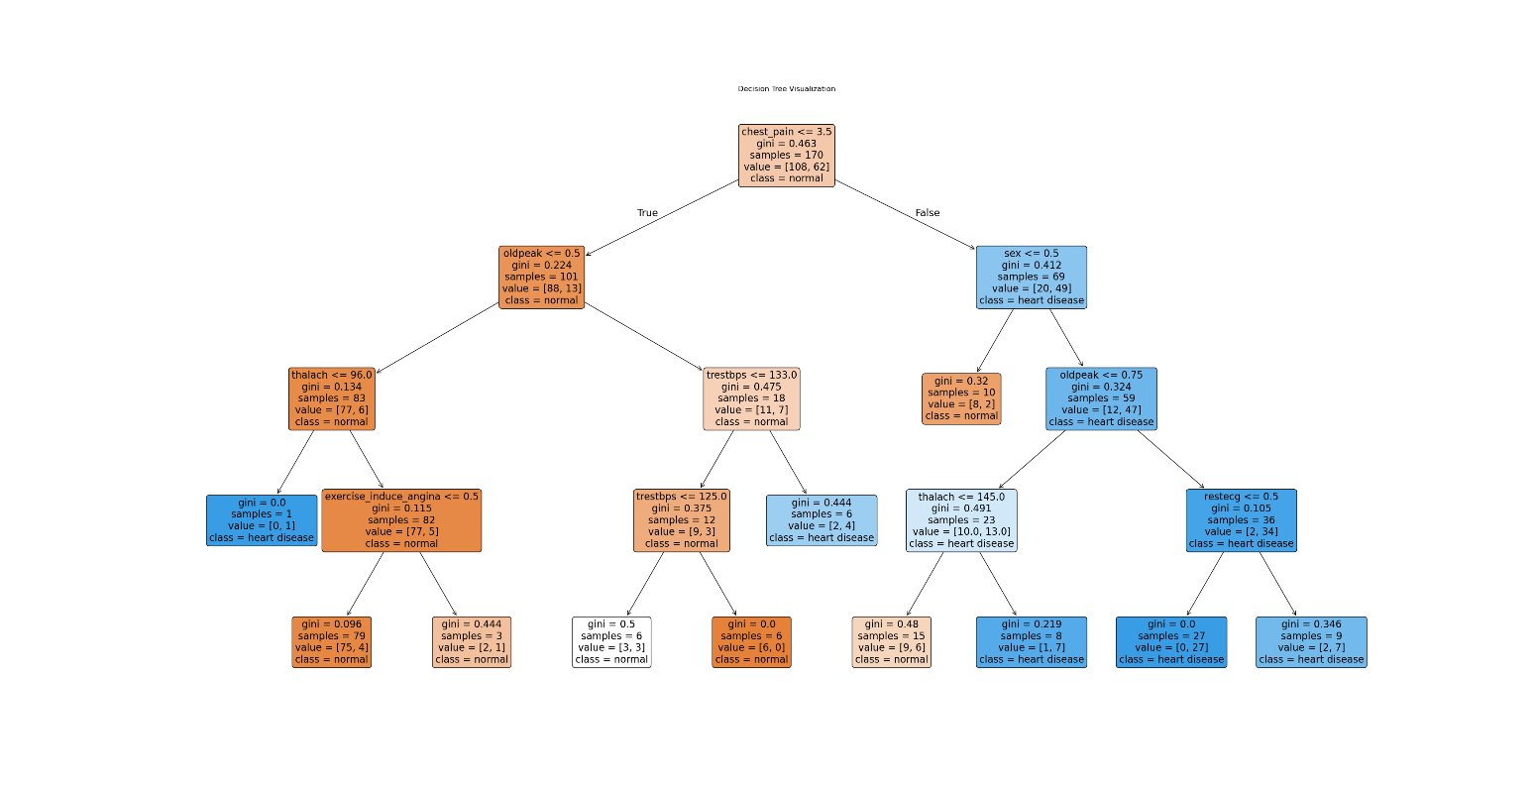
ii) The following conditional associations characterize heart diseases with certainty (all of them have a posterior probability equal to 1):
Individuals with:
- chest pain <= 3.5, oldpeak <= 0.5, thalac <= 96
- chest pain > 3.5, sex = 1, oldpeak > 0.75, restecg <= 0.5
There are also associations that are likely characteristics of heart diseases, but without certainty:
- chest pain <= 3.5, oldpeak <= 0.5, trestbps > 133 (posterior prob = 66.7%)
- chest pain > 3.5, sex = 1, oldpeak <= 0.75, thalach > 145 (posterior prob = 87.5%)
- chest pain > 3.5, sex = 1, oldpeak > 0.75, restecg > 0.5 (posterior prob = 77.8%)

