I. Pen-and-paper
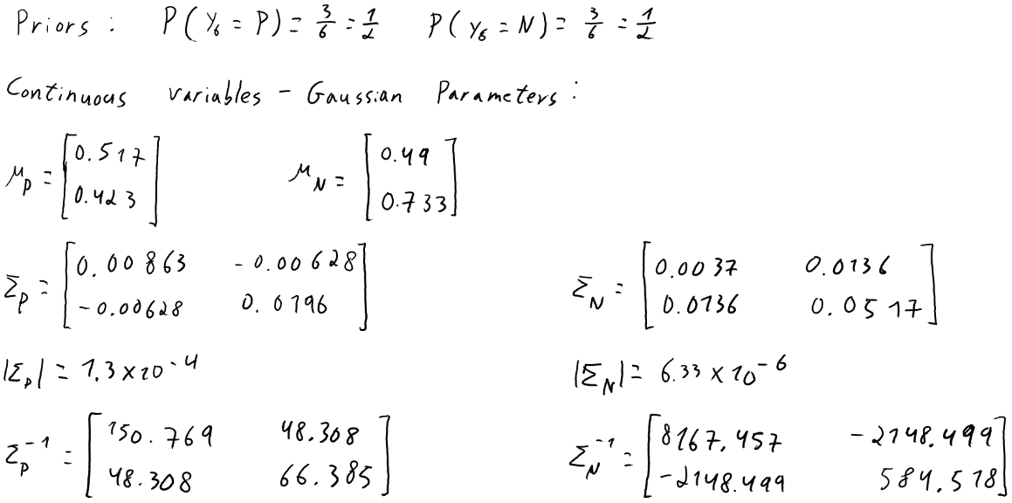
1.) a)

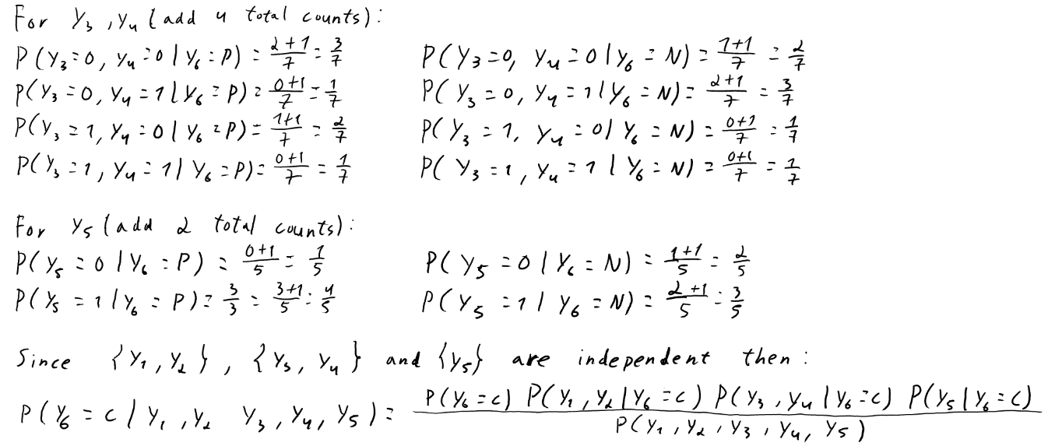
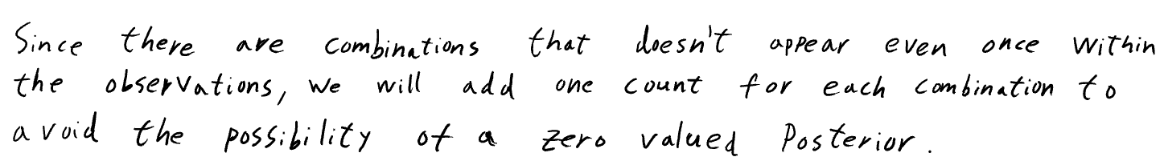

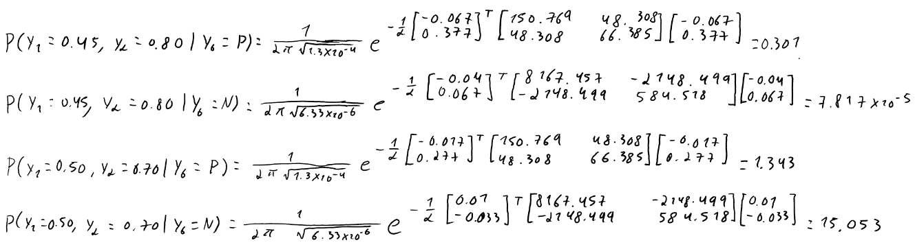
b)

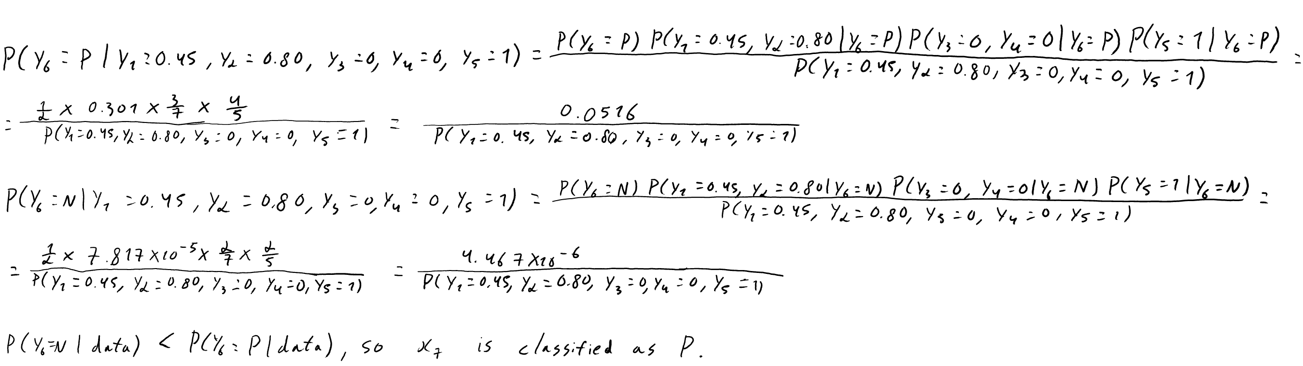

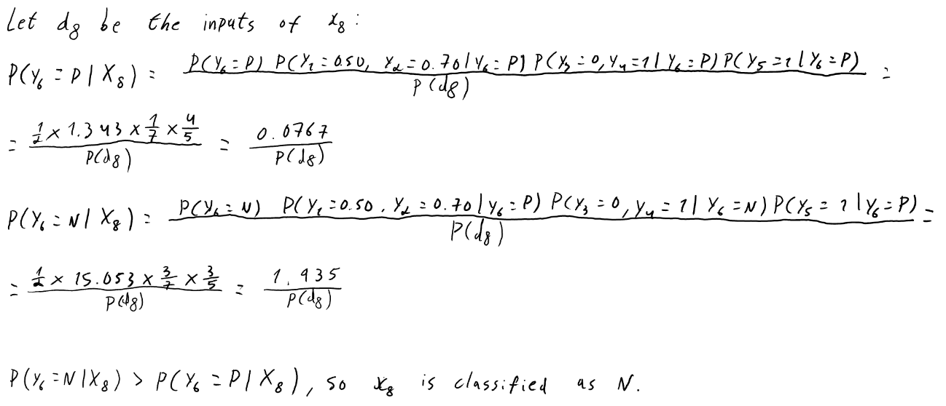

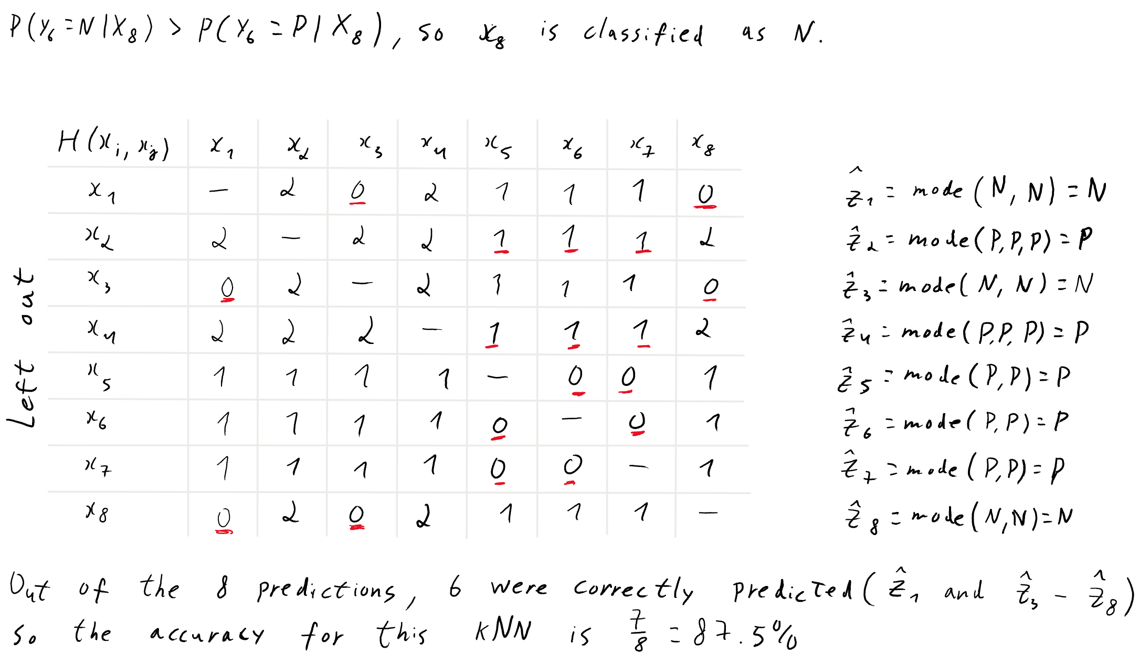

2.)

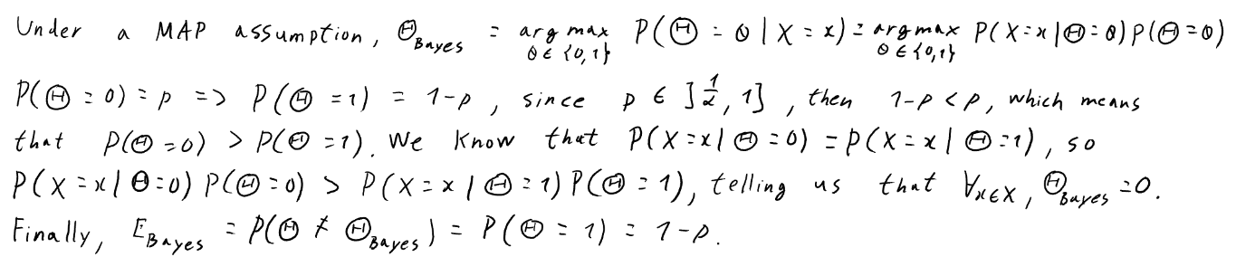
3.) a)

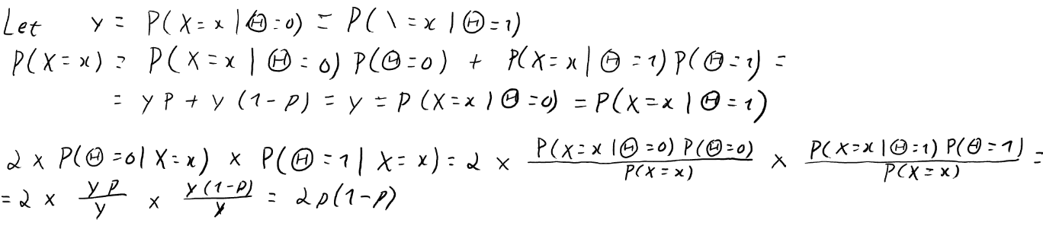
b)

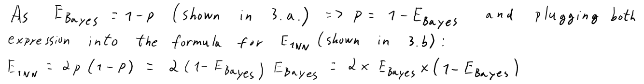
c.)

II. Programming
Note: Used random_state = 42 wherever possible to make the experiment repeatable and get consistent results.
1.) a) We got approximately an accuracy of 0.93501 with a standard deviation of 0.01961 for our kNN (with k = 5) model and a 0.93853 ± 0.02347 accuracy for the Naïve Bayes. As kNN has a lower standard deviation, it is the most stable model, which was expected since kNN is distance-based with only one parameter and its local neighborhoods are similar across folds, making it less sensitive to parameter variance. On the other hand, Naïve Bayes is probability-based, make assumptions about the independence of the features and has a high number of parameters, which may vary more with each fold.
b) After scaling, the model got higher accuracy and a lower standard deviation (from the previous 0.93501 ± 0.01961 to 0.97190 ± 0.01787). Since kNN is sensitive to feature scales, if there are any features that differ greatly from the others, the distance calculated will be most affected by that variable. By changing the features to have the same scaling, all of them will contribute equally to the distance calculation, resulting in an improvement to precision.
c) After running both scaled models (accuracy of the scaled Naïve Bayes model: 0.92973 ± 0.01992) in a paired t-test with α = 0.05, we got approximately t = 2.48661 and p-value = 0.06773. Since p-value is greater than α, we fail to reject the null hypothesis, meaning we don’t have sufficient evidence to conclude that kNN is statistically superior to Naïve Bayes in terms of accuracy.
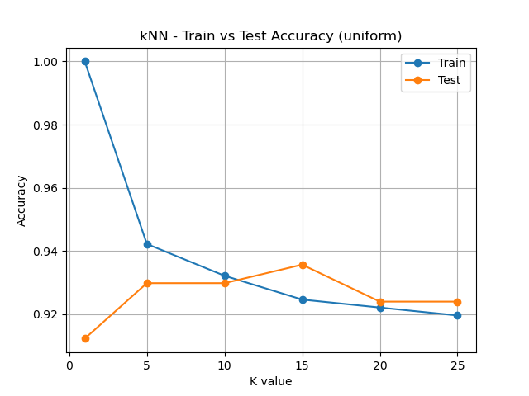
2.) a)

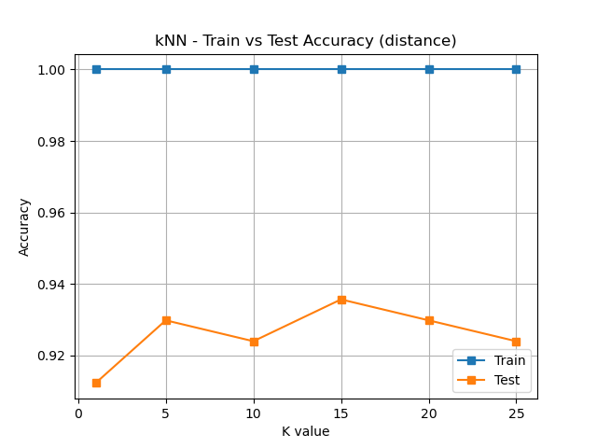
b) From the plots, we can see that when using small k values both models achieve a very high training accuracy with a lower test accuracy, meaning that the uniform model can predict very well on inputs that it has already seen, but both are sensitive to new inputs (it’s overfitting); for the distance model it always predicts perfectly for the training data since its weight prioritizes closer neighbors. On the other hand, when the number of neighbors is large, the uniform model predicts poorly in both sets since it loses local details, which may result in underfitting. This is mitigated in the distance model since it is more robust to the changes to the k value and smooths the trade-off between variance and bias, however, not totally and can still underfit if the number of neighbors continues to increase. The best k value for the uniform model is found in intermediate values, in this case k = 10 since it has the best generalization ability (have the highest accuracy for both sets while being close to each other), and for the distance model its test set accuracy peaks around k = 15, having the highest generalization ability here.
3) A kNN model would be preferable in this case. In a clinical setting, what’s most important is to avoid false negatives and achieve a high accuracy in predicting the disease, as it could be a life-threatening situation. From the experiments, even though kNN was not statistically superior to Naïve Bayes, kNN was approximately 4% more accurate and that can make a difference in real world practicality, which may reduce diagnostic errors. It was also more stable, which makes it more reliable for predicting different patient variations. Another reason would be the fact that the symptoms (features) may not be independent from each other, an assumption that Naïve Bayes makes. On the technical side, kNN has a high computational cost which could make it bad on real-time clinical predictions, however, may be justified by accurate predictions. It is also easy to interpret the meaning of a prediction since it’s close to real world thoughts: it was classified as c since it was similar to another k cases (neighbors); and it can also predict well even if the dataset is small (common in medical datasets and some rare diseases). However, this model performs rather poorly if there is missing data (may be common in some clinical settings).

