Group 114
Diogo Pan (ist1110020)
Diogo Callado (ist1110130)

I. Pen-and-paper
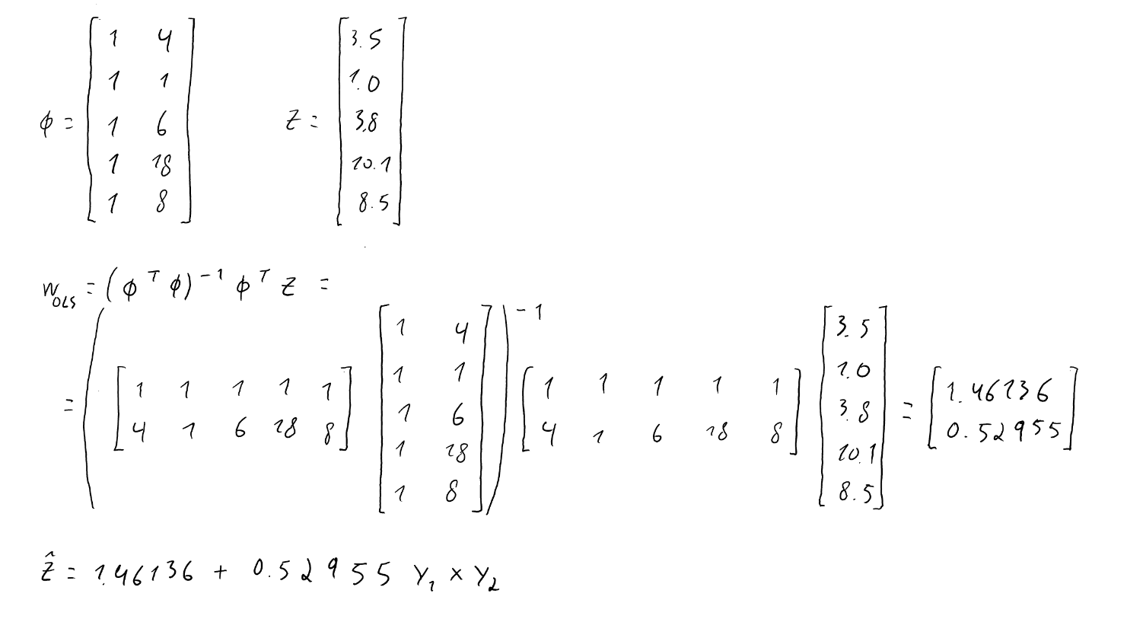
1.)

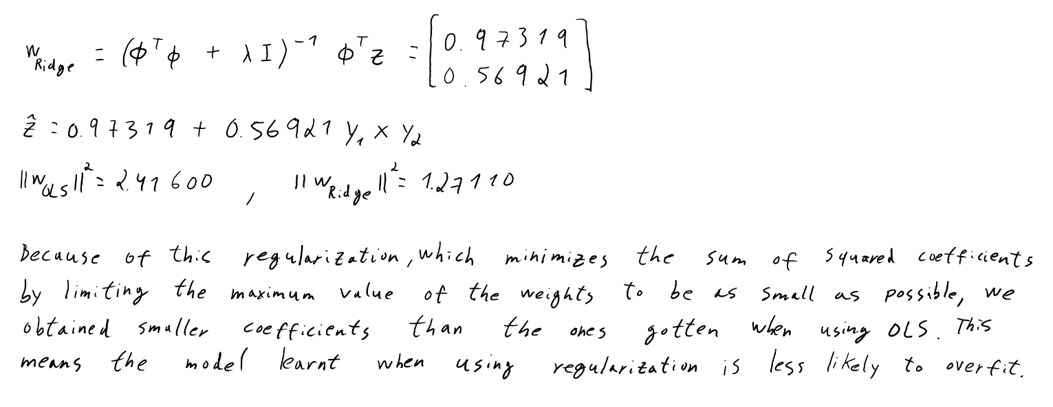
2.)



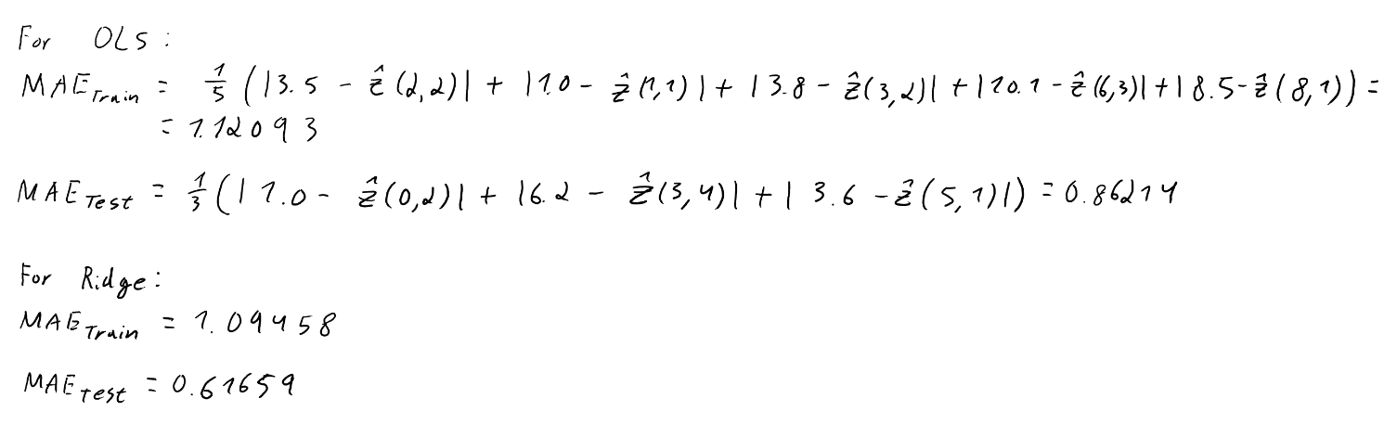
3.)



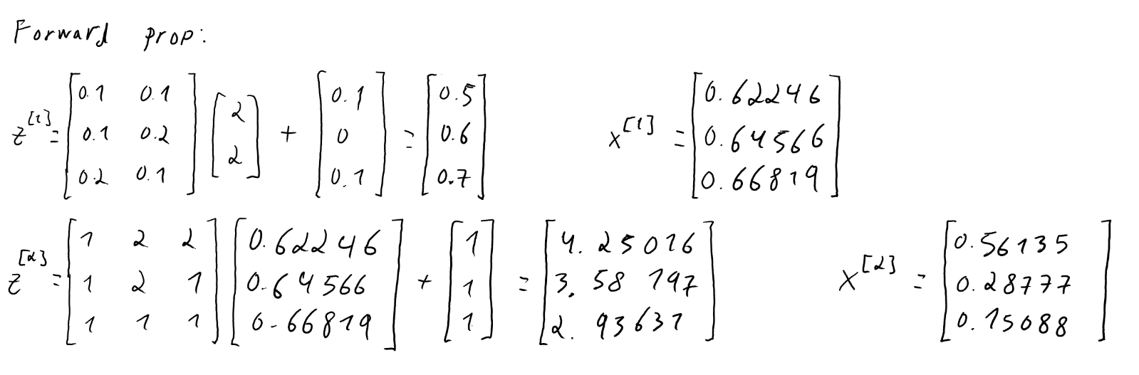
4.)

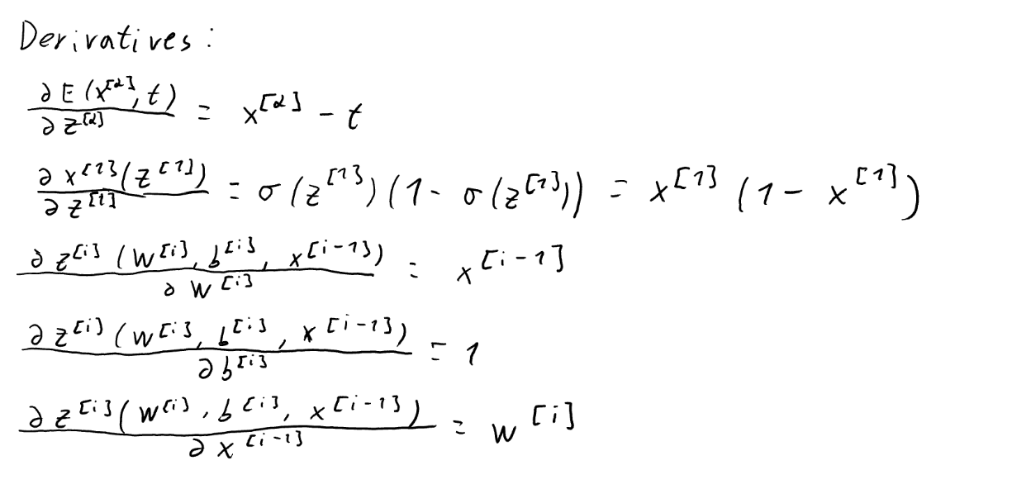

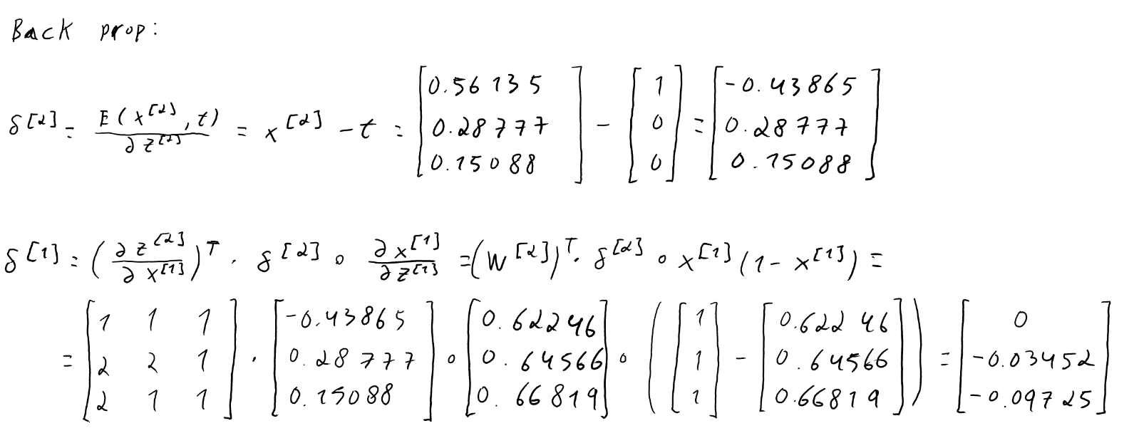

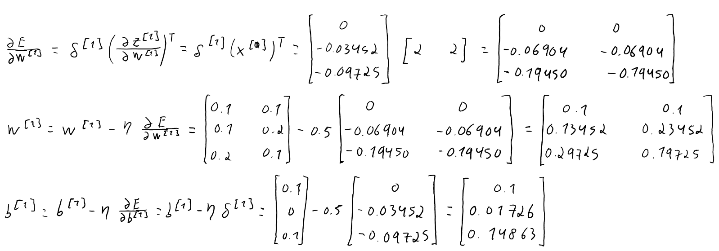

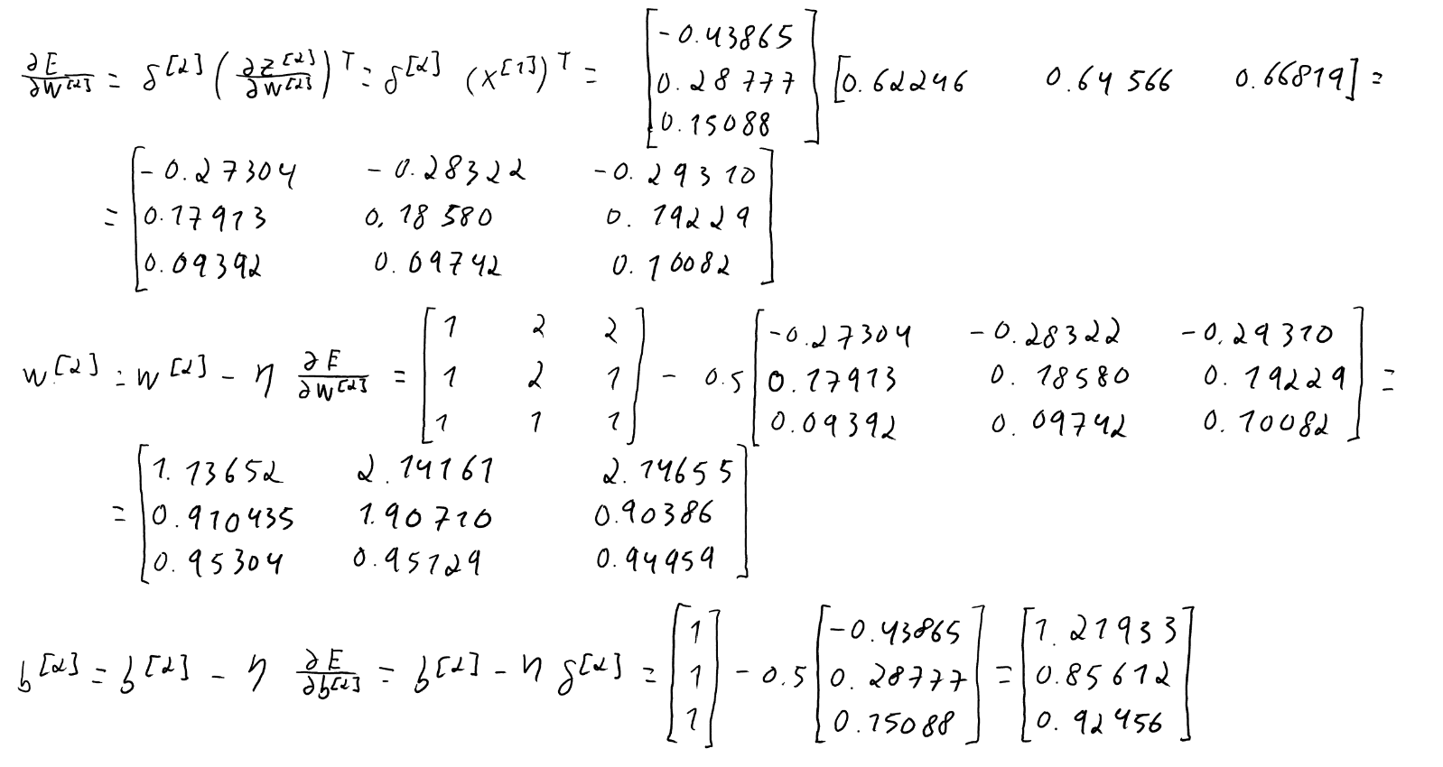


II. Programming
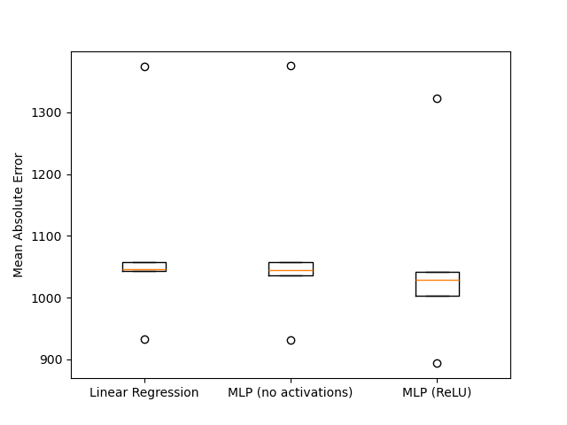
5.)

6.) A Linear Regression model can only capture linear relationships between the inputs and target which is almost identical to a MLP with no activations (hence the similarity of those models’ boxplots), while a MLP with activation functions is able to learn non-linear surfaces and approximate any continuous function, enabling the model to learn complex relationships. In this case, the rent price seems to follow a non-linear trend with the features (supported by the lowest MAE mean and boxplot of the MLP with ReLU model).

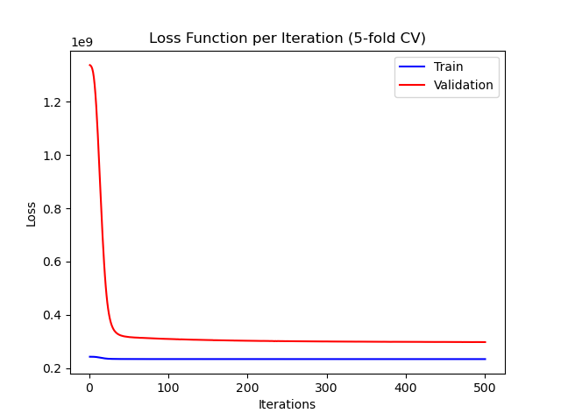
7.)

We can see that the training loss starts with a low value and decreases slowly until it reaches a plateau. On the other hand, the validation loss starts much higher and decreases until hitting a plateau above the training loss. The gap between both losses at their respective plateau is significant, which means the model is overfitting to the training data: the model learns the training data very well but doesn’t generalize to unseen data.

