I. Pen-and-paper
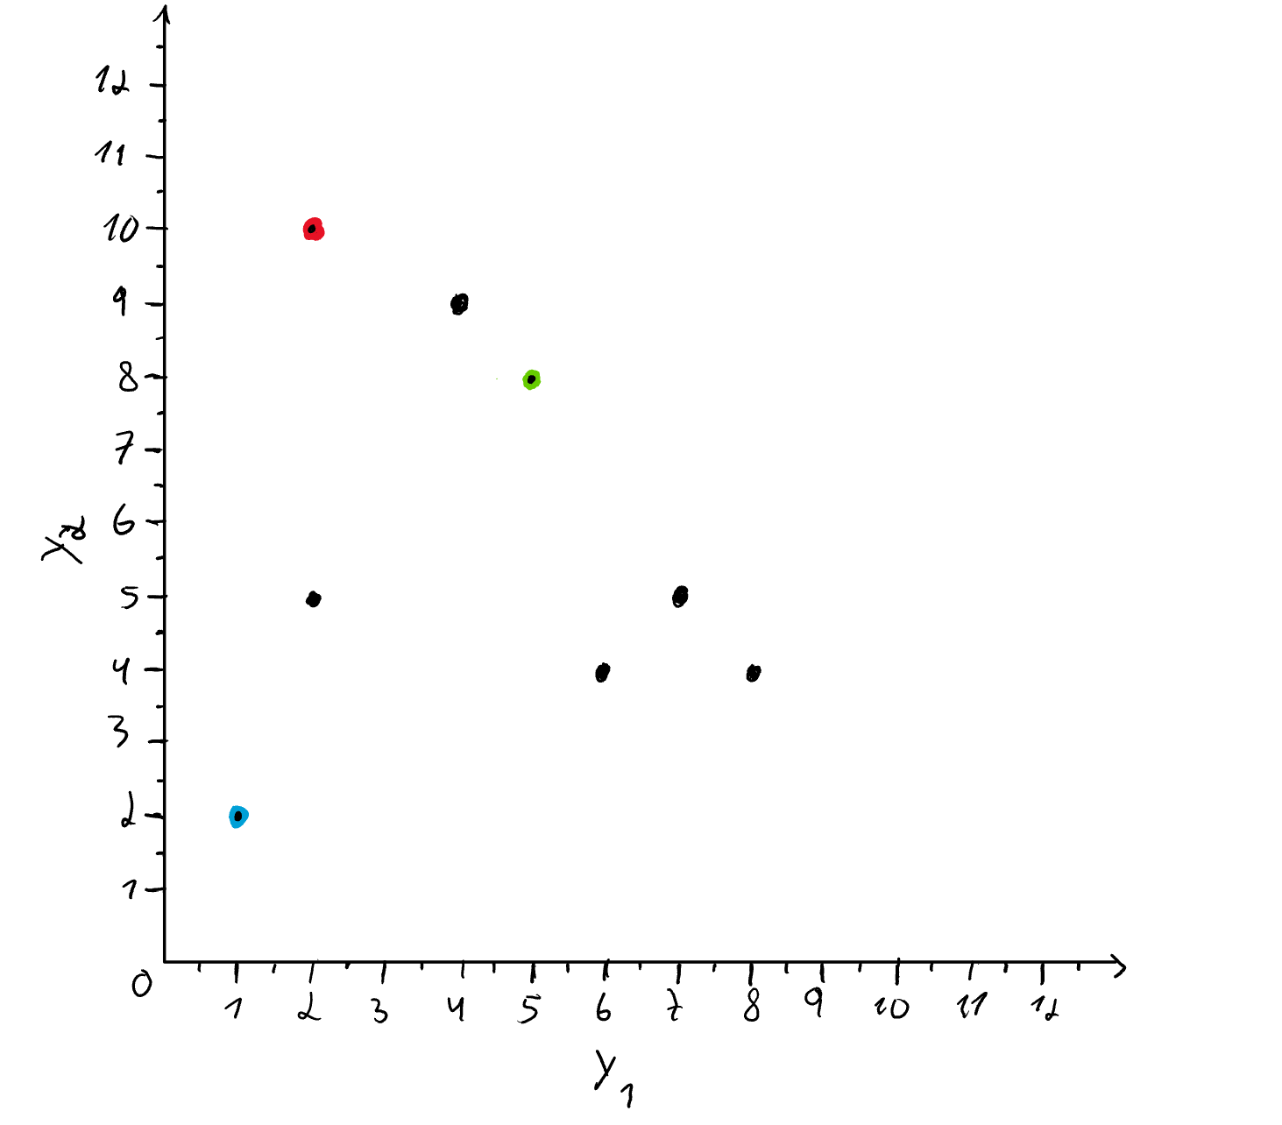
Part A: Clustering
a.)

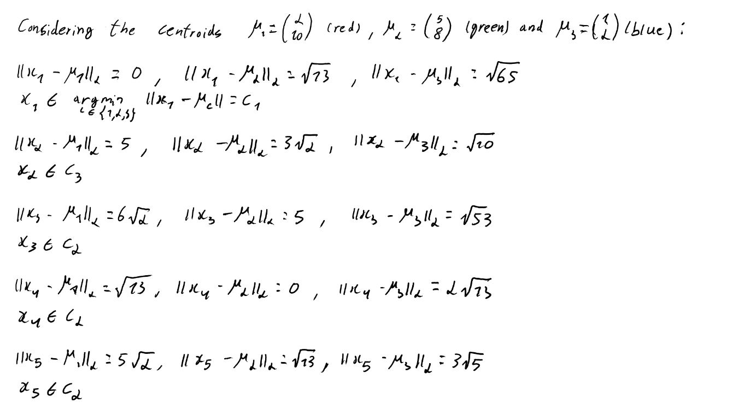
b.)

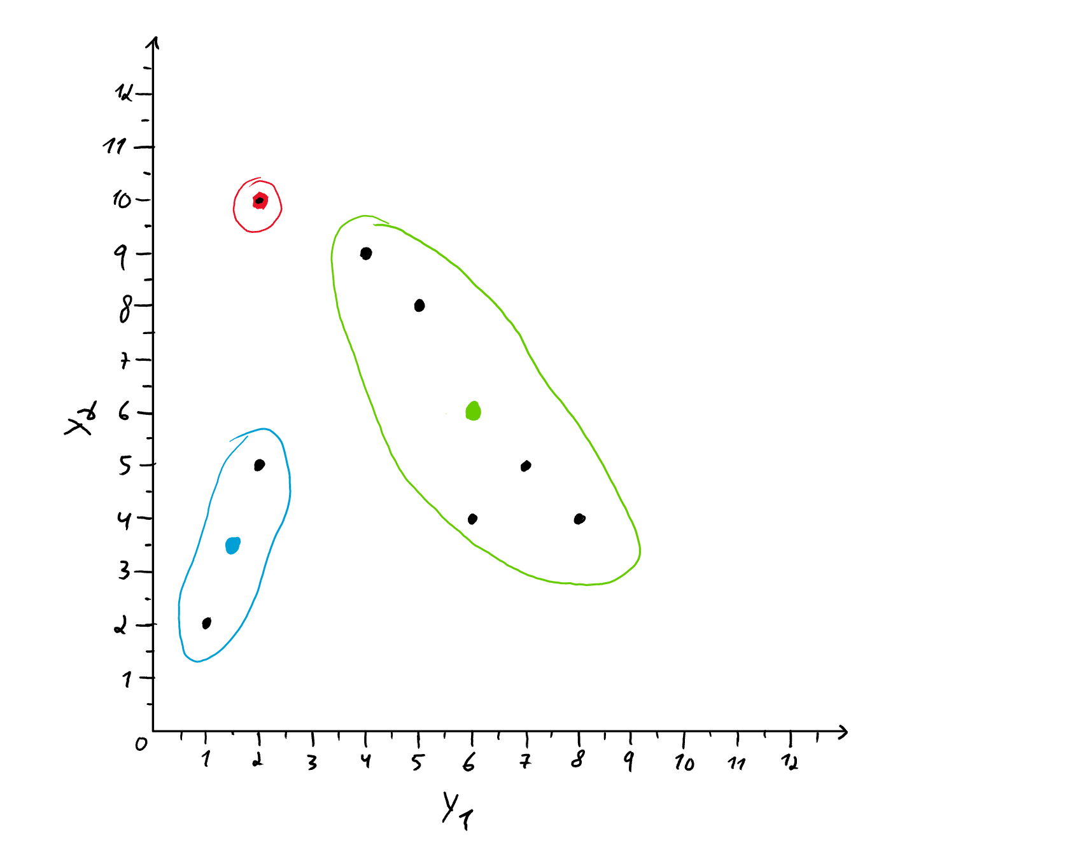
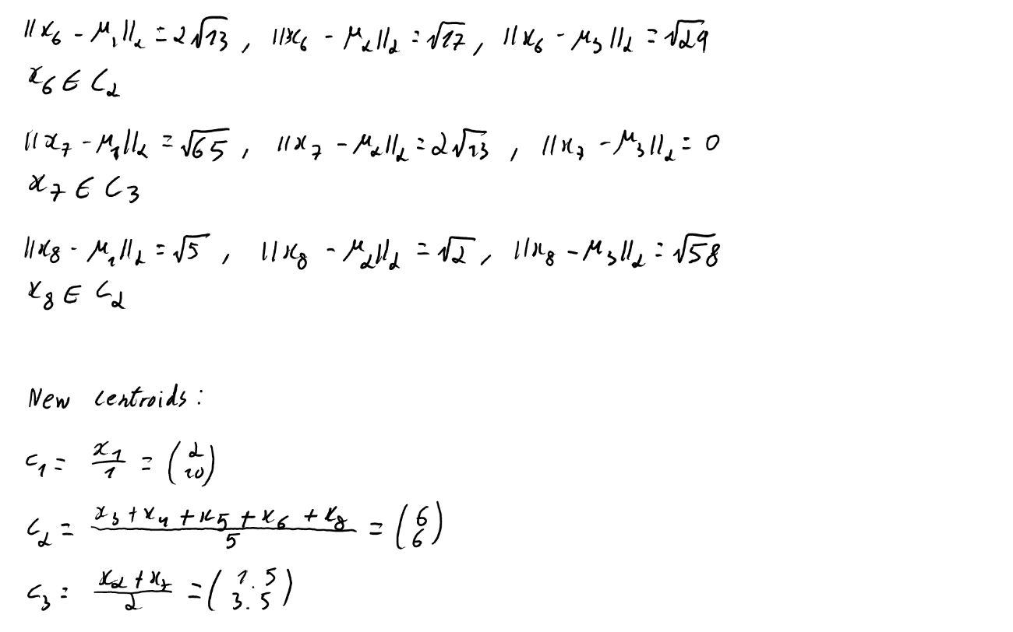
c.)


d.)

Part B: PCA
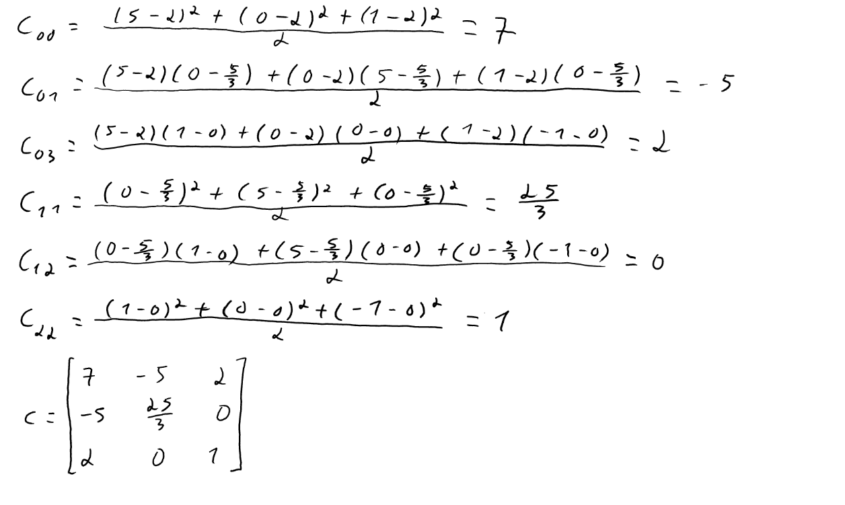
a.) 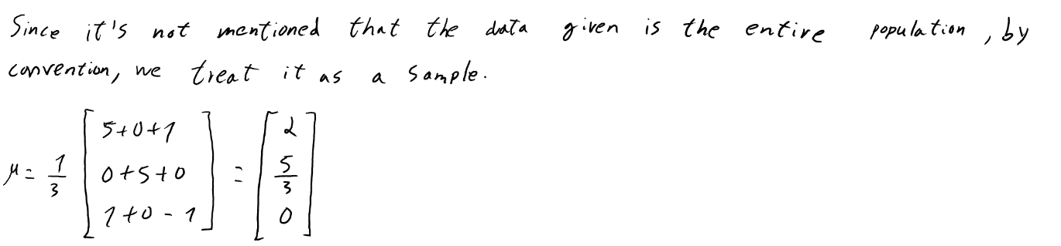

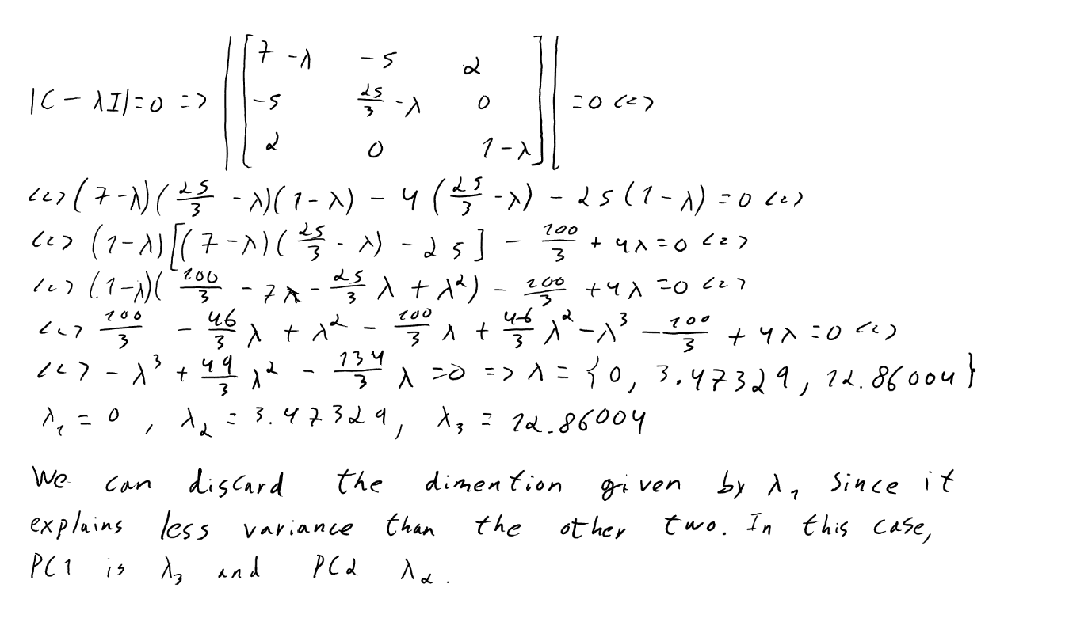
b.)

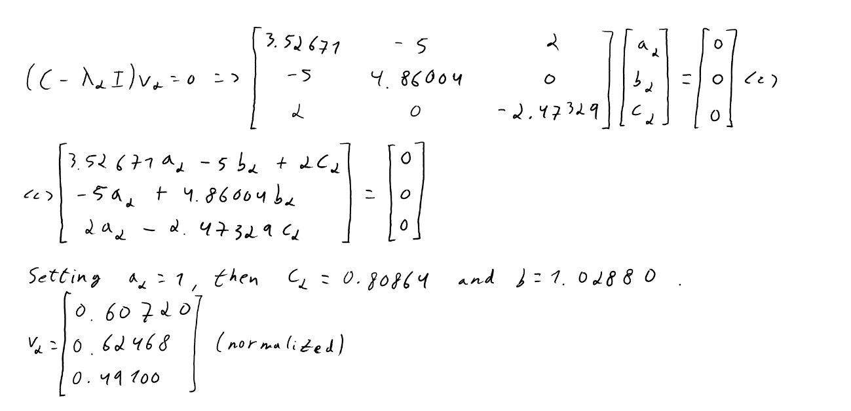

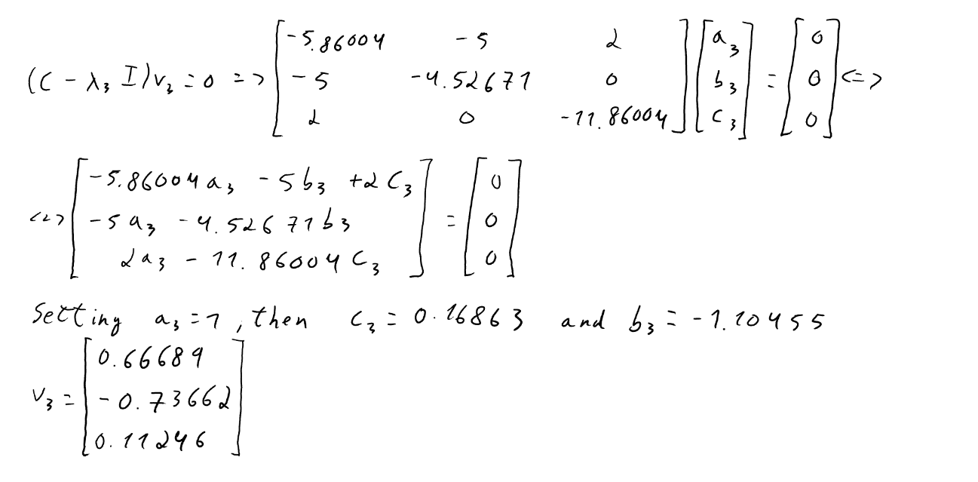

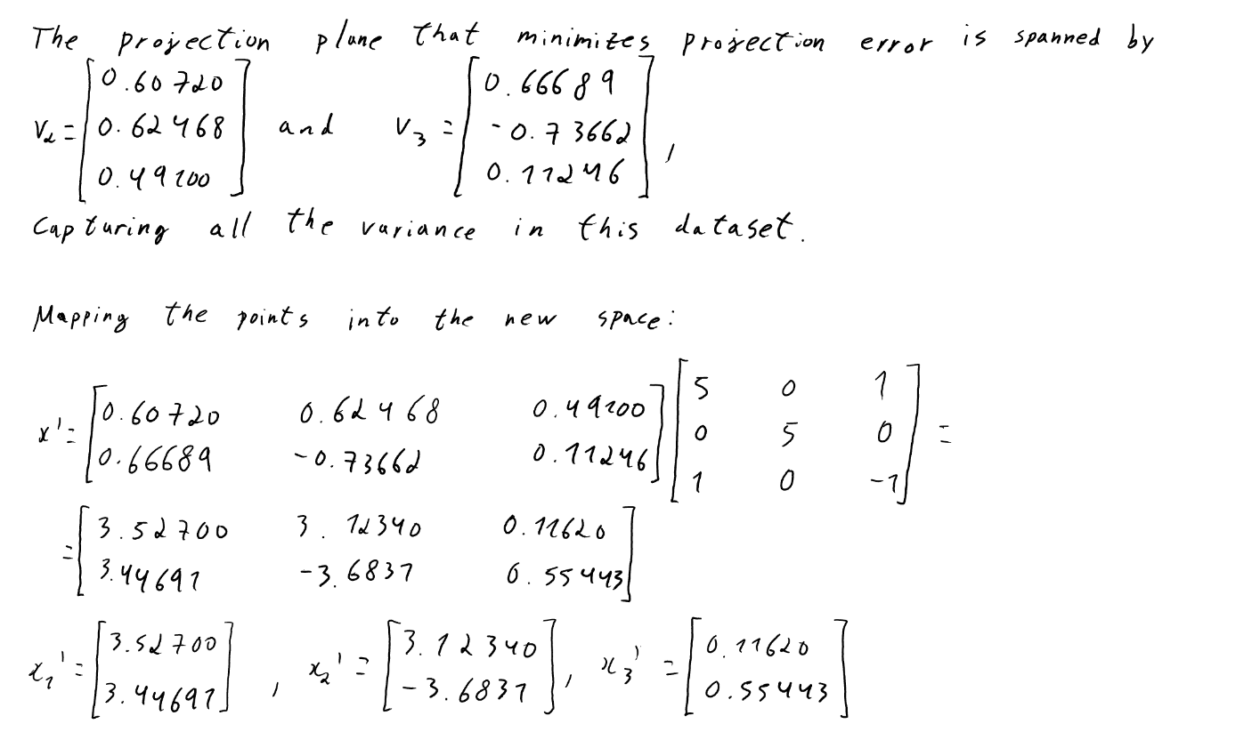

c.)

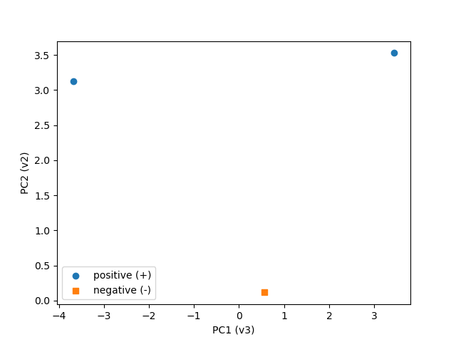

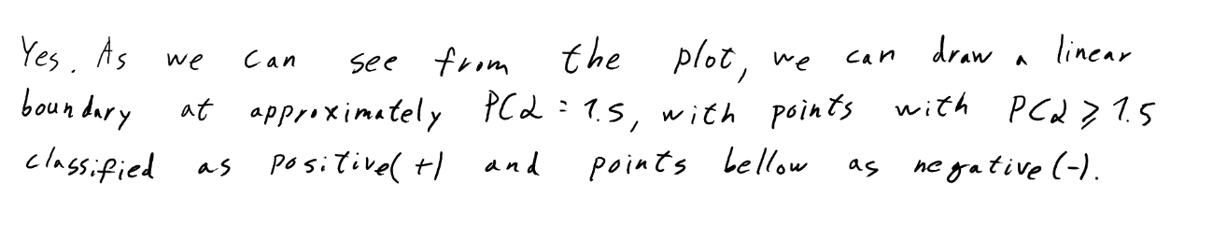

II. Programming
Part A: Clustering
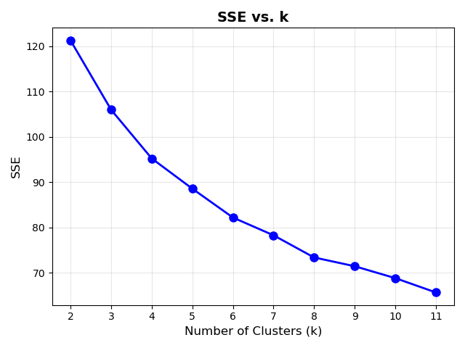
1.)

2.) This is not a good classification model: while the accuracy (70.18%) is somewhat acceptable, its precision (57.53%), recall (55.60%) and F1-score (56.55%) are too low for clinical use (almost half of its diabetic predictions are wrong and nearly half of true diabetics are mistakenly classified). This shows the limits of clustering when used for classification tasks: clustering can't model the decision boundaries, since it doesn't learn using the true labels of the observations, and the real classes may not be convex clusters (clustering can only process convex clusters).
3.) The 3 most discriminative clusters, based on their purity, are clusters 1 (90.71% being non-diabetic), 2 (62.32% being non-diabetic) and 5 (60.80% being diabetic). Cluster 1 is composed mainly of young adults (approximately 25 years old) with normal measurements across the board, meaning individuals with these features are unlikely to have diabetes. In cluster 2 are the older individuals (56.8 years old) with an elevated glucose level (135.2) and low insulin (8.1), and with 37.68% of them having diabetes, it seems like patients with these conditions are more prone to develop diabetes, but not a major concern. Finally, cluster 5 consists primarily of obese middle-aged patients (43.9 years old) with a high number of pregnancies (8.5), elevated glucose (129.9) and insulin (120.7), telling us that these conditions yield the highest risk of an individual developing diabetes (meaning those may be key factors of diabetes).

Part B: PCA
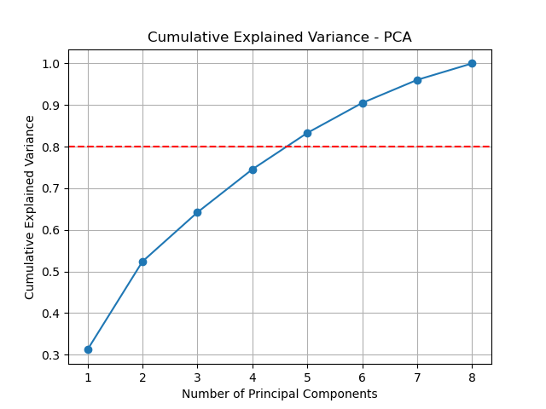
1.)

Based on this graph, a total of five principal components should be retained to explain at least 80% of the total variance.

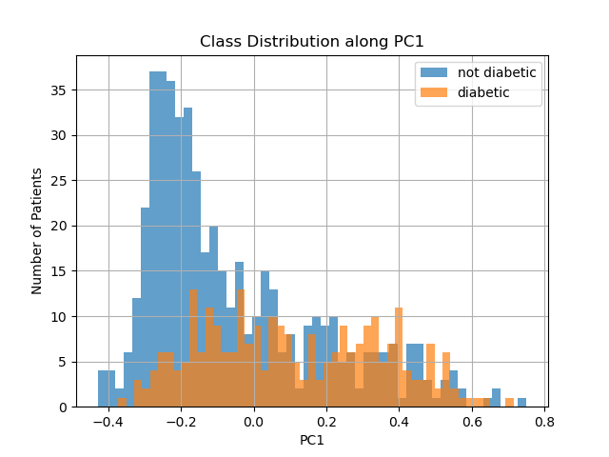
2.)

As we can see, non-diabetics tend to have lower PC1 values, with most of them below 0, and the opposite for diabetics. However, there is a lot of overlapping values between both distributions, showing that PC1 is not enough to discriminate between the two classes.
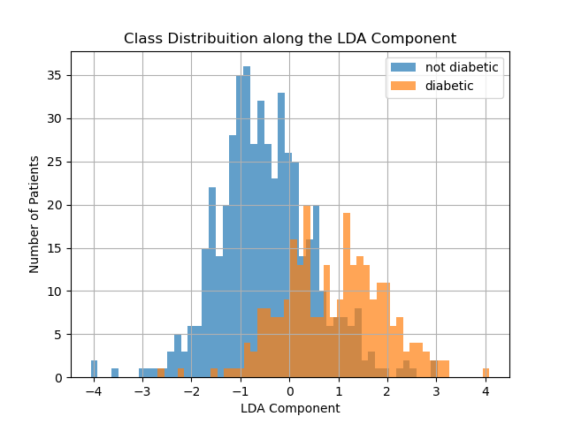
3.)

The plot shows some overlapping values between both distributions, but a shift between the distribution of diabetics and non-diabetics is evident along the component: an individual with a LDA value above 0 is more likely to have diabetes, while values below show the opposite. This suggests that a LDA value around 0 could be a reasonable linear decision boundary for classifying patients.
4.) As we have seen before, LDA is more appropriate for building a discriminant rule: a linear decision boundary around LDA component with value 0. While the distributions in the PCA plot have a lot of overlapping values, the separation between classes is more evident in the LDA plot. This was expected since PCA finds the dimensions that maximize variance in the data, without considering class labels, which makes it good for reducing the dimensionality, but not for classification. On the other hand, LDA finds dimensions that maximize separation between means of projected classes and minimizes variance for the observations within each class, being specifically designed to improve class discrimination, which is why it is more suitable for this case.

