**Electronic Part Info Explorer Application**

1. **Overview:**

Electronic Part Explorer application, developed using C# with MVC 6 features, allows user(s) to explore the technical information about its supported electronic parts. One of the current services is the ‘Resistor value’ calculator. In this portal, the users including electronic engineers and technical associates, are able to select and match any physical color codes on the resistor and receive the resistance value on the fly via display page on the portal. These calculated values include the designated color-coded value, the tolerance, and the range of resistance that is considered an acceptable good resistor.

1. **Operation:**

To use the service of calculating resistance value from the resistor’s color codes, user(s) can access its service page as follows:

There are 2 ways to access the Resistance calculation page: either from the menu bar or from a selection within the scrolling advertising screen

**System Menu Bar:**

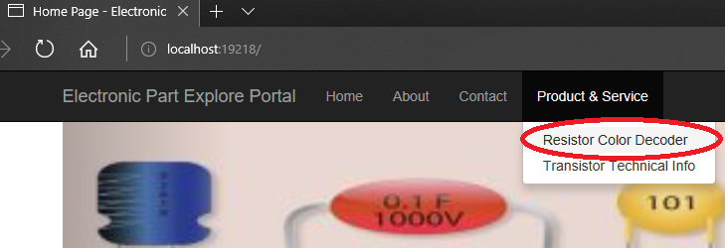

From the system menu, navigate the [Product & Service], then select the [Resistor Color Decoder] from the dropdown menu to open the “Resistor Value Calculator” portal.

**On Screen Selection:**

The “Resistor Value Calculator” portal is also accessed from the scrolling advertising screen where it is offered the link for the resistor color code calculation. Click on [GO] button to jump to the calculator portal.

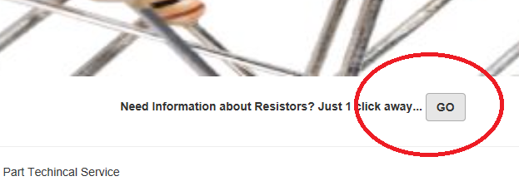

**The Resistance Value Calculation Portal:**

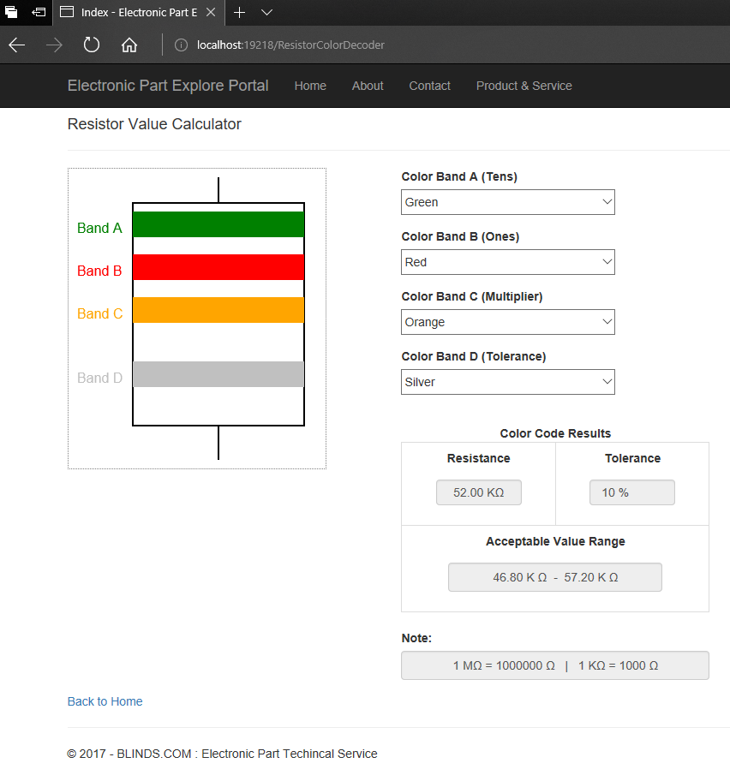

There are 3 main areas on the portal for presentation of the resistance value calculation. The entry section area contains the selections for each of color bands of the resistor that user(s) can query. The graphic visual area presents the color widgets that reflect the physical color bands from the inquired resistor. The last section is the calculation result area that show the designed resistance and tolerance values of the resistor. In the section user(s) can also see the calculated range of values where the measured resistance value must be in. Any value outside this range is definitely bad component.

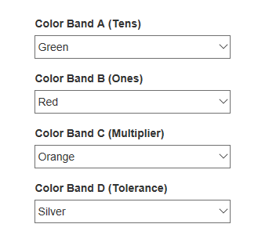**Color Band Selection Area:**

There are 4 color bands available for selections.

* The first color band (Color Band A) represents the first digits (or the tens’ value) of resistance.
* The seconds color band (Color Band B) represents the second digits (or the ones’ value) of resistance.

For example:

First Band (band A) has color Brown equivalent to 1;

Second Band (band B) has color Red equivalent to 2;

Therefore its value (as explained above) is 12.

The third band (band C) is the multiplier which is calculated by 10 to the power of its color value.

For example:

The color on band C is Red equivalent to 2, therefore, the value of multiplier is 102 = 100.

The fourth band (band D) is the tolerance value which provides the variant range which is the measured value of the physical resistor allowed to be in. Any value outside the range is consider a bad/defected component.

For example:

Band D color is Silver decoded as 10% variant.

As a result, the *designed resistance value* (described above) is

Resistance = 12 x 100 = 1200 Ohms or 1.2 K-Ohms

In real life case the *measured resistance value* can fall in the range of

Lower range = 1200 – (1200 * 10 / 100) = 1080

Upper range = 1200 + (1200 * 10 / 100) = 1320

**Visualized Widget:**

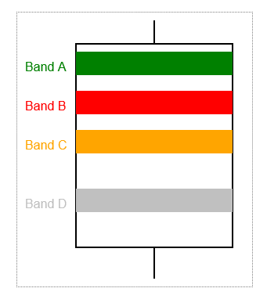

Visualized graphic widget represents the matching color band that user currently selects. The color band reflects the current selected color on the selection.

**Calculated Resistance Result:**

The calculated panel shows the results from the resistance calculator that presents the designed resistance and tolerance value being decoded from the manufacture color bands.

In addition, the value range presents the lower and upper bounds of values that the designed resistance must be in the variant set.

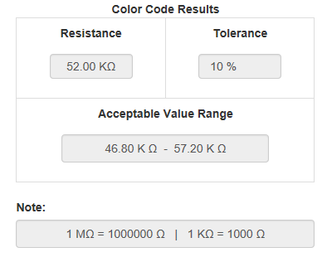

1. **Known Issues:**

* Only support 4 color bands configuration.
* Flickering screen is notice when changing a color from the color band selection.

1. **Future Release Note:**

The future release will include the following.

* Support of 5 color band resistors
* Auto-scan and decode resistance value from the physical resistor using Camera or Scan device
* Any feasible features/improvement/feedback from users, sales, product innovation groups.