 | HO CHI MINH CITY UNIVERSITY OF TECHNOLOGY  INSTITUTE OF INTERNATIONAL EDUCATION

FINAL ASSIGNMENT REPORT
MANAGEMENT ITEMs

Major: Information Technology
Course code: CMP437
Course name: Information technology base project
Lecturer’s name: DR. le thi ngoc tho
Student’s name:
- TRUONG MINH HAI ID: 1911064783 Class: 19DTHQA2
- Truong Tan Vu ID: 1911066473 Class: 19DTHQA2
- Nguyen Bui Minh Duc ID: 1911062156 Class: 19DTHQA2

Ho Chi Minh City
2022
SOCIALIST REPUBLIC OF VIETNAM
Independence – Freedom - Happiness
---------
COMMENTS OF THE LECTURER

Student’s full name:
- TRUONG MINH HAI id: 1911064783
- Truong Tan Vu ID: 1911066473
(3) Nguyen Bui Minh Duc ID: 1911062156

Lecturer’s comments:

HCMC, ………. (date)

Please sign here

Lecturer’s full name

TABLE OF CONTENT
CHAPTER I: INTRODUCTION 8
1. Introduction and System Analysis 9
2. System status and application to Item management 9
3. Identify the object using the program 9
4. Determine system requirements 10
a. Functional Requirements 10
b. System information 10
CHAPTER II: PROJECT ANALYSIS 10
1. User Requirements 10
2. Analysis and object of the system 12
a. Manage import and check items 12
b. Billing management 12
c. Item Management 12
d. Statistical 12
3. Define the Actor System 13
4. Use Case 14
5. Detailed analysis of each function 14
a. Login/Logout Function 14
b. Management Functions 16
c. Item Import Management Function 17
d. Describe The Process Of Sales Activities 18
e. Search Function 18
f. Statistics Function 19
CHAPTER III: SYSTEM DESIGN 20
1. Database Table Design 20
a. Account 20
b. Bill 20
c. Item 21
d. Statistic 21
e. ItemCategory 21
f. ShowItemTemp 22
g. UserRole 22
h. ItemReturn 22
2. Diagram Chart 23
3. Design The Interface Of The System 24
a. Form Login 24
b. Form Change Account (Profile) 25
c. Form Item Management 26
d. Form Statistics 28
e. Form Account 30
f. Form Directory (Category) 31
g. Form Item 32
h. Form Item Return 34
i. Form Export Bill 35
4. Description Of The Sales Operation 36
CHAPTER IV: IMPLEMENTATION 39
1. Requirements 39
2. Results 39
CHAPTER V: Software testing and Quality assurance 52
1. Check The Interface, The General Interface 52
2. Check System Functionality 53
CHAPTER VI: Software installtion and Encapsulation 55
1. Install The Software 55
2. Encapsulation 55
CHAPTER VII: Conclusion 56
REFENCES: 57

FiGURE table of contents

Figure 2.1: System Description 11
Figure 2.2: Table Actor System 13
Figure 2.3: Use Case Diagram 14
Figure 2.4.1: Login/Log out Use Case Diagram 14
Figure 2.4.2: Description Login/Logout Function 15
Figure 2.4.3: Management Function Diagram (Admin) 15
Figure 2.4.4: Description Management Function (Admin) 16
Figure 2.4.5: Management Function Diagram (Employee) 16
Figure 2.4.6: Item Import Management Use Case Diagram 17
Figure 2.4.7: Item Import Management Function 17
Figure 2.4.8: Describe Process Sales Activities Diagram 17
Figure 2.4.9: Search Function Use Case Diagram 18
Figure 2.4.10: Item Import Management Function 18
Figure 2.4.11: Describe Process Search Activities Diagram 18
Figure 2.4.12: Statistics Function Use Case Diagram 19
Figure 2.4.13: Statistics Function Chart 19
Figure 3.1.1: Account Table 20
Figure 3.1.2: Bill Table 20
Figure 3.1.3: Item Table 21
Figure 3.1.4: Statistic Table 21
Figure 3.1.5: ItemCategory Table 21
Figure 3.1.6: ShowItemTemp Table 22
Figure 3.1.7: UserRoles Table 22
Figure 3.1.8: ItemReturn Table 22
Figure 3.2: Diagram Chart 23
Figure 3.3.1: Form Login Interface 24
Figure 3.3.2: System Login Table 24
Figure 3.3.3: Form Change Account Interface 25
Figure 3.3.4: System Change Account Table 26
Figure 3.3.5: Form Item Management Interface 26
Figure 3.3.6: System Item Management Table 28
Figure 3.3.7: Form Statistic Interface 28
Figure 3.3.8: System Statistic Table 29
Figure 3.3.9: Form Account Interface 30
Figure 3.3.10: System Account Table 31
Figure 3.3.11: Form Directory Interface 31
Figure 3.3.12: System Directory Table 32
Figure 3.3.13: Form Item Interface 32
Figure 3.3.14: System Item Table 33
Figure 3.3.15: Form Item Return Interface 34
Figure 3.3.16: System Item Return Table 34
Figure 3.3.17: System Export Bill Table 35
Figure 3.4.1: Interface The Sale Operation 1 36
Figure 3.4.2: Interface The Sale Operation 2 36
Figure 3.4.3: Interface The Sale Operation 3 37
Figure 3.4.4: Interface The Sale Operation 4 38
Figure 4.2.1: Code Connect To Database 41
Figure 4.2.2: Code Form Login/Logout 42
Figure 4.2.3: Code Form Search, Load, Insert, Update, Delete 43
Figure 4.2.4: Code Form Show List Menu 44
Figure 4.2.5: Code Form Statistic 45
Figure 4.2.6: Code Form Add Item 46
Figure 4.2.7: Code Login Button Function 46
Figure 4.2.8: Code Exit Button Function 47
Figure 4.2.9: Code Show Password Function 47
Figure 4.2.10: Code Password Hide 47
Figure 4.2.11: Code Click “Enter” Replaces Login Button 47
Figure 4.2.12: Code Remember User Function 48
Figure 4.2.13: Code Change Password Function 49
Figure 4.2.14: Code Manage Function 49
Figure 4.2.15: Code Rename Function 50
Figure 4.2.16: Code Hide Previous Window Function 50
Figure 4.2.17: Code Clear Button Fuction 50
Figure 4.2.18: Code Search Item By Name Item 50
Figure 4.2.19: Code Search Item By ID 51
Figure 4.2.20: Code Return Item 51
Figure 5.1: Check The Interface (Software Testing) 53
Figure 5.2: Table Check System Functionality (Software Testing) 54

CHAPTER I: INTRODUCTION

The current era of technological development, the industrialization - modernization is growing strongly. We cannot mention the information technology industry. The application of information technology to services has become popular and widespread in all fields from trading, science-society, and life. Computerization is considered as one of the decisive factors in business, service, social, scientific, educational activities, etc. Information technology application plays a very important role can create breakthroughs in the life and speed of smart user development.
The successes of technology that over the past few years: AI, Business, Management, Information Security, … The information technology industry has grown strongly. Because it helps a lot for people in every job.
One of the successful technological achievements is the application of that information technology to the inventory management of the store in the business, which is of great interest to many stores because of its convenience, speed, and high accuracy, making warehouse management more efficient. It's easier to carry every day. That's why we decided to choose the topic "Item Management " to better understand the warehouse management following technology solutions.

Introduction and System Analysis

- Target audience: Convenience store chains, mini shops, small restaurants, ..
- Software is getting attention and can be rated as one of the leading places to manage, supply, import items.
- It creates fast, high accuracy for users.

System status and application to Item management

Item management software by manual method such as the daily import and export of goods, mainly the synthesis of imported and exported goods, is still manually entered by employees with the help of computers. With such management, it is possible to avoid mistakes and difficulties in work such as miscalculation of goods value, confusion in inventory, time-consuming goods lookup that must go through many times. and cause delays and difficulties for the compilation of daily, monthly, and annual revenue statistics reports. This will help with item management, minimize losses and increase sales for the store.

Identify the object using the program
Based on current observations, learned knowledge of system analysis and design, the report will analyze:
- For the manager (Admin): managing the import and export of item must do business smoothly and quickly, limiting confusion, saving time, and managing the budget significantly.
- For Employee: Add, order, edit, delete, search for items conveniently, quickly and simply.

Determine system requirements

Functional Requirements
- Basic functionality required:
- Log in and Log out function
- Search, add, edit and delete functions
- Statistical function
- Import management
- Unit management
- Billing management
- Item Management
- Employee Information Management
- Merchandise unit management
- Manage bill history

System information
- The system should have an easy-to-see and easy-to-operate interface for users.
- High reliability, speed is always guaranteed during use.
- Programming tools and management environment:
- Windows Form .NET
- Visual studio programming tools
- .NET programming language (C#)
- Database management system (SQL Server)

CHAPTER II: PROJECT ANALYSIS

User Requirements

- Items table, this table manages product information with information such as, goods name, unit code, inventory and selling price, inventory quantity, update date, notes, promotions, with each Commodity code is unique.
- User table, managing employee information, with each employee code being unique, with information such as: name, date of birth, address, email, phone number as login name, position.
- Bill table, including unit code, unit name, discount code.
- BillInfo table, including the following information: bill code, user brand, employee information, time, address, note, total amount of goods to be paid from the unit table, QR.
- Profit/Statistic table, containing stored information from invoices over payment of invoices, displays: total revenue earned by shift/day/week/month, transaction history, item sold the most, the lowest.

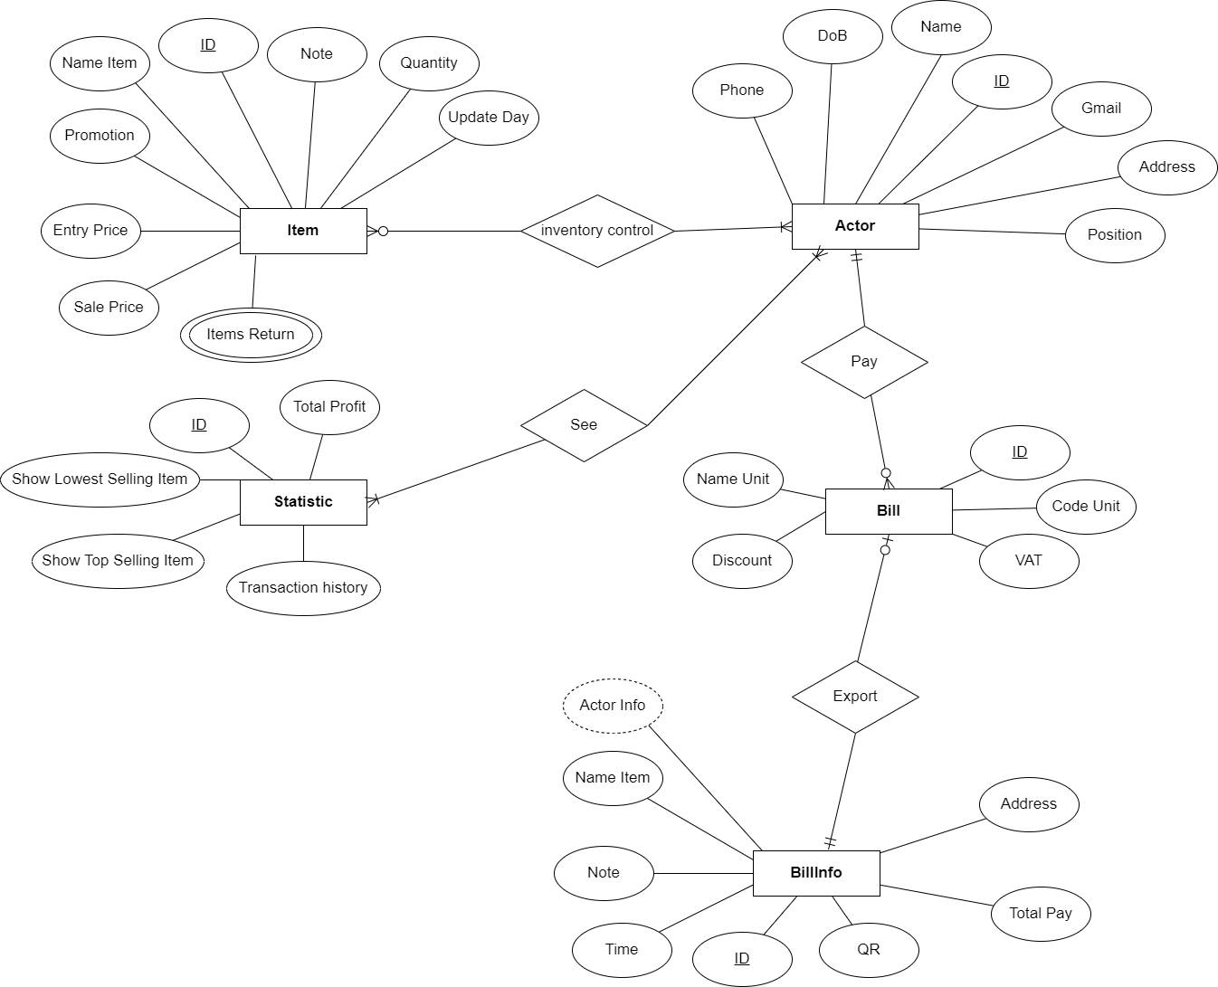

Figure 2.1: System Description

Analysis and object of the system

Manage import and check items
- Newly imported items will be saved by the management employee into the management system, the information includes: quantity, selling price, unit of the item....
- Import item, management record more quantity, observe goods entering the warehouse. Each item has its own code, add to the existing product code, for new items, enter a new one.
- The current inventory status of the warehouse is zero, then all the store's import operations are manual
- If a business item is sold out, notify the import manager and suspend the sale of that item.

Billing management
- Managers (Admin) or Employees are thoroughly checked before printing and exporting to customers. When exporting, the system will record the item, export date and quantity of products exported.
- Billing status of stores: all activities will be supported by the system quickly and with the least errors.

Item Management
Items will be managed in the form of a program that can import products easily, without data loss and with high security, with the ability to add, edit and delete easily and search by item name.

Statistical
- Employee: See the number of items currently displayed and collate externally for reporting, see the sales of that day
- Managers (Admin): Regularly view and report statistics for each period they want. Statistics classified by product. Without this management software, this job is very time consuming and laborious.

Define the Actor System

Actor | Use Case
Manager (Admin) | - Login/Logout  - Search  - Merchandise management  - Item type management  - Information manage  - Import management  - Inventory management  - Shipment management  - Order  - Item Return  - Payment  - Statistical  - Inventory statistics  - View Profits  - Export Bill  - Change personal information
Employee | - Login/Logout  - Search  - Order  - Item Return  - Payment  - Inventory Checking  - Export Bill  - Change Personal Information
Figure 2.2: Table Actor System

Use Case

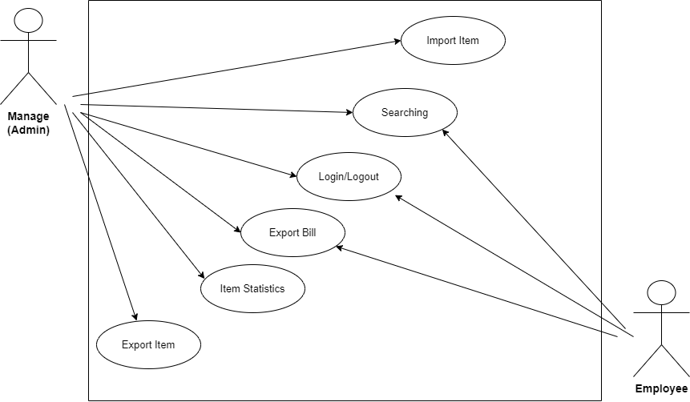
Figure 2.3: Use Case Diagram

Detailed analysis of each function

Login/Logout Function

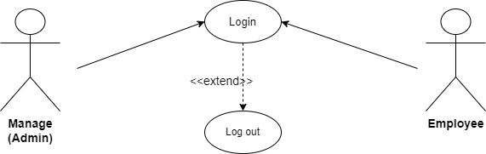
Figure 2.4.1: Login/Logout Use Case Diagram

Use Case | Login/Logout
Actor | Manage (Admin)  Employee
Purpose | Perform the login function to enter the system and exit the system .
Describe | Enter username and password to have the right to choose the management functions in the system.  The system will check and grant access based on the actor type.
Condition | If you enter the correct usename and password, you will log in to the system.  If entered incorrectly, it will show an error message and ask to re-enter.
Figure 2.4.2: Description Login/Logout Function

Management Functions
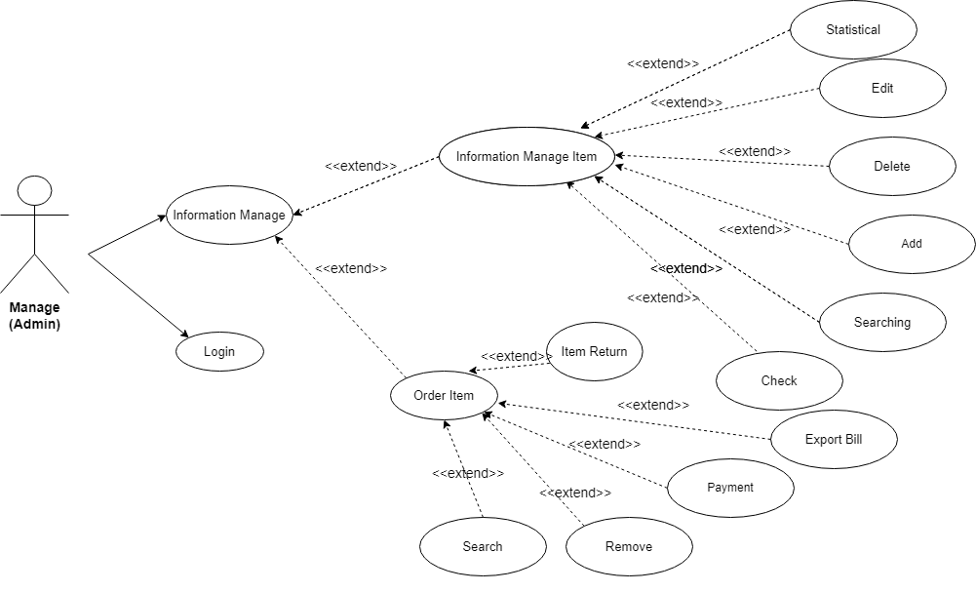
Figure 2.4.3: Management Function Diagram (Admin)

Use Case | Management Function
Actor | Manage (Admin)
Purpose | Edit information, manage and update items quickly.
Describe | Information management, observation from the recording system.  It is also possible to Place Orders as an Employee when dealing with a Customer.
Condition | Agent: The item is in short supply, in excess quantity when no one buys it for too long.  Agent logged in successfully. Use case meets the requirements, has information, then update.

Figure 2.4.4: Description Management Function (Admin)

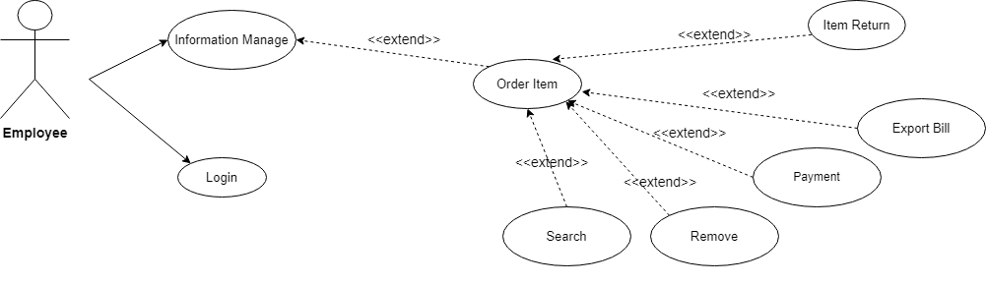

Figure 2.4.4: Management Function Diagram (Employee)

Item Import Management Function
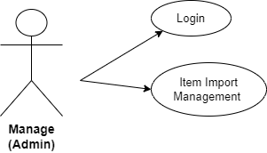
Figure 2.4.5: Item Import Management Use Case Diagram

Use Case | Item Import Management Function
Actor | Manage (Admin)
Purpose | Manage, observe, check the quantity and import items after updating.
Describe | The management use case starts when the store owner wants to manage the inventory.
Condition | The update agent adds items to the store.  Agent login successful.
Figure 2.4.7: Item Import Management Function

Describe The Process Of Sales Activities
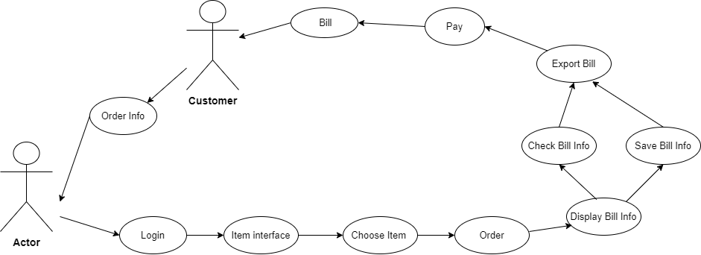
Figure 2.4.8: Describe Process Sales Activities Diagram

Search Function
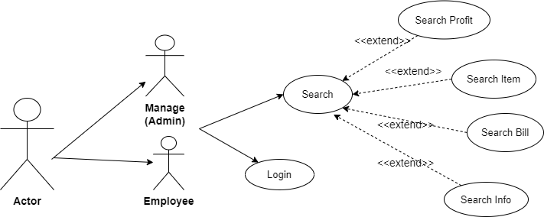
Figure 2.4.9: Search Function Use Case Diagram

Use Case | Search Function
Actor | Manage (Admin)  Employee
Purpose | Find information, items, bill, profit ....
Describe | Search for information you need to know on request.

Figure 2.4.10: Item Import Management Function

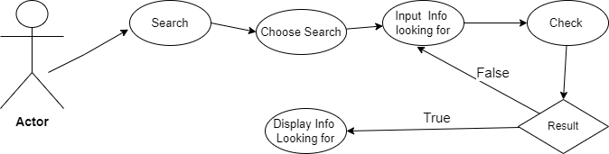
Figure 2.4.11: Describe Process Search Activities Diagram

Statistics Function

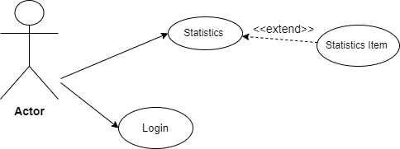
Figure 2.4.12: Statistics Function Use Case Diagram

Use Case | Statistics Function
Actor | Manage (Admin)  Employee
Purpose | Import-export statistics, inventory, profit, bill.
Describe | Start statistics and ask the system to record.  For Employees, the number of items displayed on the system must be reconciled after each shift ends.

Figure 2.4.13: Statistics Function

CHAPTER III: SYSTEM DESIGN

Database Table Design

Account
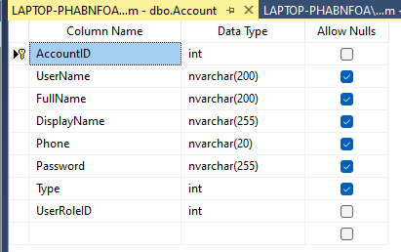
Figure 3.1.6: Account Table

Bill

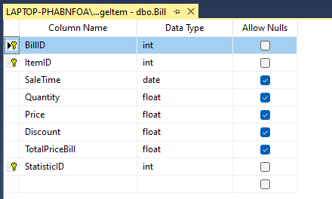
Figure 3.1.7: Bill Table

Item
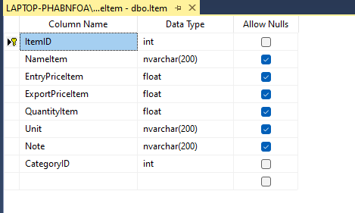
Figure 3.1.3: Item Table

Statistic
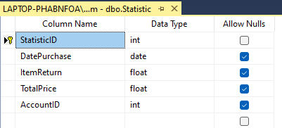
Figure 3.1.4: Statistic Table

ItemCategory

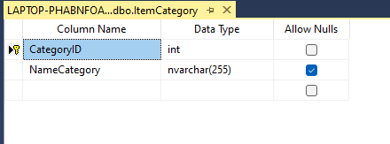

Figure 3.1.5: ItemCategory Table

ShowItemTemp

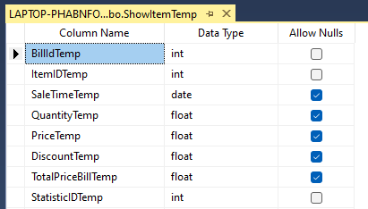

Figure 3.1.6: ShowItemTemp Table

UserRole

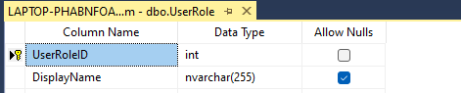
Figure 3.1.7: UserRole Table

ItemReturn

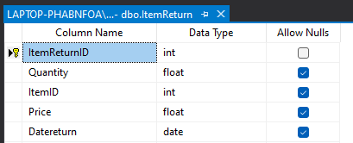

Figure 3.1.8: ItemReturn Table

Diagram Chart

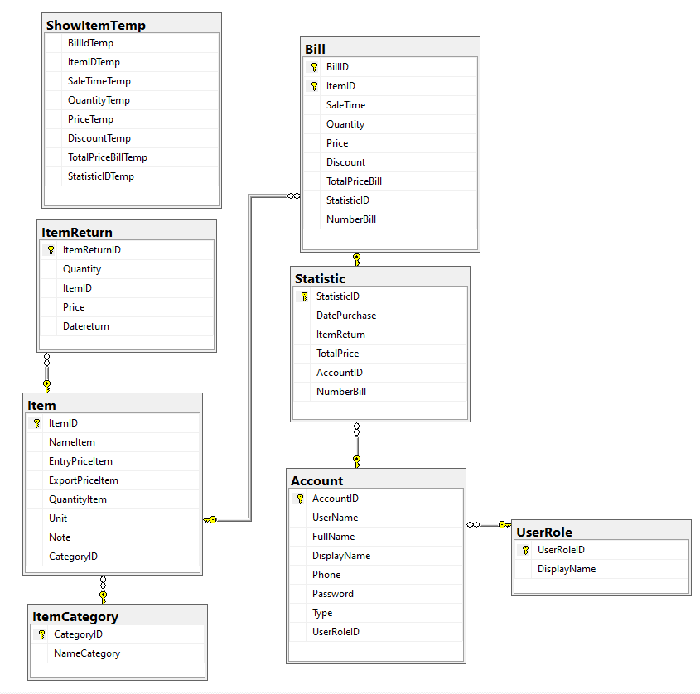

Figure 3.2: Diagram Chart

Design The Interface Of The System

Form Login
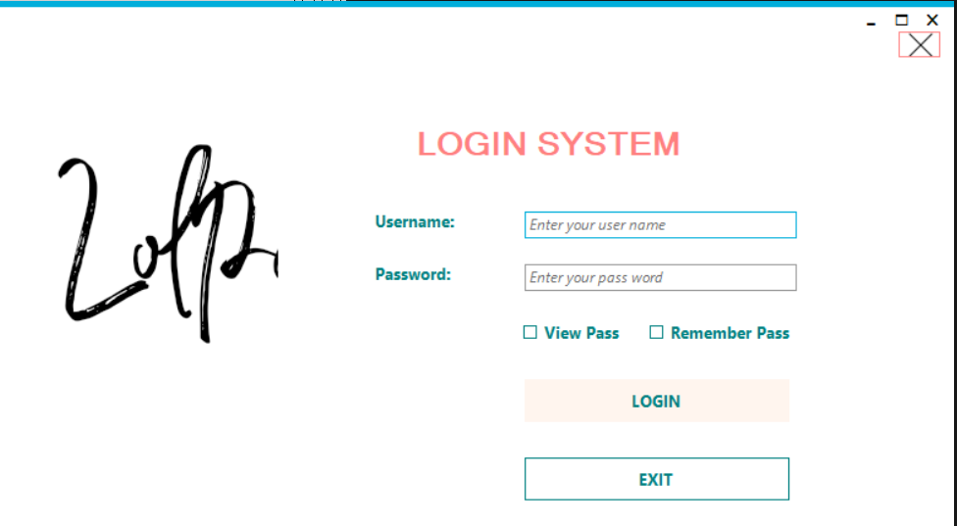
Figure 3.3.1: Form Login Interface

No. | Name | Type | Description | Value | Default values | Note
1 | Username | Textbox | Allows importing user accounts | Text | 0 | Not null
2 | Password | Textbox | Allows entering user passwords | Text | 0 | Not null,  Password Character = *
3 | Login | Button | Click to proceed with login | 0 | 0
4 | Exit | Button | Click to exit the program | 0 | 0
5 | View Pass | CheckBox | Show password
6 | Remember  Pass | CheckBox | Save a quick login account

Figure 3.3.2: System Login Table

Form Change Account (Profile)

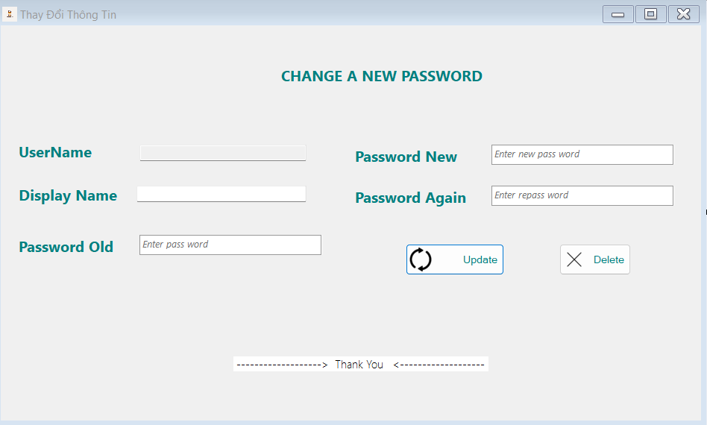
Figure 3.3.3: Form Change Account Interface

No. | Name | Type | Description | Value | Default values | Note
1 | Username | Textbox | Allows importing user accounts | Text | 0 | Not null
2 | Display Name | Textbox | Fullname displays username | Text | 0
3 | Password  Old | Textbox | Enter the old password | Text | 0 | Not null,  Password Character = *
4 | Password  New | Textbox | Enter a new password | Text | 0 | Not null,  Password Character = *
5 | Password  Again | Textbox | Reconfirm a new password | Text | 0 | Not null,  Password Character = *
6 | Update | Button | Refresh update information
7 | Delete | Button | Delete all information just entered.

Figure 3.3.4: System Change Account Table

Form Item Management
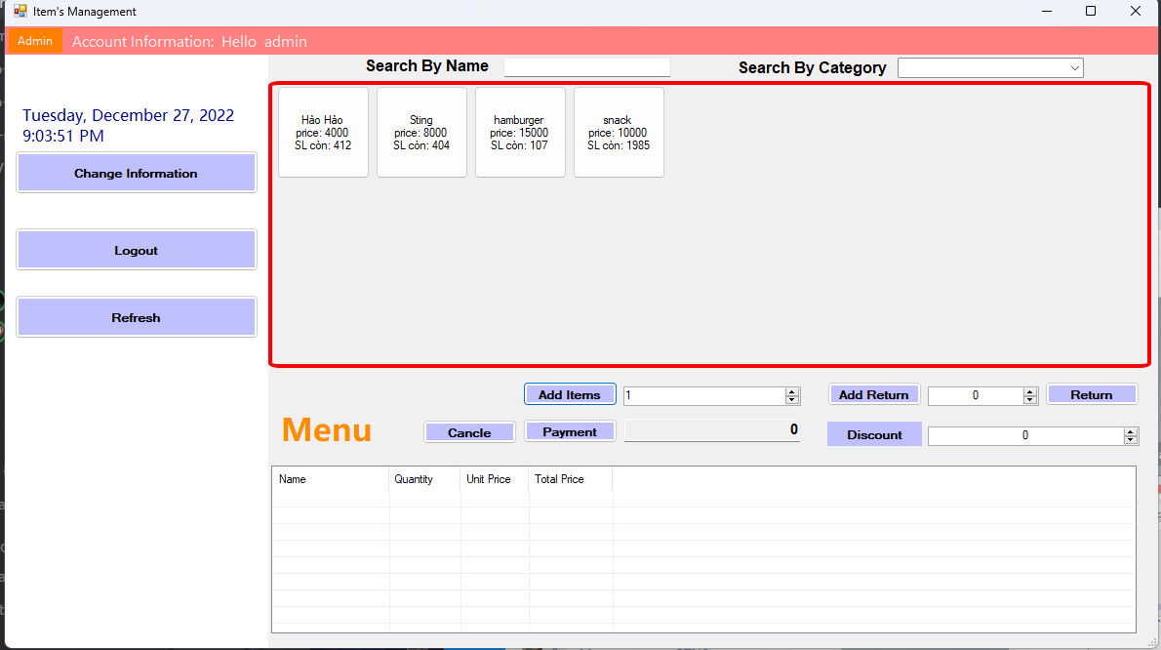
Figure 3.3.5: Form Item Management Interface

No. | Name | Type | Description | Value | Default values | Note
1 | List Item | Button | Show the products to be sold
2 | Logout | Button | Account logout
3 | Search Item by Name | Textbox | Search by Item name
4 | Search Item by Category | ComboBox | Search by Product type ID
5 | Refresh | Button | Refresh, update main page again
6 | Change Infomation | Button | Change user information
7 | Time | Date | Show current time
8 | Add Item | Numberic UpDown | Add a new number of items
9 | Cancel Order | Button | Cancel all actions just ordered
10 | Payment | Button | Click will pay and finish 1 bill
11 | Discount | Numberic UpDown | Product discounts before payment |  |  | Discounts depending on item type
12 | Menu | ListView | Show the item information that has just been ordered and prepared for payment
13 | Admin | ToolStrip  MenuItem | Go to the Admin's management page
14 | Account information | ToolStrip  MenuItem | Menu change information and logout.
15 | Display Name | MenuStrip | Display the user's full name
16 | Return | Button | Once you're done with Add Return, click this button to return.
17 | Add Return | Numberic UpDown | Click on the item on the display, then select the returned quantity |  |  | Want to do this, after exporting the bill but the customer wants to return the item

Figure 3.3.6: System Item Management Table

Form Statistics

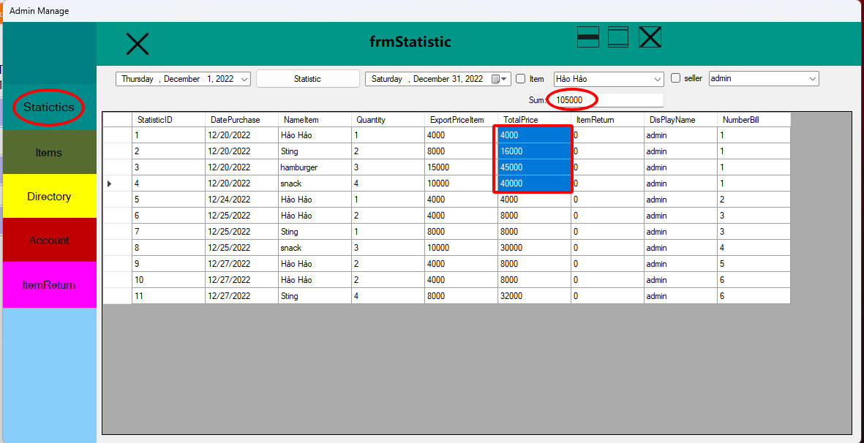

Figure 3.3.7: Form Statistic Interface

No. | Name | Type | Description | Value | Default values | Note
1 | Statistic | Label | Name Statistical Interface
2 | Date Check In | Date | Show the first timeline |  |  | Show the information items that have been sold during this time period
3 | Date Check Out | Date | Show the last timeline
4 | List Statistic | ListView | Show list statistics sold
5 | Seller | Textbox | Show the seller's name
6 | Item | ComboBox | Search by NameItem of Category
7 | Sum | Textbox | Calculate the total number in the scanned range | Int |  | Sum will be calculated when the type of number (type: int) after scanning the mouse

Figure 3.3.8: System Statistic Table

Form Account
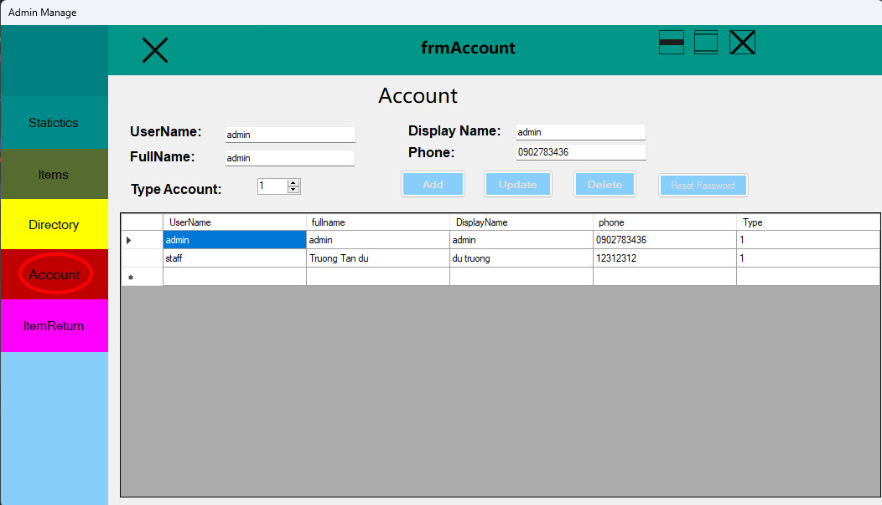
Figure 3.3.9: Form Account Interface

No. | Name | Type | Description | Value | Default values | Note
1 | Username | Textbox | Allows importing user accounts | Text | 0 | Not null
2 | Display Name | Textbox | Fullname displays username | Text | 0
3 | Type User | Numberic UpDown | Have 2 Account Types: Admin and employee |  |  | If Type = 1: Admin  If Type = 0: Employee
4 | Full Name | Textbox | Full name user | Text
5 | Phone | Textbox | Phone of account | Int
6 | Add | Button | Add a new account | 0 | 0 | Create accounts include type: Admin, Employee
7 | Reset Password | Button | Reconfirm a new password
8 | Update | Button | Refresh update information
9 | Delete | Button | Delete an Account |  |  | Only employee accounts can be deleted

Figure 3.3.10: System Account Table

Form Directory (Category)

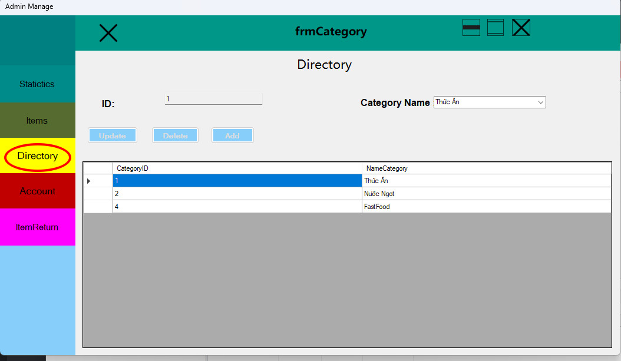
Figure 3.3.11: Form Directory Interface

No. | Name | Type | Description | Value | Default values | Note
1 | ID | TextBox | Show Name Item | Int
2 | Caterory Name | ComboBox | List of Item Type
3 | Add | Button | Add a new type item
4 | Update | Button | Refresh update added Type Item information
5 | Delete | Button | Delete a type item

Figure 3.3.12: System Directory Table

Form Item

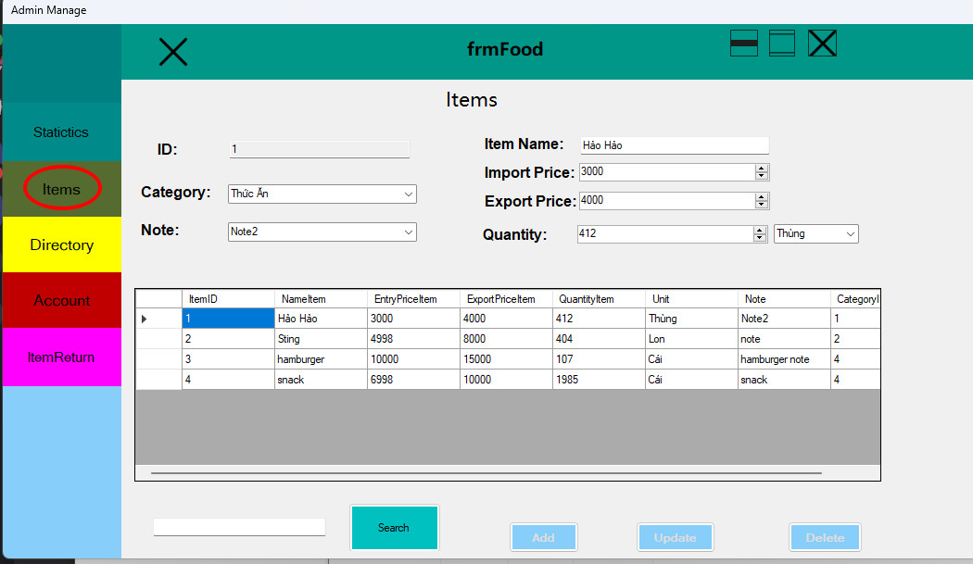
Figure 3.3.13: Form Item Interface

No. | Name | Type | Description | Value | Default values | Note
1 | ID | TextBox | Show Name Item
2 | Name Item | TextBox | Input Name Item
3 | Category | ComboBox | Show directory to want to find
4 | Import Price | Numberic UpDown | Enter Item Import Price | Int
5 | Export Price | Numberic UpDown | Enter Item Export Price | Int
6 | Note | TextBox | Notes Item
7 | Quantity | Numberic UpDown | Number of Item by Unit
8 | Unit | ComboBox | Unit classification for each item type
9 | Update | Button | Refresh update added Item information
10 | Delete | Button | Delete an Item
11 | Search | Button | List products by name
12 | Add | Button | Add Item to the system

Figure 3.3.14: System Item Table

Form Item Return
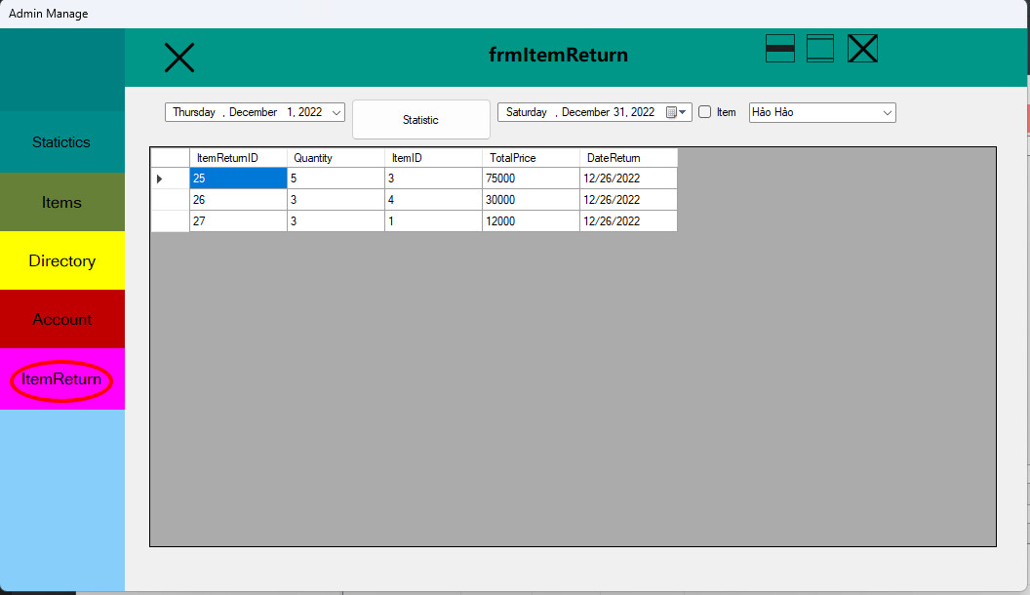
Figure 3.3.15: Form Item Return Interface

No. | Name | Type | Description | Value | Default values | Note
1 | Statistic | Label | Name Statistical Interface
2 | Date Check In | Date | Show the first timeline |  |  | Show the information items that have been sold during this time period
3 | Date Check Out | Date | Show the last timeline
4 | List ItemReturn | ListView | Show list ItemReturn of statistics sold
5 | Item | ComboBox | Search by NameItem of Category

Figure 3.3.16: System Item Return Table

Form Export Bill

No. | Name | Type | Description | Value | Default values | Note
1 | IDBill | TextBox | Bill Code
2 | UserName | TextBox | Show seller information
3 | Display Export Information | ListView | Show all information: NameItem, Type, Unit, Quantity, Discount,…
4 | Total Price | Label | Show the price of all items
5 | Exit | Button | Turn off the export Bill interface
6 | Export Bill | Button | Print Bill and complete the transaction
7 | Some other information, attributes ...

Figure 3.3.17: System Export Bill Table

Description Of The Sales Operation
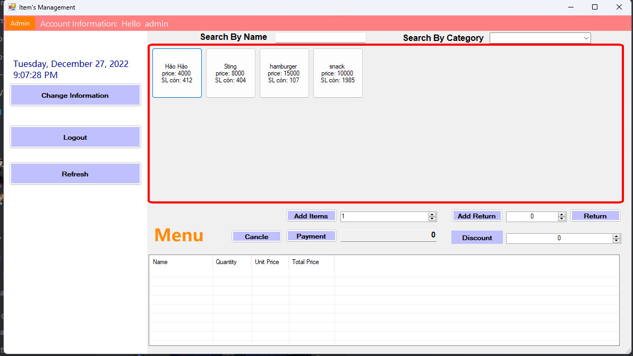
Figure 3.4.1: Interface The Sale Operation 1

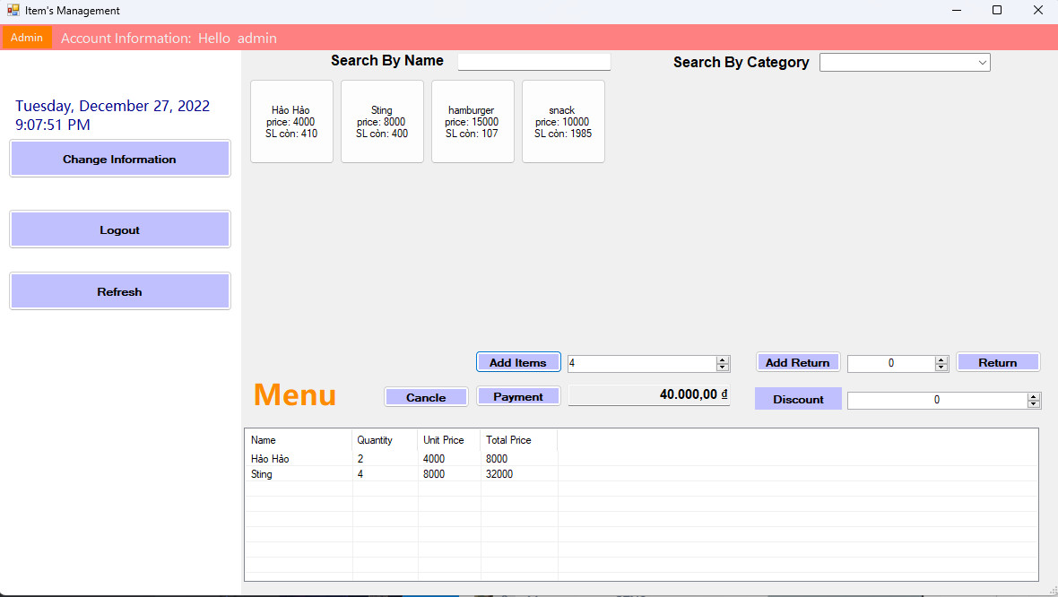
Figure 3.4.2: Interface The Sale Operation 2

After successful Login, this grid shows all product information. products taken from "Items" :
  - Manager/ Employee choose products to sell .
  - Enter Quantity product and click "Add Item" to add it to the purchase list
  - Enter more discount segments for the order if available and click "Buy"
  - Select "Cancel Order", if the Order is canceled
  - After Payment, a notification and the total price of the order will be displayed
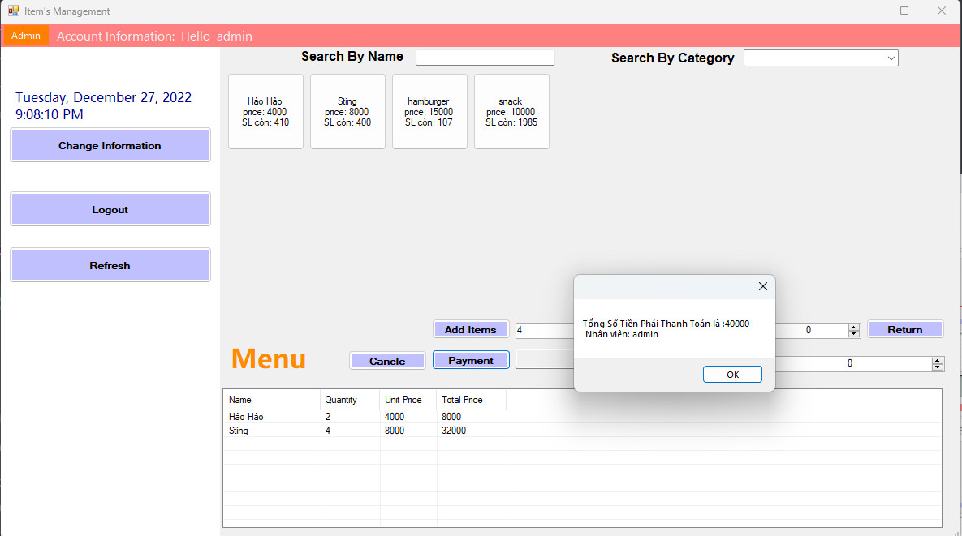
Figure 3.4.3: Interface The Sale Operation 3

After completing the payment . the data in the invoice will be pushed through the "Statistic – Doanh Thu" section:
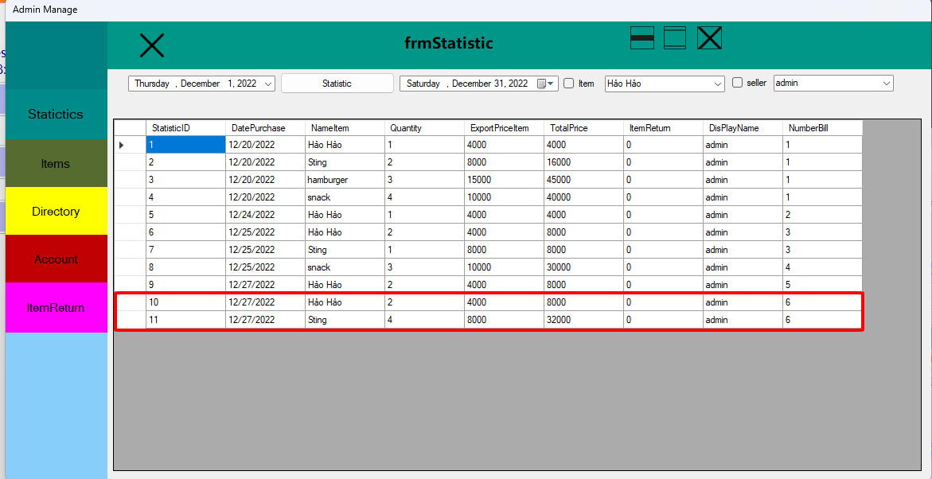
Figure 3.4.4: Interface The Sale Operation 4

CHAPTER IV: IMPLEMENTATION

Requirements

- Programming language: C# Window Form (Winform)
- Support tools:
- Code execution software: Visual Studio 2019
- Database Management System: SQL Server 2019
- Reason for choosing language:
- C# is a language quite associated with management software programs because of its simplicity in logic, quite powerful and flexible, and quite popular with many people. Besides, C# is also easy, safe, it has inheritance like C, C++ or Java. Using with it will have few simple keywords for newbies and it is enough to create complete software products.
- C# has Microsoft's powerful VisualStudio IDE, which is a great code editor that supports Code/Build, features like code completion, debugging, reporting, git integration, software testing and many more another ability. Can be used for web programming through pure C# or ASP.NET.
- .NET so is lightweight, easy to install, and free.
- The Visual Studio IDE supports debugging, builds massively, is fully featured, and is completely free, making it easy to get to the code.
- It is one of the pure object-oriented languages.
- Fully supported by windows controls.
- Designing WinForm is quite easy compared to all other programming languages, it's simple and easy to understand.
- Interoperability with the database is much easier with less hassle.

Results
- The software works as perfectly as expected.
- Product results are less likely to go wrong.

public class DataProvider
{
private static DataProvider instance; // Ctrl + R + E
public static DataProvider Instance
{
get { if (instance == null) instance = new DataProvider(); return DataProvider.instance; }
private set { DataProvider.instance = value; }
}
private DataProvider() { }
private string connectionStr = @"Data Source=LAPTOP-PHABNFOA\EXPRESSS;Initial Catalog=ManageItem;Integrated Security=True";

public DataTable ExecuteQuery(string query, object[] parameter = null)
{
DataTable data = new DataTable();
using (SqlConnection connection = new SqlConnection(connectionStr))
{
connection.Open();
SqlCommand command = new SqlCommand(query, connection);
if (parameter != null)
{
string[] listPara = query.Split(' ');
int i = 0;
foreach (string item in listPara)
{
if (item.Contains('@'))
{
string para = item.Replace(",", "");
command.Parameters.AddWithValue(item, parameter[i]);
i++;
}
}
}
SqlDataAdapter adapter = new SqlDataAdapter(command);
adapter.Fill(data);
connection.Close();
}
return data;
}
public int ExecuteNonQuery(string query, object[] parameter = null)
{
int data = 0;
using (SqlConnection connection = new SqlConnection(connectionStr))
{
connection.Open();
SqlCommand command = new SqlCommand(query, connection);
if (parameter != null) {
string[] listPara = query.Split(' ');
int i = 0;
foreach (string item in listPara)
{
if (item.Contains('@'))
{
command.Parameters.AddWithValue(item, parameter[i]);
i++;
}
}
}
data = command.ExecuteNonQuery();
connection.Close();
}
return data;
}
public object ExecuteScalar(string query, object[] parameter = null){
object data = 0;
using (SqlConnection connection = new SqlConnection(connectionStr))
{
connection.Open();
SqlCommand command = new SqlCommand(query, connection);
if (parameter != null) {
string[] listPara = query.Split(' ');
int i = 0;
foreach (string item in listPara) {
if (item.Contains('@'))
{
command.Parameters.AddWithValue(item, parameter[i]);
i++;
}
}
}
data = command.ExecuteScalar();
connection.Close();
}
return data;
}
}

Figure 4.2.8: Code Connect To Database

public class AccountDAO
{
private static AccountDAO instance;

public static AccountDAO Instance
{
get { if (instance == null) instance = new AccountDAO(); return instance; }
private set { instance = value; }
}

private AccountDAO() { }

public bool Login(string userName, string passWord)
{
string query = "USP_Login @userName , @passWord";

DataTable result = DataProvider.Instance.ExecuteQuery(query, new object[] { userName, passWord });

return result.Rows.Count > 0;
}

public bool Checkuserexist(string userName)
{
string query = string.Format("select * from dbo.Account WHERE UserName = N'{0}'", userName);
DataTable result = DataProvider.Instance.ExecuteQuery(query);

return result.Rows.Count > 0;
}
public DataTable GetListAccount()
{
return DataProvider.Instance.ExecuteQuery("SELECT UserName,fullname, DisplayName,phone, Type FROM dbo.Account ");
}

public Account GetAccountByUserName(string userName)
{
DataTable data = DataProvider.Instance.ExecuteQuery("Select * from account where userName = '" + userName + "'");

foreach (DataRow item in data.Rows)
{
return new Account(item);
}

return null;
}

public bool InsertAccount(string name, string fullname, string displayName, string phone, int type)
{
string query = string.Format("INSERT dbo.Account ( UserName,fullname, DisplayName,phone, Type ,password,UserRoleID )VALUES ( N'{0}', N'{1}',N'{2}',N'{3}', {4},{5},{6})", name,fullname, displayName,phone, type,0, type);
int result = DataProvider.Instance.ExecuteNonQuery(query);

return result > 0;
}
public bool UpdateAccount(string name, string fullname, string displayName, string phone, int type)
{
string query = string.Format("UPDATE dbo.Account SET fullname = N'{1}',DisplayName ='{2}',phone ='{3}', Type = {4} WHERE UserName = N'{0}'", name,fullname, displayName,phone, type);

int result = DataProvider.Instance.ExecuteNonQuery(query);

return result > 0;
}
public bool UpdateAccount(string userName, string displayName, string pass, string newPass)
{
int result = DataProvider.Instance.ExecuteNonQuery("exec USP_UpdateAccount @userName , @displayName, @password , @newPassword", new object[] { userName, displayName, pass, newPass });

return result > 0;
}
public bool DeleteAccount(string name)
{
string query = string.Format("Delete Account where UserName = N'{0}'", name);
int result = DataProvider.Instance.ExecuteNonQuery(query);
return result > 0;
}
public bool ResetPassword(string name)
{
string query = string.Format("update account set password = N'0' where UserName = N'{0}'", name);
int result = DataProvider.Instance.ExecuteNonQuery(query);
return result > 0;
}
}

Figure 4.2.2: Code Form Login/Logout
public class CategoryDAO
{
private static CategoryDAO instance;
public static CategoryDAO Instance
{
get { if (instance == null) instance = new CategoryDAO(); return CategoryDAO.instance; }
private set { CategoryDAO.instance = value; }
}
private CategoryDAO() { }
public List<ItemCategory> GetlistCategory()
{
List<ItemCategory> list = new List<ItemCategory>();

string query= "select * from ItemCategory";
DataTable data = DataProvider.Instance.ExecuteQuery(query);
foreach (DataRow item in data.Rows)
{
ItemCategory category = new ItemCategory(item);
list.Add(category);
}
return list;
}
public ItemCategory GetCategoryByID(int id) {
ItemCategory category = null;
List<ItemCategory> list = new List<ItemCategory>();
string query = "select * from ItemCategory where id = " + id;
DataTable data = DataProvider.Instance.ExecuteQuery(query);
foreach (DataRow item in data.Rows){
category = new ItemCategory(item);
list.Add(category);
}
return category;
}
public bool InsertCategory(string name) {
string query = string.Format("INSERT dbo.ItemCategory( NameCategory ) VALUES ( N'{0}')", name );
int result = DataProvider.Instance.ExecuteNonQuery(query);
return result > 0;
}
public bool UpdateCategory(int id,string name)
{
string query = string.Format("UPDATE dbo.ItemCategory SET NameCategory = N'{0}' WHERE id = {1}", name, id);
int result = DataProvider.Instance.ExecuteNonQuery(query);

return result > 0;
}
public bool DeleteCategory(int id){
string query = string.Format("Delete ItemCategory where CategoryID = {0}", id);
int result = DataProvider.Instance.ExecuteNonQuery(query);
return result > 0;
}
}

Figure 4.2.3: Code Form Search, Load, Insert, Update, Delete

private static MenuDAO instance;

public static MenuDAO Instance
{
get { if (instance == null) instance = new MenuDAO(); return MenuDAO.instance; }
private set { MenuDAO.instance = value; }
}
private MenuDAO() { }

public List<Menu> GetlistMenuByItems()
{
List<Menu> listMenu = new List<Menu>();
//string query = "SELECT f.name, bi.count, f.price, f.price*bi.count AS totalPrice FROM dbo.BillInfo AS bi, dbo.Bill AS b, dbo.Item AS f WHERE bi.idBill = b.id AND bi.idFood = f.id AND b.status =0 AND f.id = " + id;
string query = "SELECT f.NameItem, " +
"Sit.QuantityTemp, f.ExportPriceItem, " +
"f.ExportPriceItem * Sit.QuantityTemp AS totalPrice FROM dbo.ShowItemTemp AS Sit," +
" dbo.Item AS f WHERE Sit.ItemIDTemp = f.ItemID ";
DataTable data = DataProvider.Instance.ExecuteQuery(query);

foreach (DataRow item in data.Rows)
{
Menu menu = new Menu(item);
listMenu.Add(menu);
}

return listMenu;
}
}

Figure 4.2.4: Code Form Show List Menu

public List<Statistic> LoadlistStatistic() {
List<Statistic> StatisticList = new List<Statistic>();
string query = "SELECT st.StatisticID , st.DatePurchase , st.ItemReturn , st.TotalPrice ,st.AccountID, ac.DisplayName ,st.NumberBill FROM Statistic st, account ac WHERE ac.AccountID= st.AccountID";
DataTable data = DataProvider.Instance.ExecuteQuery(query);
foreach (DataRow item in data.Rows) {
Statistic doanhthu = new Statistic(item);
StatisticList.Add(doanhthu);
}
return StatisticList;
}
public int GetMaxIDStatistic() {
try {
return (int)DataProvider.Instance.ExecuteScalar("SELECT MAX(StatisticID) FROM dbo.Statistic");
}
catch {
return 1;
}
}
public void InsertIDstatistic(int idStatistic)
{
DataProvider.Instance.ExecuteQuery("exec USP_InsertIDstatistic @StatisticID ", new object[] { idStatistic });
}
public string LoadtotalStatistic()
{
float totalStatistic = 0;
List<Statistic> Statisticlist = StatisticDAO.Instance.LoadlistStatistic();
foreach (Statistic item in Statisticlist)
{
totalStatistic += item.TotalPrice;
}
return totalStatistic.ToString();
}
public List<Statistic> GetlistStatistic(DateTime checkIn, DateTime checkOut)
{
List<Statistic> TotalStatisticList = new List<Statistic>();
string query = "select * from Statistic where DatePurchase >=" + @checkIn + " and DatePurchase<=" + @checkOut;

DataTable data = DataProvider.Instance.ExecuteQuery(query);

foreach (DataRow item in data.Rows)
{
Statistic table = new Statistic(item);
TotalStatisticList.Add(table);
}

return TotalStatisticList;

}

}

Figure 4.2.5: Code Form Statistic

public List<Items> LoadFoodList()
{
List<Items> tableList = new List<Items>();
string query1 = "Select * From Item";

DataTable data = DataProvider.Instance.ExecuteQuery(query1);

foreach (DataRow item in data.Rows)
{
Items table = new Items(item);
tableList.Add(table);
}
return tableList;
}

public List<Items> GetListTabble()
{
List<Items> list = new List<Items>();

string query = "Select * From Item";
DataTable data = DataProvider.Instance.ExecuteQuery(query);
foreach (DataRow item in data.Rows)
{
Items table = new Items(item);
list.Add(table);
}

return list;
}

Figure 4.2.6: Code Form Add Item

private void btnLogin_Click(object sender, EventArgs e)
{
string userName = txtUserName.Text;
string passWord = txtPassWord.Text;
if (Login(userName, passWord))
{
Account loginAccount = AccountDAO.Instance.GetAccountByUserName(userName);
fTableManager f = new fTableManager(loginAccount);
SavePassword();
this.Hide();
f.ShowDialog();
this.Close();
}
Else {
System.Windows.MessageBox.Show("Wrong username or password!");
}
bool Login(string username, string password)
{
return AccountDAO.Instance.Login(userName, passWord);
}
}

Figure 4.2.7: Code Login Button Function

private void btnExit_Click(object sender, EventArgs e)
{
Application.Exit();
}

Figure 4.2.8: Code Exit Button Function

private void chkShowpass_CheckedChanged(object sender, EventArgs e)
{
if (chkShowpass.Checked)
{
txtPassWord.UseSystemPasswordChar = false;
}
else
{
txtPassWord.UseSystemPasswordChar = true;
}
}

Figure 4.2.9: Code Show Password Function

private void fLogin_Load(object sender, EventArgs e)
{
txtPassWord.UseSystemPasswordChar = true;
}

Figure 4.2.10: Code Password Hide

private void txtUserName_KeyPress(object sender, KeyPressEventArgs e)
{
if (e.KeyChar.Equals(Convert.ToChar(13)))
{
btnLogin_Click(sender, e);
}
}

private void txtPassWord_KeyPress(object sender, KeyPressEventArgs e)
{
if (e.KeyChar.Equals(Convert.ToChar(13)))
{
btnLogin_Click(sender, e);
}
}

Figure 4.2.11: Code Click “Enter” Replaces Login Button

private void SavePassword() {
try {
if (chksavepass.Checked) {
String path = Application.StartupPath + @"\Savepassword.txt";
try{
using (StreamWriter sr = new StreamWriter(path))
sr.WriteLine(txtUserName.Text + ";" + txtPassWord.Text);
}
catch (Exception e) {
}
}
}
catch (Exception e){
}
}
private void txtUserName_TextChanged(object sender, EventArgs e) {
Try {
String pathsp = Application.StartupPath + @"\Savepassword.txt";//
if (!File.Exists(pathsp)){
}
StreamReader sr = new StreamReader(pathsp);

String rf = sr.ReadLine();
String[] rfsplit;
Try {
String[] spearator = { ";" };
Int32 count = 2;
rfsplit = rf.Split(spearator, count, StringSplitOptions.RemoveEmptyEntries);

if ((txtUserName.Text) == rfsplit[0])
{
txtPassWord.Text = rfsplit[1];
}
else {
txtPassWord.Text = "";
}

}
catch{
}
sr.Close();
}
catch{}
}

Figure 4.2.12: Code Remember User Function

void ChangeAccount(Account acc)
{
txbUserName.Text = LoginAccount.UserName;
txbDissPlay.Text = LoginAccount.DisplayName;

}
void UpdateAccountInfo()
{
string displayName = txbDissPlay.Text;
string password = txbPassWord.Text;
string newpass = txbNewPass.Text;
string reenterPass = txbreEnterPass.Text;
string userName = txbUserName.Text;

if (!newpass.Equals(reenterPass))
{
MessageBox.Show("Please re-enter the correct password with the new password!");
}
else
{
if (AccountDAO.Instance.UpdateAccount(userName, displayName, password, newpass))
{
MessageBox.Show("Update successful");
if (updateAccount != null)
updateAccount(this, new AccountEvent(AccountDAO.Instance.GetAccountByUserName(userName)));
}
else
{
MessageBox.Show("Please enter the correct password");
}
}
}

Figure 4.2.13: Code Change Password Function

public partial class fTableManager : Form {
private Account loginAccount;
public Account LoginAccount
{
get { return loginAccount; }
set { loginAccount = value; ChangeAccount(loginAccount.Type); }
}
public fTableManager(Account acc)
{
InitializeComponent();
this.LoginAccount = acc;
timer1.Start();
LoadTable();
LoadCategory();
LoadCategoryIntoCombobox(cbSearhCategoryName);
cbSearhCategoryName.SelectedIndex = -1;
}

Figure 4.2.14: Code Manage Function

private void btnRename_Click(object sender, EventArgs e)
{
fAccoutProfile1 f = new fAccoutProfile1(loginAccount);
f.ShowDialog();
}

Figure 4.2.15: Code Rename Function

private void btnLogout_Click(object sender, EventArgs e)
{
this.Hide();
this.Close();
fLogin f = new fLogin();
f.ShowDialog();
}

Figure 4.2.16: Code Hide Previous Window Function

private void btnClear_Click(object sender, EventArgs e)
{
lsvBill.Items.Clear();
txbTotalPrice.Text = "0";
BillDAO.Instance.Deletedulieushowtemp();
}

Figure 4.2.17: Code Clear Button Fuction

private void btnSearchFood_Click(object sender, EventArgs e)
{
flpTable.Controls.Clear();
List<Items> tablelist = ItemsDAO.Instance.SearchitemByName(txbSearchItem.Text);
foreach (Items item in tablelist)
{
Button btn = new Button() { Width = TableDAO.TableWidth, Height = TableDAO.TableHeight };
btn.Text = item.NameItem
+ Environment.NewLine + "price: " + item.ExportPriceItem
+ Environment.NewLine + "SL còn: " + item.QuantityItem
+ Environment.NewLine + "ID :" + item.ItemID;

btn.Click += Btn_Click;
btn.Tag = item;
flpTable.Controls.Add(btn);
}
}

Figure 4.2.18: Code Search Item By Name Item

private void cbSearchItems_click(object sender, EventArgs e)
{
if(cbSearhCategoryName.SelectedValue == null)
{
LoadTable();
}
else
{
int categoryID = (cbSearhCategoryName.SelectedItem as ItemCategory).CategoryID;
flpTable.Controls.Clear();
List<Items> tablelist = ItemsDAO.Instance.GetitemByCategoryID(categoryID);
foreach (Items item in tablelist)
{
Button btn = new Button() { Width = TableDAO.TableWidth, Height = TableDAO.TableHeight };
btn.Text = item.NameItem
+ Environment.NewLine + "price: " + item.ExportPriceItem
+ Environment.NewLine + "SL còn: " + item.QuantityItem
+ Environment.NewLine + "ID :" + item.ItemID;

btn.Click += Btn_Click;
btn.Tag = item;

flpTable.Controls.Add(btn);

}
}

}

Figure 4.2.19: Code Search Item By ID

public static ItemReturnDAO Instance
{
get { if (instance == null) instance = new ItemReturnDAO(); return ItemReturnDAO.instance; }
private set { ItemReturnDAO.instance = value; }
}

private ItemReturnDAO() { }

public List<ItemReturn> GetListitem()
{
List<ItemReturn> list = new List<ItemReturn>();

string query = "Select * from ItemReturn";
DataTable data = DataProvider.Instance.ExecuteQuery(query);
foreach (DataRow item in data.Rows)
{
ItemReturn items = new ItemReturn(item);
list.Add(items);
}
return list;
}

Figure 4.2.20: Code Return Item

CHAPTER V: Software testing and Quality assurance

Check The Interface, The General Interface

No. | Describe | Steps | Desired Result | Test Results
1 | Check the zoom interface | Key combinations: Ctrl -, Ctrl + | The interface is not broken, the screen is stable when zoomed out and zoomed in. | Good
2 | Check to select 1 value | Select 1 value in to check the data displayed on the Form. | The export interface gets the value set and selected on the Form. | Good
3 | Check the overall interface | Check: layout, font, spelling, font color. | Check for labels that use the same font type, font size, typos, logical and easy-to-use sentence structure...  The label, textbox, combobox, button must be of equal size and spacing. | Good
4 | Check for unwanted appearance information | Remove, clean up redundant functions | The interface will not appear redundant attributes and junk information: text, color, label, textbox, combobox, button. | Good
5 | Check the interface in the default state | Check the displayed information.  Check the values.  Check the focus of mouse movement. | Full display of functions and information on the screen.  Full display of data in the document. | Good

Figure 5.9: Check The Interface (Software Testing)

Check System Functionality

No. | Function Description | Steps | Desired Result | Test Result
1 | Login/Logout | Enter the correct registered username and password.  If enter wrong information, need to re-enter right. | Display the successful login message, go to the main interface. | Good
2 | Order | When click on any item, the data will be received and returned to the order information item. | Information add to the Form Order and update to the database.  If payment, data will be deleted immediately in the Bill table and it will be saved in the Statistic table in DataBase. | Good
3 | Add | The information will be displayed on the update screen and updated to the database. |  | Good
4 | Delete/Remove | The information is removed from the database and also removed from the main form. |  | Good
5 | Search | Search and suggest exactly what information you want to find quickly. |  | Good
6 | Update | After adding, editing, deleting information will update to the screen and save information in the Database |  | Good
7 | Edit | The edit information will be updated and saved data in the database |  | Good
8 | Enter a value | Make sure that the input values are not reported in the main interface and also at the database. | The information is updated on the database.  Display the entered information to the main screen. | Good
9 | Return Item | After payment, Customer has a request to return 1 wrong item, the system will compensate the excess product | There is an entry to enter item refund information, the total bill price will be deducted and display more annotated milestones next to the database and system. | Good
10 | Export Bill | The necessary information is enough, moving to the step of getting the information from the database. Then assign all values to print output | Error about value String in the Code process, the function is not transmitted. | Fail

Figure 5.10: Table Check System Functionality (Software Testing)

CHAPTER VI: Software installtion and Encapsulation

Install The Software
Program installation components and solutions allow manufacturers and administrators to quickly configure the application to provide a customized experience tailored to the user's work.
Export File: Dynamic Build File EXE Winform (C#).
In Database SQL there is Dynamic SQL, so is in C# Winform.
Microsoft has provided us with NameSpace using Microsoft.CSharp, it helps us to Compile code from string to Exe file run time and will compile for us a new Exe File named File.exe

Encapsulation
Encapsulation in C#: Makes it easy for users to use without being too knowledgeable about programming.
When designing an object, think about how others might use it. In the best case, any program that uses the object will be well designed and the code will never change. However, the reality is that programs change frequently, and in a team environment, many people touch the same piece of code at one time or another. It is therefore beneficial to consider what could go wrong as well as an early picture of how the object should be used.
There will be experts and staff to guide the product in detail and fix when exporting software errors.

CHAPTER VII: Conclusion

Currently, information technology has become an integral part of all spheres of social life, from technical, economic, and political issues. Especially, the application of information technology in the field of business and management is increasingly showing its important role. In the financial sector in general as well as in the business sector in particular, the application of supporting programs and software is a very important issue for businesses and stores. In the topic "Building Items Management Software" described the actual situation of sales management stores and conducted evaluation, system design analysis and initial program software according to practical requirements.
The resulting product is quite functionally complete, but the implementation structure is a bit wrong and lacks experience in the process of verifying information and obtaining information in the database. In the process of working, despite trying very hard, due to limited knowledge and practical experience, in the project as well as in the program, limitations and shortcomings cannot be avoided. The group is looking forward to receiving the comments of the teachers so that the group can draw a lot of experience.
Once again, my team would like to thank Dr. Le Thi Ngoc Tho who directly guided the team in the process of making this project. Thanks !!!

REFENCES:
[1]. https://laptrinhvb.net/bai-viet/ebook-it/---Csharp----Huong-dan-build-code-dong-xuat-file-exe-tren-Winform/782e8b9b8408f0df.html
[2]. https://stackoverflow.com/questions/1345508/how-do-i-connect-to-a-sql-database-from-c
[3]. https://stackoverflow.com/questions/15091400/get-single-listview-selecteditem
[4]. https://stackoverflow.com/questions/9999458/clear-combobox-selected-text
[5]. https://stackoverflow.com/questions/18867180/check-if-list-is-empty-in-c-sharp

