# COSC2083 - Intro to Information Technology

AMIGO GROUP

# **Assignment 3: Our IT Project**

*TABLE OF CONTENT:*

Title Page……………………………………………………………..1

Team Profile………………………………………………………….2

Tools………………………………………………………………….5

Project Description:

*Overview*………………………………………………………..6

*Detailed Description*……………………………………………7

Skills and Jobs………………………………………………………14

Feedback…………………………………………………………….15

Group Reflection……………………………………………………17

WORDS: 6009

Team Profile:

**- Team name: AMIGO**

 - **Personal Information:**

* **Vo Tran Truong Duy (3818381):** was born on August 8th, 2001 in Tien Giang Province. He loves listening to music, and he can play the piano and harmonica as well. Duy found his IT interest during 11th grade, which is suitable for his working style: solving the problem by logic and making many things by his creativity. Up to now, Duy just has some basic and general knowledge about the IT area so he usually tries his best to gain more experience from school and learn more outside in his part-time.
* **Bui Duc Huy (3817842):** was born on September 20th, 2000 in Ha Noi City, Vietnam. Reading books and watching videos are his hobbies and he does it very regularly because he believes that is a good way to get more knowledge efficiently. Huy has found his interest in IT since he watched a film called Wall - E. He recognized that it is our future when the robot is one of the most important parts of life. As a result, he wants to prevent all of the risks caused by AI. Participating in some robotic competitions such as Srobot and Robotacon, Huy has some foundation knowledge in programming.
* **Hoang Ngoc Tuan (3817872):** was born in Ho Chi Minh City. He found interested in IT when he was in high school after being introduced to a programming app which is Grasshopper. Moreover, Tuan is keen on solving problems and expanding his creativity by playing the programming app. However, after enrolling in the programing course at RMIT University, Tuan has more chances to approach basic knowledge of programming languages.
* **Nguyen Cat Tuong (3818196):** was born on Jan 4th, 1998 in HCM city. He is a big fan of sports such as badminton and tennis. Tuong found his IT interest when he had a chance to visit a sample smart home a year ago. This smart apartment is equipped with interior furniture (such as curtains, air conditioners, TVs, light systems…) automatically controlled by smartphones even though the host is away. Tuong just has some basic and general knowledge about the IT area such as C++, HTML, and CSS…
* **Team name:** We choose Amigo for our team because it means ‘friends’ in Spain.

- **Team Profile:**

* **Vo Tran Truong Duy:**

Test 1 - LEARNING SKILLS:  Duy works and learns by hearing most, compared to seeing and doing. During a lecture, he can be able to easily comprehend, process and retain information.

Test 2 – CREATIVITY TEST: Persistence and Complexity have the highest grades, turn out that he can be able to process and manage complicated information with the persistent behavior. However, Duy’s Boldness score is quite low because he’s scared of trying something new or too challenged.

Test 3 – PERSONALITIES TEST: Duy is an introvert, and he’s quite observant and assertive, so he could get angry easily if someone can’t follow the flow of the team or be lazy. In addition, Duy always looks at the details meticulously and tries to imagine a bigger picture to tackle this issue.

* **Bui Duc Huy:**

Test 1 - LEARNING SKILLS:  Kinesthetic style is learning by doing. Consequently, this kind of learning style shows that Huy is good at getting more knowledge through physical activities. In fact, in Amigos, there are 3 different learning styles so it is a good element for us to support each other. For example, there is some theoretical knowledge that only showed in a textbook so a person who is good at getting knowledge by reading can share that for other people more easily.

Test 2 – CREATIVITY TEST: Due to the fact that most of Amigos' members have a high score in the creative test (> 70). As a consequence, it is possible for us to have many good ideas while doing the project.

Test 3 – PERSONALITIES TEST: Protagonists are natural-born leaders, full of passion and charisma, Protagonists easily see people’s motivations and seemingly disconnected events, and they are able to connect those ideas for a common goal. As a result, Huy tends to be a leader of a group that can connect with other members and ideas together for a team goal. Moreover, he is good at communication and motivating people so other teammates would have a good mood while they are doing a group project.

* **Hoang Ngoc Tuan:**

Test 1 - LEARNING SKILLS:   Tuan is good at working and studying by seeing. He is able to remember and learn well from what he has seen. In addition, he can process and organize well information in lecture classes.

Test 2 – CREATIVITY TEST: Paradox is his highest skill, which he simply accepts to work in a contradictory environment. Nevertheless, Tuan’s weakness skills are Perspective and Connection which are important to be equipped when we are working as a team.

Test 3 – PERSONALITIES TEST: Tuan is an active person that he likely to take part in group activities and get energized by social activities. Moreover, the test shows that he is also open-minded and imaginative.

* **Nguyen Cat Tuong:**

Test 1 - Myers-Briggs test:   He enjoys taking responsibility for his actions, and takes pride in the work he does – when working towards a goal, Logisticians hold back none of his time and energy completing each relevant task with accuracy and patience.

Test 2 – CREATIVITY TEST: His creativity score is not as high as an average score so he is not suitable for creating new things or designing UI/UX.

Test 3 – LEARNING STYLE TEST: kinesthetic is his primary learning style. He could gain new information through the process of physical activity.

**- Group processes:**

* About the previous assignment: Assignment 2, we did very well for all the aspects of the assignment, from doing the research, writing the report to assemble the ideas together, everything was fluent and successful. We feel satisfied with the grade of the assignment. However, we also got some small unexpected mistakes for each part of the assignment that we would improve it more in this one.
* In terms of the process of assignment 3, we get more work to deal with, especially creating the actual product - a dynamic website. Therefore, each member has to work harder for this assignment. Our team learned all the steps of making a complete website, from front-end to back-end. Fortunately, the time before the deadline is quite a lot that we could use it to fulfill our knowledge about these things. In addition, we also make sure that each member could exploit as much as their strengths to complete the assignment fluently and successfully.

**- Career Plans:**

* Vo Tran Truong Duy: chooses software security for his future career.
* Bui Duc Huy: chooses AI for mobile and robotics and computer, and security.
* Hoang Ngoc Tuan: chooses design software or web for his future career.
* Nguyen Cat Tuong: chooses software developers or web security for his future career.

**→** Overall, all of us have different aspects of interest and habit so it’s quite hard for us to work together because there will be some parts that someone likes but the other doesn’t. However, we think each aspect has its own attraction, which we can learn something good from them. From that way, each member could get a little knowledge and find out some informative documents for their future jobs. In addition, we all take responsibility for working as a team so we didn’t find any difficulty, in terms of characteristics. Although we don’t get the same age, it’s not a big problem that we always follow the works from the leader, and support each other.

### Tools:

### Group’s website: <https://s3818381.github.io/Assignment3.github.io/>

### Group’s Git repository: <https://github.com/s3818381/Assignment3.github.io>

### Generally, because we had already decided equally which one would tackle this part or that part, the insight for the process is nearly similar. In addition, we used to do this one for Assignment 2 so now we got used to it and didn’t find any difficulty about working on Github. It’s very beneficial for us to monitor the procedure well and help the leader to command the group better.

### Project Description:

#### Overview:

* **Topic**:

Nutrition and Fitness is a website that is available on both PC and mobile phones is easily used. In short, this website is used to balance the number of nutrition that people consume and support people who are doing gymnastics. Moreover, Nutrition and Fitness also suggest for customers many options that they can reduce obesity and heart disease. It is a good assistant for people who want to lose weight because Nutrition and Fitness are able to calculate the number of calories that people consume to release the best solution for customers.

Moreover, this web also guides people on how to release or reduce nutrition so they can avoid overweight and obesity, and have better health status. We hope that we could give a guaranteed source for people to improve their healthy life. This project is also useful for us to enhance our CV when getting a job.

* **Motivation**:

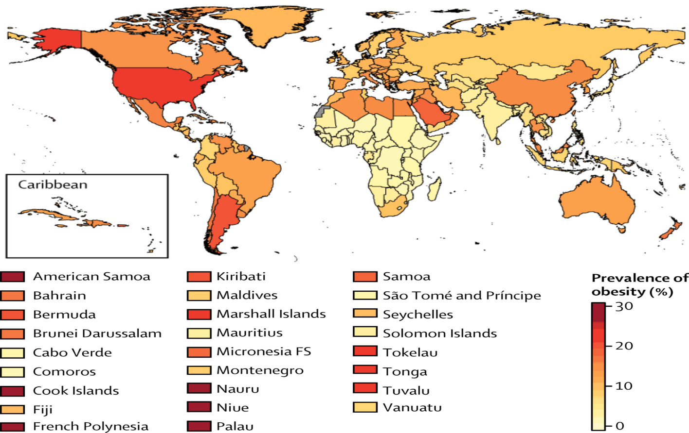

Health plays an important role in daily life. However, people are prone to ignore their health status. People are stuck in their businesses and they usually do not have enough time to work out or select nutrients for their meals. Our project is a website which people are able to use at home, so they do not spend much time preparing meals. Nowadays, there are many websites and apps that focus on fitness and health but they are not really credible. Furthermore, this project guides people on how to manage their diets and nutrients that they consume every day so that customers are able to avoid obesity and have better health status.

* **Landscape**:

Due to the fact that health is one of the most considerable problems in the world. There are many websites that show people how to get good health by advising a healthy diet or some exercises such as <https://therealfoodrds.com/> and <https://www.thehealthymaven.com/>. However, those websites cannot calculate and show the users how they are with personal statistics like are they obesity or did they get enough fiber. Based on those statistics, our website can show the user what exactly they can do to have better health and avoid general information.

#### Detailed Description:

1. 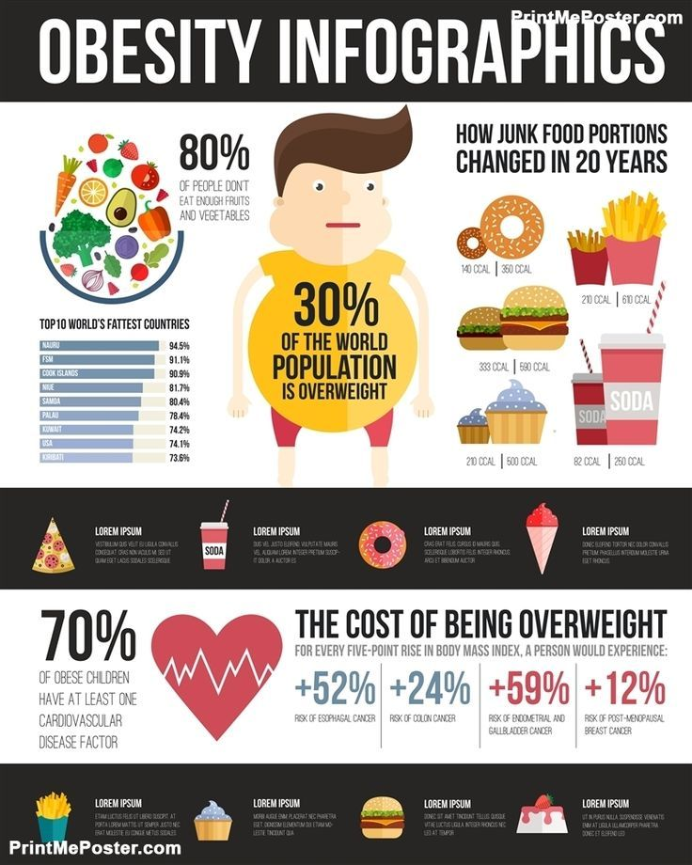**Aims:**

This project gives our teammates a chance to improve our teamwork skills such as planning, problem-solving and decision-making, and how to create a website. We expected to develop people’s awareness about fitness and health that they can improve their health as well as their family. Moreover, they can change their eating habits in order to reduce the number of people has heart diseases and obesity. The most important step is creating a website because it is a huge challenge for us. Due to the fact that our group decided to set priority for this step. We are making an effort to this project to become a unique and attractive website about fitness and health, which brings clients convenience.

After completing this project, we are going to achieve experiences of working as a team and web development. These experiences might contribute to our success in the future. Moreover, raising people’s consciousness about health and fitness is the most expected goals of my project. Also, we are able to have deeper learning about web development because this stage is the most difficult part that we have to cross over.

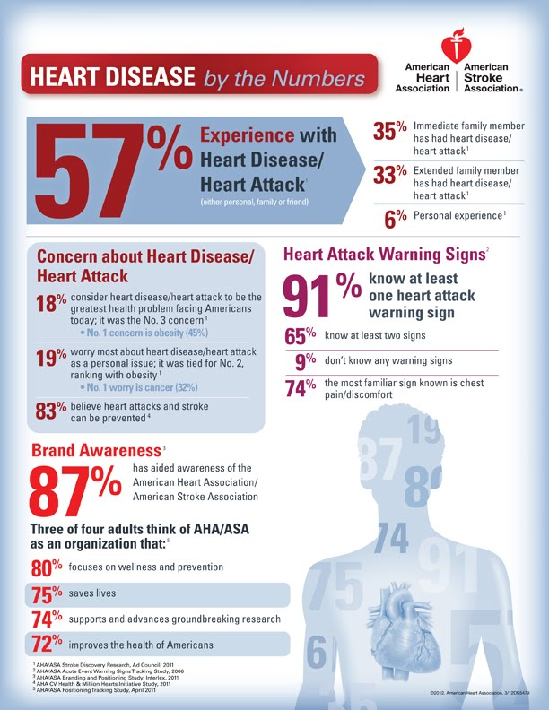

1. **Plans and Progress:**

Our project is being developed to raise people’s consciousness and support customers who want to keep fit, stay healthy and lose weight.

We have planned some features that help clients to improve their health:

Firstly, the website will ask customers to sign an account up so that we are able to record and follow their health. Also, the website will ask customers to provide their weight every day in order to help them see clearly their changes. Moreover, the website will base on the information that customers provide every day to create a meal or some dishes which are suitable for their diets.

Lastly, there are many kinds of work-out tutorials that we put in the home of the website. Customers are able to choose any kind of tutorial that they find excitement in. Furthermore, these tutorials contain not only video clips but also theory and images that clearly describe how the exercise is. Therefore, customers are easier to deeply understand the details of the exercises.

Working on this project is our huge challenge because web development is a new field that we are approaching. We have already finished the sign in and log in the step which is the hardest part that we have to come over. It took us 2 weeks to understand and complete this stage. The most confidant of the sign in and log in a stage that we can show errors to customers when they repeated the wrong password, wrong email. However, when the errors are shown up, the websites will be refreshed without clearing the right information. This stage that we think it is the hardest part of this project because it is required to have insight into the database as well as HTML. Also, the home has already been done with many tutorials for customers so that they have massive choices.

We are working on the personal weight record and meal recommendation stage that we expected to finish in a short time. Moreover, we are going to add some more features to the home. In addition, we are going to collect news about health and fitness and put them in the home. We are also adding BMI calculation in personal weight record page, customers will do the calculation then the result will be automatically saved with the day when customers do the calculation so that they are able to see how they change and how much weight as well as BMI they have reduced than the previous results. Moreover, we expected to add a button called “suffer” to the meal recommendation function, which helps customers to change the dishes that our apps provided if they do not like these.

Initially, we planned to add a charge function that seems to be a PT online for clients but we decided to remove it. Moreover, we had expected to create a platform for an administrator who manages posts and articles on this project. However, because of spending 2 weeks on finishing sign in and log in stage, it seems impossible for us to create a platform for an administrator.

* + 1. **Roles:**

From the beginning, we have already decided that each person has their own roles that suit their dominances and aptitudes. If someone does his part which is not his interest, the productivity would be decreased and it affects the whole grade for other members.

There are 4 members in the Amigo group: Duy, Huy, Tuan, and Tuong. After discussion, we decided that:

- Duy will get a role in writing the report mainly, supporting the back-end part and doing the presentation. He has good writing skills so he wants to get this role. He also tries his best to support back-end for a web designer.

- Huy will write the report, support the front-end part and do the presentation. Over 2 Assignment, we know that he could design the website well for the users, so we decided to give this role for him.

- Tuan will take part in writing the report and research all the information about health care and nutrients. This project is inspired by his Assignment 2 so he understands this project really well. Therefore, he could do it fluently.

- Tuong will create the whole website, get a full-stack website development. He used to do it so he could make it easier. Then he gets the information from Tuan and some support from Duy and Huy.

* + 1. **Scope and Limits:**

To be honest, we have a lot of good ideas for this project so we had to spend a lot of time to decide which project is the most suitable for us by making some comparison between each idea. The idea could be easy enough for us to put into practice and it has to be helpful that everyone would use this website for a purpose. Consequently, a healthy website has been chosen which can help people who consider their health can know what they should do to improve their own health. Luckily, we are really good at making a plan and working as a team. As a result, after choosing the project we can do this project quite quickly and also have enough time to relax to avoid stress because of overworking.

As the introduction in assignment 2, we will make a healthy website for people who want to know about their health and how to improve it. Therefore, our website is necessary to have the sign-up function so the users would have specific information about their health and avoid the general one which can make them confused. However, there are many people who would utilize our website so it is a good idea to use cloud computing to store all of the information. In that case, we use the google cloud that the user can utilize their google account to sign up into our website. The main function of this website is to calculate the IBM of the user and giving them advice based on that information. That advice could help them know how many time they should spend to do exercise or what should they eat to have good health. In contrast, this is just a website so the users have to check their own weight and their height quite regularly to update their information again. Fortunately, this website also has a function that people can see their previous statistics. In addition, our website also connects to some videos on YouTube that teach the users how to work-out in the right way. Furthermore, there are some PT that the users can hire them and get more information and experience to do exercise. On the other hand, from the beginning, there might be not enough PT for every user because of the popularity of the website.

* + 1. **Tools and Technologies:**

- SOFTWARE:

* Sublime Text: for coding HTML and CSS which are the foundation for coding a website. After doing assignments 1 and 2, all of the members in a group have received some basic experiences to coding HTML on this software.
* Xampp: To run the localhost on the computer. Just only Tuong knows how to use this type of software.

- HARDWARE: Windows operating system.

* + 1. ​**Testing:**

First of all, we will check each function of the website separately because we can easily fix some errors we might have before we try all of that. After that, we test it by making an admin account and try all of the features that the website has at the same time. Moreover, we also send this website to our friends who also consider their health to make sure that our website works efficiently with different statistics. This project would be successful when we are possible to make an account and the website can calculate the statistics that we entered and give us some useful advice that helps us have better health.

* + 1. **Timeframe:**

|  |  |  |
| --- | --- | --- |
| **Week** | **Plan** | **Result** |
| 8 | * Find a good idea for the project * Decide each part for members * Write the report for Assignment 2: The IT World. | * Run the project with a nice idea on Monday * Finish the Assignment 2 on Friday * No conflict or controversy. |
| 9 | * Cover some knowledge in creating a website. | * Understand commonly how front-end and back-end work. |
| 10 | * Research all the information and instruction for health care and healthy nutrients. | * Have enough material for the project. |
| 11 | * Create Github to monitor the project’s process * Assimilate web designing and health knowledge together. * Finish the report for Assignment 3: Our IT Project. | * Have a Github repository * Complete 50% of the website * Complete 70% of the report. |
| 12 | * Create the presentation slides by Microsoft Office PowerPoint * Finish the website and report as well. | * Finish the report and website. * Create some part of the presentation. |
| 13 | * Practice doing the presentation * Submit the report |  |

* + 1. **Risks:**

At the first time trying to run the website, our team got many issues because we didn’t have many experiences about finding and fixing the bugs:

+ Sometimes, there will be missing the button, videos, and images when changing the website between macOS and Windows because we run the project mainly on Windows

+ The lack of cyber-security, someone could sign in the website with the wrong password

+ The website is quite slow when switching the tab or using the function.

* + 1. **Group processes and communications:**

Each member of our group understands that communication is one of the most vital aspects that could decide the success of the project. Everyone always tries their best at reducing the conflict between each other and find the best solution for this problem, maybe meeting the lecturer or other people outside the group. In addition, we already know each other before this course so it’s easier for us to work as a team.

       Members of the Amigo group meet each other every day so we could make an appointment easily. We tend to meet face-to-face because we couldn’t follow the plan if using online society communication like Skype, Facebook or Email. We think that it’s better to encounter twice a week, after the lecture and tutorial, to communicate and discuss some features or problems about the process.

       Although we know each other very well, however, if there is somebody that against the group. We think the best solution is to be calm and listen to his or her opinion. Because everyone will have their own opinion, and it’s really hard for people to refuse someone’s effort or idea. Communication breakdown occurs when the other members don’t respect his or her opinion. We should listen and try to convince this person so that we can get the belief from each other.

### Skills and Jobs:

In terms of this project, we will separate this into each part for each member because creating a dynamic website for a huge number of users is extremely difficult to release to the market industry. We will manage this team like:

* One person will take the front-end design for the website. Designing the good-looking and affordable website for many users require a lot of research and knowledge for that area, but we think that’s enough for a member to tackle this thing. Mostly front-end skills such as HTML, CSS, and JavaScript are necessary. This member has to be patient because he or she has to listen and assess the feedback from the users carefully to make the website more appealing and attractive. Because this part is relevant to many other areas like the back-end part or taking the healthy material and knowledge for the website, he or she must run this part together with other people who take another aspect of the project.
* Another member will run the system through the back-end part. They will create a system to contain the front-end part, upgrade it regularly, and store the information from the website and the user’s accounts as well. This person needs some skills related to this area like Ruby on Rails, PHP framework, etc. This aspect has to assimilate with other areas so he or she can’t run this part lonely.
* In addition, one person will have research in the healthy aspect and some nutrient for the users. This information is quite wide and huge because we want to put many areas into this project, from providing users many courses to train and exercise, to giving many meals and nutrients for their daily routine. The skills for this part is not too difficult, research skills are needed for this one. We think this member could do it individually because it is totally independent of the others. But at the end of the process, he or she has to give the achievement for the one who takes the front-end part for designing.
* Finally, we will give the last person a mission that creates the database and the security for the website. It’s really essential for users when they really want to give their personal information for the organizers like their name, address, and even their bank account because we take some fees for the course or the V.I.P. customers. SQL is important to be learned in this aspect. We think it’s necessary to work with the person who creates the back-end system for the website.

Feedback:

- Duy:

* Huy: he always takes responsibility for working with a team, because he always finished his part really soon and well. He also put his passion into this project so I don’t have any disappointment for him.
* Tuan: although I knew that he is very hard-working and enthusiastic, however, there was always something that interrupted him from working for the project. Nonetheless, it didn’t affect too much in a negative way. He tried his best for this project perfectly so if I saw someone like that, I would have forgiven him.
* Tuong: I’m very admirable with his knowledge and aptitude because he carried all the website working for us, in both front-end and back-end parts. It worked perfectly with the attractive looking and fluently with the system behind.
* In terms of myself, I feel satisfied with my work. I always attempted to run the project fairly and punctually. I wish I could have some knowledge about website creating so that I could carry some parts for Tuong.

- Huy:

* Duy: He is very smart and enthusiastic while doing this project. He is really good at studying a new thing that makes our work become more fluency. I feel that I am really lucky to work with him.
* Tuong: In my opinion, Tuong is the best teammate in our group. He has a lot of skills and knowledge of IT because he studied this type of subject 2 years ago at another university. As a result, we are really confident to make a demo website for the presentation.
* Tuan: Tuan is really good at making jokes and boosts the teammates’ mood. He always makes us feel comfortable while working and his jokes also release a lot of stress. Although he is not good at this kind of subject as other members, he still works with the highest enthusiasm.
* I believe that I worked really hard while doing this project. I finished all of my work with the highest passion and I did it quite well. However, sometimes, I want to make everything perfectly so I make our work become more slowly.

- Tuan:

* Duy: Although he is the youngest person in our team, he is very hard-working and smart. He always tries to boost our mood as well as our enthusiasm. Moreover, he also gives me some recommendations and advice that help me to complete my work well.
* Huy: In my opinion, Huy is smart and very good at making a decision. Moreover, he usually makes some jokes that provide teammates with energy for working.
* Tuong: Tuong is not only the oldest person in our team but also has insight knowledge about HTML as well as SQL. Furthermore, he is hard-working and always completes work on time.
* As Duy mentioned above that I was usually interrupted by talking and some kinds of stuff that are not related to our work. However, I have tried to finish my work on time.

- Tuong:

* Duy: Although he is the youngest person in our group, he is a good leader. He knows the strengths and weaknesses of each member. Therefore, he gives us the right tasks which we could do best.
* Huy: He always is the person who finished his parts first in our group. I am impressed by his productivity
* Tuan: I think he has a sense of humor because he usually makes us happy during our meeting. Even though he faces a lot of difficulties, he could finish his tasks on time.
* About my work, I take responsibility for making a new website, which takes me a huge amount of time to learn about HTML, CSS, JS, and PHP. Therefore it is very hard for me to create a perfect web. I think I should spend more time to have a good preparation for this course.

Group Reflection:

**DUY:**

I took the mission of writing the report, taking the presentation and creating the slides for the presentation. From my perspective, I think I always put all effort at working on time and accurately because I understand that it’s not easy and annoying to wait for someone doing their part which they could actually do it better and faster than the present. Also, all the parts I got are my dominance so it’s easier to work in the right way without any help. About my group, I think we were successful at running the project without any hesitation and conflict. We assimilated very fluently and understanding is a key that helps us finish the project effectively.

I was surprised that we could run the project before the deadline because I thought from the beginning that it was really hard for all of us to take this idea. I learned a lot from my teammates because I didn’t have many good experiences in some parts. During the process, patience and hardworking are extremely important that I could get from them. Also, I could learn how to create a website system in the back-end part which was really difficult if I weren’t taught by someone. After all, I think we are a good team that works efficiently and I think we could get better for the next time.

**HUY:**

My perceptions in this project are writing a report, preparing for the question for our presentation. Working with Amigo, I am really surprised that we could work efficiently and fluently. We did not have many arguments between each member of a group so we worked very connected. Moreover, we did not get any stress while doing this project because we can easily combine play and work together. Besides that, doing this project, I have learned a lot of things from them, Tuong helped me know more about coding and making a good website, Duy showed me how to divide works for other members efficiently and Tuan taught me that combining play and work is really necessary and how to do it. In a nutshell, I believe that Amigo is a good team and I am really lucky to be a part of it.

**TUAN:**

My task is writing a report for the project. I have been working with Amigo for 2 months, I was very interested in my teammates’ skills and knowledge. They taught me not only soft skills but also programming skills. Our project was successfully completed on time and we are very pleased with our outcome. I had tried to punctually complete my work because I am not good at coding and creating the web. Since doing this project, I have learned HTML and SQL which is helpful for my job in the future. After this project, I will spend more time learning HTML and SQL to preparing for my future. In addition, working as a team helps me improve my team working skills. I believe that I should concentrate on my tasks because I am simply interrupted by jokes. There are some tasks that I could not solve it by myself because I do not have much experience. However, my teammates taught and pointed me out the solutions to these problems. Moreover, they usually provide some ideas that I would easily get through my tasks. From my perspective, I have learned how to create a website that I thought is the hardest part of the projects. To sum up, I think we did a good job and work efficiently, I wish I had helped my teammates more.

**TUONG:**

To be honest, we experienced different feelings during our working time. From nervousness, when we started to do this project because we do not know everything about IT before this course. Then, we had some heated arguments about choosing a topic for this project. At some time, we felt depressed and nearly wanted to give up, so we sit together to discuss this problem. As a result, we have a trip on Christmas break to chill out and avoid stress.  Finally, we come back strongly to continue doing this project. Now, we could finish our website with the effort of the whole team. We fulfill our expectations and take proud of ourselves when we have done this task because no one in our team could think that we can create a web about health. I realized that even though we have done a lot of work, there are many things which we need to improve. We spent spend a huge amount of time to have a project idea, while other teams decide quickly their project and started to do in the early period. However, after this time, everything is good now. I also learned that we should combine work and play instead of work and work to get higher productivity.

**GROUP:**

Individually, each member will have their own strengths and limits. When we are working or doing an assignment or a project, it will become a challenge if we’re not good at it. Therefore, we could know the importance of teamwork. Assembling people as a group, we could cover the limits and exploit the strengths of all members in the group. From the beginning of the process, we honestly revealed which part we could work or not. Because one mistake from a person could affect a lot for the whole team. As a result, we had to think and decide carefully for this one.

About the idea for this project, we took the concept nearly similar to the inspiration of Tuan’s project because it’s more affordable and reliable from the truth issue: health care. Although this assignment doesn’t require a whole product, we want to make this become a good website that has almost all the features like a real product. Because we believed that it could make our presentation more reliable, not just some pictures of the project, but we also could create a dynamic website that helps audiences more conceivable. Although we might get lots of difficulties while running this, we would get more confident and proud of ourselves because at least we could use it in the real online market which is not so much common and abstract as some other groups.

While we ran the project, we definitely got some trouble because we are the newbies which just took this course in nearly 2 months. Fortunately, the lecturers were very kind to us which always gave advice or instruction in detail. We had 6 weeks to cover all the requirements from the course, including a report, the group's website, the project’s website and a presentation. However, we only need 5 weeks to get this intention because we separated the job for each member really well, and mostly all members could use their own strengths to complete their part.

More clearly in the insight, overall all members tried their best at working and supporting, we think Duy and Tuong got more jobs than the others because Duy covered a lot of parts on the report and designed the slides for the presentation as well, Tuong had to create a whole product which has lots of features for users. Other members are really good at finishing their parts well. We could learn from each other a lot, from teamwork, leadership, and relationship, to much knowledge that we haven’t experienced before.

In conclusion, we worked in peace and seriousness and all of us feel satisfied which this assignment. If we could give a wish for us from the past, we wish we could work a little bit harder, so that we could concentrate on other courses better.