１、径向模糊效果
最先在这里看到:http://www.gamerendering.com/2008/12/20/radial-blur-filter/

这效果在鬼泣4中切换场景时见过, 极品飞车12的运动模糊也有这种感觉.

原理:

确定一个中心点(如0.5, 0.5), 跟当前像素连一条线. 以当前像素为中心, 在线上的附近像素进行采样, 最后取一下平均值.

代码翻译成HLSL:

view plaincopy to clipboardprint?
// This texture should hold the image to blur.
sampler2D Texture0;

// some const, tweak for best look
const float fSampleDist;
const float fSampleStrength;

// some sample positions
float samples[10] =
{
-0.08,
-0.05,
-0.03,
-0.02,
-0.01,
0.01,
0.02,
0.03,
0.05,
0.08
};

float4 ps_main( float2 texCoord : TEXCOORD0 ) : COLOR
{
// 0.5,0.5 is the center of the screen
// so substracting uv from it will result in
// a vector pointing to the middle of the screen
float2 dir = 0.5 - texCoord;
// calculate the distance to the center of the screen
float dist = length(dir);
// normalize the direction (reuse the distance)
dir /= dist;

// this is the original colour of this pixel
// using only this would result in a nonblurred version
float4 color = tex2D(Texture0, texCoord);

float4 sum = color;
// take 10 additional blur samples in the direction towards
// the center of the screen
for (int i = 0; i < 10; ++i)
{
sum += tex2D(Texture0, texCoord + dir * samples[i] * fSampleDist);
}

// we have taken eleven samples
sum /= 11.0;

// weighten the blur effect with the distance to the
// center of the screen ( further out is blurred more)
float t = saturate(dist * fSampleStrength);

//Blend the original color with the averaged pixels
return lerp(color, sum, t);
}
// This texture should hold the image to blur.
sampler2D Texture0;

// some const, tweak for best look
const float fSampleDist;
const float fSampleStrength;

// some sample positions
float samples[10] =
{
-0.08,
-0.05,
-0.03,
-0.02,
-0.01,
0.01,
0.02,
0.03,
0.05,
0.08
};

float4 ps_main( float2 texCoord : TEXCOORD0 ) : COLOR
{
// 0.5,0.5 is the center of the screen
// so substracting uv from it will result in
// a vector pointing to the middle of the screen
float2 dir = 0.5 - texCoord;
// calculate the distance to the center of the screen
float dist = length(dir);
// normalize the direction (reuse the distance)
dir /= dist;

// this is the original colour of this pixel
// using only this would result in a nonblurred version
float4 color = tex2D(Texture0, texCoord);

float4 sum = color;
// take 10 additional blur samples in the direction towards
// the center of the screen
for (int i = 0; i < 10; ++i)
{
sum += tex2D(Texture0, texCoord + dir * samples[i] * fSampleDist);
}

// we have taken eleven samples
sum /= 11.0;

// weighten the blur effect with the distance to the
// center of the screen ( further out is blurred more)
float t = saturate(dist * fSampleStrength);

//Blend the original color with the averaged pixels
return lerp(color, sum, t);
}

两个参数, 动态调整的话可以产生极品飞车12那种速度感(也算是第一人称运动模糊的简单实现吧).

这是RM里的效果:
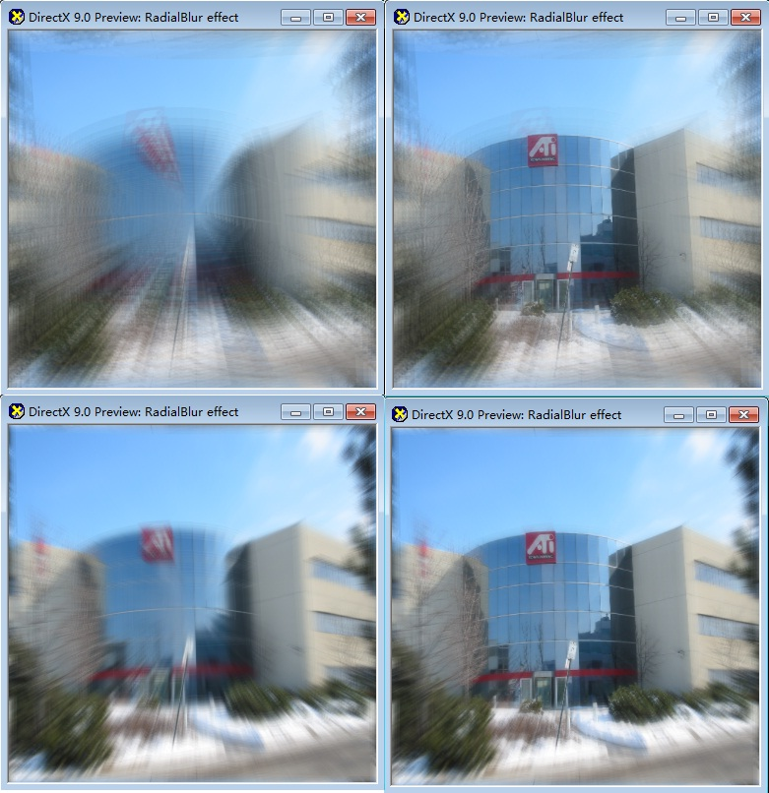
本文来自CSDN博客，转载请标明出处：http://blog.csdn.net/xoyojank/archive/2010/01/06/5146297.aspx

