多主一从方案

业务背景：
公司在多地部署多台MySql，多租户的数据需要统一同步到一个实例，以便于备份，分析等操作。

实现方案：
MySql5.7多源同步（多主一从策略）。
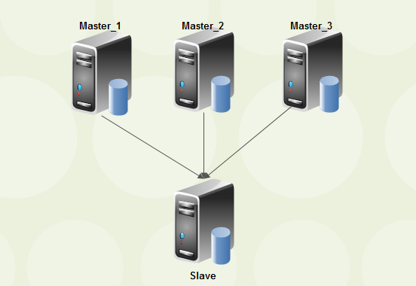

硬件环境：
Windows10/MySql5.7

方案细节：

1,下载安装配置数据库。
下载安装mysql5.7免安装版，复制三份，分别叫做Master1，Master2，Slave1，简称M1,M2,S1.
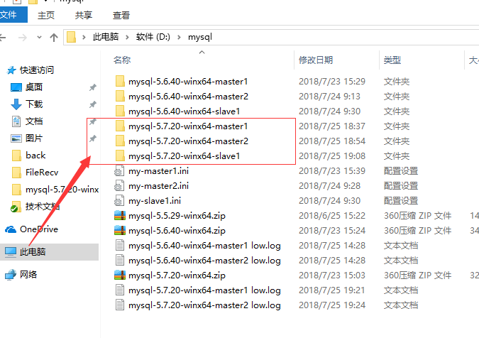

2,配置MySql配置文件
##############################################################start
M1与M2配置几乎相同,serverId,data,base,log不相同。

###########################我是分割线###################################
M1配置：

# The following options will be passed to all MySQL clients
[client]
#password = your_password
port = 13307
[mysql]
#设置mysql客户端的字符集
default-character-set = utf8
# The MySQL server
[mysqld]
port = 13307
#设置mysql的安装目录
basedir = D:\mysql\mysql-5.7.20-winx64-master1
#设置mysql数据库的数据存放目录,必须是data或者\xxx-data
datadir = D:\mysql\mysql-5.7.20-winx64-master1\data

server-id =1
user=mysql
log-bin=master-mysql-bin
character-set-server = utf8mb4
default-storage-engine = InnoDB
log-bin=mysql-bin
binlog_format=row
log_slave_updates=1
gtid_mode=ON
enforce_gtid_consistency=ON
auto_increment_increment = 2
query-cache-size = 0
external-locking = FALSE
max_allowed_packet = 32M
sort_buffer_size = 2M
join_buffer_size = 2M
thread_cache_size = 51
query_cache_size = 32M
tmp_table_size = 96M
query_cache_type=1
log-error=D:\mysql\mysql-5.7.20-winx64-master1\mysqld.log
slow_query_log = 1
slow_query_log_file = D:\mysql\mysql-5.7.20-winx64-master1\slow.log
long_query_time = 0.1
expire-logs-days = 14
sync_binlog = 1
binlog_cache_size = 4M
max_binlog_cache_size = 8M
max_binlog_size = 1024M
log_slave_updates
binlog_format = MIXED
#这里使用的混合模式复制
relay_log_recovery = 1
#不需要同步的表
replicate-wild-ignore-table=mydb.sp_counter
#不需要同步的库
replicate-ignore-db = mysql,information_schema,performance_schema
key_buffer_size = 32M
read_buffer_size = 1M
read_rnd_buffer_size = 16M
bulk_insert_buffer_size = 64M
myisam_sort_buffer_size = 128M
myisam_max_sort_file_size = 10G
myisam_repair_threads = 1
transaction_isolation = REPEATABLE-READ
#innodb_additional_mem_pool_size = 16M
innodb_buffer_pool_size = 1024M
innodb_buffer_pool_load_at_startup = 1
innodb_buffer_pool_dump_at_shutdown = 1
#innodb_data_file_path = ibdata1:1024M:autoextend
innodb_flush_log_at_trx_commit = 2
innodb_log_buffer_size = 32M
innodb_log_file_size = 2G
innodb_log_files_in_group = 2
innodb_io_capacity = 4000
innodb_io_capacity_max = 8000
innodb_max_dirty_pages_pct = 50
# innodb_flush_method = O_DIRECT
innodb_file_format = Barracuda
innodb_file_format_max = Barracuda
innodb_lock_wait_timeout = 10
innodb_rollback_on_timeout = 1
innodb_print_all_deadlocks = 1
innodb_file_per_table = 1
innodb_locks_unsafe_for_binlog = 0
symbolic-links=0

###########################我是分割线###################################

M2配置：

# The following options will be passed to all MySQL clients
[client]
#password = your_password
port = 13308
[mysql]
#设置mysql客户端的字符集
default-character-set = utf8
# The MySQL server
[mysqld]
port = 13308
#设置mysql的安装目录
basedir = D:\mysql\mysql-5.7.20-winx64-master2
#设置mysql数据库的数据存放目录,必须是data或者\xxx-data
datadir = D:\mysql\mysql-5.7.20-winx64-master2\data

server-id =1
user=mysql
log-bin=master-mysql-bin
character-set-server = utf8mb4
default-storage-engine = InnoDB
log-bin=mysql-bin
binlog_format=row
log_slave_updates=1
gtid_mode=ON
enforce_gtid_consistency=ON
auto_increment_increment = 2
query-cache-size = 0
external-locking = FALSE
max_allowed_packet = 32M
sort_buffer_size = 2M
join_buffer_size = 2M
thread_cache_size = 51
query_cache_size = 32M
tmp_table_size = 96M
query_cache_type=1
log-error=D:\mysql\mysql-5.7.20-winx64-master2\mysqld.log
slow_query_log = 1
slow_query_log_file = D:\mysql\mysql-5.7.20-winx64-master2\slow.log
long_query_time = 0.1
expire-logs-days = 14
sync_binlog = 1
binlog_cache_size = 4M
max_binlog_cache_size = 8M
max_binlog_size = 1024M
log_slave_updates
binlog_format = MIXED
#这里使用的混合模式复制
relay_log_recovery = 1
#不需要同步的表
replicate-wild-ignore-table=mydb.sp_counter
#不需要同步的库
replicate-ignore-db = mysql,information_schema,performance_schema
key_buffer_size = 32M
read_buffer_size = 1M
read_rnd_buffer_size = 16M
bulk_insert_buffer_size = 64M
myisam_sort_buffer_size = 128M
myisam_max_sort_file_size = 10G
myisam_repair_threads = 1
transaction_isolation = REPEATABLE-READ
#innodb_additional_mem_pool_size = 16M
innodb_buffer_pool_size = 1024M
innodb_buffer_pool_load_at_startup = 1
innodb_buffer_pool_dump_at_shutdown = 1
#innodb_data_file_path = ibdata1:1024M:autoextend
innodb_flush_log_at_trx_commit = 2
innodb_log_buffer_size = 32M
innodb_log_file_size = 2G
innodb_log_files_in_group = 2
innodb_io_capacity = 4000
innodb_io_capacity_max = 8000
innodb_max_dirty_pages_pct = 50
# innodb_flush_method = O_DIRECT
innodb_file_format = Barracuda
innodb_file_format_max = Barracuda
innodb_lock_wait_timeout = 10
innodb_rollback_on_timeout = 1
innodb_print_all_deadlocks = 1
innodb_file_per_table = 1
innodb_locks_unsafe_for_binlog = 0
# Disabling symbolic-links is recommended to prevent assorted security risks
symbolic-links=0

###########################我是分割线###################################

S1配置：

# The following options will be passed to all MySQL clients
[client]
#password = your_password
port = 13309
[mysql]
#设置mysql客户端的字符集
default-character-set = utf8
# The MySQL server
[mysqld]
port = 13309
#设置mysql的安装目录
basedir = D:\mysql\mysql-5.7.20-winx64-slave1
#设置mysql数据库的数据存放目录,必须是data或者\xxx-data
datadir = D:\mysql\mysql-5.7.20-winx64-slave1\data
#设置服务器段的字符集
character_set_server = utf8

slave-skip-errors=1062,1053,1146,1213,1264,1205,1396
#跳过指定error no类型的错误
#slave-skip-errors=all #跳过所有错误

log-bin=mysql-bin
server-id=3
#skip-grant-tables

sql_mode=NO_ENGINE_SUBSTITUTION,STRICT_TRANS_TABLES
#mysql5.7多源复制必须添加的参数(不加报错)，5.7版本之前不用加
master_info_repository=TABLE
relay_log_info_repository=TABLE
binlog_format=row
log_slave_updates=1
#GTID模式(使用GTID就可以不用记录备份位置点)
gtid_mode=ON
enforce_gtid_consistency=ON
auto_increment_increment = 2

#不复制的库
replicate-ignore-db = mysql
replicate-ignore-db = information_schema
replicate-ignore-db = performance_schema
replicate-ignore-db = sys

########################################################################END

3,初始化MySql数据库，配置账号密码，加入服务，启动数据库，校验server_id

M1:
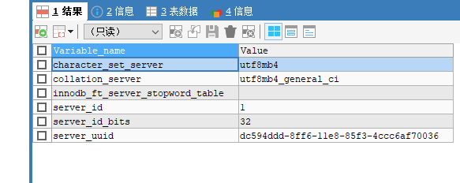

M2:
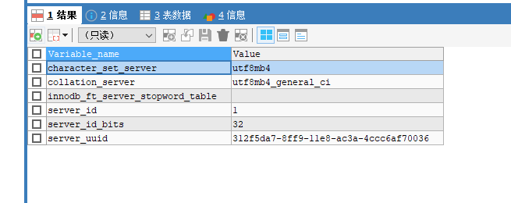

M3:
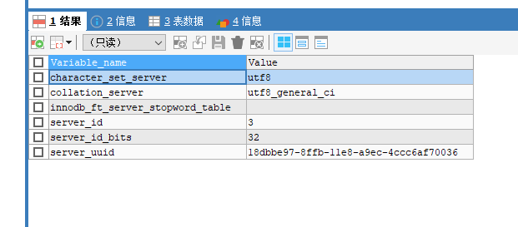

4,分别在三个库创建测试库测试表，同时重置当前库的binlog。

Create database testdb;
USE testdb;
CREATE TABLE aa(
tid INT
);

RESET MASTER;

5,在M1,M2建立同步数据用户。
该案例并没有建立，只是拿root账号做同步。
在S1下建立同步信息与管道信息。
分别从M1,M2同步，管道名为：'slave1', 'slave2'

CHANGE MASTER TO MASTER_HOST='127.0.0.1',MASTER_USER='root',MASTER_PASSWORD='123456',MASTER_PORT=13307,master_auto_position=1 FOR channel 'slave1';

CHANGE MASTER TO MASTER_HOST='127.0.0.1',MASTER_USER='root',MASTER_PASSWORD='123456',MASTER_PORT=13308,master_auto_position=1 FOR channel 'slave2';

开启所有同步：
START SLAVE;
STOP SLAVE;

开启单个同步：
START SLAVE FOR channel 'slave2';
STOP SLAVE FOR channel 'slave2';

查看S1的同步信息，Slave_IO_State为Waiting for master to send event则表示成功通信：

SHOW SLAVE STATUS;

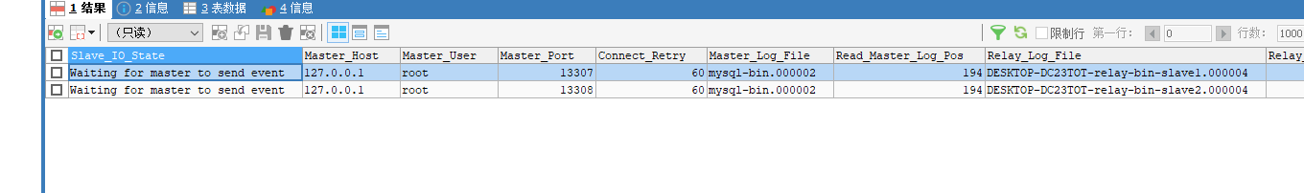

6,插入测试数据。
在M1数据库执行 ：INSERT INTO aa VALUES(1);
在M2数据库执行 ：INSERT INTO aa VALUES(2);

在S1上校验数据：
