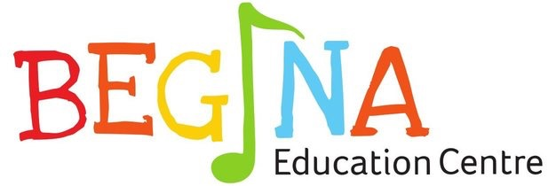**Item**

(02) 8056 2939

info@begina.com.au

Shop 2/17-25 Kerrs Rd, Lidcombe

NSW 2141

ORDER FORM

|  |  |  |  |
| --- | --- | --- | --- |
| Items | Unit Price* | Quantity | Total Price* |
| mBot Blue | $150.00 |  |  |
| mBot Pink | $150.00 |  |  |
| Codeybot | $270.00 |  |  |
| Codeybot Turret | $50.00 |  |  |
| **Total** |  |  |  |

*Includes GST

**Please make a direct payment by EFT to:**

Account Name: Begina Education Pty Ltd

Commonwealth Bank BSB: 062 221

Account Number: 1031 4776