Supporting information
The association between screen time and cognitive function in children: The partially mediating role of putamen volume

Table S1 The association between screen time on each digital device and each domain of cognitive function
device | cognitive function | beta | 95%CI low | 95%CI upper | t val. | d.f. | p | r2 | FDR p
video game | executive function | -0.027 | -0.048 | -0.006 | -2.523 | 9868.574 | 0.012 | 0.057 | 0.291
video game | episodic memory | -0.034 | -0.055 | -0.013 | -3.186 | 9812.946 | 0.001 | 0.066 | 0.018
video game | language | -0.015 | -0.034 | 0.004 | -1.554 | 9730.272 | 0.120 | 0.220 | 1
video game | processing speed | -0.001 | -0.022 | 0.021 | -0.065 | 9933.317 | 0.948 | 0.035 | 1
video game | working memory | -0.041 | -0.062 | -0.021 | -3.920 | 9837.553 | <0.001 | 0.117 | 0.000
texting | executive function | -0.025 | -0.045 | -0.004 | -2.385 | 9955.263 | 0.017 | 0.057 | 0.071
texting | episodic memory | -0.057 | -0.077 | -0.037 | -5.466 | 9954.056 | <0.001 | 0.068 | <0.001
texting | language | -0.056 | -0.075 | -0.038 | -6.068 | 9823.132 | 0.000 | 0.223 | <0.001
texting | processing speed | -0.024 | -0.045 | -0.003 | -2.274 | 9949.972 | 0.023 | 0.036 | 0.064
texting | working memory | -0.044 | -0.064 | -0.024 | -4.308 | 9938.337 | <0.001 | 0.117 | <0.001
televsion | executive function | -0.044 | -0.064 | -0.024 | -4.328 | 9946.479 | <0.001 | 0.058 | <0.001
televsion | episodic memory | -0.024 | -0.044 | -0.005 | -2.405 | 9924.318 | 0.016 | 0.065 | 0.034
televsion | language | -0.067 | -0.084 | -0.049 | -7.391 | 9609.475 | <0.001 | 0.225 | <0.001
televsion | processing speed | -0.036 | -0.056 | -0.016 | -3.531 | 9953.640 | <0.001 | 0.037 | 0.001
televsion | working memory | -0.039 | -0.059 | -0.020 | -3.990 | 9909.414 | <0.001 | 0.117 | <0.001
video chat | executive function | -0.052 | -0.073 | -0.032 | -5.053 | 9893.460 | <0.001 | 0.059 | <0.001
video chat | episodic memory | -0.069 | -0.089 | -0.048 | -6.628 | 9789.545 | <0.001 | 0.069 | <0.001
video chat | language | -0.071 | -0.089 | -0.053 | -7.681 | 9742.772 | <0.001 | 0.225 | <0.001
video chat | processing speed | -0.041 | -0.062 | -0.021 | -3.939 | 9944.146 | <0.001 | 0.037 | <0.001
video chat | working memory | -0.069 | -0.089 | -0.049 | -6.864 | 9799.444 | <0.001 | 0.120 | <0.001
videos | executive function | -0.020 | -0.041 | 0.000 | -1.939 | 9818.793 | 0.053 | 0.056 | 0.063
videos | episodic memory | -0.040 | -0.061 | -0.019 | -3.818 | 9714.346 | <0.001 | 0.066 | <0.001
videos | language | -0.039 | -0.057 | -0.020 | -4.086 | 9843.659 | <0.001 | 0.222 | <0.001
videos | processing speed | -0.037 | -0.058 | -0.016 | -3.507 | 9886.811 | <0.001 | 0.037 | <0.001
videos | working memory | -0.051 | -0.071 | -0.031 | -4.958 | 9744.782 | <0.001 | 0.118 | <0.001

CI, confidence interval
FDR, false discovery rate
We applied FDR correction for all p-values in the table.

Figure S1 The association between screen time each digital device and each domain of cognitive function
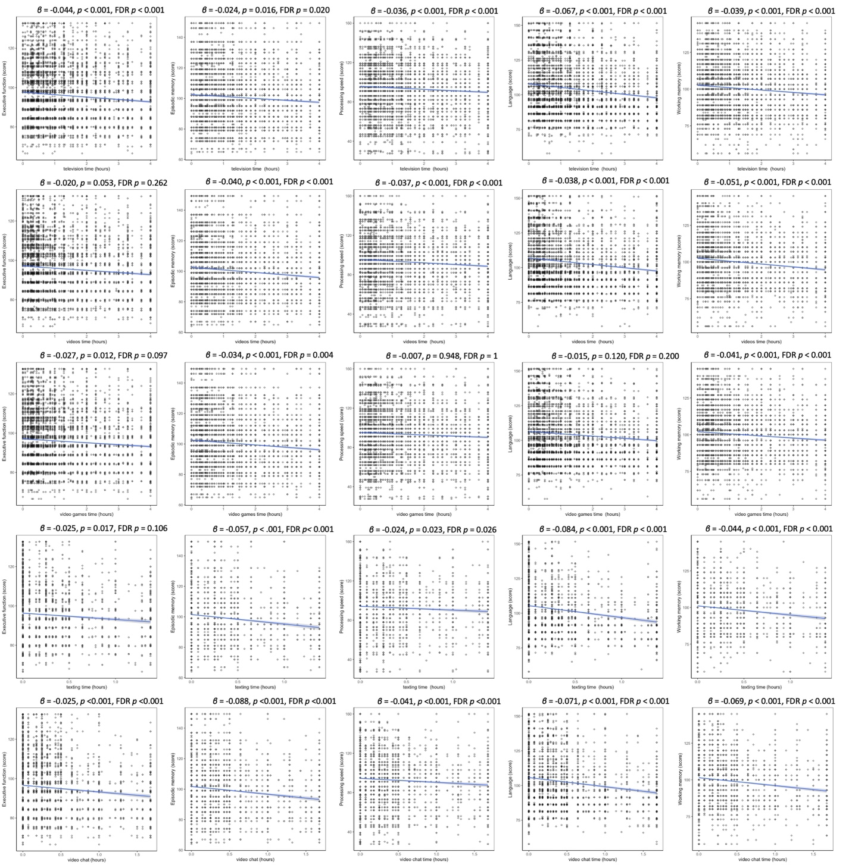

FDR, false discovery rate

Table S2 The correlations among each domain of cognitive function
 | executive function | episodic memory | language | processing speed | working memory
executive function | - | 0.248*** | 0.296*** | 0.451*** | 0.297***
episodic memory | 0.248*** | - | 0.257*** | 0.180*** | 0.332***
language | 0.296*** | 0.257*** | - | 0.181*** | 0.433***
processing speed | 0.451*** | 0.180*** | 0.181*** | - | 0.186***
working memory | 0.297*** | 0.332*** | 0.433*** | 0.186*** | -

***: p<0.001

