Supplemental Figure 1. Directed Acyclic Graph depicting the hypothesized interrelationships between variables examined in the current study.

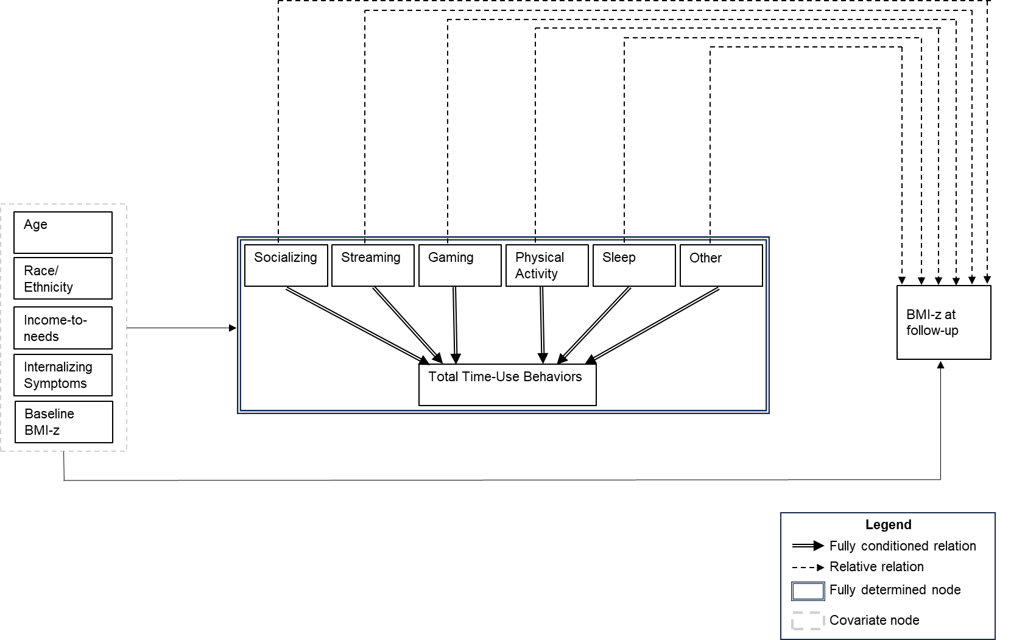

Supplemental Table 1. Compositional model estimates of the association (β[95% CI]) between baseline behavioral composition and follow-up BMI z-score by sex without 30-second assignments for PA (N=4,590).
 |  | Females (n=2,233) | Males (n=2,357)
 | Socializing | -0.01 (-0.02, 0.02) | 0.06 (0.02, 0.09)
 | Streaming | 0.01 (-0.02, 0.05) | 0.01 (-0.03, 0.05)
 | Gaming | 0.01 (-0.02, 0.05) | 0.01 (-0.01, 0.04)
 | Physical Activity | -0.04 (-0.08, 0.01) | 0.002 (-0.04, 0.04)
 | Sleep | 0.01 (-0.10, 0.12) | -0.13 (-0.23, -0.03)
 | Other Activities | 0.01 (-0.07, 0.09) | 0.04 (-0.02, 0.10)

Note. Models were adjusted for participant age, race/ethnicity, socioeconomic status, internalizing symptoms, and BMI z-score at baseline. We report the isometric logarithmic ratio (ILR) 1 of each behavior rotation (12 total models). The analytic sample does not contain participants with 0 minutes per day of physical activity, socializing, streaming, or gaming. Bolded estimates are statistically significant as indicated by a confidence interval that does not overlap with 0.

