NCVS Analyses and Tables (Unweighted)

Index:

Social Crimes (Co-offending + Observed
- All Available data
- Violent Crime data
- Theft and Burglary data
Co-offending vs. alone + observed
- All Available data
- Violent Crime data
- Theft and Burglary data

- Social Crimes

All available data

Pre-Analysis Validity Checks
- Proportion of Co-Offenses Involving an Age Gap Between Offenders
Counts and percentage of co-offenses where the youngest and oldest offenders differ by at least one age group. This helps assess whether assigning offenses to both groups might overlook intermediate age categories.

Gap Size | Frequency
2 groups apart | 171
3 groups apart | 88
4 groups apart | 41
5 groups apart | 24
Total with Age Gap | 324
Proportion of Total | 0.11

- Percentages of co-offense age partners for each offender age group.
Offender Age | Co-Offender Age Group (%)
 | <12 | 12-14 | 15-17 | 18-20 | 21-29 | 30+
<12 | 48 | 26.3 | 6.7 | 2.2 | 3.4 | 13.4
12-14 | 9.6 | 59.3 | 17 | 4.3 | 2.7 | 7.2
15-17 | 1.6 | 11.3 | 54.9 | 15 | 7.4 | 9.7
18-20 | 0.5 | 2.8 | 14.5 | 48.3 | 22.8 | 11.1
21-29 | 0.4 | 0.8 | 3.2 | 10.3 | 62.6 | 22.7
30+ | 1.2 | 1.7 | 3.4 | 4 | 18.3 | 71.5

Descriptive Crime Role Distributions by Age Group:

Age Group | Alone | Group | Observed | Total
<12 | 261 | 139 | 91 | 491
12-14 | 515 | 347 | 367 | 1,229
15-17 | 620 | 551 | 379 | 1,550
18-20 | 794 | 597 | 328 | 1,719
21-29 | 3,329 | 1,226 | 1,328 | 5,883
30+ | 7,413 | 1,338 | 2,781 | 11,532
Total | 12,932 | 4,198 | 5,274 | 22,404
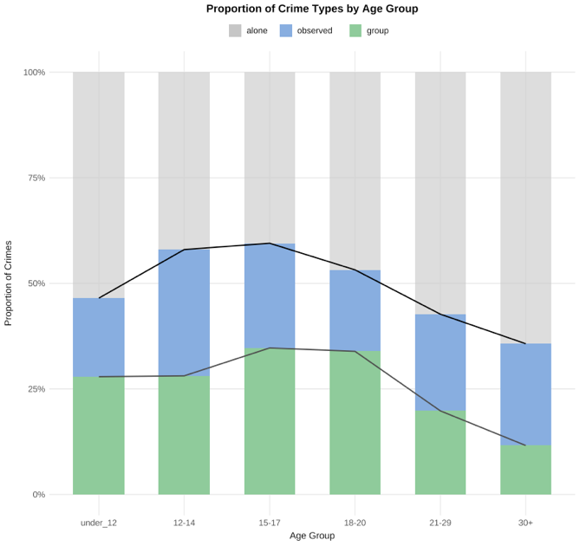

- Attributing co-offenses to youngest and oldest present.
Age Group | Alone (%) | Group (%) | Observed (%)
<12 | 53.2 | 28.3 | 18.5
12-14 | 41.9 | 28.2 | 29.9
15-17 | 40 | 35.5 | 24.5
18-20 | 46.2 | 34.7 | 19.1
21-29 | 56.6 | 20.8 | 22.6
30+ | 64.3 | 11.6 | 24.1

Analyses of difference in proportion of crimes committed alone between age groups

- Chi Squared of solo crime committed in each age group
Note - A chi-squared test measures whether there's a significant difference between expected and observed frequencies in categorical data — in this case, whether age groups differ in how often they commit crimes alone. I had R produce these tables ascending P value size (the significance of the difference between groups gets smaller as you go down the table) so that we can quickly visualize the largest differences.

- Attributing co-offenses to youngest and oldest present.

Age Group 1 | Age Group 2 | Chi-Square (χ²) | df | Phi | p | p (Bonferroni)
ALL | vs. all | 600.263 | 5 |  | 0.0000
<12 | 12-14 | 18.097 | 1 | 0.103 | 0.0000 | 0.0000
<12 | 15-17 | 24.743 | 1 | 0.111 | 0.0000 | 0.0000
<12 | 30+ | 23.185 | 1 | 0.044 | 0.0000 | 0.0000
12-14 | 21-29 | 95.382 | 1 | 0.116 | 0.0000 | 0.0000
12-14 | 30+ | 232.788 | 1 | 0.135 | 0.0000 | 0.0000
15-17 | 21-29 | 137.073 | 1 | 0.137 | 0.0000 | 0.0000
15-17 | 30+ | 321.035 | 1 | 0.157 | 0.0000 | 0.0000
18-20 | 21-29 | 58.604 | 1 | 0.088 | 0.0000 | 0.0000
18-20 | 30+ | 191.482 | 1 | 0.120 | 0.0000 | 0.0000
21-29 | 30+ | 78.724 | 1 | 0.067 | 0.0000 | 0.0000
15-17 | 18-20 | 12.577 | 1 | 0.062 | 0.0004 | 0.0060
<12 | 18-20 | 6.538 | 1 | 0.055 | 0.0106 | 0.1590
12-14 | 18-20 | 6.390 | 1 | 0.047 | 0.0115 | 0.1725
<12 | 21-29 | 2.573 | 1 | 0.020 | 0.1087 | 1.0000
12-14 | 15-17 | 0.559 | 1 | 0.014 | 0.4548 | 1.0000

Logistic Regression Analyses Predicting Likelihood of Solo Offending by Age Group

- Logistic Regression Predicting Solo Offending, Reference Group: Ages 15–17

- Attributing co-offenses to youngest and oldest present.

Age Group | Odds Ratio | Std. Error | z | p | CI Lower | CI Upper
Intercept (15–17) | 0.68 | 0.05 | -7.37 | 0.0000 | 0.61 | 0.75
<12 | 1.69 | 0.10 | 5.00 | 0.0000 | 1.38 | 2.07
12-14 | 1.06 | 0.08 | 0.79 | 0.4316 | 0.91 | 1.24
18-20 | 1.29 | 0.07 | 3.58 | 0.0003 | 1.12 | 1.48
21-29 | 1.97 | 0.06 | 11.62 | 0.0000 | 1.76 | 2.21
30+ | 2.64 | 0.06 | 17.48 | 0.0000 | 2.37 | 2.95

- Logistic Regression Predicting Solo Offending, Reference Group: Ages 18–20

- Attributing co-offenses to youngest and oldest present.

Age Group | Odds Ratio | Std. Error | z | p | CI Lower | CI Upper
Intercept (18–20) | 0.88 | 0.05 | -2.64 | 0.0082 | 0.80 | 0.97
<12 | 1.31 | 0.10 | 2.60 | 0.0092 | 1.07 | 1.60
12-14 | 0.82 | 0.08 | -2.56 | 0.0103 | 0.71 | 0.96
15-17 | 0.77 | 0.07 | -3.58 | 0.0003 | 0.67 | 0.89
21-29 | 1.53 | 0.06 | 7.66 | 0.0000 | 1.37 | 1.70
30+ | 2.05 | 0.05 | 13.67 | 0.0000 | 1.85 | 2.27

Violent crime data

Pre-Analysis Validity Checks
- Proportion of Co-Offenses Involving an Age Gap Between Offenders
Counts and percentage of co-offenses where the youngest and oldest offenders differ by at least one age group. This helps assess whether assigning offenses to both groups might overlook intermediate age categories.

Gap Size | Frequency
2 groups apart | 73
3 groups apart | 52
4 groups apart | 25
5 groups apart | 9
Total with Age Gap | 159
Proportion of Total | 0.13

- Percentages of co-offense age partners for each offender age group.

Offender Age | Co-Offender Age Group (%)
 | <12 | 12-14 | 15-17 | 18-20 | 21-29 | 30+
<12 | 43.1 | 35.4 | 3.1 | 0 | 4.6 | 13.8
12-14 | 8.6 | 65.9 | 13.5 | 1.5 | 2.2 | 8.2
15-17 | 0.7 | 13.3 | 46.5 | 11.8 | 10.7 | 17
18-20 | 0 | 1.5 | 12 | 47.4 | 24.8 | 14.3
21-29 | 0.4 | 0.9 | 4.3 | 9.8 | 60.1 | 24.4
30+ | 1.1 | 2.7 | 5.6 | 4.6 | 19.9 | 66.2

Descriptive Crime Role Distributions by Age Group:

- Counts of Crime Type by Age Group
- Attributing co-offenses to youngest and oldest present.
Age Group | Alone | Group | Observed | Total
<12 | 148 | 51 | 55 | 254
12-14 | 321 | 179 | 235 | 735
15-17 | 282 | 208 | 190 | 680
18-20 | 359 | 203 | 156 | 718
21-29 | 1,631 | 470 | 659 | 2,760
30+ | 4,056 | 552 | 1,601 | 6,209
Total | 6,797 | 1,663 | 2,896 | 11,356

- Percentages of Crime Type by Age Group

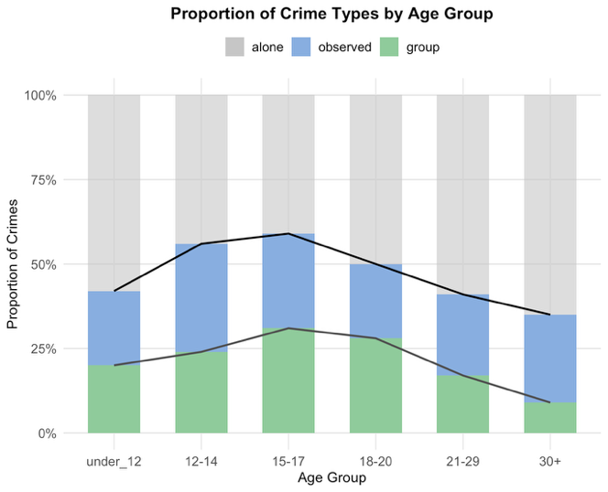
- Attributing co-offenses to youngest and oldest present.
Age Group | Alone (%) | Group (%) | Observed (%)
<12 | 58.3 | 20.1 | 21.7
12-14 | 43.7 | 24.4 | 32
15-17 | 41.5 | 30.6 | 27.9
18-20 | 50 | 28.3 | 21.7
21-29 | 59.1 | 17 | 23.9
30+ | 65.3 | 8.9 | 25.8

Analyses of difference in proportion of crimes committed alone between age groups
- Chi Squared of solo crime committed in each age group
Note - A chi-squared test measures whether there's a significant difference between expected and observed frequencies in categorical data — in this case, whether age groups differ in how often they commit crimes alone. I had R produce these tables ascending P value size (the significance of the difference between groups gets smaller as you go down the table) so that we can quickly visualize the largest differences.
- Attributing co-offenses to youngest and oldest present.
Age Group 1 | Age Group 2 | Chi-Square (χ²) | df | Phi | p | p (Bonferroni)
ALL | vs. all | 282.992 | 5 |  | 0.0000
<12 | 15-17 | 20.331 | 1 | 0.148 | 0.0000 | 0.0000
12-14 | 21-29 | 55.353 | 1 | 0.126 | 0.0000 | 0.0000
12-14 | 30+ | 131.286 | 1 | 0.138 | 0.0000 | 0.0000
15-17 | 21-29 | 67.933 | 1 | 0.141 | 0.0000 | 0.0000
15-17 | 30+ | 148.536 | 1 | 0.147 | 0.0000 | 0.0000
18-20 | 21-29 | 18.881 | 1 | 0.074 | 0.0000 | 0.0000
18-20 | 30+ | 64.729 | 1 | 0.097 | 0.0000 | 0.0000
21-29 | 30+ | 31.697 | 1 | 0.059 | 0.0000 | 0.0000
<12 | 12-14 | 15.545 | 1 | 0.125 | 0.0001 | 0.0015
15-17 | 18-20 | 9.893 | 1 | 0.084 | 0.0017 | 0.0255
12-14 | 18-20 | 5.587 | 1 | 0.062 | 0.0181 | 0.2715
<12 | 30+ | 5.039 | 1 | 0.028 | 0.0248 | 0.3720
<12 | 18-20 | 4.814 | 1 | 0.070 | 0.0282 | 0.4230
12-14 | 15-17 | 0.614 | 1 | 0.021 | 0.4334 | 1.0000
<12 | 21-29 | 0.036 | 1 | 0.003 | 0.8496 | 1.0000

Logistic Regression Analyses Predicting Likelihood of Solo Offending by Age Group
- Logistic Regression Predicting Solo Offending, Reference Group: Ages 15–17
- Attributing co-offenses to youngest and oldest present.

Age Group | Odds Ratio | Std. Error | z | p | CI Lower | CI Upper
Intercept (15–17) | 0.71 | 0.08 | -4.43 | 0.0000 | 0.61 | 0.82
<12 | 1.97 | 0.15 | 4.55 | 0.0000 | 1.47 | 2.64
12-14 | 1.09 | 0.11 | 0.84 | 0.4025 | 0.89 | 1.35
18-20 | 1.41 | 0.11 | 3.19 | 0.0014 | 1.14 | 1.74
21-29 | 2.04 | 0.09 | 8.19 | 0.0000 | 1.72 | 2.42
30+ | 2.66 | 0.08 | 11.89 | 0.0000 | 2.26 | 3.13

- Logistic Regression Predicting Solo Offending, Reference Group: Ages 18–20
- Attributing co-offenses to youngest and oldest present.

Age Group | Odds Ratio | Std. Error | z | p | CI Lower | CI Upper
Intercept (18–20) | 1.00 | 0.07 | 0.00 | 1.0000 | 0.86 | 1.16
<12 | 1.40 | 0.15 | 2.26 | 0.0237 | 1.05 | 1.87
12-14 | 0.78 | 0.11 | -2.41 | 0.0157 | 0.63 | 0.95
15-17 | 0.71 | 0.11 | -3.19 | 0.0014 | 0.57 | 0.88
21-29 | 1.44 | 0.08 | 4.37 | 0.0000 | 1.23 | 1.70
30+ | 1.88 | 0.08 | 7.99 | 0.0000 | 1.61 | 2.20

Theft & Burglary data

Pre-Analysis Validity Checks
- Proportion of Co-Offenses Involving an Age Gap Between Offenders
Counts and percentage of co-offenses where the youngest and oldest offenders differ by at least one age group. This helps assess whether assigning offenses to both groups might overlook intermediate age categories.

Gap Size | Frequency
2 groups apart | 59
3 groups apart | 22
4 groups apart | 9
5 groups apart | 8
Total with Age Gap | 98
Proportion of Total | 0.08

- Percentages of co-offense age partners for each offender age group.

Offender Age | Co-Offender Age Group (%)
 | <12 | 12-14 | 15-17 | 18-20 | 21-29 | 30+
<12 | 59.6 | 20.2 | 7.4 | 1.1 | 3.2 | 8.5
12-14 | 11.7 | 52.8 | 20.2 | 9.2 | 2.5 | 3.7
15-17 | 2.2 | 10.5 | 58.4 | 19.4 | 4.1 | 5.4
18-20 | 0.2 | 3.7 | 15.2 | 53.9 | 20.9 | 6
21-29 | 0.4 | 0.5 | 1.6 | 10.3 | 69.7 | 17.6
30+ | 1.1 | 0.8 | 2.2 | 3.2 | 18.9 | 73.9

Descriptive Crime Role Distributions by Age Group:

- Counts of Crime Type by Age Group

- Attributing co-offenses to youngest and oldest present.
Age Group | Alone | Group | Observed | Total
<12 | 81 | 66 | 27 | 174
12-14 | 113 | 120 | 85 | 318
15-17 | 195 | 223 | 120 | 538
18-20 | 291 | 293 | 128 | 712
21-29 | 1,079 | 533 | 465 | 2,077
30+ | 1,727 | 480 | 639 | 2,846
Total | 3,486 | 1,715 | 1,464 | 6,665

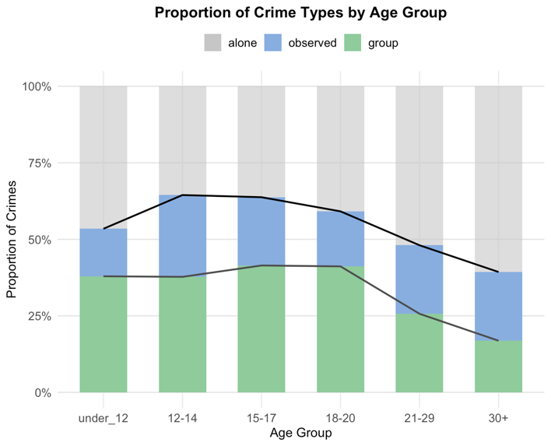
- Attributing co-offenses to youngest and oldest present.
Age Group | Alone (%) | Group (%) | Observed (%)
<12 | 46.6 | 37.9 | 15.5
12-14 | 35.5 | 37.7 | 26.7
15-17 | 36.2 | 41.4 | 22.3
18-20 | 40.9 | 41.2 | 18
21-29 | 51.9 | 25.7 | 22.4
30+ | 60.7 | 16.9 | 22.5

Analyses of difference in proportion of crimes committed alone between age groups

- Chi Squared of solo crime committed in each age group
Note - A chi-squared test measures whether there's a significant difference between expected and observed frequencies in categorical data — in this case, whether age groups differ in how often they commit crimes alone. I had R produce these tables ascending P value size (the significance of the difference between groups gets smaller as you go down the table) so that we can quickly visualize the largest differences.
- Attributing co-offenses to youngest and oldest present.
Age Group 1 | Age Group 2 | Chi-Square (χ²) | df | Phi | p | p (Bonferroni)
ALL | vs. all | 211.249 | 5 |  | 0.0000
12-14 | 21-29 | 29.072 | 1 | 0.110 | 0.0000 | 0.0000
12-14 | 30+ | 73.301 | 1 | 0.152 | 0.0000 | 0.0000
15-17 | 21-29 | 41.557 | 1 | 0.126 | 0.0000 | 0.0000
15-17 | 30+ | 109.114 | 1 | 0.180 | 0.0000 | 0.0000
18-20 | 21-29 | 25.601 | 1 | 0.096 | 0.0000 | 0.0000
18-20 | 30+ | 90.246 | 1 | 0.159 | 0.0000 | 0.0000
21-29 | 30+ | 36.995 | 1 | 0.087 | 0.0000 | 0.0000
<12 | 30+ | 13.044 | 1 | 0.066 | 0.0003 | 0.0045
<12 | 15-17 | 5.457 | 1 | 0.088 | 0.0195 | 0.2925
<12 | 12-14 | 5.264 | 1 | 0.103 | 0.0218 | 0.3270
15-17 | 18-20 | 2.568 | 1 | 0.045 | 0.1091 | 1.0000
12-14 | 18-20 | 2.407 | 1 | 0.048 | 0.1208 | 1.0000
<12 | 21-29 | 1.663 | 1 | 0.027 | 0.1972 | 1.0000
<12 | 18-20 | 1.627 | 1 | 0.043 | 0.2021 | 1.0000
12-14 | 15-17 | 0.018 | 1 | 0.005 | 0.8921 | 1.0000

Logistic Regression Analyses Predicting Likelihood of Solo Offending by Age Group
- Logistic Regression Predicting Solo Offending, Reference Group: Ages 15–17

- Attributing co-offenses to youngest and oldest present.
Age Group | Odds Ratio | Std. Error | z | p | CI Lower | CI Upper
Intercept (15–17) | 0.57 | 0.09 | -6.30 | 0.0000 | 0.48 | 0.68
<12 | 1.53 | 0.18 | 2.42 | 0.0156 | 1.08 | 2.17
12-14 | 0.97 | 0.15 | -0.21 | 0.8342 | 0.73 | 1.29
18-20 | 1.22 | 0.12 | 1.66 | 0.0969 | 0.97 | 1.53
21-29 | 1.90 | 0.10 | 6.44 | 0.0000 | 1.57 | 2.32
30+ | 2.71 | 0.10 | 10.24 | 0.0000 | 2.24 | 3.29

- Logistic Regression Predicting Solo Offending, Reference Group: Ages 18–20

- Attributing co-offenses to youngest and oldest present.

Age Group | Odds Ratio | Std. Error | z | p | CI Lower | CI Upper
Intercept (18–20) | 0.69 | 0.08 | -4.84 | 0.0000 | 0.59 | 0.80
<12 | 1.26 | 0.17 | 1.36 | 0.1740 | 0.90 | 1.76
12-14 | 0.80 | 0.14 | -1.62 | 0.1054 | 0.61 | 1.05
15-17 | 0.82 | 0.12 | -1.66 | 0.0969 | 0.65 | 1.04
21-29 | 1.56 | 0.09 | 5.08 | 0.0000 | 1.32 | 1.86
30+ | 2.23 | 0.09 | 9.41 | 0.0000 | 1.89 | 2.64

- Co-offending. (this section counts observed as alone in order to see if other papers should’ve still found a difference in teens between group and solo crime EVEN IN THERE OWN FRAMEWORK when the data is treated with statistical care).

All available data

Analyses of difference in proportion of crimes committed alone between age groups

- Chi Squared of solo crime committed in each age group
Note - A chi-squared test measures whether there's a significant difference between expected and observed frequencies in categorical data — in this case, whether age groups differ in how often they commit crimes alone. I had R produce these tables ascending P value size (the significance of the difference between groups gets smaller as you go down the table) so that we can quickly visualize the largest differences.

a. Attributing co-offenses to youngest and oldest present.

Age Group 1 | Age Group 2 | Chi-Square (χ²) | df | Phi | p | p (Bonferroni)
ALL | vs. all | 1,078.893 | 5 |  | 0.0000
<12 | 30+ | 120.447 | 1 | 0.100 | 0.0000 | 0.0000
12-14 | 15-17 | 18.599 | 1 | 0.084 | 0.0000 | 0.0000
12-14 | 21-29 | 31.843 | 1 | 0.067 | 0.0000 | 0.0000
12-14 | 30+ | 266.615 | 1 | 0.145 | 0.0000 | 0.0000
15-17 | 21-29 | 147.053 | 1 | 0.142 | 0.0000 | 0.0000
15-17 | 30+ | 619.099 | 1 | 0.219 | 0.0000 | 0.0000
18-20 | 21-29 | 140.023 | 1 | 0.136 | 0.0000 | 0.0000
18-20 | 30+ | 639.790 | 1 | 0.220 | 0.0000 | 0.0000
21-29 | 30+ | 264.014 | 1 | 0.123 | 0.0000 | 0.0000
<12 | 21-29 | 14.585 | 1 | 0.048 | 0.0001 | 0.0015
12-14 | 18-20 | 13.592 | 1 | 0.068 | 0.0002 | 0.0030
<12 | 15-17 | 9.712 | 1 | 0.071 | 0.0018 | 0.0270
<12 | 18-20 | 6.800 | 1 | 0.055 | 0.0091 | 0.1365
15-17 | 18-20 | 0.661 | 1 | 0.015 | 0.4164 | 1.0000
<12 | 12-14 | 0.000 | 1 | 0.000 | 1.0000 | 1.0000

Logistic Regression Analyses Predicting Likelihood of Solo Offending by Age Group
- Logistic Regression Predicting Solo Offending, Reference Group: Ages 15–17

- Attributing co-offenses to youngest and oldest present.
Age Group | Odds Ratio | Std. Error | z | p | CI Lower | CI Upper
Intercept (15–17) | 1.76 | 0.06 | 10.24 | 0.0000 | 1.58 | 1.97
<12 | 1.44 | 0.11 | 3.16 | 0.0016 | 1.15 | 1.80
12-14 | 1.44 | 0.08 | 4.35 | 0.0000 | 1.22 | 1.70
18-20 | 1.07 | 0.08 | 0.85 | 0.3952 | 0.92 | 1.23
21-29 | 2.15 | 0.06 | 11.99 | 0.0000 | 1.90 | 2.44
30+ | 4.32 | 0.06 | 23.40 | 0.0000 | 3.82 | 4.88

- Logistic Regression Predicting Solo Offending, Reference Group: Ages 18–20
- Attributing co-offenses to youngest and oldest present.

Age Group | Odds Ratio | Std. Error | z | p | CI Lower | CI Upper
Intercept (18–20) | 1.88 | 0.05 | 12.45 | 0.0000 | 1.70 | 2.08
<12 | 1.35 | 0.11 | 2.66 | 0.0079 | 1.08 | 1.68
12-14 | 1.35 | 0.08 | 3.72 | 0.0002 | 1.15 | 1.59
15-17 | 0.94 | 0.08 | -0.85 | 0.3952 | 0.81 | 1.09
21-29 | 2.02 | 0.06 | 11.73 | 0.0000 | 1.80 | 2.27
30+ | 4.05 | 0.06 | 23.96 | 0.0000 | 3.61 | 4.54

Violent Crime Data

Analyses of difference in proportion of crimes committed alone between age groups

- Chi Squared of solo crime committed in each age group
Note - A chi-squared test measures whether there's a significant difference between expected and observed frequencies in categorical data — in this case, whether age groups differ in how often they commit crimes alone. I had R produce these tables ascending P value size (the significance of the difference between groups gets smaller as you go down the table) so that we can quickly visualize the largest differences.

a. Attributing co-offenses to youngest and oldest present.

Age Group 1 | Age Group 2 | Chi-Square (χ²) | df | Phi | p | p (Bonferroni)
ALL | vs. all | 483.436 | 5 |  | 0.0000
<12 | 30+ | 34.798 | 1 | 0.073 | 0.0000 | 0.0000
12-14 | 21-29 | 20.113 | 1 | 0.076 | 0.0000 | 0.0000
12-14 | 30+ | 165.207 | 1 | 0.154 | 0.0000 | 0.0000
15-17 | 21-29 | 62.532 | 1 | 0.135 | 0.0000 | 0.0000
15-17 | 30+ | 291.775 | 1 | 0.206 | 0.0000 | 0.0000
18-20 | 21-29 | 45.441 | 1 | 0.114 | 0.0000 | 0.0000
18-20 | 30+ | 246.977 | 1 | 0.189 | 0.0000 | 0.0000
21-29 | 30+ | 124.546 | 1 | 0.118 | 0.0000 | 0.0000
<12 | 15-17 | 9.674 | 1 | 0.102 | 0.0019 | 0.0285
12-14 | 15-17 | 6.599 | 1 | 0.068 | 0.0102 | 0.1530
<12 | 18-20 | 6.109 | 1 | 0.079 | 0.0134 | 0.2010
12-14 | 18-20 | 2.680 | 1 | 0.043 | 0.1016 | 1.0000
<12 | 12-14 | 1.701 | 1 | 0.041 | 0.1922 | 1.0000
<12 | 21-29 | 1.307 | 1 | 0.021 | 0.2529 | 1.0000
15-17 | 18-20 | 0.794 | 1 | 0.024 | 0.3729 | 1.0000

Logistic Regression Analyses Predicting Likelihood of Solo Offending by Age Group
- Logistic Regression Predicting Solo Offending, Reference Group: Ages 15–17

- Attributing co-offenses to youngest and oldest present.
Age Group | Odds Ratio | Std. Error | z | p | CI Lower | CI Upper
Intercept (15–17) | 2.27 | 0.08 | 9.85 | 0.0000 | 1.93 | 2.68
<12 | 1.75 | 0.18 | 3.17 | 0.0015 | 1.25 | 2.50
12-14 | 1.37 | 0.12 | 2.62 | 0.0087 | 1.08 | 1.73
18-20 | 1.12 | 0.12 | 0.95 | 0.3424 | 0.89 | 1.41
21-29 | 2.15 | 0.10 | 7.84 | 0.0000 | 1.77 | 2.60
30+ | 4.52 | 0.09 | 15.97 | 0.0000 | 3.75 | 5.43

- Logistic Regression Predicting Solo Offending, Reference Group: Ages 18–20
- Attributing co-offenses to youngest and oldest present.

Age Group | Odds Ratio | Std. Error | z | p | CI Lower | CI Upper
Intercept (18–20) | 2.54 | 0.08 | 11.23 | 0.0000 | 2.16 | 2.99
<12 | 1.57 | 0.18 | 2.54 | 0.0110 | 1.12 | 2.24
12-14 | 1.22 | 0.12 | 1.70 | 0.0900 | 0.97 | 1.55
15-17 | 0.89 | 0.12 | -0.95 | 0.3424 | 0.71 | 1.13
21-29 | 1.92 | 0.10 | 6.72 | 0.0000 | 1.59 | 2.32
30+ | 4.04 | 0.09 | 14.84 | 0.0000 | 3.35 | 4.85

Theft and Burglary Data

Analyses of difference in proportion of crimes committed alone between age groups

- Chi Squared of solo crime committed in each age group
Note - A chi-squared test measures whether there's a significant difference between expected and observed frequencies in categorical data — in this case, whether age groups differ in how often they commit crimes alone. I had R produce these tables ascending P value size (the significance of the difference between groups gets smaller as you go down the table) so that we can quickly visualize the largest differences.

a. Attributing co-offenses to youngest and oldest present.

Age Group 1 | Age Group 2 | Chi-Square (χ²) | df | Phi | p | p (Bonferroni)
ALL | vs. all | 312.737 | 5 |  | 0.0000
<12 | 30+ | 47.716 | 1 | 0.126 | 0.0000 | 0.000
12-14 | 21-29 | 19.668 | 1 | 0.091 | 0.0000 | 0.000
12-14 | 30+ | 79.721 | 1 | 0.159 | 0.0000 | 0.000
15-17 | 21-29 | 51.059 | 1 | 0.140 | 0.0000 | 0.000
15-17 | 30+ | 164.660 | 1 | 0.221 | 0.0000 | 0.000
18-20 | 21-29 | 60.290 | 1 | 0.147 | 0.0000 | 0.000
18-20 | 30+ | 196.101 | 1 | 0.235 | 0.0000 | 0.000
21-29 | 30+ | 56.310 | 1 | 0.107 | 0.0000 | 0.000
<12 | 21-29 | 11.755 | 1 | 0.072 | 0.0006 | 0.009
12-14 | 15-17 | 0.999 | 1 | 0.034 | 0.3177 | 1.000
12-14 | 18-20 | 0.930 | 1 | 0.030 | 0.3348 | 1.000
<12 | 15-17 | 0.537 | 1 | 0.027 | 0.4637 | 1.000
<12 | 18-20 | 0.476 | 1 | 0.023 | 0.4904 | 1.000
15-17 | 18-20 | 0.002 | 1 | 0.001 | 0.9617 | 1.000
<12 | 12-14 | 0.000 | 1 | 0.000 | 1.0000 | 1.000

Logistic Regression Analyses Predicting Likelihood of Solo Offending by Age Group
- Logistic Regression Predicting Solo Offending, Reference Group: Ages 15–17

- Attributing co-offenses to youngest and oldest present.
Age Group | Odds Ratio | Std. Error | z | p | CI Lower | CI Upper
Intercept (15–17) | 1.41 | 0.09 | 3.95 | 0.0001 | 1.19 | 1.68
<12 | 1.16 | 0.18 | 0.82 | 0.4115 | 0.82 | 1.65
12-14 | 1.17 | 0.15 | 1.07 | 0.2841 | 0.88 | 1.55
18-20 | 1.01 | 0.12 | 0.11 | 0.9156 | 0.81 | 1.27
21-29 | 2.05 | 0.10 | 7.12 | 0.0000 | 1.68 | 2.50
30+ | 3.49 | 0.10 | 12.40 | 0.0000 | 2.86 | 4.25

- Logistic Regression Predicting Solo Offending, Reference Group: Ages 18–20
- Attributing co-offenses to youngest and oldest present.

Age Group | Odds Ratio | Std. Error | z | p | CI Lower | CI Upper
Intercept (18–20) | 1.43 | 0.08 | 4.70 | 0.0000 | 1.23 | 1.66
<12 | 1.14 | 0.17 | 0.78 | 0.4381 | 0.82 | 1.61
12-14 | 1.15 | 0.14 | 1.03 | 0.3016 | 0.88 | 1.52
15-17 | 0.99 | 0.12 | -0.11 | 0.9156 | 0.79 | 1.24
21-29 | 2.03 | 0.09 | 7.74 | 0.0000 | 1.69 | 2.42
30+ | 3.45 | 0.09 | 13.58 | 0.0000 | 2.88 | 4.12

