NCVS Analyses and Tables

Index:

Social Crimes (Co-offending + Observed
- All Available data
- Violent Crime data
- Theft and Burglary data

- Social Crimes

All available data

Pre-Analysis Validity Checks
- Proportion of Co-Offenses Involving an Age Gap Between Offenders
Counts and percentage of co-offenses where the youngest and oldest offenders differ by at least one age group. This helps assess whether assigning offenses to both groups might overlook intermediate age categories.

Gap Size | Frequency
2 groups apart | 312163
3 groups apart | 103093
4 groups apart | 69071
5 groups apart | 42696
Total with Age Gap | 526968
Proportion of Total | 0.09

- Percentages of co-offense age partners for each offender age group.
Offender Age | Co-Offender Age Group (%)
 | <12 | 12-14 | 15-17 | 18-20 | 21-29 | 30+
<12 | 47.1 | 22.5 | 10 | 1.1 | 3.6 | 15.6
12-14 | 6.2 | 65.1 | 17.2 | 3.7 | 2 | 5.9
15-17 | 1.9 | 11.8 | 62.2 | 12.7 | 5.9 | 5.6
18-20 | 0.2 | 2.5 | 12.8 | 50 | 23 | 11.4
21-29 | 0.3 | 0.6 | 2.6 | 10.2 | 62.2 | 24.2
30+ | 1.1 | 1.5 | 2.1 | 4.2 | 20.3 | 70.7

Descriptive Crime Role Distributions by Age Group:

Age Group | Alone | Group | Observed | Total
<12 | 361,160 | 208,788 | 189,505 | 759,453
12-14 | 1,160,109 | 671,277 | 870,701 | 2,702,087
15-17 | 1,307,821 | 997,387 | 755,182 | 3,060,390
18-20 | 1,506,392 | 1,075,954 | 660,930 | 3,243,276
21-29 | 6,071,722 | 2,236,077 | 2,282,067 | 10,589,866
30+ | 13,392,373 | 2,492,521 | 4,803,683 | 20,688,577
Total | 23,799,577 | 7,682,004 | 9,562,068 | 41,043,649

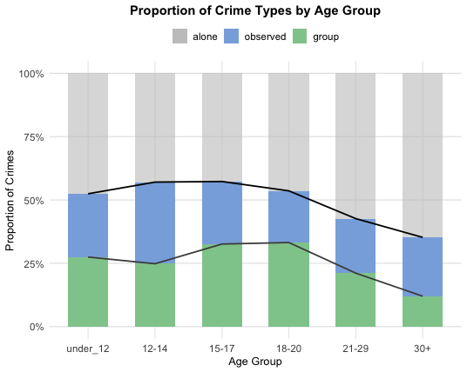

- Attributing co-offenses to youngest and oldest present.
Age Group | Alone (%) | Group (%) | Observed (%)
<12 | 47.6 | 27.5 | 25
12-14 | 42.9 | 24.8 | 32.2
15-17 | 42.7 | 32.6 | 24.7
18-20 | 46.4 | 33.2 | 20.4
21-29 | 57.3 | 21.1 | 21.5
30+ | 64.7 | 12 | 23.2

Analyses of difference in proportion of crimes committed alone between age groups

- Chi Squared of solo crime committed in each age group
- Attributing co-offenses to youngest and oldest present.

Group 1 | Group 2 | F (Rao–Scott) | df | Phi | p | P(Bonferroni)
ALL | vs. all | 108.075 | 4.499887 |  | 0.0000
18-20 | 30+ | 341.279 | 1.000000 |  | 0.0000 | 0.0000
15-17 | 30+ | 235.191 | 1.000000 |  | 0.0000 | 0.0000
21-29 | 30+ | 171.738 | 1.000000 |  | 0.0000 | 0.0000
12-14 | 30+ | 94.705 | 1.000000 |  | 0.0000 | 0.0000
18-20 | 21-29 | 61.511 | 1.000000 |  | 0.0000 | 0.0000
<12 | 30+ | 61.413 | 1.000000 |  | 0.0000 | 0.0000
15-17 | 21-29 | 61.138 | 1.000000 |  | 0.0000 | 0.0000
12-14 | 18-20 | 18.751 | 1.000000 |  | 0.0000 | 0.0004
12-14 | 15-17 | 17.326 | 1.000000 |  | 0.0001 | 0.0008
<12 | 21-29 | 7.365 | 1.000000 |  | 0.0074 | 0.1107
12-14 | 21-29 | 5.125 | 1.000000 |  | 0.0249 | 0.3741
<12 | 18-20 | 3.728 | 1.000000 |  | 0.0553 | 0.8295
<12 | 15-17 | 2.947 | 1.000000 |  | 0.0880 | 1.0000
<12 | 12-14 | 0.938 | 1.000000 |  | 0.3342 | 1.0000
15-17 | 18-20 | 0.092 | 1.000000 |  | 0.7615 | 1.0000

APA Result:
A Rao–Scott adjusted chi-squared test indicated a significant effect of age group on the likelihood of committing crimes alone (F(4.50) = 108.08, p < .001). Pairwise comparisons (Bonferroni-adjusted) revealed that all age groups were significantly less likely than adults aged 30 and older to commit crimes alone (all Fs(1) ≥ 61.41, all adjusted ps < .001). Additionally, individuals aged 18–20 and 15–17 were significantly less likely to offend solo than those aged 21–29 (F(1) = 61.51 and 61.14, respectively, both adjusted ps < .001). Additionally, individuals aged 12–14 were significantly less likely to offend alone than those aged 18–20 and 15–17 (F(1) = 18.75 and 17.33, respectively, both adjusted ps < .01). See Table X for all pairwise comparisons. No other comparisons were statistically significant after correction (adjusted *ps* > .11). Differences between individuals under 12 and other youth groups (e.g., 12–14, 15–17, 18–20, and 21–29) did not reach significance after adjustment, nor did the comparison between 15–17- and 18–20-year-olds (F(1) = 0.09, p = 1.00).

Logistic Regression Analyses Predicting Likelihood of Solo Offending by Age Group

- Logistic Regression Predicting Solo Offending, Reference Group: Ages 15–17

- Attributing co-offenses to youngest and oldest present.

Age Group | Odds Ratio | Std. Error | z | p | CI Lower | CI Upper
Intercept (15–17) | 0.75 | 0.08 | -3.69 | 0.00 | 0.64 | 0.87
<12 | 1.22 | 0.15 | 1.32 | 0.19 | 0.91 | 1.63
12-14 | 1.01 | 0.12 | 0.07 | 0.95 | 0.79 | 1.28
18-20 | 1.16 | 0.08 | 1.79 | 0.08 | 0.98 | 1.37
21-29 | 1.80 | 0.07 | 7.95 | 0.00 | 1.56 | 2.08
30+ | 2.46 | 0.08 | 11.55 | 0.00 | 2.11 | 2.87

A weighted logistic regression model examined age group differences in the likelihood of committing crimes alone, using individuals aged 15–17 as the reference group (see Table X for full results). Adults aged 30 and older were significantly more likely to offend alone than 15–17-year-olds (OR = 2.46, 95% CI [2.11, 2.87], p < .001), as were those aged 21–29 (OR = 1.80, 95% CI [1.56, 2.08], p < .001). The 18–20 group showed marginally higher odds (OR = 1.16, 95% CI [0.98, 1.37], p = .08), while individuals under 12 also showed a nonsignificant tendency toward higher odds (OR = 1.22, 95% CI [0.91, 1.63], p = .19). No differences were observed for those aged 12–14 (OR = 1.01, 95% CI [0.79, 1.28], p = .95).

Logistic Regression Predicting Solo Offending, Reference Group: Ages 18–20

- Attributing co-offenses to youngest and oldest present.

Age Group | Odds Ratio | Std. Error | z | p | CI Lower | CI Upper
Intercept (18–20) | 0.87 | 0.05 | -2.61 | 0.01 | 0.78 | 0.97
<12 | 1.05 | 0.15 | 0.30 | 0.77 | 0.78 | 1.40
12-14 | 0.87 | 0.12 | -1.19 | 0.23 | 0.69 | 1.10
15-17 | 0.86 | 0.08 | -1.79 | 0.08 | 0.73 | 1.02
21-29 | 1.55 | 0.06 | 7.41 | 0.00 | 1.38 | 1.74
30+ | 2.12 | 0.06 | 11.78 | 0.00 | 1.87 | 2.40

Violent crime data

Pre-Analysis Validity Checks
- Proportion of Co-Offenses Involving an Age Gap Between Offenders
Counts and percentage of co-offenses where the youngest and oldest offenders differ by at least one age group. This helps assess whether assigning offenses to both groups might overlook intermediate age categories.

Gap Size | Frequency
2 groups apart | 242843
3 groups apart | 85914
4 groups apart | 54113
5 groups apart | 30263
Total with Age Gap | 413136
Proportion of Total | 0.10

- Percentages of co-offense age partners for each offender age group.

Offender Age | Co-Offender Age Group (%)
 | <12 | 12-14 | 15-17 | 18-20 | 21-29 | 30+
<12 | 42 | 27.4 | 10.8 | 1.3 | 2 | 16.5
12-14 | 6.3 | 67.1 | 15.4 | 2.6 | 2.3 | 6.3
15-17 | 1.9 | 11.6 | 60.8 | 12.4 | 7 | 6.2
18-20 | 0.2 | 2 | 12.9 | 47.5 | 24.5 | 12.8
21-29 | 0.2 | 0.8 | 3.3 | 11.1 | 60.2 | 24.4
30+ | 1.1 | 1.9 | 2.4 | 4.8 | 20.1 | 69.7

Descriptive Crime Role Distributions by Age Group:

- Counts of Crime Type by Age Group
- Attributing co-offenses to youngest and oldest present.
Age Group | Alone | Group | Observed | Total
<12 | 266,509 | 144,988 | 151,650 | 563,147
12-14 | 968,786 | 528,503 | 752,933 | 2,250,222
15-17 | 960,010 | 731,518 | 592,864 | 2,284,392
18-20 | 1,079,591 | 768,354 | 468,996 | 2,316,941
21-29 | 4,584,582 | 1,557,665 | 1,627,682 | 7,769,929
30+ | 10,843,616 | 1,762,483 | 3,879,997 | 16,486,096
Total | 18,703,094 | 5,493,511 | 7,474,122 | 31,670,727
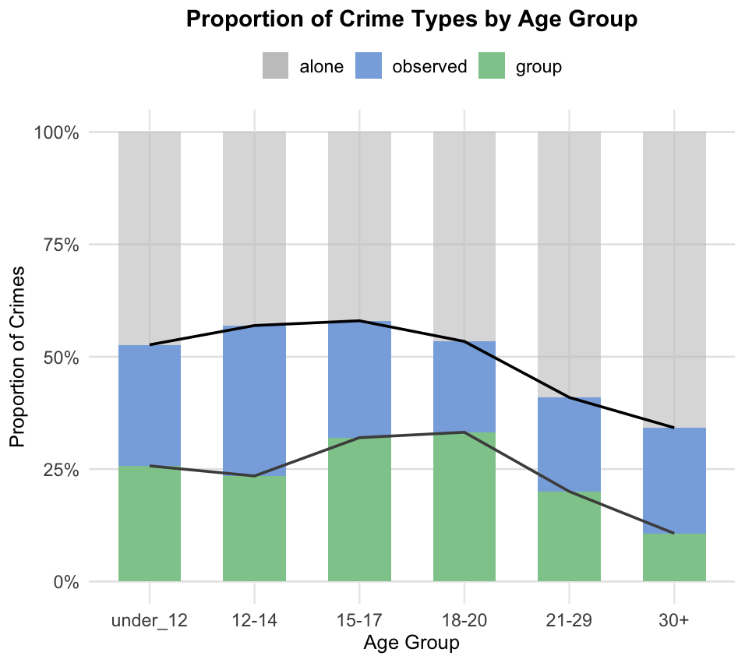
- Percentages of Crime Type by Age Group

- Attributing co-offenses to youngest and oldest present.
Age Group | Alone (%) | Group (%) | Observed (%)
<12 | 47.3 | 25.7 | 26.9
12-14 | 43.1 | 23.5 | 33.5
15-17 | 42 | 32 | 26
18-20 | 46.6 | 33.2 | 20.2
21-29 | 59 | 20 | 20.9
30+ | 65.8 | 10.7 | 23.5

Analyses of difference in proportion of crimes committed alone between age groups
- Chi Squared of solo crime committed in each age group
Note - A chi-squared test measures whether there's a significant difference between expected and observed frequencies in categorical data — in this case, whether age groups differ in how often they commit crimes alone. I had R produce these tables ascending P value size (the significance of the difference between groups gets smaller as you go down the table) so that we can quickly visualize the largest differences.
- Attributing co-offenses to youngest and oldest present.
Group 1 | Group 2 | F (Rao–Scott) | df | Phi | p | p (Bonferroni)
ALL | vs. all | 83.878 | 4.460482 |  | 0.0000
18-20 | 30+ | 297.631 | 1.000000 |  | 0.0000 | 0.0000
15-17 | 30+ | 166.685 | 1.000000 |  | 0.0000 | 0.0000
21-29 | 30+ | 113.352 | 1.000000 |  | 0.0000 | 0.0000
12-14 | 30+ | 77.174 | 1.000000 |  | 0.0000 | 0.0000
18-20 | 21-29 | 62.617 | 1.000000 |  | 0.0000 | 0.0000
15-17 | 21-29 | 43.378 | 1.000000 |  | 0.0000 | 0.0000
<12 | 30+ | 40.393 | 1.000000 |  | 0.0000 | 0.0000
12-14 | 18-20 | 18.037 | 1.000000 |  | 0.0000 | 0.0006
12-14 | 15-17 | 15.860 | 1.000000 |  | 0.0001 | 0.0016
<12 | 18-20 | 4.314 | 1.000000 |  | 0.0394 | 0.5912
<12 | 21-29 | 3.924 | 1.000000 |  | 0.0493 | 0.7397
12-14 | 21-29 | 3.498 | 1.000000 |  | 0.0633 | 0.9493
<12 | 15-17 | 2.919 | 1.000000 |  | 0.0895 | 1.0000
<12 | 12-14 | 0.486 | 1.000000 |  | 0.4866 | 1.0000
15-17 | 18-20 | 0.246 | 1.000000 |  | 0.6204 | 1.0000

Logistic Regression Analyses Predicting Likelihood of Solo Offending by Age Group
- Logistic Regression Predicting Solo Offending, Reference Group: Ages 15–17
- Attributing co-offenses to youngest and oldest present.

Age Group | Odds Ratio | Std. Error | z | p | CI Lower | CI Upper
Intercept (15–17) | 0.72 | 0.10 | -3.09 | 0.00 | 0.59 | 0.89
<12 | 1.24 | 0.18 | 1.22 | 0.23 | 0.87 | 1.76
12-14 | 1.04 | 0.14 | 0.30 | 0.76 | 0.79 | 1.38
18-20 | 1.20 | 0.11 | 1.73 | 0.09 | 0.97 | 1.49
21-29 | 1.99 | 0.10 | 7.20 | 0.00 | 1.64 | 2.40
30+ | 2.65 | 0.10 | 10.22 | 0.00 | 2.20 | 3.20

- Logistic Regression Predicting Solo Offending, Reference Group: Ages 18–20
- Attributing co-offenses to youngest and oldest present.

Age Group | Odds Ratio | Std. Error | z | p | CI Lower | CI Upper
Intercept (18–20) | 0.87 | 0.07 | -1.87 | 0.06 | 0.76 | 1.01
<12 | 1.03 | 0.18 | 0.16 | 0.87 | 0.72 | 1.47
12-14 | 0.87 | 0.14 | -1.02 | 0.31 | 0.66 | 1.14
15-17 | 0.83 | 0.11 | -1.73 | 0.09 | 0.67 | 1.03
21-29 | 1.65 | 0.08 | 6.56 | 0.00 | 1.42 | 1.92
30+ | 2.20 | 0.08 | 9.73 | 0.00 | 1.88 | 2.59

Theft & Burglary data

Pre-Analysis Validity Checks
- Proportion of Co-Offenses Involving an Age Gap Between Offenders
Counts and percentage of co-offenses where the youngest and oldest offenders differ by at least one age group. This helps assess whether assigning offenses to both groups might overlook intermediate age categories.

Gap Size | Frequency
2 groups apart | 69320
3 groups apart | 17222
4 groups apart | 14975
5 groups apart | 12436
Total with Age Gap | 113955
Proportion of Total | 0.07

- Percentages of co-offense age partners for each offender age group.

Offender Age | Co-Offender Age Group (%)
 | <12 | 12-14 | 15-17 | 18-20 | 21-29 | 30+
<12 | 57.5 | 12.6 | 8.2 | 0.8 | 7 | 13.9
12-14 | 5.6 | 56.8 | 24.4 | 8 | 0.7 | 4.3
15-17 | 1.9 | 12.3 | 65.7 | 13.5 | 2.8 | 3.8
18-20 | 0.2 | 3.7 | 12.6 | 55.9 | 19.4 | 8.2
21-29 | 0.6 | 0.1 | 1.1 | 8.2 | 66.4 | 23.6
30+ | 1.1 | 0.8 | 1.3 | 3 | 20.8 | 73

Descriptive Crime Role Distributions by Age Group:

- Counts of Crime Type by Age Group

- Attributing co-offenses to youngest and oldest present.

Age Group | Alone | Group | Observed | Total
<12 | 94,652 | 63,800 | 37,855 | 196,307
12-14 | 191,323 | 142,773 | 117,767 | 451,863
15-17 | 347,811 | 265,869 | 162,318 | 775,998
18-20 | 426,801 | 307,599 | 191,934 | 926,334
21-29 | 1,487,140 | 678,412 | 654,385 | 2,819,937
30+ | 2,548,757 | 730,038 | 923,686 | 4,202,481
Total | 5,096,484 | 2,188,491 | 2,087,945 | 9,372,920
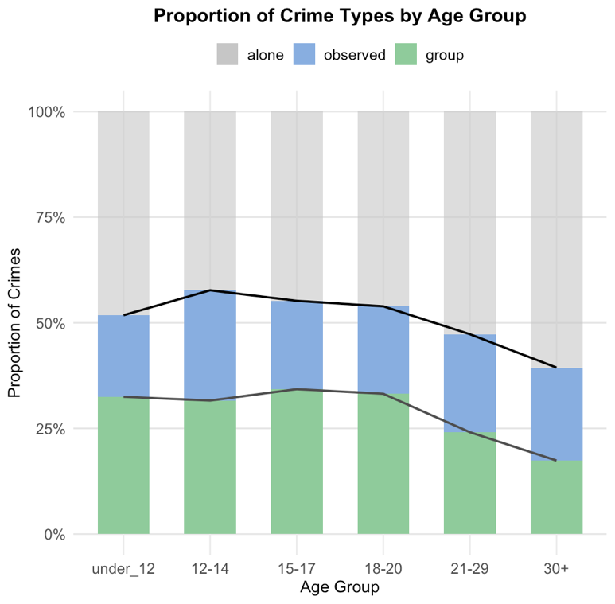

- Attributing co-offenses to youngest and oldest present.
Age Group | Alone (%) | Group (%) | Observed (%)
<12 | 48.2 | 32.5 | 19.3
12-14 | 42.3 | 31.6 | 26.1
15-17 | 44.8 | 34.3 | 20.9
18-20 | 46.1 | 33.2 | 20.7
21-29 | 52.7 | 24.1 | 23.2
30+ | 60.6 | 17.4 | 22

Analyses of difference in proportion of crimes committed alone between age groups

- Chi Squared of solo crime committed in each age group
- Attributing co-offenses to youngest and oldest present.
Group 1 | Group 2 | F (Rao–Scott) | df | Phi | p | p (Bonferroni)
ALL | vs. all | 29.003 | 4.594359 |  | 0.0000
15-17 | 30+ | 80.865 | 1.000000 |  | 0.0000 | 0.0000
18-20 | 30+ | 69.555 | 1.000000 |  | 0.0000 | 0.0000
21-29 | 30+ | 39.163 | 1.000000 |  | 0.0000 | 0.0000
12-14 | 30+ | 32.691 | 1.000000 |  | 0.0000 | 0.0000
15-17 | 21-29 | 24.040 | 1.000000 |  | 0.0000 | 0.0000
under_12 | 30+ | 19.218 | 1.000000 |  | 0.0000 | 0.0003
18-20 | 21-29 | 17.984 | 1.000000 |  | 0.0000 | 0.0006
12-14 | 21-29 | 7.263 | 1.000000 |  | 0.0078 | 0.1169
under_12 | 21-29 | 4.694 | 1.000000 |  | 0.0318 | 0.4763
12-14 | 15-17 | 0.797 | 1.000000 |  | 0.3733 | 1.0000
12-14 | 18-20 | 0.276 | 1.000000 |  | 0.6002 | 1.0000
15-17 | 18-20 | 0.164 | 1.000000 |  | 0.6859 | 1.0000
under_12 | 15-17 | 0.147 | 1.000000 |  | 0.7024 | 1.0000
under_12 | 12-14 | 0.038 | 1.000000 |  | 0.8464 | 1.0000
under_12 | 18-20 | 0.024 | 1.000000 |  | 0.8780 | 1.0000

Logistic Regression Analyses Predicting Likelihood of Solo Offending by Age Group
- Logistic Regression Predicting Solo Offending, Reference Group: Ages 15–17

- Attributing co-offenses to youngest and oldest present.
Age Group | Odds Ratio | Std. Error | z | p | CI Lower | CI Upper
Intercept (15–17) | 0.81 | 0.10 | -2.07 | 0.04 | 0.67 | 0.99
<12 | 1.15 | 0.20 | 0.67 | 0.50 | 0.77 | 1.71
12-14 | 0.90 | 0.15 | -0.68 | 0.49 | 0.68 | 1.21
18-20 | 1.05 | 0.12 | 0.41 | 0.68 | 0.82 | 1.34
21-29 | 1.37 | 0.11 | 2.78 | 0.01 | 1.10 | 1.72
30+ | 1.90 | 0.12 | 5.32 | 0.00 | 1.50 | 2.41

- Logistic Regression Predicting Solo Offending, Reference Group: Ages 18–20

- Attributing co-offenses to youngest and oldest present.

Age Group | Odds Ratio | Std. Error | z | p | CI Lower | CI Upper
Intercept (18–20) | 0.85 | 0.08 | -2.02 | 0.05 | 0.73 | 1.00
<12 | 1.09 | 0.19 | 0.45 | 0.65 | 0.75 | 1.58
12-14 | 0.86 | 0.14 | -1.06 | 0.29 | 0.65 | 1.14
15-17 | 0.95 | 0.12 | -0.41 | 0.68 | 0.75 | 1.21
21-29 | 1.31 | 0.09 | 2.84 | 0.01 | 1.08 | 1.57
30+ | 1.80 | 0.09 | 6.85 | 0.00 | 1.52 | 2.14

