June 5, 2025

To whom it may concern,

I am providing this letter to support my sponsorship of Kirsten Lee’s non-member poster submission to the 2025 Psychonomic Society Annual Meeting, entitled *Substance-Specific Cognitive Mechanisms Underlying Drug and Alcohol Use Across Development in a Low-Use Sample.*

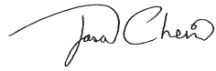

Jason Chein

Director, Temple University Brain Research & Imaging Center

Professor, Department of Psychology & Neuroscience

Temple University