Project ACCESS tables:
Index:
- Survey Completion and Usability Summaries
- Criteria Ranking
  - Medicare
  - Medicaid
  - Private
- Demographics
  - Notes
  - All usable participant demographics
    - Clinician details
    - General demographics
  - HDT completed participant demographics
    - Clinician details
    - General demographics

Survey Completion and Usability Summaries

Summary of Data usability
Survey | Complete | Partial
Hypothetical Demand Task | 309 | 14
Margaret | 306 | 0
Briana | 306 | 1
Criteria Ranking | 329 | 0
Medicare | 134 | 0
Medicaid | 312 | 0
Private Insurance | 329 | 0

Summary of survey completion
Status | Sample
Usable Data | 329
Fraudulent | 84
Incomplete | 115
Ineligible Clinician | 396
Unlicensed Provider | 2
Not Private Practice | 12
< 10 Weekly Hours | 27
No Decision Regarding Insurance | 7
>50% Reimbursed In-Network Insurance | 169
<50% Individual Therapy | 15
Unverified Therapist Information | 159
Accepts >50% Medicare | 5

Notes:
- “Incomplete” are people who met all the necessary clinician demographics after the screener and then just stopped before the consent form for no apparent reason.
- Small note: 2 record ids (87 and 563) were unlicensed providers, but the survey didn’t end - and they ended up meeting other disqualifying criteria (87 also worked in community mental health, and 563 also accepted > 50% in network insurance). I only counted these in the unlicensed provider tallies because they should’ve already been removed from the survey.
- You already know this but just clarifying – these are not accurate demographic trends of the sample because the survey stopped as soon as a criteria wasn’t met, this just reflects when they stopped. People could’ve met numerous disqualifying criteria but only one will be reflected.
Note: 74 people completed the criteria ranking survey but stopped during demographics at the NPI questions. (or provided an incorrect NPI number)

Criteria Ranking

Rankings of Reasons for Not Accepting Medicare
Reason | Mean | Median | Most Common
Reimbursement rates are too low | 2.53 | 2.0 | 1.0
Administrative burden of submitting claims | 2.77 | 2.0 | 2.0
Delays in getting paid | 3.6 | 4.0 | 3.0
Concerns about treatment regulations | 3.41 | 4.0 | 4.0
Concerns about audit risk | 3.77 | 4.0 | 5.0
Not accepted onto an insurance panel | 4.92 | 6.0 | 6.0

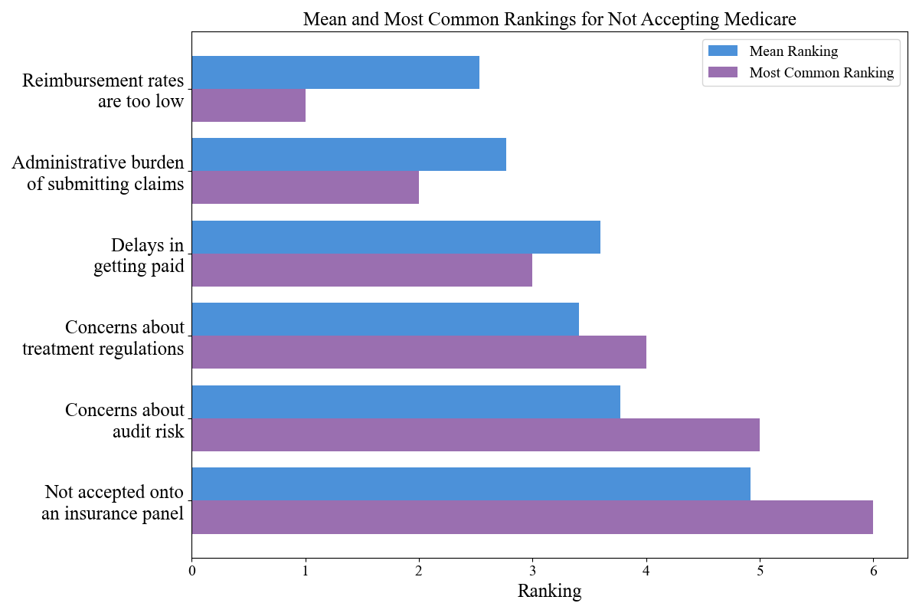

Rankings of Reasons for Not Accepting Medicaid
Reason | Mean | Median | Most Common
Reimbursement rates are too low | 2.28 | 1.0 | 1.0
Administrative burden of submitting claims | 2.69 | 2.0 | 2.0
Delays in getting paid | 3.45 | 3.0 | 3.0
Concerns about treatment regulations | 3.59 | 4.0 | 4.0
Concerns about audit risk | 3.96 | 4.0 | 5.0
Not accepted onto an insurance panel | 5.03 | 6.0 | 6.0

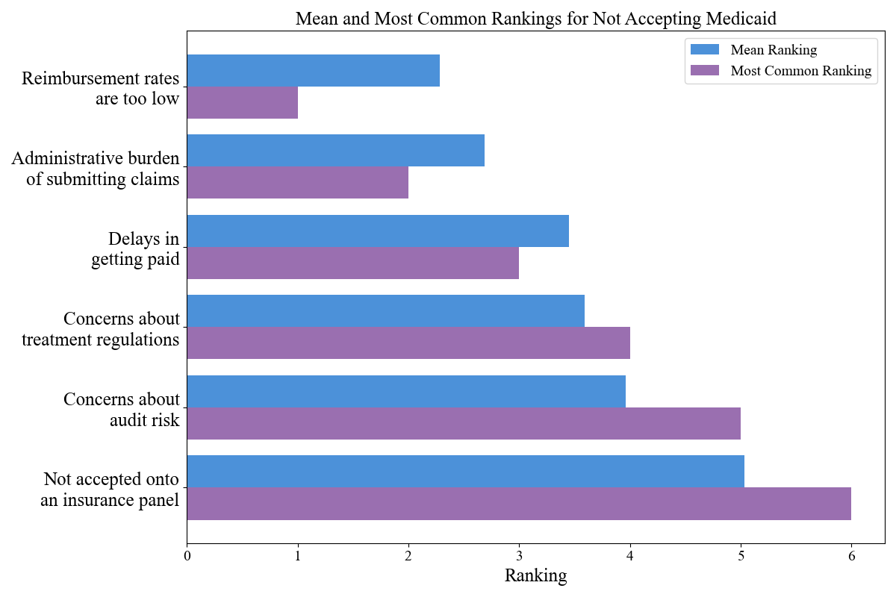

Rankings of Reasons for Not Accepting Private Insurance
Reason | Mean | Median | Most Common
Reimbursement rates are too low | 2.24 | 1.0 | 1.0
Administrative burden of submitting claims | 2.85 | 2.0 | 2.0
Delays in getting paid | 3.44 | 3.0 | 3.0
Concerns about treatment regulations | 3.49 | 4.0 | 4.0
Concerns about audit risk | 3.87 | 4.0 | 5.0
Not accepted onto an insurance panel | 5.1 | 6.0 | 6.0

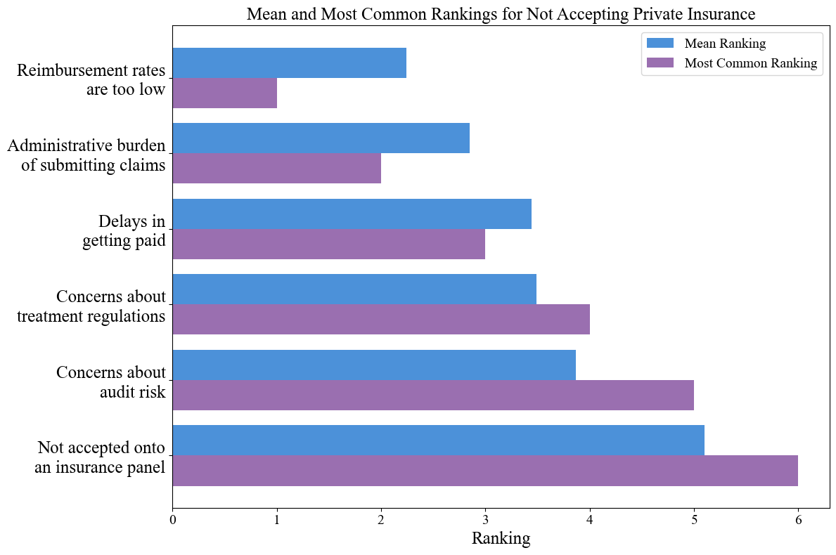

Demographics

Demographics Notes

Note: For "Lowest sliding scale fee," I converted text responses into a single dollar amount per session. If context was provided, I used the lowest amount mentioned that is being charged to a current patient.

Example: “I typically charge as low as $40 but take on a few pro bono patients” was recorded as $0

Example: “I used to offer pro bono/$40 sessions but now don’t go below $190” was recorded as $190.

Note: For annual income responses of participants to be included, I converted any response that was just a 2- or 3-digit number by adding "000" to represent thousands (e.g., ‘35’ became 35,000, and ‘150’ became 150,000).

Excluded participants: Annual income responses were excluded if they:
- Only provided a range (e.g., ">100k per year") instead of a specific number.
- Explicitly reported only net income. It was generally clear that participants were reporting gross income, as most who mentioned "gross and net" provided their gross income. Therefore, responses that stated only "net income - ###" were excluded.
- Included irrelevant or non-numerical responses (e.g., "I don’t want to say").

Demographics (all usable data)

Clinician Demographics from total sample of usable data
Variable | N | Mean | SD | Median | %
Self-Pay Fee | 220 | $216.73 | $88.83 | $200.00 | -
Sliding Scale Offered
Yes | 214 |  |  |  | 65.0%
No | 115 |  |  |  | 35.0%
Lowest Sliding Scale Fee | 211 | $87.91 | $58.25 | $85.00
Estimated Annual Income | 319 | $134,948.28 | $885,20.78 | $115,000.00
License Type
PhD, PsyD | 204 |  |  |  | 62.4%
LCSW, LMSW, LICSW | 81 |  |  |  | 24.8%
LPC | 21 |  |  |  | 6.4%
LMHC | 13 |  |  |  | 4.0%
LMFT | 8 |  |  |  | 2.4%
Practice Context
Solo practice | 272 |  |  |  | 82.9%
Group practice | 56 |  |  |  | 17.1%
Service Area
Urban | 170 |  |  |  | 51.8%
Suburban | 142 |  |  |  | 43.3%
Rural | 16 |  |  |  | 4.9%

Participant Demographics from total sample of usable data
Variable | N | %
Race/Ethnicity
White/European American | 270 | 82.8%
Latino/a/x or Spanish Origin | 13 | 4.0%
Asian or Asian American | 12 | 3.7%
Prefer not to answer | 9 | 2.8%
Bi/Multiracial | 7 | 2.1%
Black or African American | 6 | 1.8%
Arab American, Middle Eastern, or North African | 5 | 1.5%
American Indian, Alaska Native, and/or Indigenous | 3 | 0.9%
Another race or ethnicity not listed above | 1 | 0.3%
Gender Identity
Female/Woman | 262 | 80.4%
Male/Man | 53 | 16.3%
Nonbinary | 6 | 1.8%
Prefer not to answer | 5 | 1.5%
Transgender Identification
No | 310 | 95.1%
Yes | 11 | 3.4%
Prefer not to answer | 5 | 1.5%

- Demographics (HDT data)

Clinician Demographics from sample who completed HDT
Variable | N | Mean | SD | Median | %
Self-Pay Fee | 211 | $213.46 | $69.48 | $200.00
Sliding Scale Offered
Yes | 200 |  |  |  | 64.7%
No | 109 |  |  |  | 35.3%
Lowest Sliding Scale Fee | 198 | $88.51 | $59.33 | $85.00
Estimated Annual Income | 301 | $136,303.99 | $90,238.38 | $120,000.00
License Type
PhD, PsyD | 194 |  |  |  | 62.8%
LCSW, LMSW, LICSW | 77 |  |  |  | 24.9%
LPC | 18 |  |  |  | 5.8%
LMHC | 12 |  |  |  | 3.9%
LMFT | 8 |  |  |  | 2.6%
Practice Context
Solo practice | 254 |  |  |  | 82.2%
Group practice | 55 |  |  |  | 17.8%
Service Area
Urban | 161 |  |  |  | 52.1%
Suburban | 132 |  |  |  | 42.7%
Rural | 16 |  |  |  | 5.2%

Participant Demographics from sample who completed HDT
Variable | N | %
Race/Ethnicity
White/European American | 257 | 83.2%
Latino/a/x or Spanish Origin | 12 | 3.9%
Asian or Asian American | 12 | 3.9%
Prefer not to answer | 8 | 2.6%
Bi/Multiracial | 6 | 1.9%
Black or African American | 5 | 1.6%
Arab American, Middle Eastern, or North African | 5 | 1.6%
American Indian, Alaska Native, and/or Indigenous | 3 | 1.0%
Another race or ethnicity not listed above | 1 | 0.3%
Gender Identity
Female/Woman | 246 | 79.6%
Male/Man | 52 | 16.8%
Nonbinary | 6 | 1.9%
Prefer not to answer | 5 | 1.6%
Transgender Identification
No | 295 | 95.5%
Yes | 9 | 2.9%
Prefer not to answer | 5 | 1.6%

