Study Guide Exam 3
Josh Klugman

Exam 3 Study Guide
Exam 3 covers course material from between-subjects factorial ANOVA to splot-plot ANOVA. You will be allowed to bring a double-sided sheet of hand-written notes. You should be able to do the following:
- Interpret all figures and tables in the Simmons Nelson, and Simonsohn article.
Answer: Below are the exact tables/figures from Simmons et al. (2011), each followed by a clear interpretation.
Table 1 Interpretation: Analytic flexibility inflates false positives well above 5%. Two DVs already push p<.05 to 9.5%. Combining common flexibilities (A+B+C+D) pushes p<.05 to 60.7%.
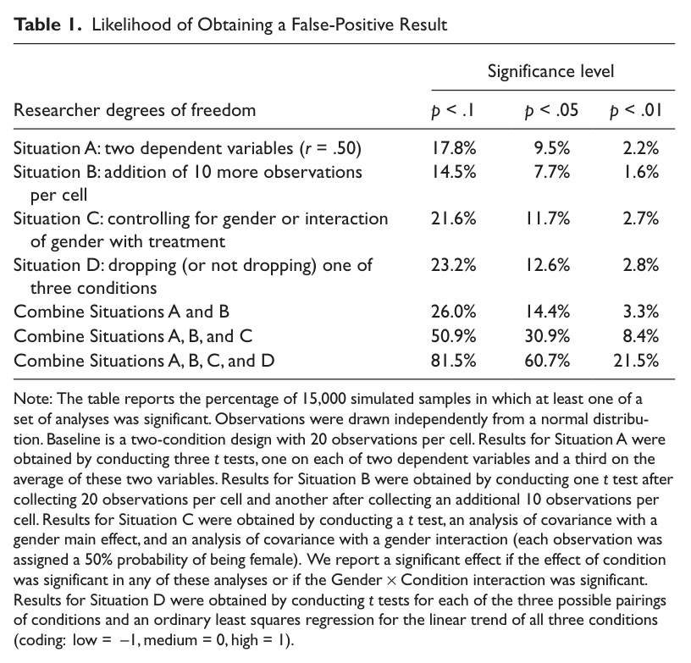

Figure 1 Interpretation: Optional stopping raises false‑positive rates; more frequent testing and smaller minimum N produce the largest inflation.
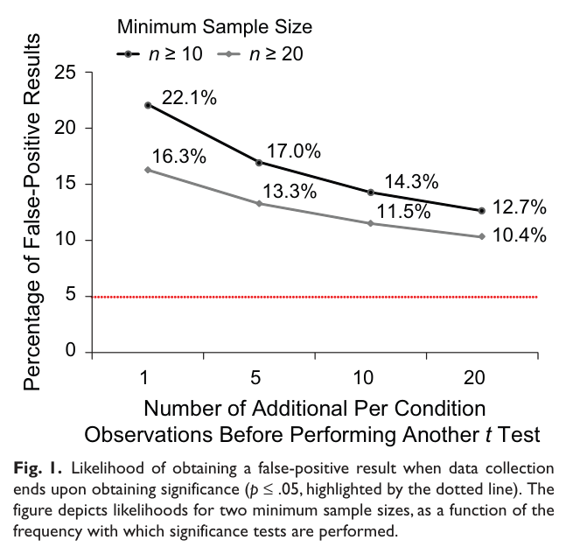

Figure 2 Interpretation: P‑values drift with added data; early significance can disappear, so peeking is misleading.
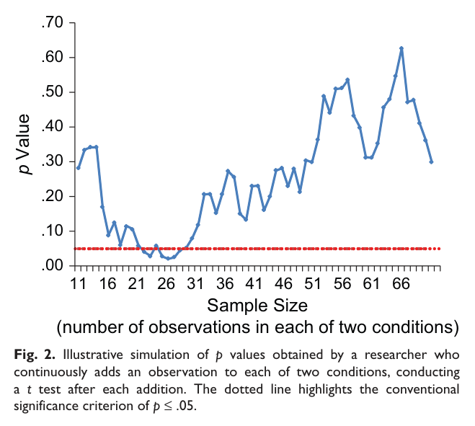

Table 2 Interpretation: Disclosure requirements + reviewer checks enforce transparency: pre‑specify stopping, list all variables/conditions, and show robustness to exclusions and covariates.
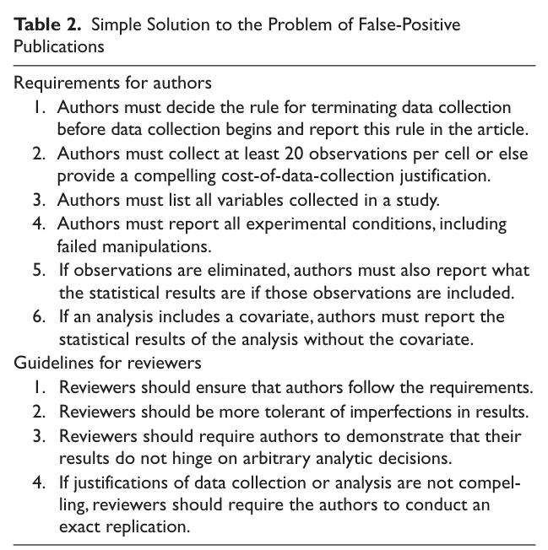

Table 3 Interpretation: When all choices are disclosed, the “significant” Study 2 result depends on covariate choice and flexible sampling; without the covariate the effect is nonsignificant.
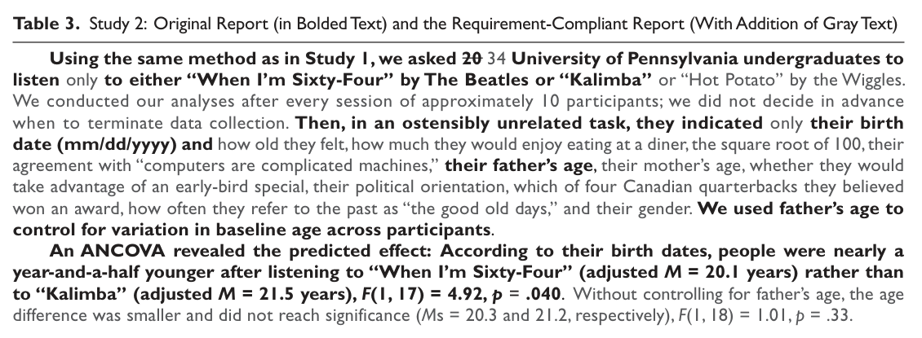

- List the different ways researcher discretion (aka “research degrees of freedom”) can increase the chances of getting a false positive
Answer: PARA::Researcher degrees of freedom are the analytic choices that are reasonable on their own but inflate Type I error when many are tried. When multiple analyses are run and only the “best” one is reported, the overall chance of at least one p<.05 can be far above .05.
Examples include optional stopping or peeking at p values while data are still being collected; trying multiple dependent variables and reporting only the significant one; deciding post‑hoc whether to include or exclude covariates; dropping or merging conditions; trimming outliers after seeing results; transforming variables in multiple ways; and searching across subgroups.
The key idea is multiplicity: each additional choice is another statistical test. Unless choices are pre‑registered or fully disclosed, the reported p value does not reflect the true false‑positive probability.
- Calculate the “effects” for the general linear model for a two-way between-subjects ANOVA, a single-factor within-subjects ANOVA, a multi-factor within-subjects, and a split-plot ANOVA ( , , , eijk). Do not worry about random effects, like subject effects or subject interactions.
Answer: PARA::An “effect” is a deviation from the grand mean Ȳ. The fixed effects describe how group means differ from Ȳ, and the interaction describes how a cell mean deviates from what would be expected from the main effects alone.
Formula (Between‑subjects 2‑way): α_{j}=Ȳ_{j}−Ȳ, β_{k}=Ȳ_{k}−Ȳ, (αβ)_{jk}=Ȳ_{jk}−Ȳ_{j}−Ȳ_{k}+Ȳ, ε_{ijk}=Y_{ijk}−Ȳ_{jk}.
Formula (Within‑subjects 1‑way): α_{j}=Ȳ_{j}−Ȳ, ε_{ij}=Y_{ij}−Ȳ_{j}−Ȳ_{i}+Ȳ (subject mean removed).
Formula (Within‑subjects 2‑way, fixed): α_{j}, β_{k}, (αβ)_{jk} as above; subject terms omitted per prompt.
Formula (Split‑plot): α_{j}, β_{k}, (αβ)_{jk} as above; ε_{ijk}=Y_{ijk}−Ȳ_{ij}−Ȳ_{jk}+Ȳ_{j} (subject nested in A).
- You will not have to calculate sums of squares, but you should be able to understand what are the sources of error for specific effects in ANOVA (especially pertinent for multi-factor repeated measures ANOVA and split-plot ANOVA)
Answer: PARA::The correct error term is the variability that remains after removing the effect being tested. This is why repeated‑measures designs use subject×effect terms instead of a single within‑cell error.
Between‑subjects: error = MS_{within} (individual differences within each cell).
Within‑subjects 1‑way: error = MS_{subject×A} (people differ in the size of the A effect).
Within‑subjects 2‑way: A uses MS_{A×S}; B uses MS_{B×S}; A×B uses MS_{A×B×S}.
Split‑plot: A uses MS_{subject(A)}; B and A×B use MS_{B×subject(A)} because they involve within‑subject variation.
  - Relatedly, explain, in a conceptual, intuitive way, the error components in a one-way and two-way within-subject design.
Answer: PARA::In a one‑way within‑subjects design, each person provides multiple scores. Subtracting each person’s mean removes stable individual differences, leaving the subject×condition term — the remaining within‑person noise. That term is the error.
In a two‑way within‑subjects design, each effect has its own error: A×Subject, B×Subject, and A×B×Subject. Each one captures how that effect varies across people beyond the average effect.
  - Explain the difference between between-subject ANOVAs and a within-subject ANOVAs in terms of design, ANOVA tables, sums of squares, and F ratios.
Answer: PARA::Design: Between‑subjects assigns each participant to one condition; within‑subjects measures each participant across all conditions.
ANOVA tables: Between‑subjects has one error term (within‑cell variance). Within‑subjects partitions subject variance and uses subject×effect error terms.
Sums of squares: Within‑subjects removes subject SS, reducing residual error and increasing power. Between‑subjects does not remove subject SS.
F ratios: BS uses MS_{effect}/MS_{within}. WS uses MS_{effect}/MS_{subject×effect} and requires sphericity or corrections.
- Interpret R output for two-way ANOVA, within-subject ANOVA, multi-factor repeated measures ANOVA, and split-plot ANOVA
Answer: PARA::Step 1: Identify the rows for each effect (A, B, A×B). Note df and sums of squares.
Step 2: Confirm which error term each effect uses. For within‑subject factors, this is an effect×subject term.
Step 3: Check Mauchly’s test; if sphericity is violated, report GG/HF‑adjusted p values.
Step 4: Interpret the direction using cell means and plots; significant interactions override simple main‑effect interpretations.
- In a two-way ANOVA context, conceptually describe main effects and interaction effects. Know what a “consistent main effect” is.
Answer: PARA::Main effect: average difference across the other factor (marginal means).
Interaction: the effect of one factor changes across levels of the other; graphically, lines are non‑parallel.
Consistent main effect: the direction and ordering are the same at every level of the other factor; an interaction is absent or trivial.
- In a between-subject context, calculate mean differences between groups according to the Type I and Type III methods of calculating sums of squares and explain what a difference between a Type I effect and a Type III effect means
Answer: PARA::Type I uses weighted marginal means based on cell sizes; Type III averages cell means equally to represent a balanced design.
If Type I and Type III differ, the effect is partially driven by imbalance in the other factor. Type III is the “pure” effect; Type I is the observed effect in the sample.
- Look at data for a two-way ANOVAs (either between-subjects, within-subjects, or split-plot) and calculate and describe main effect contrasts, simple effect contrasts, and interaction contrasts
Answer: PARA::Main‑effect contrasts compare marginal means (e.g., A1 vs A2).
Simple‑effect contrasts compare levels of one factor within a fixed level of the other factor.
Interaction contrasts compare two simple effects (difference of differences) to test whether the simple effects differ.
- Apply the post-hoc adjustments to a variety of situations (main effects contrasts, simple effects contrasts, interaction contrasts)
Answer: PARA::Use Tukey for pairwise comparisons and Scheffé for complex contrasts.
Tukey: t* = q_{a,df,α}/√2 (or q_{b,df,α}/√2).
Scheffé: t* = √(df_{effect} · F_{df_{effect},df_{error},α}).
For simple effects, adjust α by the number of comparisons (α/b for A|B or α/a for B|A). For interactions, use df_{effect}=(a−1)(b−1).

Equations on the Test
$t=\frac{\hat{ψ}}{\sqrt{MSW\left(Σ\frac{c_{j}^{2}}{n_{j}}\right)}}$
$t=\frac{\hat{ψ}}{\sqrt{MSW\left(Σ\frac{c_{k}^{2}}{n_{k}}\right)}}$
$t=\frac{\hat{ψ}}{\sqrt{MSW\left(Σ\frac{c_{j}^{2}k}{n_{j}k}\right)}}$
Effects:
$\hat{α_{j}}=\overline{Y_{j}}−\overline{Y}$
$\hat{β_{k}}=\overline{Y_{k}}−\overline{Y}$
$\hat{αβ_{jk}}=\overline{Y_{jk}}−\overline{Y_{j}}−\overline{Y_{k}}+\overline{Y}$
Adjusted t-critical values for post-hoc contrasts
effect | tukey | scheffe
Main Effect of A | $q_{a,denom,α=.05}/\sqrt{2}$ | $\sqrt{(a−1)F_{a−1,denom,α=.05}}$
Main Effect of B | $q_{b,denom,α=.05}/\sqrt{2}$ | $\sqrt{(b−1)F_{b−1,denom,α=.05}}$
Simple Effects A By B | $q_{a,denom,α=.05/b}/\sqrt{2}$ | $\sqrt{(a−1)F_{a−1,denom,α=.05/b}}$
Simple Effects B By A | $q_{b,denom,α=.05/a}/\sqrt{2}$ | $\sqrt{(b−1)F_{b−1,denom,α=.05/b}}$
Interaction | $NA$ | $\sqrt{(a−1)(b−1)F_{(a−1)(b−1),denom,α=.05}}$
Denominator Degrees of Freedom For Contrasts (BS=between subject; WS=within subject)
analysis | df
BS ANOVA, 1-way | n-a
BS ANOVA, 2-way | n-ab
WS ANOVA, 1-way | n-1
WS ANOVA, 2-way | n-1
Split-Plot ANOVA | n-a

Problems

Problem 1
Here is data on the reading scores (converted to z-scores, so the unit of measurement is standard deviation) of first graders in 2013, by the education of the caretaking parent and income. The numbers in parentheses are cell sizes.
Calculate the difference between children from low-income families (<$75,000) and children from high-income families (>=$75,001) using the Type I and Type III approaches. Interpret the different effects. What conclusion do you make about the Type I effect of income—is it a “pure” income effect or not?
Answer: PARA::We are comparing income groups. Type I uses weighted means (cell sizes matter), while Type III uses unweighted means (balanced design).
Step 1 (Type I): Low‑income mean = (−0.24·6668 + 0.30·1437)/(6668+1437)=−0.14. High‑income mean=(0.19·1424 + 0.50·2916)/(1424+2916)=0.40.
Step 2 (Type I difference): 0.40 − (−0.14) = 0.54 SD. This is the observed gap in the sample.
Step 3 (Type III): Low‑income mean=(−0.24+0.30)/2=0.03. High‑income mean=(0.19+0.50)/2=0.35.
Step 4 (Type III difference): 0.35 − 0.03 = 0.32 SD. This is the income gap if parental education were balanced.
Conclusion: Type I is larger because parental education is distributed differently across income groups. So Type I is not a “pure” income effect; Type III is closer to the pure income effect.
First Grade Reading Scores (z) By Family Income and Parental Education
Parental Education | <$75,000 | $75,001+
Less than BA | -0.24 | 0.19
 | (n=6668) | (n=1424)
BA+ | 0.30 | 0.50
 | (n=1437) | (n=2916)

Problem 2
A researcher classifies her white subjects based on their political views into liberals, moderates, and conservatives. She gives them a vignette based on the Rodney King case: a police officer is accused of beating a motorist. The officer is acquitted of assault charges in state court but subsequently indicated and found guilty of violating the motorist’s civil rights in federal courts. Subjects were assigned to either of two conditions (this is a completely between-subjects design!): in one condition, the officer is white; in the other one, the officer is black. Subjects were asked to rate, on a scale from 1 to 7, how much they think this is a case of double jeopardy (a constitutional right not to be charged for the same crime twice). There are 10 people in each cell.
Here is the researcher’s data & ANOVA table:
df2<-data.frame(treatment=c("Black Officers","White Officers","Mean"),
liberal=c(3.19,1.91,2.55),
moderate=c(3.40,3.35,3.38),
conservative=c(1.25,4.62,2.94),
mean=c(2.61,3.29,2.95))
fdf2<-flextable(df2)
fdf2<-set_caption(fdf2,
caption="Problem 2 Cell and Marginal Means")
fdf2
Problem 2 Cell and Marginal Means
treatment | liberal | moderate | conservative | mean
Black Officers | 3.19 | 3.40 | 1.25 | 2.61
White Officers | 1.91 | 3.35 | 4.62 | 3.29
Mean | 2.55 | 3.38 | 2.94 | 2.95
summary(m2)
## Anova Table (Type 3 tests)
##
## Response: dj
## num Df den Df MSE F ges Pr(>F)
## treatment 1 54 1.73 4.01 0.069 0.05 .
## orientation 2 54 1.73 2.00 0.069 0.15
## treatment:orientation 2 54 1.73 16.72 0.382 2.2e-06 ***
## ---
## Signif. codes: 0 '***' 0.001 '**' 0.01 '*' 0.05 '.' 0.1 ' ' 1
m2$Anova
## Anova Table (Type III tests)
##
## Response: dv
## Sum Sq Df F value Pr(>F)
## (Intercept) 523 1 301.64 < 2e-16 ***
## treatment 7 1 4.01 0.05 .
## orientation 7 2 2.00 0.15
## treatment:orientation 58 2 16.72 2.2e-06 ***
## Residuals 94 54
## ---
## Signif. codes: 0 '***' 0.001 '**' 0.01 '*' 0.05 '.' 0.1 ' ' 1

Problem 2a
Interpret the omnibus F-statistics in this table.
Answer: PARA::The key question is whether the effects are statistically reliable in the ANOVA table.
Interaction: F(2,54)=16.72, p<.001 → strong evidence that officer race effects differ by ideology.
Treatment main effect: F(1,54)=4.01, p=.05 → marginal overall race effect.
Orientation main effect: F(2,54)=2.00, p=.15 → no overall ideology effect when collapsing across officer race.

Problem 2b
Interpret the main effect of the officer race factor. Is this a “consistent” main effect? (just based on the cell means)
Answer: PARA::Marginal means show White officer=3.29, Black officer=2.61.
This suggests higher double‑jeopardy ratings when the officer is white.
However, the pattern is not consistent: liberals show the opposite direction, moderates show almost no difference, and conservatives show a strong white>black pattern.

Problem 2c
Interpret the main effects of political views. Are these “consistent” main effects? (just based on the cell means)
Answer: PARA::Overall means: Moderate=3.38, Conservative=2.94, Liberal=2.55.
On average, moderates rate higher. But this is not consistent because the ordering changes when you look separately at black vs white officer conditions.

Problem 2d
Interpret how the effect of the officer race factor varies by levels of political views. (just based on the cell means)
Answer: PARA::Liberals: Black officer (3.19) > White officer (1.91).
Conservatives: White officer (4.62) > Black officer (1.25).
Moderates: Black (3.40) ≈ White (3.35).
This is a textbook interaction: the direction of the officer‑race effect reverses by ideology.

Problem 2e
Calculate all $\hat{α_{j}}$, $\hat{β_{k}}$, $\hat{αβ_{jk}}$
Answer: Grand mean:: Ȳ=2.95.
α (race): α_{black}=2.61−2.95=−0.34; α_{white}=3.29−2.95=+0.34.
β (ideology): β_{liberal}=2.55−2.95=−0.40; β_{moderate}=3.38−2.95=+0.43; β_{conservative}=2.94−2.95=−0.01.
(αβ) interactions: black,lib=+0.98; black,mod=+0.36; black,cons=−1.35; white,lib=−0.98; white,mod=−0.37; white,cons=+1.34.

Problem 2f
A subject in our study is a conservative and he is assigned to the black officer condition. He gives a rating of 7. What is his $e_{ijk}$?
Answer: PARA::Use ε_{ijk}=Y_{ijk}−Ȳ_{jk}. The conservative‑black cell mean is 1.25.
Compute: ε=7−1.25=5.75.
He is 5.75 points above his cell mean.

Problems 2g-2i
For each contrast, identify what kind of contrast it is (main effect of orientation; main effect of treatment; simple effect of orientation by treatment; simple effect of treatment by orientation; interaction); calculate the contrast value (psi-hat); interpret the contrast value; the t-test statistic; determine the post-hoc-adjusted t critical value (use Tukey if it is a pairwise contrast; use Scheffe if it is a complex contrast); and state if you retain or reject the null hypothesis.
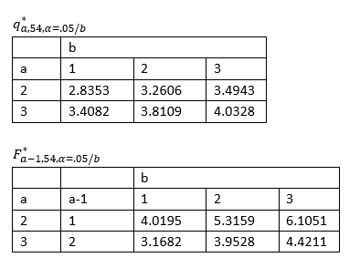

Problem 2g
Answer: PARA::Simple effect of officer race within conservatives.
H₀: μ_{cons,white}−μ_{cons,black}=0.
ψ̂: 4.62−1.25=3.37.
SE: √(MS_{error}·(1/10+1/10)), MS_{error}=1.73.
t: 5.73.
t* (Tukey): q_{2,54,α/3}/√2 = 2.471.
Decision: Reject H₀. Conservatives rate white officers higher by 3.37 points.
$H_{0}:\left(1\right)μ_{conservative,white}+\left(−1\right)μ_{conservative,black}=0$

Problem 2h
Answer: PARA::Interaction contrast (difference of simple effects).
H₀: (μ_{cons,white}−μ_{cons,black}) − (μ_{lib,white}−μ_{lib,black}) = 0.
ψ̂: 4.65; t=5.58.
t* (Scheffé): √(2·F_{2,54,0.05})=2.517.
Decision: Reject H₀. The officer‑race effect is much larger for conservatives than liberals.
$H_{0}:\left(1\right)μ_{conservative,white}+\left(−1\right)μ_{conservative,black}+\left(1\right)μ_{liberal,white}+\left(−1\right)μ_{liberal,black}=0$

Problem 2i
Answer: PARA::Simple effect of ideology within white‑officer condition (complex contrast).
H₀: μ_{cons,white}+μ_{mod,white}−2μ_{lib,white}=0.
ψ̂: 4.15; t=4.07.
t* (Scheffé): √(2·F_{2,54,0.05/2})=2.812.
Decision: Reject H₀. Under white officers, conservatives+moderates > liberals.
$H_{0}:\left(1\right)μ_{conservative,white}+\left(1\right)μ_{moderate,white}+\left(−2\right)μ_{liberal,white}=0$

Problem 3
A researcher is interested in the racial attitude of Black Americans. Here is some data from the 2024 GSS, where subjects were asked to rate Black, Hispanic, and White people’s laziness on a scale of 1-7, where 1 means “not at all lazy” and 7 means “lazy”.
eb
## racef emmean SE df lower.CL upper.CL
## Rating.of.Black.people 3.05 0.0832 302 2.89 3.22
## Rating.of.Hispanic.People 2.46 0.0819 302 2.30 2.62
## Rating.of.White.People 3.99 0.0872 302 3.82 4.16
##
## Confidence level used: 0.95

Problem 3a
Calculate all fixed effects (that is, effects not related to the subject)
Answer: PARA::Compute the grand mean and then subtract it from each group mean.
Grand mean: Ȳ=(3.05+2.46+3.99)/3=3.17.
Effects: α_{black}=−0.12; α_{hispanic}=−0.71; α_{white}=+0.82.
Interpretation: Whites are rated lazier than average; Hispanics are rated least lazy.

Problem 3b
Here is the output for a couple of contrasts. For each contrast, write the null hypothesis, the equation for the post-hoc-adjusted t critical value, find the adjusted t-critical value, and determine significance.
Answer: Contrast 1 (1,−1,0):: H₀: μ_{black}−μ_{hisp}=0. Tukey t*=2.355. t=6.979 → reject.
Contrast 2 (−1,−1,2): H₀: −μ_{black}−μ_{hisp}+2μ_{white}=0. Scheffé t*=2.460. t=11.372 → reject.
bcontrast1<-c(1,-1,0)
bcontrast2<-c(-1,-1,2)
bcontrastlist<-list(bcontrast1,bcontrast2)
contrast(eb,bcontrastlist)
## contrast estimate SE df t.ratio p.value
## c(1, -1, 0) 0.594 0.0851 302 6.979 <0.0001
## c(-1, -1, 2) 2.462 0.2170 302 11.372 <0.0001

Problem 4
Fourteen infants less than 2 days old were shown a series of images: a schematic face, concentric circles, a section of a newspaper, and a plain white circle against a blue background. The outcome is length of gaze to a particular target.
Here is the data:
e4
## condition emmean SE df lower.CL upper.CL
## face 1.679 0.158 13 1.338 2.02
## circle 1.421 0.199 13 0.992 1.85
## newspaper 0.971 0.088 13 0.781 1.16
## white 0.886 0.117 13 0.633 1.14
##
## Confidence level used: 0.95

Problem 4a
Calculate all fixed effects
Answer: Grand mean:: Ȳ=1.24.
Effects: α_{face}=+0.44; α_{circle}=+0.18; α_{newspaper}=−0.27; α_{white}=−0.36.

Problem 4b
Here is output for a couple of contrasts. For each contrast, write out the null hypothesis, interpret the contrast value, calculate the post-hoc adjusted critical value (using Tukey for pairwise contrasts and Scheffe for complex contrasts), and state if you reject or retain the null hypothesis.
Answer: Contrast (0,1,−1,0):: H₀: μ_{circle}−μ_{newspaper}=0. ψ̂=0.45. Tukey t*=2.935. t=2.870 → retain.
Contrast (1,1,−1,−1): H₀: μ_{face}+μ_{circle}−μ_{newspaper}−μ_{white}=0. ψ̂=1.24. Scheffé t*=3.199. t=4.492 → reject.
## contrast estimate SE df t.ratio p.value
## c(0, 1, -1, 0) 0.45 0.157 13 2.870 0.0131
## c(1, 1, -1, -1) 1.24 0.277 13 4.492 0.0006

Problem 5
In 2000, researchers surveyed 726 non-Hispanic, non-Jewish white Americans and asked them to rate Asians, Blacks, Hispanics, Jews, and Whites on a variety of negative traits, from 1 (most positive) to 7 (most negative). There traits are:
- Lacking commitment to family (“Anti family”)
- Lacking commitment of fairness towards all groups (“Unfairness”)
- Being lazy
- Being unintelligent
- Being violent
- Being poor
Here is their data:
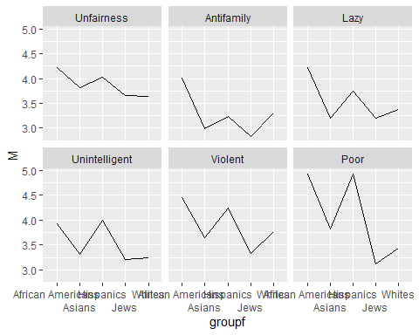

Problem 5a
Here are the sums of squares for this study.
Racial group being rated: 3494
Trait that is being rated: 1510
Subject: 5169
Racial group*trait: 955
Racial group*subject: 5641
Trait*subject: 9063
Racial grouptraitsubject: 9444
Fill in this ANOVA table:
Answer: PARA::Compute df for each effect and divide SS by df for MS. F = MS_{effect}/MS_{error}.
Group: SS=3494, df=4, MS=873.5, F=459.7; Error(A) MS=1.9.
Trait: SS=1510, df=5, MS=302.0, F=120.8; Error(B) MS=2.5.
Group×Trait: SS=955, df=20, MS=47.8, F=68.3; Error(A×B) MS=0.7.
a<-data.frame(Source=c("Racial group","Error","Trait","Error", "Racial group*trait","Error"),
SS=c(NA,NA,NA,NA,NA,NA),
df=c(NA,NA,NA,NA,NA,NA),
MS=c(NA,NA,NA,NA,NA,NA),
Fstat=c(NA,"N/A",NA,"N/A",NA,"N/A"),
Fcrit=c(NA,"N/A",NA,"N/A",NA,"N/A"),
p=c(NA,"N/A",NA,"N/A",NA,"N/A"))
fa<-flextable(a)
fa<-set_caption(fa,
caption="ANOVA table with blank cells")
fa<-width(fa,width=1.00)
fa<- border(fa, border.top = fp_border(color = "orange"))
fa
ANOVA table with blank cells
Source | SS | df | MS | Fstat | Fcrit | p
Racial group
Error |  |  |  | N/A | N/A | N/A
Trait
Error |  |  |  | N/A | N/A | N/A
Racial group*trait
Error |  |  |  | N/A | N/A | N/A

Problem 5b
Calculate the main effects of “Asian” and “unfairness”, and the interaction between “Asian” and “unfairness”. The grand mean across all observations is 3.70.
Answer: α_{asian}=3.47−3.70=−0.23.
• β_{unfairness}=3.87−3.70=+0.17.
• (αβ)_{asian,unfairness}=3.82−3.47−3.87+3.70=+0.18.
Interpretation: Asians are rated slightly less negative overall, but relatively higher on unfairness compared to their overall rating.
em5.group
## groupf emmean SE df lower.CL upper.CL
## African.Americans 4.29 0.0270 725 4.24 4.35
## Asians 3.47 0.0277 725 3.41 3.52
## Hispanics 4.03 0.0240 725 3.99 4.08
## Jews 3.23 0.0272 725 3.17 3.28
## Whites 3.46 0.0247 725 3.41 3.51
##
## Results are averaged over the levels of: traitf
## Confidence level used: 0.95
em5.trait
## traitf emmean SE df lower.CL upper.CL
## Unfairness 3.87 0.0354 725 3.80 3.94
## Antifamily 3.27 0.0332 725 3.21 3.34
## Lazy 3.55 0.0283 725 3.50 3.61
## Unintelligent 3.54 0.0304 725 3.48 3.60
## Violent 3.89 0.0285 725 3.84 3.95
## Poor 4.05 0.0227 725 4.00 4.09
##
## Results are averaged over the levels of: groupf
## Confidence level used: 0.95
em5.cell
## groupf traitf emmean SE df lower.CL upper.CL
## African.Americans Unfairness 4.22 0.0486 725 4.12 4.32
## Asians Unfairness 3.82 0.0451 725 3.74 3.91
## Hispanics Unfairness 4.02 0.0439 725 3.93 4.11
## Jews Unfairness 3.66 0.0464 725 3.57 3.75
## Whites Unfairness 3.63 0.0489 725 3.54 3.73
## African.Americans Antifamily 4.01 0.0485 725 3.92 4.11
## Asians Antifamily 2.99 0.0468 725 2.90 3.08
## Hispanics Antifamily 3.24 0.0488 725 3.14 3.33
## Jews Antifamily 2.84 0.0455 725 2.75 2.93
## Whites Antifamily 3.30 0.0458 725 3.21 3.39
## African.Americans Lazy 4.23 0.0423 725 4.14 4.31
## Asians Lazy 3.20 0.0451 725 3.12 3.29
## Hispanics Lazy 3.75 0.0454 725 3.67 3.84
## Jews Lazy 3.19 0.0425 725 3.11 3.28
## Whites Lazy 3.38 0.0392 725 3.30 3.46
## African.Americans Unintelligent 3.93 0.0404 725 3.85 4.01
## Asians Unintelligent 3.31 0.0432 725 3.23 3.39
## Hispanics Unintelligent 4.01 0.0393 725 3.93 4.08
## Jews Unintelligent 3.20 0.0406 725 3.12 3.28
## Whites Unintelligent 3.24 0.0373 725 3.16 3.31
## African.Americans Violent 4.46 0.0436 725 4.37 4.55
## Asians Violent 3.65 0.0407 725 3.57 3.73
## Hispanics Violent 4.24 0.0398 725 4.17 4.32
## Jews Violent 3.33 0.0432 725 3.25 3.42
## Whites Violent 3.77 0.0394 725 3.69 3.84
## African.Americans Poor 4.92 0.0360 725 4.85 4.99
## Asians Poor 3.82 0.0438 725 3.74 3.91
## Hispanics Poor 4.93 0.0398 725 4.85 5.01
## Jews Poor 3.12 0.0439 725 3.03 3.20
## Whites Poor 3.44 0.0341 725 3.37 3.50
##
## Confidence level used: 0.95

Problem 5c
Interpret these contrasts. Explain what they are testing and assess significance using the appropriate Tukey or Scheffe adjustment.
Answer: C1 Asian vs Jew:: t=10.204 > t* (Tukey)=2.729 → reject (Asians rated more negative overall).
C2 Unfairness vs Antifamily: t=14.826 > t* (Tukey)=2.851 → reject.
C3 Asian vs Jew within Unfairness: t=4.030 > t* (Tukey)=3.312 → reject.
C4 Asian vs Jew within Antifamily: t=12.088 > t* (Tukey)=3.312 → reject.
C5 Interaction: t=0.116 < t* (Scheffé)=5.606 → retain.
em5.group
## groupf emmean SE df lower.CL upper.CL
## African.Americans 4.29 0.0270 725 4.24 4.35
## Asians 3.47 0.0277 725 3.41 3.52
## Hispanics 4.03 0.0240 725 3.99 4.08
## Jews 3.23 0.0272 725 3.17 3.28
## Whites 3.46 0.0247 725 3.41 3.51
##
## Results are averaged over the levels of: traitf
## Confidence level used: 0.95
em5.trait
## traitf emmean SE df lower.CL upper.CL
## Unfairness 3.87 0.0354 725 3.80 3.94
## Antifamily 3.27 0.0332 725 3.21 3.34
## Lazy 3.55 0.0283 725 3.50 3.61
## Unintelligent 3.54 0.0304 725 3.48 3.60
## Violent 3.89 0.0285 725 3.84 3.95
## Poor 4.05 0.0227 725 4.00 4.09
##
## Results are averaged over the levels of: groupf
## Confidence level used: 0.95
em5.cell
## groupf traitf emmean SE df lower.CL upper.CL
## African.Americans Unfairness 4.22 0.0486 725 4.12 4.32
## Asians Unfairness 3.82 0.0451 725 3.74 3.91
## Hispanics Unfairness 4.02 0.0439 725 3.93 4.11
## Jews Unfairness 3.66 0.0464 725 3.57 3.75
## Whites Unfairness 3.63 0.0489 725 3.54 3.73
## African.Americans Antifamily 4.01 0.0485 725 3.92 4.11
## Asians Antifamily 2.99 0.0468 725 2.90 3.08
## Hispanics Antifamily 3.24 0.0488 725 3.14 3.33
## Jews Antifamily 2.84 0.0455 725 2.75 2.93
## Whites Antifamily 3.30 0.0458 725 3.21 3.39
## African.Americans Lazy 4.23 0.0423 725 4.14 4.31
## Asians Lazy 3.20 0.0451 725 3.12 3.29
## Hispanics Lazy 3.75 0.0454 725 3.67 3.84
## Jews Lazy 3.19 0.0425 725 3.11 3.28
## Whites Lazy 3.38 0.0392 725 3.30 3.46
## African.Americans Unintelligent 3.93 0.0404 725 3.85 4.01
## Asians Unintelligent 3.31 0.0432 725 3.23 3.39
## Hispanics Unintelligent 4.01 0.0393 725 3.93 4.08
## Jews Unintelligent 3.20 0.0406 725 3.12 3.28
## Whites Unintelligent 3.24 0.0373 725 3.16 3.31
## African.Americans Violent 4.46 0.0436 725 4.37 4.55
## Asians Violent 3.65 0.0407 725 3.57 3.73
## Hispanics Violent 4.24 0.0398 725 4.17 4.32
## Jews Violent 3.33 0.0432 725 3.25 3.42
## Whites Violent 3.77 0.0394 725 3.69 3.84
## African.Americans Poor 4.92 0.0360 725 4.85 4.99
## Asians Poor 3.82 0.0438 725 3.74 3.91
## Hispanics Poor 4.93 0.0398 725 4.85 5.01
## Jews Poor 3.12 0.0439 725 3.03 3.20
## Whites Poor 3.44 0.0341 725 3.37 3.50
##
## Confidence level used: 0.95
group.contrast5<-c(0,1,0,-1,0)
trait.contrast5<-c(1,-1,0,0,0,0)
cell.contrast5.1<-c(0,1,0,-1,0, # unfairness
0,0,0,0,0, # anti-family
0,0,0,0,0, # lazy
0,0,0,0,0, # unintelligent
0,0,0,0,0, # violent
0,0,0,0,0) # poor
cell.contrast5.2<-c(0,0,0,0,0, # unfairness
0,1,0,-1,0, # anti-family
0,0,0,0,0, # lazy
0,0,0,0,0, # unintelligent
0,0,0,0,0, # violent
0,1,0,-1,0) # poor
cell.contrast5.3<-c(0,1,0,-1,0, # unfairness
0,-1,0,1,0, # anti-family
0,0,0,0,0, # lazy
0,0,0,0,0, # unintelligent
0,0,0,0,0, # violent
0,0,0,0,0) # poor
group.list5<-list(group.contrast5)
trait.list5<-list(trait.contrast5)
cell.list5<-list(cell.contrast5.1,cell.contrast5.2,cell.contrast5.3)
contrast(em5.group,group.list5)
## contrast estimate SE df t.ratio p.value
## c(0, 1, 0, -1, 0) 0.242 0.0237 725 10.204 <0.0001
##
## Results are averaged over the levels of: traitf
contrast(em5.trait,trait.list5)
## contrast estimate SE df t.ratio p.value
## c(1, -1, 0, 0, 0, 0) 0.598 0.0403 725 14.826 <0.0001
##
## Results are averaged over the levels of: groupf
contrast(em5.cell,cell.list5)
## contrast estimate
## c(0, 1, 0, -1, 0, 0, 0, 0, 0, 0, 0, 0, 0, 0, 0, 0, 0, 0, 0, 0, 0.15978
## c(0, 0, 0, 0, 0, 0, 1, 0, -1, 0, 0, 0, 0, 0, 0, 0, 0, 0, 0, 0, 0.85813
## c(0, 1, 0, -1, 0, 0, -1, 0, 1, 0, 0, 0, 0, 0, 0, 0, 0, 0, 0, 0.00551
## SE df t.ratio p.value
## 0.0396 725 4.030 <0.0001
## 0.0710 725 12.088 <0.0001
## 0.0473 725 0.116 0.9074
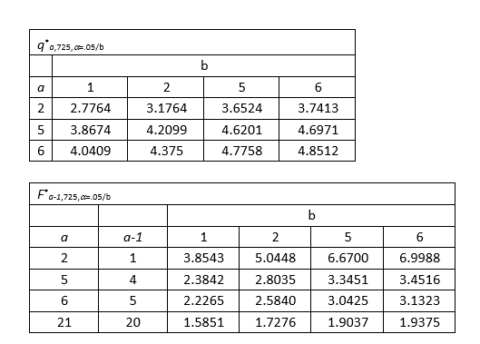

Problem 6
We are looking at subjects’ ability to recall characters in a string based on (a) the type of string (digits/letters/mixed – within-subject factor) and (b) the type of brain damage the subject suffered (left brain / right brain / control – between-subject factor). The experiment is using a 3×3 design; n = 18. Note: when we tested assumptions we found equality of variances as well as equality of the covariance/variance matrices.
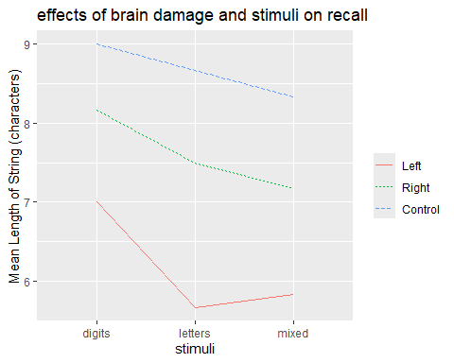

Problem 6a
Calculate the effects of “right brain”, “mixed”, and “right brain-mixed”. The grand mean across all subjects and observations is 7.48 characters.
Answer: α_{right}=7.61−7.48=+0.13; β_{mixed}=7.11−7.48=−0.37; (αβ)_{right,mixed}=7.17−7.61−7.11+7.48=−0.07.
Interpretation: Right‑brain group is slightly above average; mixed stimuli reduce recall; interaction is tiny.
em6.damage
## damagef emmean SE df lower.CL upper.CL
## Left 6.17 0.254 15 5.62 6.71
## Right 7.61 0.254 15 7.07 8.15
## Control 8.67 0.254 15 8.12 9.21
##
## Results are averaged over the levels of: stimuli
## Confidence level used: 0.95
em6.stimuli
## stimuli emmean SE df lower.CL upper.CL
## digits 8.06 0.218 15 7.59 8.52
## letters 7.28 0.259 15 6.72 7.83
## mixed 7.11 0.251 15 6.58 7.65
##
## Results are averaged over the levels of: damagef
## Confidence level used: 0.95
em6.cell
## damagef stimuli emmean SE df lower.CL upper.CL
## Left digits 7.00 0.378 15 6.20 7.80
## Right digits 8.17 0.378 15 7.36 8.97
## Control digits 9.00 0.378 15 8.20 9.80
## Left letters 5.67 0.449 15 4.71 6.62
## Right letters 7.50 0.449 15 6.54 8.46
## Control letters 8.67 0.449 15 7.71 9.62
## Left mixed 5.83 0.435 15 4.91 6.76
## Right mixed 7.17 0.435 15 6.24 8.09
## Control mixed 8.33 0.435 15 7.41 9.26
##
## Confidence level used: 0.95

Problem 6b
Fill in this ANOVA table.
Answer: Damage:: MS=28.50, F=23.8 (error MS=1.20).
Stimuli: MS=4.50, F=4.4 (error MS=1.02).
Damage×Stimuli: MS=0.50, F=0.5 (error MS=1.02).
Damage SS: 57
Stimuli SS: 9
Subject SS: 17.4
Damage*Stimuli SS: 2
Subject*Stimuli SS: 30.6
a<-data.frame(Source=c("Damage group","Error","Stimuli","Error", "Damage*stimuli","Error"),
SS=c(NA,NA,NA,NA,NA,NA),
df=c(NA,NA,NA,NA,NA,NA),
MS=c(NA,NA,NA,NA,NA,NA),
Fstat=c(NA,"N/A",NA,"N/A",NA,"N/A"),
Fcrit=c(NA,"N/A",NA,"N/A",NA,"N/A"),
p=c(NA,"N/A",NA,"N/A",NA,"N/A"))
fa<-flextable(a)
fa<-set_caption(fa,
caption="ANOVA table with blank cells")
fa<-width(fa,width=1.00)
fa<- border(fa, border.top = fp_border(color = "orange"))
fa
ANOVA table with blank cells
Source | SS | df | MS | Fstat | Fcrit | p
Damage group
Error |  |  |  | N/A | N/A | N/A
Stimuli
Error |  |  |  | N/A | N/A | N/A
Damage*stimuli
Error |  |  |  | N/A | N/A | N/A

Problem 6c
For each contrast: (a) identify the type of contrast; (b) write the null hypothesis that contrast is testing; (c) calculate the appropriate posthoc-adjusted critical value; and (d) interpret the contrast, including directionality. (you should be able to explain exactly what comparison the contrast is referring to). (use the Tukey adjustment for pairwise contrasts; use the Scheffe adjustment for complex contrasts).
Answer: 1) Damage main effect:: ψ̂=3.94, t=6.335, t* (Scheffé)=2.714 → reject. Left damage worse than (right+control).
2) Stimuli main effect: ψ̂=0.944, t=3.034, t* (Scheffé)=2.714 → reject. Digits > mixed.
3) Simple effect (digits): ψ̂=3.167, t=3.424, t* (Scheffé)=3.300 → reject.
4) Simple effect (mixed): ψ̂=3.833, t=3.601, t* (Scheffé)=3.300 → reject.
5) Interaction contrast: ψ̂=−0.667, t=−0.505, t* (Scheffé)=3.496 → retain.
em6.damage
## damagef emmean SE df lower.CL upper.CL
## Left 6.17 0.254 15 5.62 6.71
## Right 7.61 0.254 15 7.07 8.15
## Control 8.67 0.254 15 8.12 9.21
##
## Results are averaged over the levels of: stimuli
## Confidence level used: 0.95
em6.stimuli
## stimuli emmean SE df lower.CL upper.CL
## digits 8.06 0.218 15 7.59 8.52
## letters 7.28 0.259 15 6.72 7.83
## mixed 7.11 0.251 15 6.58 7.65
##
## Results are averaged over the levels of: damagef
## Confidence level used: 0.95
em6.cell
## damagef stimuli emmean SE df lower.CL upper.CL
## Left digits 7.00 0.378 15 6.20 7.80
## Right digits 8.17 0.378 15 7.36 8.97
## Control digits 9.00 0.378 15 8.20 9.80
## Left letters 5.67 0.449 15 4.71 6.62
## Right letters 7.50 0.449 15 6.54 8.46
## Control letters 8.67 0.449 15 7.71 9.62
## Left mixed 5.83 0.435 15 4.91 6.76
## Right mixed 7.17 0.435 15 6.24 8.09
## Control mixed 8.33 0.435 15 7.41 9.26
##
## Confidence level used: 0.95
damage.contrast6<-c(-2,1,1)
stimuli.contrast6<-c(1,0,-1)
cell.contrast6.1<-c(-2,1,1,0,0,0,0,0,0)
cell.contrast6.2<-c(0,0,0,0,0,0,-2,1,1)
cell.contrast6.3<-c(-2,1,1,0,0,0,2,-1,-1)
damage6.list<-list(damage.contrast6)
stimuli6.list<-list(stimuli.contrast6)
cell6.list<-list(cell.contrast6.1,cell.contrast6.2,cell.contrast6.3)
contrast(em6.damage,damage6.list)
## contrast estimate SE df t.ratio p.value
## c(-2, 1, 1) 3.94 0.623 15 6.335 <0.0001
##
## Results are averaged over the levels of: stimuli
contrast(em6.stimuli,stimuli6.list)
## contrast estimate SE df t.ratio p.value
## c(1, 0, -1) 0.944 0.311 15 3.034 0.0084
##
## Results are averaged over the levels of: damagef
contrast(em6.cell,cell6.list)
## contrast estimate SE df t.ratio p.value
## c(-2, 1, 1, 0, 0, 0, 0, 0, 0) 3.167 0.925 15 3.424 0.0038
## c(0, 0, 0, 0, 0, 0, -2, 1, 1) 3.833 1.060 15 3.601 0.0026
## c(-2, 1, 1, 0, 0, 0, 2, -1, -1) -0.667 1.320 15 -0.505 0.6211
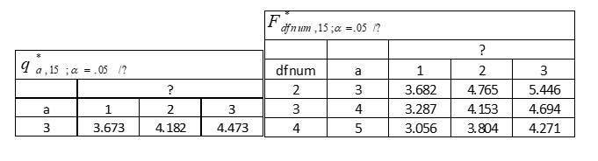 ## Solutions

Problem 1
First Grade Reading Scores (z) By Family Income and Parental Education
Parental Education | <$75,000 | $75,001+
Less than BA | -0.24 | 0.19
 | (n=6668) | (n=1424)
BA+ | 0.30 | 0.50
 | (n=1437) | (n=2916)

Type I approach:
We have to construct weighted averages.
Low-income mean: (-.246668 + .301437)/(6668+1437) = -.14 SD
High-income mean: (.191424 + .502916)/(1424+2916) = .40SD
Difference: .40 - -.14 = .54 SD
On average, children from high-income families have reading scores that is .54 SD higher than children from low-income families, if we ignore the fact that these two groups have different distributions of parental education.

Type III approach:
Low-income mean: (-.24 + .30)/2 = .03
High income mean: (.19+.50)/2 = .35
Difference: .35 - .03 = .32

Wrap-Up
On average, if we envisioned a world where low-income and high-income families had the same distribution of parental education, we would see that high-income children score better on the reading test by .32 SD.
If we compare these differences, we see that the Type I approach is larger than the Type III approach. The Type III approach yields an effect that is 41% smaller than the Type I approach. The Type I approach gives us an effect that is not a “pure” income effect. It is picking up also a parental education effect (although the purer income effect using the Type III approach is also quite sizable!)

Problem 2

Problem 2a
A 2 × 3 ANOVA of subjects’ evaluation that the government is violating the double jeopardy clause in the constitution shows a significant interaction between subjects’ political orientation and the experimental condition, F(2,54) = 16.716, p<.001, but no significant main effects of political orientation or the experimental condition (ps>.05). The effect of treatment is marginally significant however, F(1,54) = 4.010, p=.51.

Problem 2b
On average, subjects reported a stronger case for double jeopardy when the hypothetical officer was white (M = 3.29) than when the officer is black (M = 2.61). However, this is not a consistent main effect; we see this pattern only for conservatives but not for liberals or moderates.

Problem 2c
On average, moderate subjects (M=3.38) reported a stronger case for double jeopardy than liberal (M = 2.55) or conservative (M=2.94) subjects . This is not a consistent main effect; we do not see this Moderate > Conservative > Liberal pattern for either the black officer condition (moderate > liberal > conservative) or the white officer condition ( conservative > moderate > liberal).

Problem 2d
Liberal subjects report a stronger case for double jeopardy when the hypothetical officer is black (M=3.19) than when the officer is white (M=1.91); conservatives have the opposite pattern (Ms=1.25 vs 4.62, respectively); and moderates make a similar case for double jeopardy regardless of the officer rate (Ms = 3.40 vs 3.35, respectively).

Problem 2e
Let’s make the alphas the race of the officer factor and the betas the political views factor.
Grand mean = 2.95
$\hat{α_{black}}$ = 2.61-2.95 = -.34 $\hat{α_{white}}$ = 3.29-2.95 = +.34 $\hat{β_{liberal}}$ = 2.55-2.95 = -.4 $\hat{β_{moderate}}$ = 3.38-2.95 = .43 $\hat{β_{conservative}}$ = 2.94-2.95 = -.01 $\hat{αβ_{black,liberal}}$ = 3.19-2.61-2.55+2.95 =0.98 $\hat{αβ_{black,moderate}}$ = 3.4-2.61-3.38+2.95=0.36 $\hat{αβ_{black,conservative}}$ = 1.25-2.61-2.94+2.95=-1.35 $\hat{αβ_{white,liberal}}$=1.91-3.29-2.55+2.95=-0.98 $\hat{αβ_{white,moderate}}$=3.35-3.29-3.38+2.95=-0.37 $\hat{αβ_{white,conservative}}$=4.62-3.29-2.94+2.95=1.34

Problem 2f
e_{ijk} = 7-1.25 = 5.75

Problem 2g
Answer: PARA::Simple effect of officer race within conservatives.
H₀: μ_{cons,white}−μ_{cons,black}=0.
ψ̂: 4.62−1.25=3.37.
SE: √(MS_{error}·(1/10+1/10)), MS_{error}=1.73.
t: 5.73.
t* (Tukey): q_{2,54,α/3}/√2 = 2.471.
Decision: Reject H₀. Conservatives rate white officers higher by 3.37 points.
Simple effect of officer race by orientation.
psihat=4.62-1.25= 3.37
Conservative subjects indicated stronger agreement that there is double-jeopardy when the officer is white than when the officer is black by 3.37 points.
$t=\frac{3.37}{1.734\left(\frac{1}{10}+\frac{1}{10}\right)}=5.7226$
t crit=$\frac{q_{2,54,α=.05/3}}{\sqrt{2}}=\frac{3.4943}{\sqrt{2}}=2.4708$
q2,54,=.05/3 /sqrt(2)=3.4943/sqrt(2) = 2.4708 We reject the null hypothesis.

Problem 2h
Answer: PARA::Interaction contrast (difference of simple effects).
H₀: (μ_{cons,white}−μ_{cons,black}) − (μ_{lib,white}−μ_{lib,black}) = 0.
ψ̂: 4.65; t=5.58.
t* (Scheffé): √(2·F_{2,54,0.05})=2.517.
Decision: Reject H₀. The officer‑race effect is much larger for conservatives than liberals.
Interaction contrast.
psihat= 4.62-1.25-1.91+3.19=4.65
Conservatives are more likely to agree that there is double-jeopardy when the hypothetical officer is white than when the officer is black by 3.37 points; liberals are less likely to agree that there is double-jeopardy when the officer is white than when the officer is black by 1.28 points. In other words, the “white officer” effect is +3.37 points for conservatives; it is -1.28 for liberals. The difference between these two effects of officer race for liberals and conservatives is 4.65 points (3.37 - -1.28 = 4.65).
$t=\frac{4.65}{\sqrt{1.734\left(\frac{1}{10}+\frac{1}{10}+\frac{1}{10}+\frac{1}{10}\right)}}=5.5834$
t-crit = sqrt(2F_{2,54,a=.05}) = sqrt(2*3.1682) = 2.5172
We reject the null hypothesis.

Problem 2i
Answer: PARA::Simple effect of ideology within white‑officer condition (complex contrast).
H₀: μ_{cons,white}+μ_{mod,white}−2μ_{lib,white}=0.
ψ̂: 4.15; t=4.07.
t* (Scheffé): √(2·F_{2,54,0.05/2})=2.812.
Decision: Reject H₀. Under white officers, conservatives+moderates > liberals.
Simple effect of ideology by officer race. psihat = 3.35+4.62-2*1.91=4.15
Conservatives and moderates are on average agree that there is double jeopardy for the white officer than liberals by 2.08 points (4.15*2/4).
$t=\frac{4.15}{1.734\left(\frac{1}{10}+\frac{1}{10}+\frac{4}{10}\right)}=4.0686$
t-crit= sqrt(2F_{2,54,a=.05/2})=sqrt(2*3.9528)=2.8117
We reject the null hypothesis.

Problem 3

Problem 3a
Calculating the fixed effects: for the race factor:
Grand mean is (3.05+2.46+3.99)/3=3.17
$\hat{α_{black}}$ = 3.05-3.17 = -.12
$\hat{α_{hispanic}}$ = 2.46-3.17 = -.71
$\hat{α_{white}}$ = 3.99-3.17 = .82

Problem 3b

Contrast 1
$H_{0}:\left(1\right){\hat{α}}_{black}+\left(−1\right){\hat{α}}_{hispanic}+\left(0\right){\hat{α}}_{white}=0$
tcrit: $t^{*}=\frac{3,302}{\sqrt{2}}≈\frac{q_{3,120}}{\sqrt{2}}=\frac{3.36}{\sqrt{2}}=2.47$
African-Americans give African Americans a significantly higher laziness rating than they do Hispanic people.

Contrast 2
$H_{0}:\left(−1\right){\hat{α}}_{black}+\left(−1\right){\hat{α}}_{hispanic}+\left(2\right){\hat{α}}_{white}=0$
tcrit: $t^{*}=\frac{3,302}{\sqrt{2}}≈\frac{q_{3,120}}{\sqrt{2}}=\frac{3.36}{\sqrt{2}}=2.47$
African-Americans give white people a significantly higher laziness rating than they do Black people and Hispanic people.
African-Americans give African Americans a significantly higher rating than they do Hispanic people.

Problem 4

problem 4a
Grand mean: (1.68+1.42+.97+.88)/4=4.95/4=1.24
$\hat{α_{face}}=1.68−1.24=+.44$
$\hat{α_{circles}}=1.42−1.24=+.18$
$\hat{α_{newspaper}}=0.97−1.24=−.27$
$\hat{α_{whitecircle}}=.88−1.24=−.36$

Problem 4b

Contrast 1
$H_0: (0){face} + (1){circles} + (-1){newspaper} + (0){whitecircle}=0 $
Contrast value: The infants looked at the circles longer than the newspaper on average by .45 seconds.
t-crit:
$t*=\frac{q_{4,13,α=.05}}{\sqrt{(}2)}=\frac{4.15}{\sqrt{(}2)}=2.93$
We RETAIN the null hypothesis.

Contrast 2
$H_0: (1){face} + (1){circles} + (-1){newspaper} + (-1){whitecircle}=0 $
Contrast value: On average the infants looked at the face and circles longer than the newspaper and white circle by .625 seconds (1.25*4/2).
$t^{*}=\sqrt{3F_{3,13,α=.05}}=\sqrt{\left(3*3.4105\right)}=3.20$
We REJECT the null hypothesis.

Problem 5

Problem 5a
a<-data.frame(Source=c("Racial group","Error","Trait","Error", "Racial group*trait","Error"),
SS=c(3494,5641,1510,9063,955,9444),
df=c("4","725*4=2900","5","725*5=3625","20","725*20=14500"),
MS=c(873.5,1.9,302,2.5,47.8,.7),
Fstat=c("459.7","N/A","120.8","N/A","68.3","N/A"),
Fcrit=c("2.4472 [F(4,120)]","N/A","2.2899 [F(5,120)]","N/A","1.9588 [F(9,120)]","N/A"),
p=c("<.05","N/A","<.05","N/A","<.05","N/A"))
fa<-flextable(a)
fa<-set_caption(fa,
caption="ANOVA table with filled-in cells")
fa<-width(fa,width=1)
fa<- border(fa, border.top = fp_border(color = "orange"))
fa
ANOVA table with filled-in cells
Source | SS | df | MS | Fstat | Fcrit | p
Racial group | 3,494 | 4 | 873.5 | 459.7 | 2.4472 [F(4,120)] | <.05
Error | 5,641 | 725*4=2900 | 1.9 | N/A | N/A | N/A
Trait | 1,510 | 5 | 302.0 | 120.8 | 2.2899 [F(5,120)] | <.05
Error | 9,063 | 725*5=3625 | 2.5 | N/A | N/A | N/A
Racial group*trait | 955 | 20 | 47.8 | 68.3 | 1.9588 [F(9,120)] | <.05
Error | 9,444 | 725*20=14500 | 0.7 | N/A | N/A | N/A

Problem 5b
em5.group
## groupf emmean SE df lower.CL upper.CL
## African.Americans 4.29 0.0270 725 4.24 4.35
## Asians 3.47 0.0277 725 3.41 3.52
## Hispanics 4.03 0.0240 725 3.99 4.08
## Jews 3.23 0.0272 725 3.17 3.28
## Whites 3.46 0.0247 725 3.41 3.51
##
## Results are averaged over the levels of: traitf
## Confidence level used: 0.95
em5.trait
## traitf emmean SE df lower.CL upper.CL
## Unfairness 3.87 0.0354 725 3.80 3.94
## Antifamily 3.27 0.0332 725 3.21 3.34
## Lazy 3.55 0.0283 725 3.50 3.61
## Unintelligent 3.54 0.0304 725 3.48 3.60
## Violent 3.89 0.0285 725 3.84 3.95
## Poor 4.05 0.0227 725 4.00 4.09
##
## Results are averaged over the levels of: groupf
## Confidence level used: 0.95
em5.cell
## groupf traitf emmean SE df lower.CL upper.CL
## African.Americans Unfairness 4.22 0.0486 725 4.12 4.32
## Asians Unfairness 3.82 0.0451 725 3.74 3.91
## Hispanics Unfairness 4.02 0.0439 725 3.93 4.11
## Jews Unfairness 3.66 0.0464 725 3.57 3.75
## Whites Unfairness 3.63 0.0489 725 3.54 3.73
## African.Americans Antifamily 4.01 0.0485 725 3.92 4.11
## Asians Antifamily 2.99 0.0468 725 2.90 3.08
## Hispanics Antifamily 3.24 0.0488 725 3.14 3.33
## Jews Antifamily 2.84 0.0455 725 2.75 2.93
## Whites Antifamily 3.30 0.0458 725 3.21 3.39
## African.Americans Lazy 4.23 0.0423 725 4.14 4.31
## Asians Lazy 3.20 0.0451 725 3.12 3.29
## Hispanics Lazy 3.75 0.0454 725 3.67 3.84
## Jews Lazy 3.19 0.0425 725 3.11 3.28
## Whites Lazy 3.38 0.0392 725 3.30 3.46
## African.Americans Unintelligent 3.93 0.0404 725 3.85 4.01
## Asians Unintelligent 3.31 0.0432 725 3.23 3.39
## Hispanics Unintelligent 4.01 0.0393 725 3.93 4.08
## Jews Unintelligent 3.20 0.0406 725 3.12 3.28
## Whites Unintelligent 3.24 0.0373 725 3.16 3.31
## African.Americans Violent 4.46 0.0436 725 4.37 4.55
## Asians Violent 3.65 0.0407 725 3.57 3.73
## Hispanics Violent 4.24 0.0398 725 4.17 4.32
## Jews Violent 3.33 0.0432 725 3.25 3.42
## Whites Violent 3.77 0.0394 725 3.69 3.84
## African.Americans Poor 4.92 0.0360 725 4.85 4.99
## Asians Poor 3.82 0.0438 725 3.74 3.91
## Hispanics Poor 4.93 0.0398 725 4.85 5.01
## Jews Poor 3.12 0.0439 725 3.03 3.20
## Whites Poor 3.44 0.0341 725 3.37 3.50
##
## Confidence level used: 0.95
${\hat{α}}_{Asian}=3.47−3.70=−0.23$
${\hat{β}}_{unfairness}=3.87−3.70=.17$
${\hat{αβ}}_{Asian,unfairness}=3.82−3.47−3.87+3.70=0.18$

Problem 5c

Contrast 1
Main effect, racial group.
Null: $H_{0}:\left(0\right)α_{Black}+\left(1\right)α_{Asian}+\left(0\right)α_{Hispanic}+\left(−1\right)α_{Jew}+\left(0\right)α_{White}$
t-crit: $t^{*}=\frac{q_{5,725,α=.05}}{\sqrt{2}}=\frac{3.8674}{\sqrt{2}}=2.7347$
Non-Hispanic, Non-Jewish white people rate Asians significantly more negatively than Jews.

Contrast 2
Main effect, trait
Null:
$H_{0}:\left(1\right)β_{unfairness}+\left(−1\right)β_{antifamily}+\left(0\right)β_{lazy}+\left(0\right)α_{unintelligent}+\left(0\right)β_{violent}+\left(0\right)β_{poor}=0$
t-crit: $t^{*}=\frac{q_{6,725,α=.05}}{\sqrt{2}}=\frac{4.0409}{\sqrt{2}}=2.8573$
Non-Hispanic, Non-Jewish white people tend to rate all groups significantly higher on “unfairness” than “antifamily-ness”.

Contrast 3
Simple effect of racial group by trait
$H_{0}:\left(1\right)αβ_{Asian,unfairness}+\left(−1\right)αβ_{Jew,unfairness}=0$
t-crit: $t^{*}=\frac{q_{5,725,α=.05/6}}{\sqrt{2}}=\frac{4.6971}{\sqrt{2}}=3.3214$
Non-Hispanic, Non-Jewish White people significantly rate Asians higher on unfairness than Jews.

Contrast 4
Simple effect of racial group by trait
$H_{0}:\left(1\right)αβ_{Asian,antifamily}+\left(−1\right)αβ_{Jew,antifamily}=0$
t-crit: $t^{*}=\frac{q_{5,725,α=.05/6}}{\sqrt{2}}=\frac{4.6971}{\sqrt{2}}=3.3214$
Non-Hispanic, Non-Jewish White people significantly rate Asians higher on “antifamily-ness” than Jews.

Contrast 5
Interaction
$H_{0}:\left(1\right)αβ_{Asian,unfairness}+\left(−1\right)αβ_{Jew,unfairness}+\left(−1\right)αβ_{Asian,antifamily}+\left(1\right)αβ_{Jew,antifamily}=0$
t-crit: $t^{*}=\sqrt{\left(5−1\right)\left(6−1\right)F_{\left(5−1\right)\left(6−1\right),725,α=.05}}=\sqrt{20*1.5851}=5.6305$
Non-Hispanic, Non-Jewish White people rate Asians more negatively than Jews on both “unfairness” and “antifamilyness” as seen above. For “unfairness”, Asians are rated more negatively by .16 points, and for “antifamilyness”, Asians are rated more negatively by .15 points, and the difference between these two effects is not significant.

Problem 6

Problem 6a
em6.damage
## damagef emmean SE df lower.CL upper.CL
## Left 6.17 0.254 15 5.62 6.71
## Right 7.61 0.254 15 7.07 8.15
## Control 8.67 0.254 15 8.12 9.21
##
## Results are averaged over the levels of: stimuli
## Confidence level used: 0.95
em6.stimuli
## stimuli emmean SE df lower.CL upper.CL
## digits 8.06 0.218 15 7.59 8.52
## letters 7.28 0.259 15 6.72 7.83
## mixed 7.11 0.251 15 6.58 7.65
##
## Results are averaged over the levels of: damagef
## Confidence level used: 0.95
em6.cell
## damagef stimuli emmean SE df lower.CL upper.CL
## Left digits 7.00 0.378 15 6.20 7.80
## Right digits 8.17 0.378 15 7.36 8.97
## Control digits 9.00 0.378 15 8.20 9.80
## Left letters 5.67 0.449 15 4.71 6.62
## Right letters 7.50 0.449 15 6.54 8.46
## Control letters 8.67 0.449 15 7.71 9.62
## Left mixed 5.83 0.435 15 4.91 6.76
## Right mixed 7.17 0.435 15 6.24 8.09
## Control mixed 8.33 0.435 15 7.41 9.26
##
## Confidence level used: 0.95
${\hat{α}}_{right}=7.61−7.48=+.13$
${\hat{β}}_{mixed}=7.11−7.48=−.37$
${\hat{αβ}}_{right,mixed}=7.17−7.61−7.11+7.48=−.07$

Problem 6b
a<-data.frame(Source=c("Damage group","Error","Stimuli","Error", "Damage*stimuli","Error"),
SS=c(57,17.4,9,30.6,2,30.6),
df=c(2,15,2,30,4,30),
MS=c(28.5,1.2,4.5,1.02,.5,1.02),
Fstat=c(23.8,"N/A",4.4,"N/A",.5,"N/A"),
Fcrit=c(NA,"N/A",NA,"N/A",NA,"N/A"),
p=c(NA,"N/A",NA,"N/A",NA,"N/A"))
fa<-flextable(a)
fa<-set_caption(fa,
caption="ANOVA table with filled-in cells")
fa<-width(fa,width=1.00)
fa<- border(fa, border.top = fp_border(color = "orange"))
fa
ANOVA table with filled-in cells
Source | SS | df | MS | Fstat | Fcrit | p
Damage group | 57.0 | 2 | 28.50 | 23.8
Error | 17.4 | 15 | 1.20 | N/A | N/A | N/A
Stimuli | 9.0 | 2 | 4.50 | 4.4
Error | 30.6 | 30 | 1.02 | N/A | N/A | N/A
Damage*stimuli | 2.0 | 4 | 0.50 | 0.5
Error | 30.6 | 30 | 1.02 | N/A | N/A | N/A

Problem 6c

Contrast 1
Main effect of damage (between-subject factor)
$H_{0}:\left(−2\right)α_{left}+\left(1\right)α_{right}+\left(1\right)α_{control}$
t-crit: $t^{*}=\sqrt{\left(3−1\right)F_{3−1,15,α=.05}}=\sqrt{2*3.682}=2.71$
Subjects with left-brain damage recalled significantly fewer characters than a combined group consisting of subjects with right-brain damage and control subjects.

Contrast 2
Main effect of stimuli (within-subject factor)
$H_{0}:\left(−1\right)β_{digits}+\left(0\right)β_{letters}+\left(1\right)β_{mixed}=0$
t-crit: $t^{*}=\sqrt{\left(3−1\right)F_{3−1,15,α=.05}}=\sqrt{2*3.682}=2.71$
Subjects recalled significantly more characters when the stimuli was digits only, as opposed to a mixture of digits and strings.

Contrast 3
Simple effect of damage by stimuli
$H_{0}:\left(−2\right)αβ_{left,digits}+\left(1\right)αβ_{right,digits}+\left(1\right)αβ_{control,digits}=0$
t-crit: $t^{*}=\sqrt{\left(3−1\right)F_{3−1,15,α=.05/3}}=\sqrt{2*5.446}=3.3003$
When digits are the stimuli, subjects with left-brain damage recalled significantly fewer characters than a combined group of right-brain damaged subjects and control subjects.

Contrast 4
Simple effect of damage by stimuli
$H_{0}:\left(−2\right)αβ_{left,mixed}+\left(1\right)αβ_{right,mixed}+\left(1\right)αβ_{control,mixed}=0$
t-crit: $t^{*}=\sqrt{\left(3−1\right)F_{3−1,15,α=.05/3}}=\sqrt{2*5.446}=3.3003$
When mixed characters are the stimuli, subjects with left-brain damage recalled significantly fewer characters than a combined group of right-brain damaged subjects and control subjects.

Contrast 5
Interaction
$H_{0}:\left(−2\right)αβ_{left,digits}+\left(1\right)αβ_{right,digits}+\left(1\right)αβ_{control,digits}+\left(+2\right)αβ_{left,mixed}+\left(−1\right)αβ_{right,mixed}+\left(−1\right)αβ_{control,mixed}=0$
t-crit: $t^{*}=\sqrt{\left(3−1\right)\left(3−1\right)F_{\left(3−1\right)\left(3−1\right),15,α=.05}}=\sqrt{4*3.056}=3.4963$
Regardless if the stimuli is pure digits or mixed characters, left-brain damaged subjects did worse than a combined group of right-brain damaged subjects and control subjects. The effect is slightly larger for mixed characters (M_{DIF}=1.9 characters) than for digits (M_{DIF}=1.6 characters), but the difference between these effects is not significant.

END END END END END END END END END END

