Lab Session 25 ANSWER KEY
Joshua Klugman

Multiple Regression, Spuriousness, and Mediation
We will be using data from the Early Childhood Longitudinal Study (ECLS) data, a cohort of kindergarteners from the 1998-1999 school year. We are interested in examining the association between general knowledge scores and parental warmth in schools. We want to see if it is spurious (caused by parental education and marital status) and if it’s mediated by other variables (parental involvement in schools, cognitively stimulating materials).
We suspect that parental education and marital status may affect both parental investment and children’s cognition scores. We also suspect that warmth may explain the effect of parental investment on general knowledge scores.
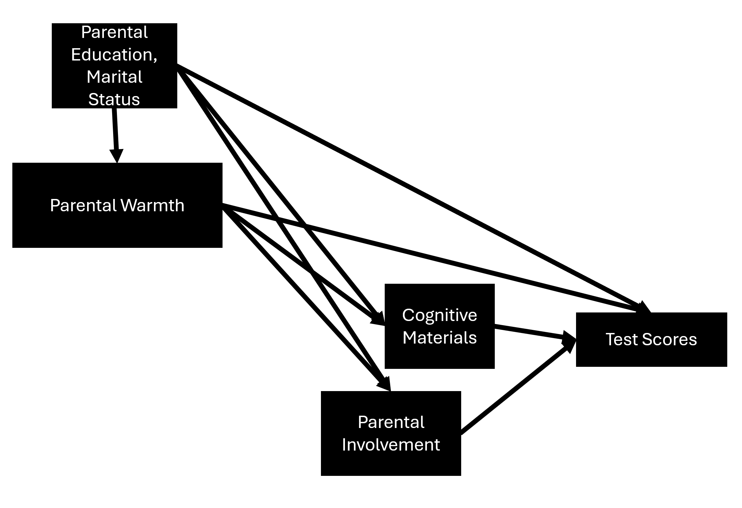

1. Set working directory and load packages
# packages
library(tidyverse)
library(psych)
library(stargazer)
library(haven)

Answer
# packages
library(tidyverse)
## ── Attaching core tidyverse packages ──────────────────────── tidyverse 2.0.0 ──
## ✔ dplyr 1.1.4 ✔ readr 2.1.6
## ✔ forcats 1.0.1 ✔ stringr 1.6.0
## ✔ ggplot2 4.0.1 ✔ tibble 3.3.0
## ✔ lubridate 1.9.4 ✔ tidyr 1.3.2
## ✔ purrr 1.2.0
## ── Conflicts ────────────────────────────────────────── tidyverse_conflicts() ──
## ✖ dplyr::filter() masks stats::filter()
## ✖ dplyr::lag() masks stats::lag()
## ℹ Use the conflicted package (<http://conflicted.r-lib.org/>) to force all conflicts to become errors
library(psych)
##
## Attaching package: 'psych'
##
## The following objects are masked from 'package:ggplot2':
##
## %+%, alpha
library(stargazer)
##
## Please cite as:
##
## Hlavac, Marek (2022). stargazer: Well-Formatted Regression and Summary Statistics Tables.
## R package version 5.2.3. https://CRAN.R-project.org/package=stargazer
library(haven)

2. Load data
load("ecls_labsession25.rda")

Answer
load("ecls_labsession25.rda")

3. Get summary statistics for all variables
describe(ecls)

Answer
describe(ecls)
## vars n mean sd median trimmed mad min
## childid* 1 21260 10630.50 6137.38 10630.50 10630.50 7880.02 1.00
## race* 2 21190 2.19 1.75 1.00 1.84 0.00 1.00
## c2rtscor 3 18937 50.62 9.91 51.46 50.86 9.17 14.93
## c2mtscor 4 19649 50.59 9.90 50.81 50.86 9.82 11.78
## c2gtscor 5 18903 50.35 10.04 50.86 50.56 10.18 15.90
## p1hmemp* 6 17627 2.16 1.28 2.00 2.08 1.48 1.00
## p2marsta* 7 18942 1.91 1.55 1.00 1.60 0.00 1.00
## wkpared* 8 20141 4.70 1.94 5.00 4.61 2.97 1.00
## wkincome 9 20141 52039.89 56398.95 40000.00 43974.95 31134.60 0.00
## foodsec 10 18860 0.00 0.78 0.31 0.21 0.00 -6.37
## meddummy* 11 18769 1.75 0.43 2.00 1.81 0.00 1.00
## cogmat 12 16685 0.00 0.71 -0.10 -0.06 0.73 -1.02
## parinv 13 18843 4.30 1.79 4.00 4.34 1.48 0.00
## warmth 14 18632 0.00 0.60 0.22 0.09 0.53 -4.38
## cogstim 15 18072 0.00 0.56 0.01 0.01 0.56 -2.01
## p2less18 16 18962 2.51 1.19 2.00 2.38 1.48 1.00
## max range skew kurtosis se
## childid* 2.126e+04 21259.00 0.00 -1.20 42.09
## race* 8.000e+00 7.00 1.59 1.92 0.01
## c2rtscor 8.316e+01 68.23 -0.24 0.15 0.07
## c2mtscor 8.178e+01 70.00 -0.29 0.11 0.07
## c2gtscor 8.502e+01 69.11 -0.20 -0.11 0.07
## p1hmemp* 4.000e+00 3.00 0.53 -1.43 0.01
## p2marsta* 6.000e+00 5.00 1.43 0.44 0.01
## wkpared* 9.000e+00 8.00 0.35 -0.42 0.01
## wkincome 1.000e+06 999999.99 6.36 74.68 397.40
## foodsec 4.100e-01 6.78 -3.43 13.94 0.01
## meddummy* 2.000e+00 1.00 -1.15 -0.67 0.00
## cogmat 2.530e+00 3.55 0.75 0.36 0.01
## parinv 8.000e+00 8.00 -0.25 -0.50 0.01
## warmth 7.000e-01 5.07 -1.28 1.78 0.00
## cogstim 1.370e+00 3.38 -0.20 -0.17 0.00
## p2less18 1.500e+01 14.00 1.58 5.11 0.01

4. Restructure marriage variable
Create a new marriage variable using the existing p2marsta variable. This new variable should only have three levels – married, not together (divorced/separated), and other (widowed, never married, and no biological/adoptive parent).
First, check the current variable structure using table().
table(ecls$p2marsta,exclude=NULL)
Second, use recode from dplyr to create a new marriage variable with the simplified categories:
ecls$marriage<-recode(ecls$p2marsta,`MARRIED`="married",
`SEPARATED`="not together",
`DIVORCED`="not together",
`WIDOWED`="other",
`NEVER MARRIED`="other",
`NO BIO/ADOPTIVE PARENT`="other"
)
Finally, check your work to make sure the recodes were done correctly.
table(ecls$p2marsta,ecls$marriage, exclude=NULL)

Answer
table(ecls$p2marsta,exclude=NULL)
##
## MARRIED SEPARATED DIVORCED
## 13227 883 1684
## WIDOWED NEVER MARRIED NO BIO/ADOPTIVE PARENT
## 151 2524 473
## <NA>
## 2318
#ecls$marriage<-NA
ecls$marriage<-recode(ecls$p2marsta,`MARRIED`="married",
`SEPARATED`="not together",
`DIVORCED`="not together",
`WIDOWED`="other",
`NEVER MARRIED`="other",
`NO BIO/ADOPTIVE PARENT`="other"
)
table(ecls$p2marsta,ecls$marriage, exclude=NULL)
##
## married not together other <NA>
## MARRIED 13227 0 0 0
## SEPARATED 0 883 0 0
## DIVORCED 0 1684 0 0
## WIDOWED 0 0 151 0
## NEVER MARRIED 0 0 2524 0
## NO BIO/ADOPTIVE PARENT 0 0 473 0
## <NA> 0 0 0 2318

5. Restructure the education variable.
Create a new numeric education variable using the existing wkpared variable.
table(ecls$wkpared,exclude=NULL)
ecls$edn<-recode(ecls$wkpared, `8TH GRADE OR BELOW`=8,
`9TH - 12TH GRADE`=11,
`HIGH SCHOOL DIPLOMA/EQUIVALENT`=12,
`VOC/TECH PROGRAM`=13,
`SOME COLLEGE`=14,
`BACHELOR'S DEGREE`=16,
`GRADUATE/PROFESSIONAL SCHOOL-NO DEGREE`=17,
`MASTER'S DEGREE (MA, MS)`=18,
`DOCTORATE OR PROFESSIONAL DEGREE`=20)
table(ecls$wkpared, ecls$edn, exclude=NULL)

Answer
table(ecls$wkpared,exclude=NULL)
##
## 8TH GRADE OR BELOW 9TH - 12TH GRADE
## 610 1427
## HIGH SCHOOL DIPLOMA/EQUIVALENT VOC/TECH PROGRAM
## 5262 1140
## SOME COLLEGE BACHELOR'S DEGREE
## 5363 3548
## GRADUATE/PROFESSIONAL SCHOOL-NO DEGREE MASTER'S DEGREE (MA, MS)
## 462 1436
## DOCTORATE OR PROFESSIONAL DEGREE <NA>
## 893 1119
ecls$edn<-recode(ecls$wkpared, `8TH GRADE OR BELOW`=8,
`9TH - 12TH GRADE`=11,
`HIGH SCHOOL DIPLOMA/EQUIVALENT`=12,
`VOC/TECH PROGRAM`=13,
`SOME COLLEGE`=14,
`BACHELOR'S DEGREE`=16,
`GRADUATE/PROFESSIONAL SCHOOL-NO DEGREE`=17,
`MASTER'S DEGREE (MA, MS)`=18,
`DOCTORATE OR PROFESSIONAL DEGREE`=20)
table(ecls$wkpared, ecls$edn, exclude=NULL)
##
## 8 11 12 13 14 16 17
## 8TH GRADE OR BELOW 610 0 0 0 0 0 0
## 9TH - 12TH GRADE 0 1427 0 0 0 0 0
## HIGH SCHOOL DIPLOMA/EQUIVALENT 0 0 5262 0 0 0 0
## VOC/TECH PROGRAM 0 0 0 1140 0 0 0
## SOME COLLEGE 0 0 0 0 5363 0 0
## BACHELOR'S DEGREE 0 0 0 0 0 3548 0
## GRADUATE/PROFESSIONAL SCHOOL-NO DEGREE 0 0 0 0 0 0 462
## MASTER'S DEGREE (MA, MS) 0 0 0 0 0 0 0
## DOCTORATE OR PROFESSIONAL DEGREE 0 0 0 0 0 0 0
## <NA> 0 0 0 0 0 0 0
##
## 18 20 <NA>
## 8TH GRADE OR BELOW 0 0 0
## 9TH - 12TH GRADE 0 0 0
## HIGH SCHOOL DIPLOMA/EQUIVALENT 0 0 0
## VOC/TECH PROGRAM 0 0 0
## SOME COLLEGE 0 0 0
## BACHELOR'S DEGREE 0 0 0
## GRADUATE/PROFESSIONAL SCHOOL-NO DEGREE 0 0 0
## MASTER'S DEGREE (MA, MS) 1436 0 0
## DOCTORATE OR PROFESSIONAL DEGREE 0 893 0
## <NA> 0 0 1119

6. Standardize general knowledge scores (c2gtscor), parental involvement (parinv), parental warmth (warmth), and cognitive materials (cogmat)

Answer
ecls$zparinv<-as.numeric(scale(ecls$parinv))
ecls$zwarmth<-as.numeric(scale(ecls$warmth))
ecls$zgk<-as.numeric(scale(ecls$c2gtscor))
ecls$zcogmat<-as.numeric(scale(ecls$cogmat))

7. Select just the variables of interest
You should just select edn, marriage, and z-standardized warmth, involvement, cognitive materials, and general knowledge socres.
DF<-subset(ORIGINALDATAFRAME,select=c(COMMA-SEPARATED LIST OF VARIABLES))

Answer
e<-subset(ecls,select=c(edn,marriage, zwarmth, zparinv,zcogmat, zgk))

8. Remove missing values.
Only include kids who have no missing values in all variables of interest. You can do this using na.omit() or subset().

Answer
e<-na.omit(e)

9. Fit models
We want to fit four models. The first controls for parental warmth, education, and marital status. The second adds cognitive materials as a mediator. The third removes cognitive materials and adds parental involvement. The fourth adds both mediators.

Answer
m1<-lm(data=e,formula=zgk~zwarmth+edn+marriage)
summary(m1)
##
## Call:
## lm(formula = zgk ~ zwarmth + edn + marriage, data = e)
##
## Residuals:
## Min 1Q Median 3Q Max
## -3.7925 -0.5622 0.0540 0.6112 3.5585
##
## Coefficients:
## Estimate Std. Error t value Pr(>|t|)
## (Intercept) -1.931954 0.047200 -40.931 < 2e-16 ***
## zwarmth 0.049985 0.007491 6.673 2.60e-11 ***
## edn 0.145699 0.003139 46.421 < 2e-16 ***
## marriagenot together -0.137022 0.021990 -6.231 4.75e-10 ***
## marriageother -0.392617 0.021285 -18.446 < 2e-16 ***
## ---
## Signif. codes: 0 '***' 0.001 '**' 0.01 '*' 0.05 '.' 0.1 ' ' 1
##
## Residual standard error: 0.8918 on 15177 degrees of freedom
## Multiple R-squared: 0.1883, Adjusted R-squared: 0.1881
## F-statistic: 880.4 on 4 and 15177 DF, p-value: < 2.2e-16
m2<-lm(data=e,formula=zgk~zwarmth+edn+marriage+zcogmat)
summary(m2)
##
## Call:
## lm(formula = zgk ~ zwarmth + edn + marriage + zcogmat, data = e)
##
## Residuals:
## Min 1Q Median 3Q Max
## -3.9499 -0.5348 0.0458 0.5899 3.3168
##
## Coefficients:
## Estimate Std. Error t value Pr(>|t|)
## (Intercept) -1.399799 0.048459 -28.886 < 2e-16 ***
## zwarmth 0.027701 0.007274 3.808 0.000141 ***
## edn 0.105567 0.003274 32.241 < 2e-16 ***
## marriagenot together -0.086886 0.021314 -4.077 4.59e-05 ***
## marriageother -0.275806 0.020886 -13.205 < 2e-16 ***
## zcogmat 0.261214 0.008009 32.614 < 2e-16 ***
## ---
## Signif. codes: 0 '***' 0.001 '**' 0.01 '*' 0.05 '.' 0.1 ' ' 1
##
## Residual standard error: 0.8621 on 15176 degrees of freedom
## Multiple R-squared: 0.2415, Adjusted R-squared: 0.2413
## F-statistic: 966.4 on 5 and 15176 DF, p-value: < 2.2e-16
m3<-lm(data=e,formula=zgk~zwarmth+edn+marriage+zparinv)
summary(m3)
##
## Call:
## lm(formula = zgk ~ zwarmth + edn + marriage + zparinv, data = e)
##
## Residuals:
## Min 1Q Median 3Q Max
## -3.7697 -0.5561 0.0495 0.5915 3.3709
##
## Coefficients:
## Estimate Std. Error t value Pr(>|t|)
## (Intercept) -1.650026 0.047765 -34.545 < 2e-16 ***
## zwarmth 0.030113 0.007397 4.071 4.71e-05 ***
## edn 0.123825 0.003210 38.571 < 2e-16 ***
## marriagenot together -0.089649 0.021668 -4.137 3.53e-05 ***
## marriageother -0.302269 0.021219 -14.245 < 2e-16 ***
## zparinv 0.190738 0.007891 24.171 < 2e-16 ***
## ---
## Signif. codes: 0 '***' 0.001 '**' 0.01 '*' 0.05 '.' 0.1 ' ' 1
##
## Residual standard error: 0.8751 on 15176 degrees of freedom
## Multiple R-squared: 0.2184, Adjusted R-squared: 0.2182
## F-statistic: 848.3 on 5 and 15176 DF, p-value: < 2.2e-16
m4<-lm(data=e,formula=zgk~zwarmth+edn+marriage+zcogmat+zparinv)
summary(m4)
##
## Call:
## lm(formula = zgk ~ zwarmth + edn + marriage + zcogmat + zparinv,
## data = e)
##
## Residuals:
## Min 1Q Median 3Q Max
## -3.8431 -0.5345 0.0428 0.5808 3.3649
##
## Coefficients:
## Estimate Std. Error t value Pr(>|t|)
## (Intercept) -1.266907 0.048602 -26.067 < 2e-16 ***
## zwarmth 0.016331 0.007234 2.258 0.02398 *
## edn 0.095104 0.003299 28.832 < 2e-16 ***
## marriagenot together -0.059390 0.021167 -2.806 0.00503 **
## marriageother -0.226154 0.020882 -10.830 < 2e-16 ***
## zcogmat 0.226865 0.008177 27.745 < 2e-16 ***
## zparinv 0.137251 0.007936 17.294 < 2e-16 ***
## ---
## Signif. codes: 0 '***' 0.001 '**' 0.01 '*' 0.05 '.' 0.1 ' ' 1
##
## Residual standard error: 0.8537 on 15175 degrees of freedom
## Multiple R-squared: 0.2562, Adjusted R-squared: 0.2559
## F-statistic: 871 on 6 and 15175 DF, p-value: < 2.2e-16

10. Show regression results in stargazer

Answer
options(digits=6)
stargazer(m1,m2,m3,m4,type="text",digits.extra=0)
##
## ================================================================================================================================
## Dependent variable:
## -----------------------------------------------------------------------------------------------------------
## zgk
## (1) (2) (3) (4)
## --------------------------------------------------------------------------------------------------------------------------------
## zwarmth 0.050*** 0.028*** 0.030*** 0.016**
## (0.007) (0.007) (0.007) (0.007)
##
## edn 0.146*** 0.106*** 0.124*** 0.095***
## (0.003) (0.003) (0.003) (0.003)
##
## marriagenot together -0.137*** -0.087*** -0.090*** -0.059***
## (0.022) (0.021) (0.022) (0.021)
##
## marriageother -0.393*** -0.276*** -0.302*** -0.226***
## (0.021) (0.021) (0.021) (0.021)
##
## zcogmat 0.261*** 0.227***
## (0.008) (0.008)
##
## zparinv 0.191*** 0.137***
## (0.008) (0.008)
##
## Constant -1.932*** -1.400*** -1.650*** -1.267***
## (0.047) (0.048) (0.048) (0.049)
##
## --------------------------------------------------------------------------------------------------------------------------------
## Observations 15,182 15,182 15,182 15,182
## R2 0.188 0.242 0.218 0.256
## Adjusted R2 0.188 0.241 0.218 0.256
## Residual Std. Error 0.892 (df = 15177) 0.862 (df = 15176) 0.875 (df = 15176) 0.854 (df = 15175)
## F Statistic 880.436*** (df = 4; 15177) 966.399*** (df = 5; 15176) 848.264*** (df = 5; 15176) 870.999*** (df = 6; 15175)
## ================================================================================================================================
## Note: *p<0.1; **p<0.05; ***p<0.01
stargazer(m1,m2,m3,m4,type="text",digits.extra=0,
star.cutoffs=c(.05,.01,.001),
report="vct*",
dep.var.labels=("General Knowledge Score (z)"),
covariate.labels=c("Parental Warmth (z)",
"Parental years of Schooling",
"Parents divorced/separated (ref=Parents married)",
"Parents other marital status (ref=parents married)",
"Cognitive Materials (z)",
"Parental Involvement (z)"))
##
## ==============================================================================================================================================================
## Dependent variable:
## -----------------------------------------------------------------------------------------------------------
## General Knowledge Score (z)
## (1) (2) (3) (4)
## --------------------------------------------------------------------------------------------------------------------------------------------------------------
## Parental Warmth (z) 0.050 0.028 0.030 0.016
## t = 6.673*** t = 3.808*** t = 4.071*** t = 2.258*
##
## Parental years of Schooling 0.146 0.106 0.124 0.095
## t = 46.421*** t = 32.241*** t = 38.571*** t = 28.832***
##
## Parents divorced/separated (ref=Parents married) -0.137 -0.087 -0.090 -0.059
## t = -6.231*** t = -4.077*** t = -4.137*** t = -2.806**
##
## Parents other marital status (ref=parents married) -0.393 -0.276 -0.302 -0.226
## t = -18.446*** t = -13.205*** t = -14.245*** t = -10.830***
##
## Cognitive Materials (z) 0.261 0.227
## t = 32.614*** t = 27.745***
##
## Parental Involvement (z) 0.191 0.137
## t = 24.171*** t = 17.294***
##
## Constant -1.932 -1.400 -1.650 -1.267
## t = -40.931*** t = -28.886*** t = -34.545*** t = -26.067***
##
## --------------------------------------------------------------------------------------------------------------------------------------------------------------
## Observations 15,182 15,182 15,182 15,182
## R2 0.188 0.242 0.218 0.256
## Adjusted R2 0.188 0.241 0.218 0.256
## Residual Std. Error 0.892 (df = 15177) 0.862 (df = 15176) 0.875 (df = 15176) 0.854 (df = 15175)
## F Statistic 880.436*** (df = 4; 15177) 966.399*** (df = 5; 15176) 848.264*** (df = 5; 15176) 870.999*** (df = 6; 15175)
## ==============================================================================================================================================================
## Note: *p<0.05; **p<0.01; ***p<0.001
stargazer(m1,m2,m3,m4,type="html",digits.extra=0,
star.cutoffs=c(.05,.01,.001),
report="vct*",
dep.var.labels=("General Knowledge Score (z)"),
covariate.labels=c("Parental Warmth (z)",
"Parental years of Schooling",
"Parents divorced/separated (ref=Parents married)",
"Parents other marital status (ref=parents married)",
"Cognitive Materials (z)",
"Parental Involvement (z)"),
out="labsession25.html")
##
## <table style="text-align:center"><tr><td colspan="5" style="border-bottom: 1px solid black"></td></tr><tr><td style="text-align:left"></td><td colspan="4"><em>Dependent variable:</em></td></tr>
## <tr><td></td><td colspan="4" style="border-bottom: 1px solid black"></td></tr>
## <tr><td style="text-align:left"></td><td colspan="4">General Knowledge Score (z)</td></tr>
## <tr><td style="text-align:left"></td><td>(1)</td><td>(2)</td><td>(3)</td><td>(4)</td></tr>
## <tr><td colspan="5" style="border-bottom: 1px solid black"></td></tr><tr><td style="text-align:left">Parental Warmth (z)</td><td>0.050</td><td>0.028</td><td>0.030</td><td>0.016</td></tr>
## <tr><td style="text-align:left"></td><td>t = 6.673<sup>***</sup></td><td>t = 3.808<sup>***</sup></td><td>t = 4.071<sup>***</sup></td><td>t = 2.258<sup>*</sup></td></tr>
## <tr><td style="text-align:left"></td><td></td><td></td><td></td><td></td></tr>
## <tr><td style="text-align:left">Parental years of Schooling</td><td>0.146</td><td>0.106</td><td>0.124</td><td>0.095</td></tr>
## <tr><td style="text-align:left"></td><td>t = 46.421<sup>***</sup></td><td>t = 32.241<sup>***</sup></td><td>t = 38.571<sup>***</sup></td><td>t = 28.832<sup>***</sup></td></tr>
## <tr><td style="text-align:left"></td><td></td><td></td><td></td><td></td></tr>
## <tr><td style="text-align:left">Parents divorced/separated (ref=Parents married)</td><td>-0.137</td><td>-0.087</td><td>-0.090</td><td>-0.059</td></tr>
## <tr><td style="text-align:left"></td><td>t = -6.231<sup>***</sup></td><td>t = -4.077<sup>***</sup></td><td>t = -4.137<sup>***</sup></td><td>t = -2.806<sup>**</sup></td></tr>
## <tr><td style="text-align:left"></td><td></td><td></td><td></td><td></td></tr>
## <tr><td style="text-align:left">Parents other marital status (ref=parents married)</td><td>-0.393</td><td>-0.276</td><td>-0.302</td><td>-0.226</td></tr>
## <tr><td style="text-align:left"></td><td>t = -18.446<sup>***</sup></td><td>t = -13.205<sup>***</sup></td><td>t = -14.245<sup>***</sup></td><td>t = -10.830<sup>***</sup></td></tr>
## <tr><td style="text-align:left"></td><td></td><td></td><td></td><td></td></tr>
## <tr><td style="text-align:left">Cognitive Materials (z)</td><td></td><td>0.261</td><td></td><td>0.227</td></tr>
## <tr><td style="text-align:left"></td><td></td><td>t = 32.614<sup>***</sup></td><td></td><td>t = 27.745<sup>***</sup></td></tr>
## <tr><td style="text-align:left"></td><td></td><td></td><td></td><td></td></tr>
## <tr><td style="text-align:left">Parental Involvement (z)</td><td></td><td></td><td>0.191</td><td>0.137</td></tr>
## <tr><td style="text-align:left"></td><td></td><td></td><td>t = 24.171<sup>***</sup></td><td>t = 17.294<sup>***</sup></td></tr>
## <tr><td style="text-align:left"></td><td></td><td></td><td></td><td></td></tr>
## <tr><td style="text-align:left">Constant</td><td>-1.932</td><td>-1.400</td><td>-1.650</td><td>-1.267</td></tr>
## <tr><td style="text-align:left"></td><td>t = -40.931<sup>***</sup></td><td>t = -28.886<sup>***</sup></td><td>t = -34.545<sup>***</sup></td><td>t = -26.067<sup>***</sup></td></tr>
## <tr><td style="text-align:left"></td><td></td><td></td><td></td><td></td></tr>
## <tr><td colspan="5" style="border-bottom: 1px solid black"></td></tr><tr><td style="text-align:left">Observations</td><td>15,182</td><td>15,182</td><td>15,182</td><td>15,182</td></tr>
## <tr><td style="text-align:left">R<sup>2</sup></td><td>0.188</td><td>0.242</td><td>0.218</td><td>0.256</td></tr>
## <tr><td style="text-align:left">Adjusted R<sup>2</sup></td><td>0.188</td><td>0.241</td><td>0.218</td><td>0.256</td></tr>
## <tr><td style="text-align:left">Residual Std. Error</td><td>0.892 (df = 15177)</td><td>0.862 (df = 15176)</td><td>0.875 (df = 15176)</td><td>0.854 (df = 15175)</td></tr>
## <tr><td style="text-align:left">F Statistic</td><td>880.436<sup>***</sup> (df = 4; 15177)</td><td>966.399<sup>***</sup> (df = 5; 15176)</td><td>848.264<sup>***</sup> (df = 5; 15176)</td><td>870.999<sup>***</sup> (df = 6; 15175)</td></tr>
## <tr><td colspan="5" style="border-bottom: 1px solid black"></td></tr><tr><td style="text-align:left"><em>Note:</em></td><td colspan="4" style="text-align:right"><sup>*</sup>p<0.05; <sup>**</sup>p<0.01; <sup>***</sup>p<0.001</td></tr>
## </table>
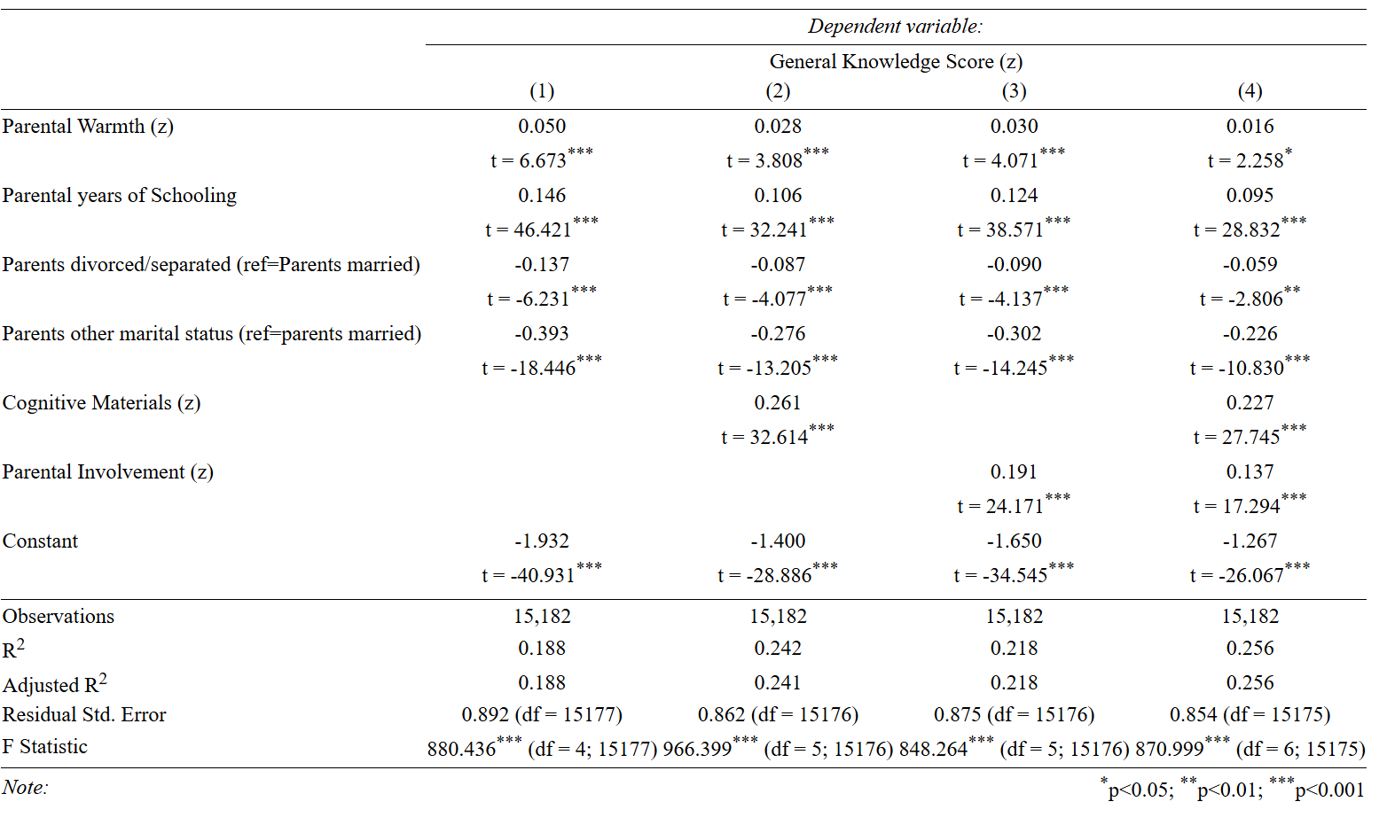

11. Model Comparisons
Does R² from Models 2, 3, and 4 significantly increase from Model 1?
anova(MODEL A, MODEL B)

Answer
We do not need to use the anova command to compare model 2 to 1 and model 3 to 1, because we just added a single variable to the model. The t tests for the added slope tell us if the increase in R² is significant or not, and we can see, it is in both cases.
To compare model 4 to model 1 we will need to use the anova command.
anova(m4,m1)
## Analysis of Variance Table
##
## Model 1: zgk ~ zwarmth + edn + marriage + zcogmat + zparinv
## Model 2: zgk ~ zwarmth + edn + marriage
## Res.Df RSS Df Sum of Sq F Pr(>F)
## 1 15175 11061
## 2 15177 12069 -2 -1008 691.8 <2e-16 ***
## ---
## Signif. codes: 0 '***' 0.001 '**' 0.01 '*' 0.05 '.' 0.1 ' ' 1
The results suggest adding both mediators does significantly increase the R².

12. Calculate Percent Change in Expanatory Power of parental warmth across models
$$\frac{Slope_{new}−Slope_{old}}{Slope_{old}}×100$$

Answer

Model 2 vs Model 1
((.028-.05)/.05)*100
## [1] -44

Model 3 vs Model 1
((.03-.05)/.05)*100
## [1] -40

Model 4 vs Model 1
((.016-.05)/.05)*100
## [1] -68

13. Interpret Findings in APA Style

Answer
Model 1 suggests that parental warmth has a positive association with general knowledge scores, even after controlling for parental education and marital status, $β$ = 0.05, t(15177) = 6.67, p < 0.001.
Models 2 and 3 explore what variables can explain this association. The results suggest that having parents who purchase cognitive materials and are involved in their child’s schooling explain some of the association. When introducing cognitive materials in model 2, the association of parental warmth decreases by 44 percent but remains significant, $β$ = 0.028, t(15176)=3.81, p<0.001. When parental involvement is introduced in model 3, the association declines by 40 percent but again remains significant, $β$=0.030, t(15176)=4.07, p<0.001.
When both mediators are included in model 4, the association decreases by 68 percent and remains significant, $β$=0.016, t(15175)=2.258, p<0.05, suggesting that aprental warmth influences general knowledge scores through mechanisms not explored in this analysis.
When comparing how mediators add explanatory power to our understanding of cognition scores, we see that both mediators add explanatory power to our analysis, but cognitive materials is a stronger predictor than parental involvement . The R² increases by 0.054 (.242-.188) when cognitive materials is added to the model, but only by 0.03 (0.218-0.188) when parental involvement is added.

