Lab 14
Danny Zweben
In this assignment, you will use the ecls.rda dataset and conduct two simple linear regressions where spring kindergarten reading scores are the outcome. One predictor is the family’s income, and the other predictor is the number of children less than 18 years old who live in the household.

Problem 1 (0 pts)
options(scipen = 100)
options(digits = 3)
library(haven)
library(ggplot2)
library(labelled)
## Warning: package 'labelled' was built under R version 4.3.3
library(psych)
## Warning: package 'psych' was built under R version 4.3.3
##
## Attaching package: 'psych'
## The following objects are masked from 'package:ggplot2':
##
## %+%, alpha
library(stargazer)
##
## Please cite as:
## Hlavac, Marek (2022). stargazer: Well-Formatted Regression and Summary Statistics Tables.
## R package version 5.2.3. https://CRAN.R-project.org/package=stargazer

Problem 2 (0 pts)
if (file.exists("ecls.rda")) {
load("ecls.rda")
} else {
load("../ecls.rda")
}
ls()
## [1] "ecls"

Problem 3 (1 pt)
attributes(ecls)["variable.labels"]
## $variable.labels
## childid
## "CHILD IDENTIFICATION NUMBER"
## race
## "Child's Race"
## c2rtscor
## "Reading Score, Spring K"
## c2mtscor
## "Math Score, Spring K"
## c2gtscor
## "General Knowledge Score, Spring K"
## p1hmemp
## "Mother's Employment Status"
## p2marsta
## "Parents' Marital Status"
## wkpared
## "Education Level of Parent With Highest Education"
## wkincome
## "Family Income"
## foodsec
## "Food Security Scale"
## meddummy
## "Medical Care Indicator"
## cogmat
## "Cognitive Materials Scale"
## parinv
## "Parental Investment Scale"
## warmth
## "Warmth Scale"
## cogstim
## "Cognitive Stimulation Scale"
## p2less18
## "P2 NUMBER IN HOUSEHOLD AGED <18"

Problem 4 (3 pt)
ecls$z_read <- as.numeric(scale(ecls$c2rtscor))
ecls$z_income <- as.numeric(scale(ecls$wkincome))
ecls$z_kids <- as.numeric(scale(ecls$p2less18))
describe(ecls[c("z_read", "z_income", "z_kids")])[, c("mean", "sd", "min", "max")]
## mean sd min max
## z_read 0 1 -3.60 3.28
## z_income 0 1 -0.92 16.81
## z_kids 0 1 -1.26 10.47

Problem 5 (1 pt)
ecls$income_k <- ecls$wkincome / 1000

Problem 6 (1 pt)
sub_ecls <- subset(
ecls,
!is.na(childid) & !is.na(c2rtscor) & !is.na(z_read) &
!is.na(income_k) & !is.na(z_income) & !is.na(p2less18) & !is.na(z_kids),
select = c(childid, c2rtscor, z_read, income_k, z_income, p2less18, z_kids)
)
head(sub_ecls)
## childid c2rtscor z_read income_k z_income p2less18 z_kids
## 1 0001001C 56.0 0.547 140 1.5596 2 -0.424
## 2 0001002C 69.6 1.918 120 1.2050 2 -0.424
## 3 0001003C 46.8 -0.382 90 0.6731 3 0.414
## 4 0001004C 49.1 -0.156 60 0.1411 2 -0.424
## 5 0001005C 55.3 0.476 150 1.7369 2 -0.424
## 6 0001006C 39.6 -1.113 50 -0.0362 2 -0.424

Problem 7 (2 pts)
nrow(ecls)
## [1] 21260
nrow(sub_ecls)
## [1] 17488
nrow(ecls) - nrow(sub_ecls)
## [1] 3772

Problem 8 (1 pt)
rm(ecls)
ls()
## [1] "sub_ecls"

Problem 9 (6 pts)
ggplot(sub_ecls, aes(c2rtscor)) +
geom_histogram(aes(y = (..count..) * 100 / sum(..count..)), fill = "grey70", color = "black") +
ylab("Percent") +
xlab("Spring Kindergarten Reading Score (points)") +
ggtitle("Distribution of Spring Kindergarten Reading Scores")
## Warning: The dot-dot notation (`..count..`) was deprecated in ggplot2 3.4.0.
## i Please use `after_stat(count)` instead.
## This warning is displayed once every 8 hours.
## Call `lifecycle::last_lifecycle_warnings()` to see where this warning was
## generated.
## `stat_bin()` using `bins = 30`. Pick better value with `binwidth`.
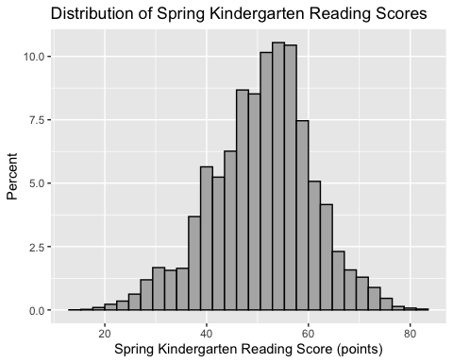
ggplot(sub_ecls, aes(income_k)) +
geom_histogram(aes(y = (..count..) * 100 / sum(..count..)), fill = "grey70", color = "black") +
ylab("Percent") +
xlab("Family Income ($1,000s)") +
ggtitle("Distribution of Family Income")
## `stat_bin()` using `bins = 30`. Pick better value with `binwidth`.
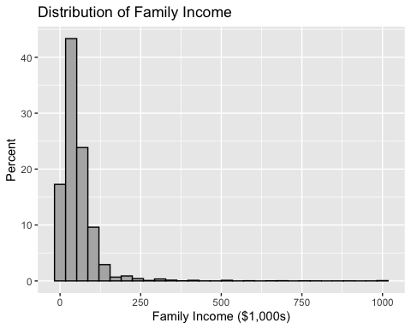
ggplot(sub_ecls, aes(p2less18)) +
geom_histogram(aes(y = (..count..) * 100 / sum(..count..)), fill = "grey70", color = "black") +
ylab("Percent") +
xlab("Number of Household Members Aged <18") +
ggtitle("Distribution of Number of Children (<18)")
## `stat_bin()` using `bins = 30`. Pick better value with `binwidth`.
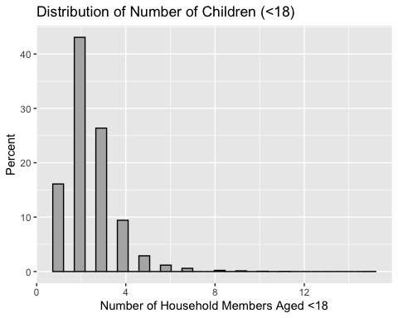

Problem 10 (2 pts)
m_income <- lm(c2rtscor ~ income_k, data = sub_ecls)
m_kids <- lm(c2rtscor ~ p2less18, data = sub_ecls)
summary(m_income)
##
## Call:
## lm(formula = c2rtscor ~ income_k, data = sub_ecls)
##
## Residuals:
## Min 1Q Median 3Q Max
## -47.76 -6.00 0.75 6.20 31.66
##
## Coefficients:
## Estimate Std. Error t value Pr(>|t|)
## (Intercept) 48.69921 0.09926 490.6 <0.0000000000000002 ***
## income_k 0.03991 0.00124 32.2 <0.0000000000000002 ***
## ---
## Signif. codes: 0 '***' 0.001 '**' 0.01 '*' 0.05 '.' 0.1 ' ' 1
##
## Residual standard error: 9.58 on 17486 degrees of freedom
## Multiple R-squared: 0.0561, Adjusted R-squared: 0.056
## F-statistic: 1.04e+03 on 1 and 17486 DF, p-value: <0.0000000000000002
summary(m_kids)
##
## Call:
## lm(formula = c2rtscor ~ p2less18, data = sub_ecls)
##
## Residuals:
## Min 1Q Median 3Q Max
## -36.60 -6.11 0.78 6.30 34.31
##
## Coefficients:
## Estimate Std. Error t value Pr(>|t|)
## (Intercept) 54.2223 0.1737 312.2 <0.0000000000000002 ***
## p2less18 -1.3447 0.0634 -21.2 <0.0000000000000002 ***
## ---
## Signif. codes: 0 '***' 0.001 '**' 0.01 '*' 0.05 '.' 0.1 ' ' 1
##
## Residual standard error: 9.73 on 17486 degrees of freedom
## Multiple R-squared: 0.0251, Adjusted R-squared: 0.025
## F-statistic: 450 on 1 and 17486 DF, p-value: <0.0000000000000002

Problem 11 (5 pts)
stargazer(
m_income, m_kids,
type = "text",
report = "vcs*",
title = "Bivariate Regressions Predicting Spring Kindergarten Reading Scores",
dep.var.caption = "Outcome",
dep.var.labels = c("Reading (points)", "Reading (points)"),
covariate.labels = c("Family Income ($1,000s)", "Number of Household Members Aged <18"),
star.cutoffs = c(0.05, 0.01, 0.001),
star.char = c("*", "**", "***"),
notes = "Stars: * p<.05; ** p<.01; *** p<.001",
notes.append = FALSE
)
##
## Bivariate Regressions Predicting Spring Kindergarten Reading Scores
## ==========================================================================
## Outcome
## -------------------------------------
## Reading (points)
## (1) (2)
## --------------------------------------------------------------------------
## Family Income (1,000s) 0.040
## (0.001)***
##
## Number of Household Members Aged <18 -1.340
## (0.063)***
##
## Constant 48.700 54.200
## (0.099)*** (0.174)***
##
## --------------------------------------------------------------------------
## Observations 17,488 17,488
## R2 0.056 0.025
## Adjusted R2 0.056 0.025
## Residual Std. Error (df = 17486) 9.580 9.730
## F Statistic (df = 1; 17486) 1,039.000*** 450.000***
## ==========================================================================
## Note: Stars: * p<.05; ** p<.01; *** p<.001

Problemn 12 (4 pts)
Model 1 (income): When family income is $0, the predicted spring kindergarten reading score is 48.699 points.
Model 2 (children): When there are 0 household members under 18, the predicted spring kindergarten reading score is 54.222 points.

Problem 13 (4 pts)
Model 1 (income): For each additional $1,000 of family income, predicted reading score increases by 0.0399 points, t(17486) = 32.23, p < .001.
Model 2 (children): For each additional household member under 18, predicted reading score decreases by 1.3447 points, t(17486) = -21.21, p < .001.

Problem 14 (4 pts)
Model 1 (income): R^2 = .056, so family income explains 5.61% of variation in spring kindergarten reading scores.
Model 2 (children): R^2 = .025, so number of household members under 18 explains 2.51% of variation in spring kindergarten reading scores.

Problem 15 (2 pts)
m_income_z <- lm(z_read ~ z_income, data = sub_ecls)
m_kids_z <- lm(z_read ~ z_kids, data = sub_ecls)
summary(m_income_z)
##
## Call:
## lm(formula = z_read ~ z_income, data = sub_ecls)
##
## Residuals:
## Min 1Q Median 3Q Max
## -4.821 -0.605 0.076 0.626 3.196
##
## Coefficients:
## Estimate Std. Error t value Pr(>|t|)
## (Intercept) 0.01585 0.00732 2.17 0.03 *
## z_income 0.22719 0.00705 32.23 <0.0000000000000002 ***
## ---
## Signif. codes: 0 '***' 0.001 '**' 0.01 '*' 0.05 '.' 0.1 ' ' 1
##
## Residual standard error: 0.967 on 17486 degrees of freedom
## Multiple R-squared: 0.0561, Adjusted R-squared: 0.056
## F-statistic: 1.04e+03 on 1 and 17486 DF, p-value: <0.0000000000000002
summary(m_kids_z)
##
## Call:
## lm(formula = z_read ~ z_kids, data = sub_ecls)
##
## Residuals:
## Min 1Q Median 3Q Max
## -3.694 -0.617 0.079 0.636 3.463
##
## Coefficients:
## Estimate Std. Error t value Pr(>|t|)
## (Intercept) 0.02352 0.00743 3.16 0.0016 **
## z_kids -0.16198 0.00764 -21.21 <0.0000000000000002 ***
## ---
## Signif. codes: 0 '***' 0.001 '**' 0.01 '*' 0.05 '.' 0.1 ' ' 1
##
## Residual standard error: 0.982 on 17486 degrees of freedom
## Multiple R-squared: 0.0251, Adjusted R-squared: 0.025
## F-statistic: 450 on 1 and 17486 DF, p-value: <0.0000000000000002

Problem 16 (2 pt)
stargazer(
m_income_z, m_kids_z,
type = "text",
report = "vcs*",
title = "Bivariate Regressions Predicting Reading Scores (SD Units)",
dep.var.caption = "Outcome",
dep.var.labels = c("Reading (SD)", "Reading (SD)"),
covariate.labels = c("Family Income (SD)", "Number of Household Members Aged <18 (SD)"),
star.cutoffs = c(0.05, 0.01, 0.001),
star.char = c("*", "**", "***"),
notes = "Stars: * p<.05; ** p<.01; *** p<.001",
notes.append = FALSE
)
##
## Bivariate Regressions Predicting Reading Scores (SD Units)
## ===============================================================================
## Outcome
## -------------------------------------
## Reading (SD)
## (1) (2)
## -------------------------------------------------------------------------------
## Family Income (SD) 0.227
## (0.007)***
##
## Number of Household Members Aged <18 (SD) -0.162
## (0.008)***
##
## Constant 0.016 0.024
## (0.007)* (0.007)**
##
## -------------------------------------------------------------------------------
## Observations 17,488 17,488
## R2 0.056 0.025
## Adjusted R2 0.056 0.025
## Residual Std. Error (df = 17486) 0.967 0.982
## F Statistic (df = 1; 17486) 1,039.000*** 450.000***
## ===============================================================================
## Note: Stars: * p<.05; ** p<.01; *** p<.001

Problem 17 (2 pts)
In the z-standardized children model, when the number of household members under 18 is at the sample mean (z_kids = 0), predicted reading score is 0.0235 SD above the mean.

Problem 18 (2 pts)
In the z-standardized children model, a 1 SD increase in number of household members under 18 predicts a 0.162 SD decrease in reading scores, t(17486) = -21.21, p < .001.

Problem 19 (2 pts)
summary(m_income)
##
## Call:
## lm(formula = c2rtscor ~ income_k, data = sub_ecls)
##
## Residuals:
## Min 1Q Median 3Q Max
## -47.76 -6.00 0.75 6.20 31.66
##
## Coefficients:
## Estimate Std. Error t value Pr(>|t|)
## (Intercept) 48.69921 0.09926 490.6 <0.0000000000000002 ***
## income_k 0.03991 0.00124 32.2 <0.0000000000000002 ***
## ---
## Signif. codes: 0 '***' 0.001 '**' 0.01 '*' 0.05 '.' 0.1 ' ' 1
##
## Residual standard error: 9.58 on 17486 degrees of freedom
## Multiple R-squared: 0.0561, Adjusted R-squared: 0.056
## F-statistic: 1.04e+03 on 1 and 17486 DF, p-value: <0.0000000000000002
summary(m_kids)
##
## Call:
## lm(formula = c2rtscor ~ p2less18, data = sub_ecls)
##
## Residuals:
## Min 1Q Median 3Q Max
## -36.60 -6.11 0.78 6.30 34.31
##
## Coefficients:
## Estimate Std. Error t value Pr(>|t|)
## (Intercept) 54.2223 0.1737 312.2 <0.0000000000000002 ***
## p2less18 -1.3447 0.0634 -21.2 <0.0000000000000002 ***
## ---
## Signif. codes: 0 '***' 0.001 '**' 0.01 '*' 0.05 '.' 0.1 ' ' 1
##
## Residual standard error: 9.73 on 17486 degrees of freedom
## Multiple R-squared: 0.0251, Adjusted R-squared: 0.025
## F-statistic: 450 on 1 and 17486 DF, p-value: <0.0000000000000002

Problem 20 (6 pts)
In separate bivariate regressions, spring kindergarten reading scores were positively associated with family income (in $1,000s), B = 0.040, β = 0.227, SE = 0.001, t(17486) = 32.23, p < .001, R^2 = .056, and negatively associated with number of household members under 18, B = -1.345, β = -0.162, SE = 0.063, t(17486) = -21.21, p < .001, R^2 = .025.

Problem 21 (0 pts)
Upload your lab to Canvas. Double check to make sure the upload took.

