Method
Participants
Participants were 33 adolescents (15 female; M_{age} = 12.73 years, SD = 1.35, range 10 to 15 years) drawn from the larger LEARN study (Clarkson et al., 2024), recruited from the community and from the Child and Adolescent Anxiety Disorders Clinic at Temple University. The sample was 66.7% White, 18.2% multiracial, 9.1% Black or African American, and 6.1% Asian, with a median household income of $55,000. Adolescents provided assent and a parent or guardian provided written consent under procedures approved by the Temple University Institutional Review Board. All 33 adolescents had usable functional MRI data and complete data on the measures reported below.
Social Anxiety Symptom Severity
Social anxiety was indexed dimensionally by the social phobia subscale of the child-report Screen for Child Anxiety Related Emotional Disorders (SCARED; Birmaher et al., 1997, 1999), a seven-item scale (range 0 to 14; M = 5.00, SD = 4.18). Using the recommended subscale cutoff (≥ 8; Birmaher et al., 1999), 27% of the sample (9 of 33) screened positive for clinically elevated social anxiety. Screening status converged with clinical diagnosis: 27% also met criteria for a social anxiety disorder on the Anxiety Disorders Interview Schedule for DSM-IV (ADIS-C/P; Silverman & Albano, 1996; clinician severity rating ≥ 4), and 42% met criteria for any anxiety disorder. Self-reported social phobia scores tracked diagnostic status (point-biserial r = .72; diagnosed M = 9.89, non-diagnosed M = 3.17). This continuous score was used in all analyses.
The LEARN Task
Adolescents completed the Learning from Evaluation And Recall of iNteractions (LEARN) task, an adaptation of the virtual-school paradigm (Jarcho et al., 2013, 2016) programmed in Presentation (Version 23.0; Neurobehavioral Systems). During an initial remote visit, each adolescent built a personalized avatar and profile and was told that their responses would be shared with gender-matched peers they would meet at a later visit. At the scanning visit, adolescents were told they would enter four classrooms and interact with four peers (Figure 1). On each trial, the adolescent predicted whether a given peer would deliver nice or mean feedback (4 s), received the peer's feedback, which confirmed or disconfirmed the prediction (3 s), and then made a response ("You're Right," "You're Wrong," "You're Nice," or "You're Mean"; 4 s), followed by a 0.5-s intertrial interval. Prediction and response reaction times were used to model epoch durations and to introduce jitter. Each of the four classrooms constituted one functional run (6 min 30 s). Each peer appeared eight times per run, yielding 32 trials per peer and 128 trials total; trial order was fixed across participants.
The four peers differed in reputation, defined by the disposition (nice or mean) and predictability of their feedback and operationalized as each peer's probability of delivering nice feedback: a predictable nice peer (80% nice), an unpredictable nice peer (60% nice), an unpredictable mean peer (40% nice), and a predictable mean peer (20% nice).
Figure 1
The LEARN Task
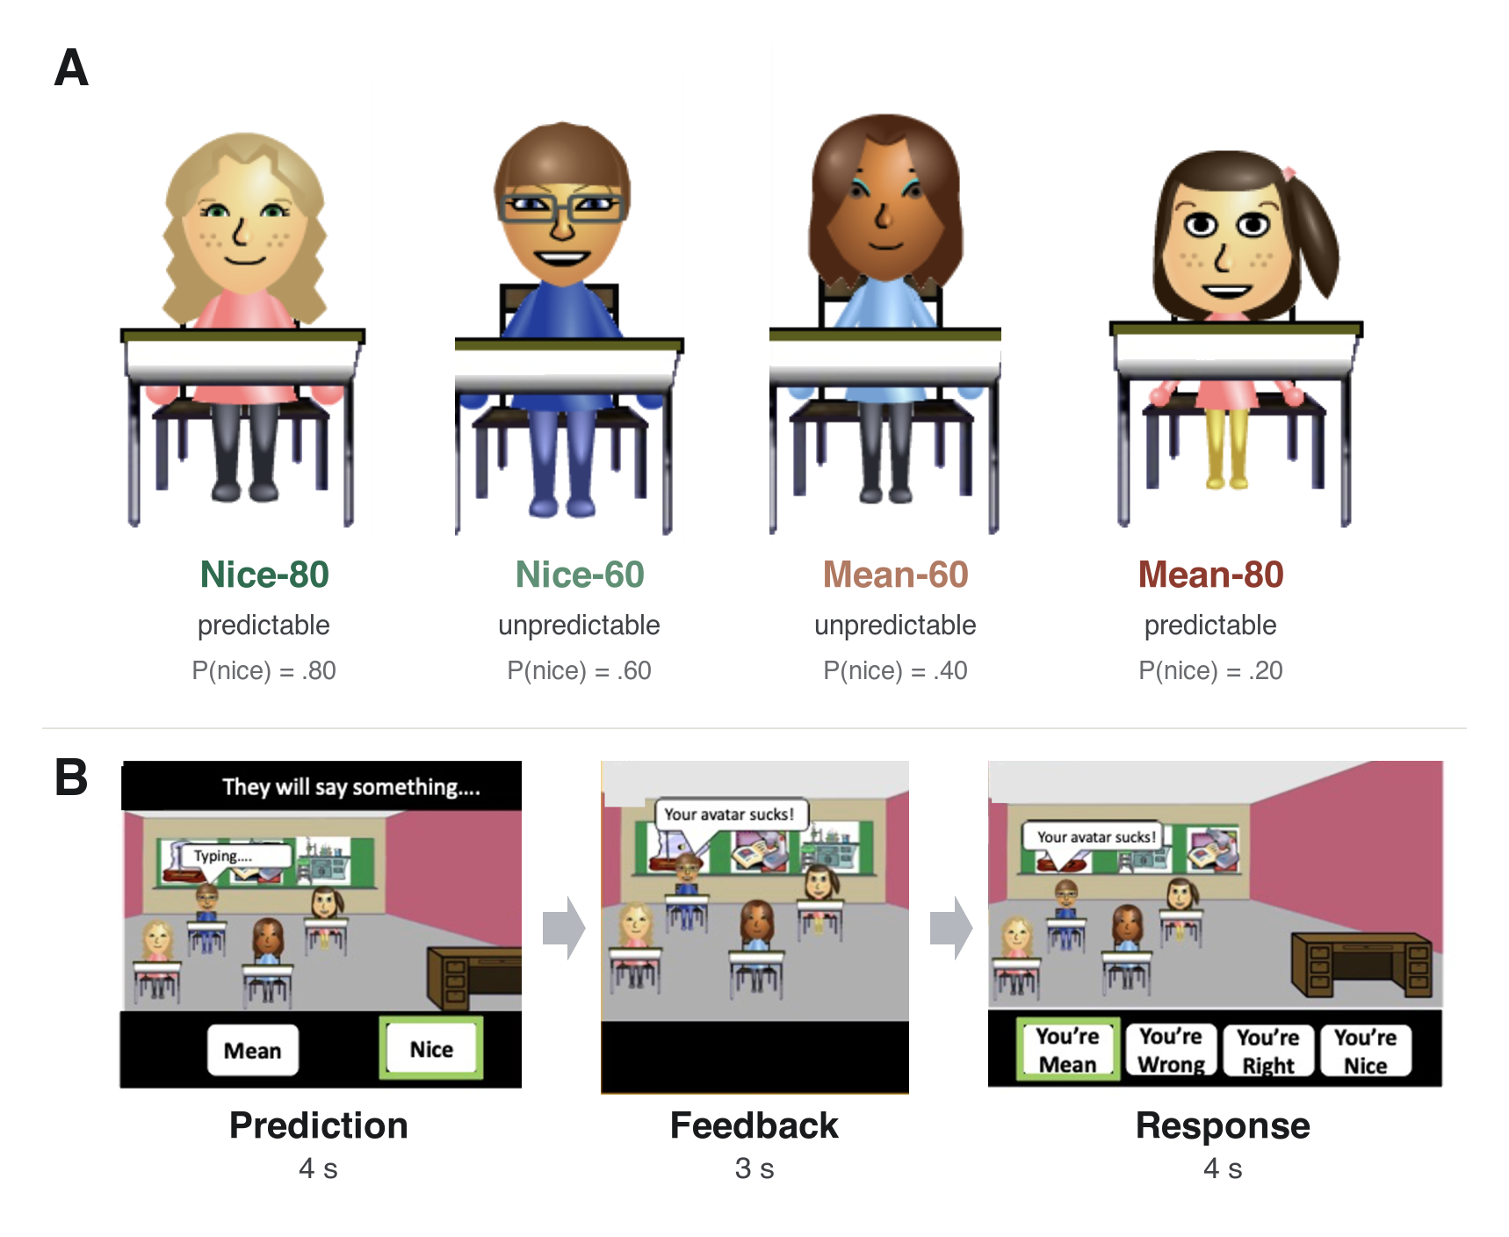
Note. (A) Participants interacted with four computer-controlled peers who differed in their probability of delivering nice feedback (Nice-80, Nice-60, Mean-60, and Mean-80; P(nice) = .80, .60, .40, and .20). (B) On each trial, participants predicted a peer's upcoming feedback (4 s), received nice or mean feedback (3 s), and made a response (4 s).
fMRI Data Acquisition
Before scanning, participants completed a mock session to acclimate to the scanner environment and practice remaining still. Images were acquired on a 3-T Siemens MAGNETOM Prisma scanner with a 20-channel head coil. Functional images were acquired with a T2*-weighted multiband echo-planar imaging (EPI) sequence (multiband factor 2; 217 volumes; 52 axial slices; 3-mm isotropic voxels; TR/TE = 1750/29 ms; flip angle = 74 degrees; FOV = 240 mm; matrix = 80 x 80). A high-resolution T1-weighted MPRAGE structural image was acquired for anatomical localization and coregistration (sagittal; 1-mm isotropic; flip angle = 8 degrees; FOV = 224 mm; matrix = 224 x 224). The task was viewed through a head-coil-mounted mirror, and responses were recorded with an MRI-compatible four-button response box.
fMRI Preprocessing and First-Level Modeling
DICOM images were converted to BIDS format and preprocessed in AFNI (Cox, 1996) using afni_proc.py. Processing included despiking, slice-timing correction, motion correction by realignment to the minimum-outlier volume, coregistration of the functional and anatomical images, nonlinear normalization to the MNI152 2009c nonlinear asymmetric template (Fonov et al., 2011) via @SSwarper, and scaling of each voxel to percent signal change. No spatial smoothing was applied. Volumes were censored when the per-volume Euclidean-norm motion derivative exceeded 1.0 mm or the outlier fraction exceeded 0.1.
First-level models were estimated with 3dDeconvolve. Feedback was modeled separately for each peer, each feedback valence, and each run using a duration-modulated block response (AFNI dmBLOCK), together with prediction, response, and prediction-to-feedback anticipation regressors and the six rigid-body motion parameters. For each peer and run, the feedback response used in the representational analysis was the average of that peer's mean-feedback and nice-feedback estimates.
Regions of Interest
Analyses were conducted in 36 a priori social-brain regions of interest defined from the meta-analytic social-brain atlas of Alcala-Lopez et al. (2018), which specifies consensus peak coordinates for social-brain regions across studies. For the 30 cortical regions, a 10-mm-radius sphere was grown around each region's consensus peak and intersected with a group mask retaining voxels with signal in at least 90% of participants. The atlas also distributes gray-matter-constrained parcels grown from these peaks; resampled to the 3-mm functional grid, however, these parcels retained too few voxels to support stable within-region multivoxel estimates, so fixed-radius spheres were used. For the six subcortical regions (bilateral hippocampus, amygdala, and nucleus accumbens), whose small, curved anatomy is poorly approximated by a sphere, regions were instead defined from the Harvard-Oxford subcortical atlas (Frazier et al., 2005; Goldstein et al., 2007; Makris et al., 2006) thresholded at 25% probability.
Representational Similarity Analysis
Representational similarity analysis (RSA; Kriegeskorte et al., 2008) compares a region's representational dissimilarity matrix (RDM) against a model RDM. We used a model-based RSA in which the model RDM encoded the veridical structure of the social environment.
The model RDM was defined over the four peers as the absolute difference in their probability of nice feedback, normalized by the maximum possible difference: d(i, j) = |P(nice)_{i} - P(nice)_{j}| / 0.60. The neural RDM was computed separately for each participant, run, and region: the multivoxel feedback pattern for each of the four peers (defined above) formed a 4 x 4 matrix of pairwise dissimilarities (1 minus the Pearson correlation between peer patterns). For each participant, run, and region, alignment was the Spearman correlation between the six unique off-diagonal neural dissimilarities and the corresponding model values, Fisher-z transformed. This procedure yielded one alignment value per participant per run (Figure 2).
To relate alignment to social anxiety, each region's Fisher-z alignment values (z) were entered into an ordinary least squares model, z ~ run + SA + run x SA, where SA is social anxiety and run was mean-centered across the four runs. The main effect indexed mean alignment across runs; the interaction indexed change in alignment across runs. The main effect was tested by permuting social anxiety scores across participants (10,000 permutations). The interaction was tested against a joint null in which social anxiety scores were permuted across participants and each participant's alignment values were independently scrambled across their four runs. The p values were corrected across the 36 regions using the Benjamini-Hochberg false discovery rate (Benjamini & Hochberg, 1995).
Figure 2
Model-Based Representational Similarity Analysis
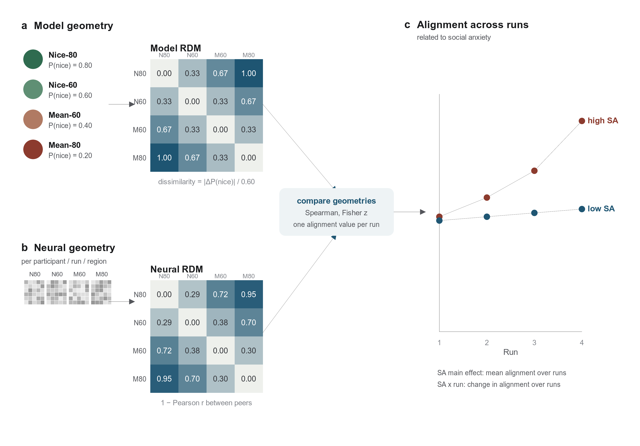
Note. (a) The model representational dissimilarity matrix (RDM) encoded the veridical social structure as the absolute difference in each peer pair's probability of nice feedback, normalized to the maximum difference. (b) For each participant, run, and region, a neural RDM was computed as 1 minus the Pearson correlation between the four peers' multivoxel feedback patterns. (c) Region-level alignment was the Fisher-z-transformed Spearman correlation between the six off-diagonal neural and model dissimilarities, yielding one value per participant per run; second-level models related alignment and its change across runs to social anxiety (SA).
Temporal Inter-Subject Correlation
We computed leave-one-out inter-subject correlation (ISC; Hasson et al., 2004; Nastase et al., 2019): within each region, each participant's region-mean time course was Pearson-correlated with the mean of the remaining participants' region-mean time courses, and the resulting coefficient was Fisher-z transformed. Because prediction and response were self-paced, feedback onsets drifted across participants over a run. This drift accumulated across runs, reaching up to 5.86 s (3.3 TR) by the fourth run, with a mean absolute deviation of 0.35 s (0.20 TR) across all feedback events. To align events before computing synchrony, each participant's run time course was temporally warped to the group-median feedback onsets by piecewise-linear interpolation anchored at the run boundaries and at each feedback onset (implemented in SciPy), then z-scored. ISC was computed within each run and averaged across runs, and each region's mean ISC was Spearman-correlated with social anxiety. The p values were corrected across the 36 regions using the Benjamini-Hochberg false discovery rate.

References
Alcala-Lopez, D., Smallwood, J., Jefferies, E., Van Overwalle, F., Vogeley, K., Mars, R. B., Turetsky, B. I., Laird, A. R., Fox, P. T., Eickhoff, S. B., & Bzdok, D. (2018). Computing the social brain connectome across systems and states. Cerebral Cortex, 28(7), 2207-2232. https://doi.org/10.1093/cercor/bhx121
Benjamini, Y., & Hochberg, Y. (1995). Controlling the false discovery rate: A practical and powerful approach to multiple testing. Journal of the Royal Statistical Society: Series B (Methodological), 57(1), 289-300. https://doi.org/10.1111/j.2517-6161.1995.tb02031.x
Birmaher, B., Khetarpal, S., Brent, D., Cully, M., Balach, L., Kaufman, J., & Neer, S. M. (1997). The Screen for Child Anxiety Related Emotional Disorders (SCARED): Scale construction and psychometric characteristics. Journal of the American Academy of Child and Adolescent Psychiatry, 36(4), 545-553. https://doi.org/10.1097/00004583-199704000-00018
Birmaher, B., Brent, D. A., Chiappetta, L., Bridge, J., Monga, S., & Baugher, M. (1999). Psychometric properties of the Screen for Child Anxiety Related Emotional Disorders (SCARED): A replication study. Journal of the American Academy of Child and Adolescent Psychiatry, 38(10), 1230-1236. https://doi.org/10.1097/00004583-199910000-00011
Clarkson, T., Savage, C., Arora, A., Quarmley, M., Barack, D. L., Johnston, C. R., Carpenter, A., Archambault, C., Kendall, P. C., Hackel, L., & Jarcho, J. M. (2024). Learning to fear social interactions: Dysregulated neural mechanisms of social learning in adolescent social anxiety [Manuscript in preparation]. Department of Psychology and Neuroscience, Temple University.
Cox, R. W. (1996). AFNI: Software for analysis and visualization of functional magnetic resonance neuroimages. Computers and Biomedical Research, 29(3), 162-173. https://doi.org/10.1006/cbmr.1996.0014
Fonov, V., Evans, A. C., Botteron, K., Almli, C. R., McKinstry, R. C., Collins, D. L., & the Brain Development Cooperative Group. (2011). Unbiased average age-appropriate atlases for pediatric studies. NeuroImage, 54(1), 313-327. https://doi.org/10.1016/j.neuroimage.2010.07.033
Frazier, J. A., Chiu, S., Breeze, J. L., Makris, N., Lange, N., Kennedy, D. N., Herbert, M. R., Bent, E. K., Koneru, V. K., Dieterich, M. E., Hodge, S. M., Rauch, S. L., Grant, P. E., Cohen, B. M., Seidman, L. J., Caviness, V. S., & Biederman, J. (2005). Structural brain magnetic resonance imaging of limbic and thalamic volumes in pediatric bipolar disorder. American Journal of Psychiatry, 162(7), 1256-1265. https://doi.org/10.1176/appi.ajp.162.7.1256
Goldstein, J. M., Seidman, L. J., Makris, N., Ahern, T., O'Brien, L. M., Caviness, V. S., Kennedy, D. N., Faraone, S. V., & Tsuang, M. T. (2007). Hypothalamic abnormalities in schizophrenia: Sex effects and genetic vulnerability. Biological Psychiatry, 61(8), 935-945. https://doi.org/10.1016/j.biopsych.2006.06.027
Hasson, U., Nir, Y., Levy, I., Fuhrmann, G., & Malach, R. (2004). Intersubject synchronization of cortical activity during natural vision. Science, 303(5664), 1634-1640. https://doi.org/10.1126/science.1089506
Jarcho, J. M., Leibenluft, E., Walker, O. L., Fox, N. A., Pine, D. S., & Nelson, E. E. (2013). Neuroimaging studies of pediatric social anxiety: Paradigms, pitfalls and a new direction for investigating the neural mechanisms. Biology of Mood & Anxiety Disorders, 3, 14. https://doi.org/10.1186/2045-5380-3-14
Jarcho, J. M., Davis, M. M., Shechner, T., Degnan, K. A., Henderson, H. A., Stoddard, J., Fox, N. A., Leibenluft, E., Pine, D. S., & Nelson, E. E. (2016). Early-childhood social reticence predicts brain function in preadolescent youths during distinct forms of peer evaluation. Psychological Science, 27(6), 821-835. https://doi.org/10.1177/0956797616638319
Kriegeskorte, N., Mur, M., & Bandettini, P. (2008). Representational similarity analysis: Connecting the branches of systems neuroscience. Frontiers in Systems Neuroscience, 2, 4. https://doi.org/10.3389/neuro.06.004.2008
Makris, N., Goldstein, J. M., Kennedy, D., Hodge, S. M., Caviness, V. S., Faraone, S. V., Tsuang, M. T., & Seidman, L. J. (2006). Decreased volume of left and total anterior insular lobule in schizophrenia. Schizophrenia Research, 83(2-3), 155-171. https://doi.org/10.1016/j.schres.2005.11.020
Nastase, S. A., Gazzola, V., Hasson, U., & Keysers, C. (2019). Measuring shared responses across subjects using intersubject correlation. Social Cognitive and Affective Neuroscience, 14(6), 667-685. https://doi.org/10.1093/scan/nsz037
Silverman, W. K., & Albano, A. M. (1996). Anxiety Disorders Interview Schedule for DSM-IV: Child and Parent Versions. Graywind Publications/Psychological Corporation.

