MPFC (Medial Prefrontal Cortex)
(He et al., 2025) Nim Tottenham
MPFC Posited Function: Integrate lower-level information and embodied representations from anterior insula and sensory motor cortex with higher-level conceptual representations in the prefrontal cortex, temporoparietal junction and temporal Lobe to make judgments about ourselves and others.

In univariate contrasts, the mPFC is activated when we make mental state inferences about others

(Mitchell 2009), form impressions of others (e.g. Mende-Siedlecki et al. 2013), hold social information in working memory (Meyer and Collier 2020), and infer how others feel about us (Eisenberger et al.
2003).

“Pseudo conjunction analysis highlighting mPFC regions common to adult mentalizing meta-analysis (neurosynth), adult schema-mediatedencoding meta-analysis (Gilboa & Marlatte 2017)”
Additionally, computational approaches demonstrate that different aspects of mentalizing, such as whether someone is emotional, sly, or trying to connect, are represented by different sub-populations of neural responding in mPFC (Tamir et al. 2016, Saxe and Houlihan 2017, González and Chang 2021)

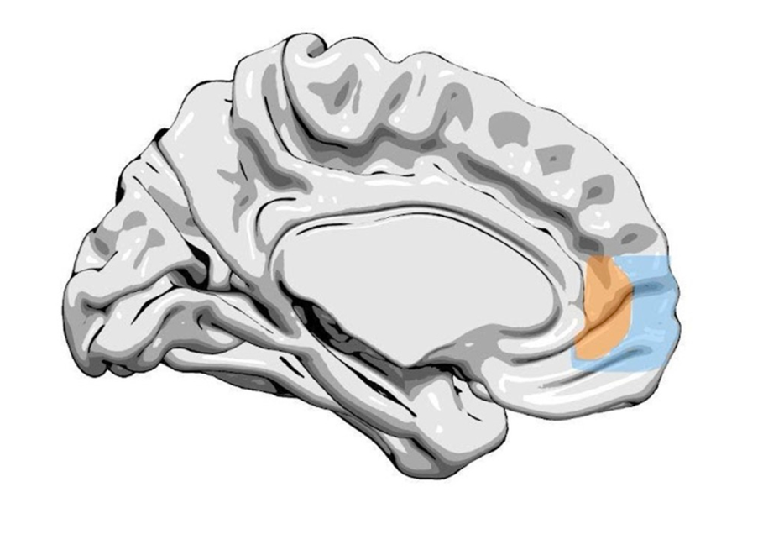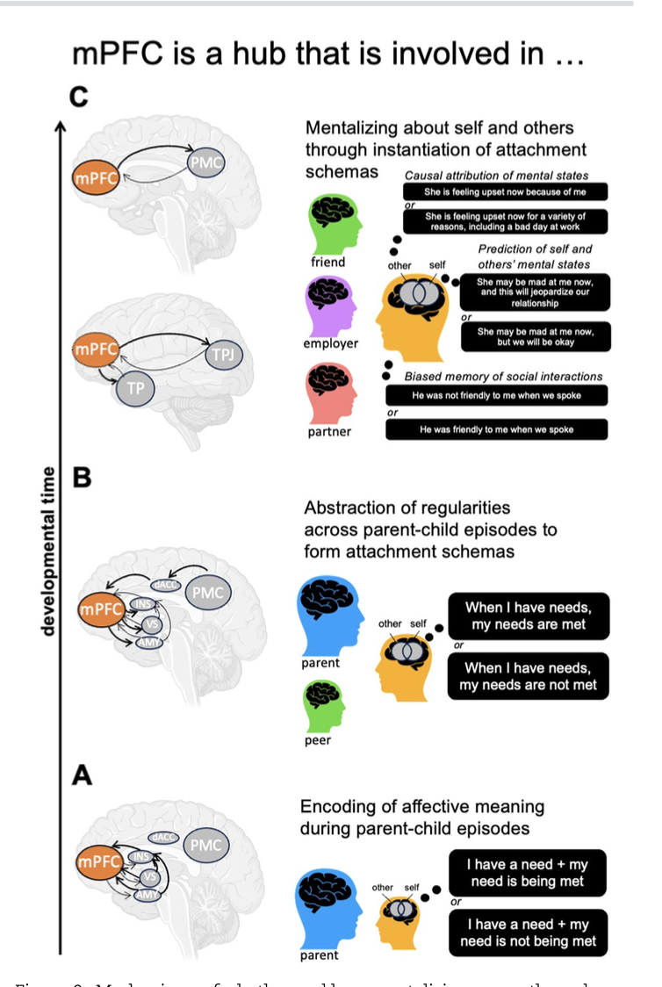
“The mPFC region we focus on comprises the midline region encompassing the anterior cingulate cortex and extends rostrally and ventrally (BA10, 32, and 24; Fig. 1). This region has been variously referred to as ventromedial prefrontal cortex,ventral anterior cingulate cortex, and rostral medial prefrontal cortex
Temporoparietal Junction (TPJ)
- Mentalizing recruits a distributed brain network, such as the temporo-parietal junction involved in representing beliefs about people (Saxe and Kanwisher 2013)
- the temporoparietal junction (i.e. implicated in representing the beliefs of others: Saxe and Kanwisher 2013),
The temporal pole involved in social semantic scripts (Olson et al. 2007, Ross and Olson 2010).
“Some candidate brain networks germane to the current investiga-tion include the temporal poles (i.e. implicated in representing multimodal concepts: Rice et al. 2015, Binney et al. 2016),”
Precuneus:
Furthermore, when the mPFC encodes the current mental state of any individual, the mPFC coordinates activity with the precuneus to automatically predict possible future mental states (Thornton et al. 2019a)

