eZ430-Chronos Custom Firmware - Benutzerhandbuch
Custom Beta - MSP430-GCC - CC430F6137
Dieses Handbuch beschreibt den aktuellen Beta-Stand der angepassten MSP430-GCC-Firmware.

Tasten / Buttons / Mga Pindutan
Button | Function
* kurz | Oberes Menü weiterschalten.
* lang | Einstellungen des aktuellen oberen Menüpunktes öffnen.
# kurz | Unteres Menü weiterschalten.
# lang | Einstellungen des aktuellen unteren Menüpunktes öffnen.
UP | Direktfunktion oben; im Alarm-Menü Alarm EIN/AUS.
DOWN | Direktfunktion unten.
LIGHT kurz | Beleuchtung einschalten.
LIGHT lang | Lichtmenü: DOWN 1-30 s, UP Dauerlicht ON/OFF, LIGHT speichern/verlassen.

Menu
LINE 1 (*): Uhrzeit -> Alarm -> Temperatur -> Höhe -> Beschleunigung
LINE 2 (#): Datum -> TZ2 -> Swatch Beat Time -> BIN Watch -> Stoppuhr -> Countdown -> Random -> Batterie
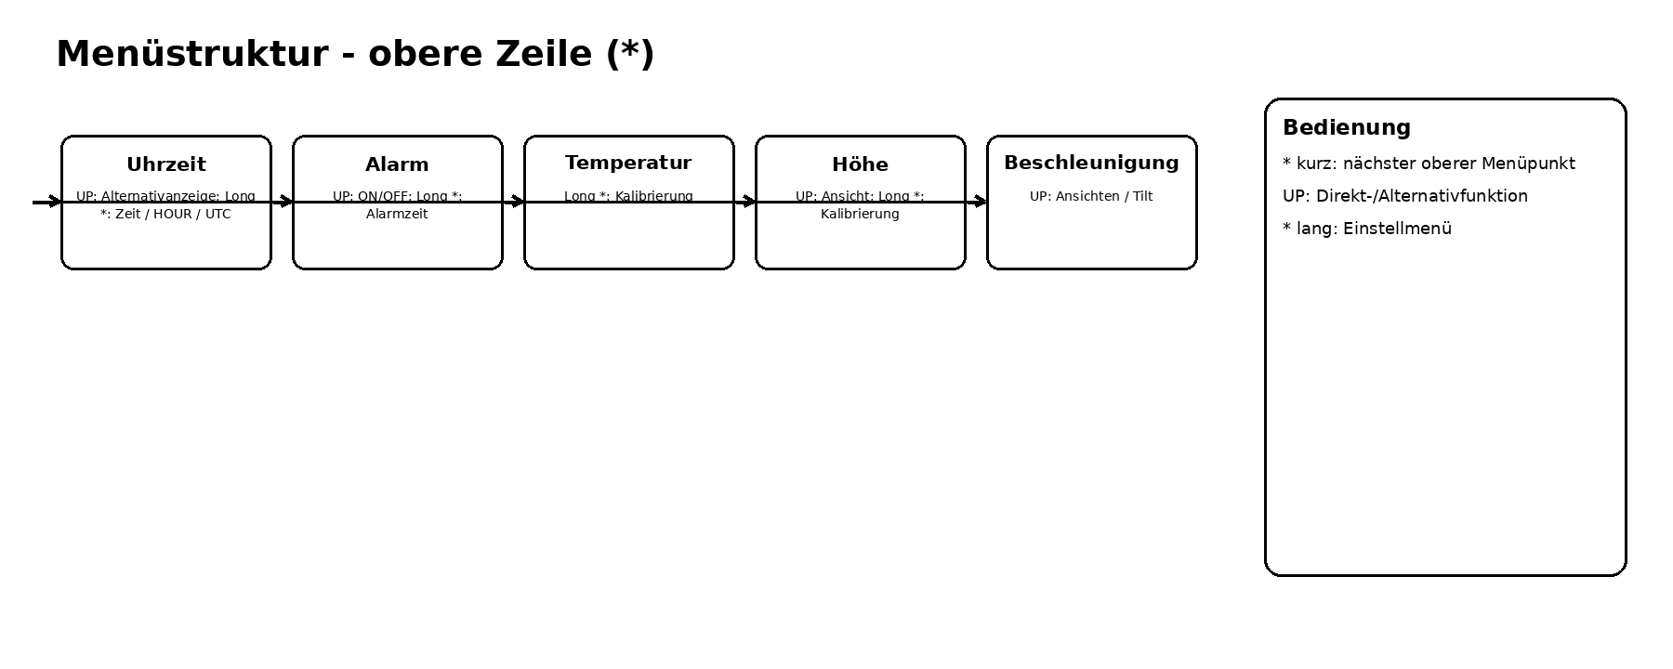
Figure A - Line 1 / *
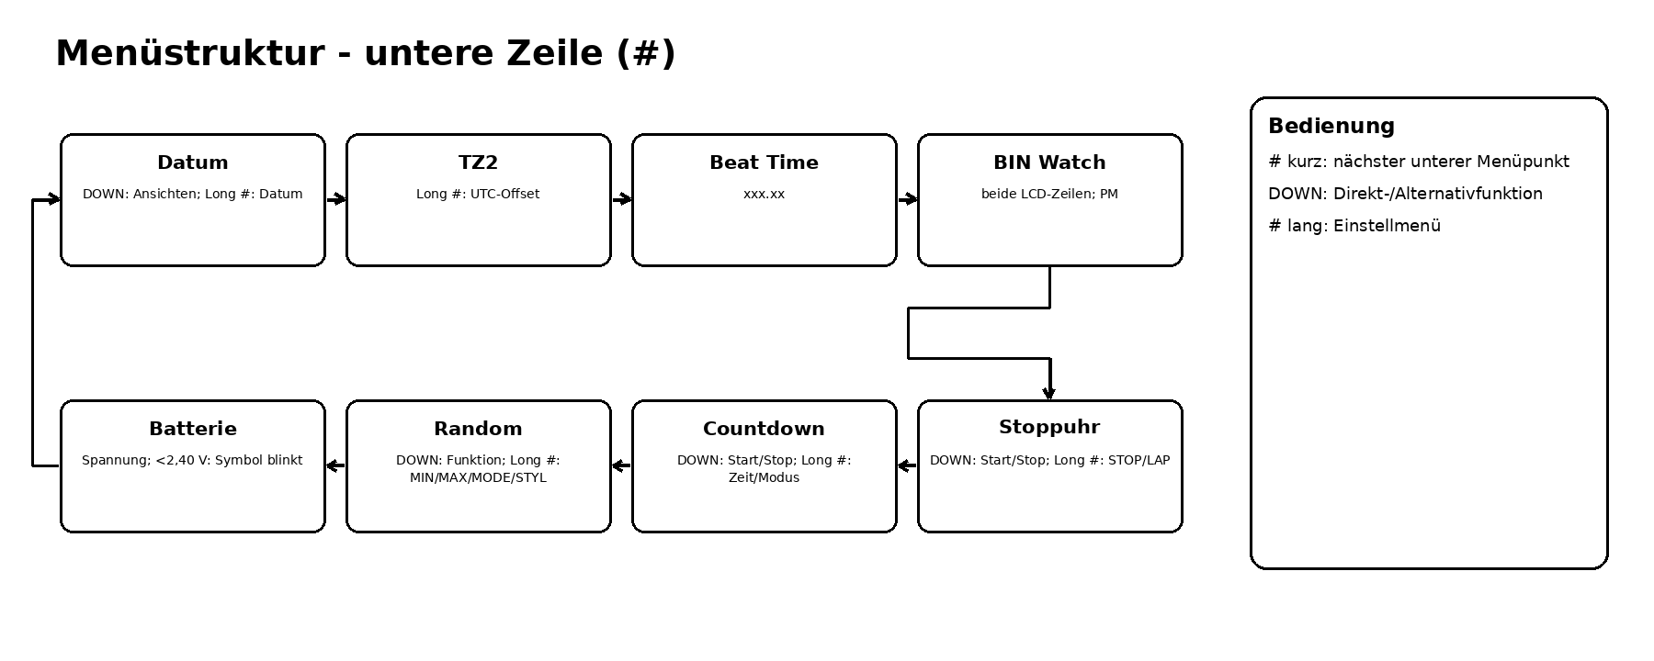
Figure B - Line 2 / #

Funktionen / Functions / Mga Function

Uhrzeit
Longpress * öffnet die Uhreinstellungen. HOUR schaltet das stündliche Doppel-Piep ein/aus. UTC definiert den Abstand der angezeigten Ortszeit zu UTC; DST/Sommerzeit wird zusätzlich berücksichtigt.

Alarm
UP schaltet EIN/AUS und zeigt kurz ON/OFF. Longpress * stellt die Alarmzeit ein.

Temperatur
Interne Temperaturanzeige; Longpress * öffnet die vorhandene Einstellung/Kalibrierung.

Höhe
Höhen-/Luftdruckfunktion des Drucksensors; vorhandene Direkt- und Einstellfunktionen bleiben erhalten.

Beschleunigung
Beschleunigungs-/Tilt-Anzeige des Sensors.

Datum
Datumsansichten; Longpress # öffnet die Datumseinstellungen.

TZ2
Zweite Zeitzone. Longpress # stellt den Offset ein. Halbstundenzonen werden unterstützt, z. B. Indien +5,5 h. Anzeige mit Stunden, Minuten und Sekunden.

Swatch Beat Time
Beat-Anzeige im Format xxx.xx, aus UTC berechnet. Benutzer-UTC und DST werden berücksichtigt.

BIN Watch
Binäres Watchface über beide LCD-Zeilen; PM kennzeichnet die zweite Tageshälfte.

Stoppuhr
DOWN bedient die Direktfunktion; Longpress # öffnet die Moduseinstellung STOP/LAP.

Countdown
Countdown-Timer mit Direktfunktion und Einstellmenü.

Random
Zufallszahlengenerator mit MIN, MAX, MODE und STYL. MIN=1/MAX=6 erzeugt nur 1 bis 6.

Batterie
Beim Öffnen erfolgt eine ADC-Messung; während der Anzeige wird aktualisiert. Unter 2,40 V blinkt das Batteriesymbol global. Die absolute Spannung im aktuellen Beta-Stand als Trendwert betrachten.

Beta / Technical
Watchdog ist aktiv. LPM3/Sleep ist absichtlich deaktiviert, weil der frühere Sleep-Pfad nach längerer Laufzeit fehlerhafte bzw. verzögerte Tastenreaktionen verursachte.
Build: make clean && make FREQUENCY=868 SUPPORT_DIR=C:/ti/msp430-gcc/include

eZ430-Chronos Custom Firmware - User Manual
Custom Beta - MSP430-GCC - CC430F6137
This manual describes the current beta build of the customized MSP430-GCC firmware.

Tasten / Buttons / Mga Pindutan
Button | Function
short * | Advance upper menu.
long * | Open settings for current upper item.
short # | Advance lower menu.
long # | Open settings for current lower item.
UP | Upper direct action; in Alarm toggles ON/OFF.
DOWN | Lower direct action.
short LIGHT | Turn on backlight.
long LIGHT | Light setup: DOWN 1-30 s, UP continuous ON/OFF, LIGHT save/exit.

Menu
LINE 1 (*): Time -> Alarm -> Temperature -> Altitude -> Acceleration
LINE 2 (#): Date -> TZ2 -> Swatch Beat Time -> BIN Watch -> Stopwatch -> Countdown -> Random -> Battery
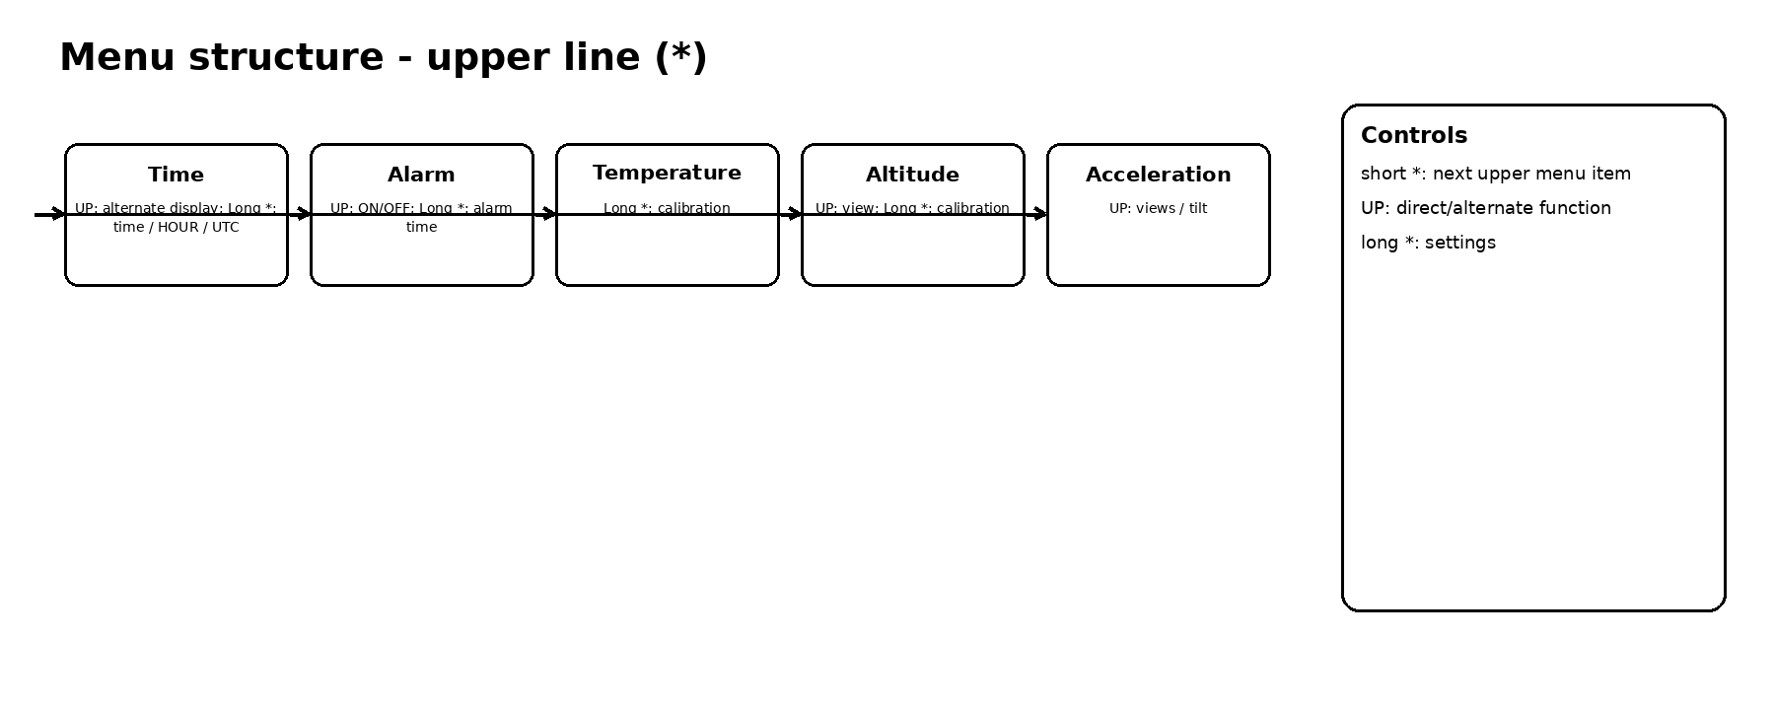
Figure A - Line 1 / *
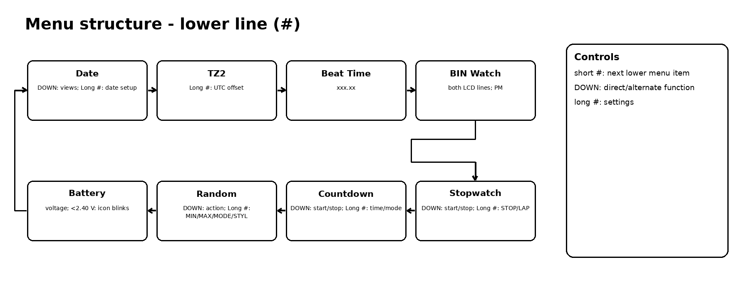
Figure B - Line 2 / #

Funktionen / Functions / Mga Function

Time
Long-press * opens time settings. HOUR toggles the hourly double beep. UTC defines the user-selected relationship between displayed local time and UTC; DST is handled separately.

Alarm
UP toggles ON/OFF and briefly displays ON/OFF. Long-press * sets alarm time.

Temperature
Internal temperature display; long-press * opens existing setup/calibration.

Altitude
Altitude/pressure sensor function; existing direct/setup functions are retained.

Acceleration
Accelerometer/tilt display.

Date
Date views; long-press # opens date settings.

TZ2
Second time zone. Long-press # sets the offset. Half-hour zones are supported, e.g. India +5.5 h. Displays hours, minutes and seconds.

Swatch Beat Time
Beat display in xxx.xx format, derived from UTC using the configured UTC relationship and DST.

BIN Watch
Binary watch face using both LCD lines; PM marks the second half of the day.

Stopwatch
DOWN operates the direct function; long-press # opens STOP/LAP mode setup.

Countdown
Countdown timer with direct control and settings.

Random
Random generator with MIN, MAX, MODE and STYL. MIN=1/MAX=6 produces only 1 through 6.

Battery
A real ADC measurement is triggered on entry and refreshed while visible. Below 2.40 V the battery icon blinks globally. In this beta, treat absolute voltage primarily as a trend value.

Beta / Technical
Watchdog is enabled. LPM3/sleep is intentionally disabled because the previous sleep path caused delayed or incorrect button behavior after longer runtime.
Build: make clean && make FREQUENCY=868 SUPPORT_DIR=C:/ti/msp430-gcc/include

eZ430-Chronos Custom Firmware - Manwal ng Gumagamit
Custom Beta - MSP430-GCC - CC430F6137
Inilalarawan ng manwal na ito ang kasalukuyang beta build ng binagong MSP430-GCC firmware.

Tasten / Buttons / Mga Pindutan
Button | Function
maikling * | Lumipat sa susunod na upper menu.
mahabang * | Buksan ang settings ng kasalukuyang upper item.
maikling # | Lumipat sa susunod na lower menu.
mahabang # | Buksan ang settings ng kasalukuyang lower item.
UP | Direct action sa itaas; sa Alarm, ON/OFF.
DOWN | Direct action sa ibaba.
maikling LIGHT | Buksan ang backlight.
mahabang LIGHT | Light setup: DOWN 1-30 s, UP tuloy-tuloy ON/OFF, LIGHT save/exit.

Menu
LINE 1 (*): Oras -> Alarm -> Temperatura -> Altitude -> Acceleration
LINE 2 (#): Petsa -> TZ2 -> Swatch Beat Time -> BIN Watch -> Stopwatch -> Countdown -> Random -> Baterya
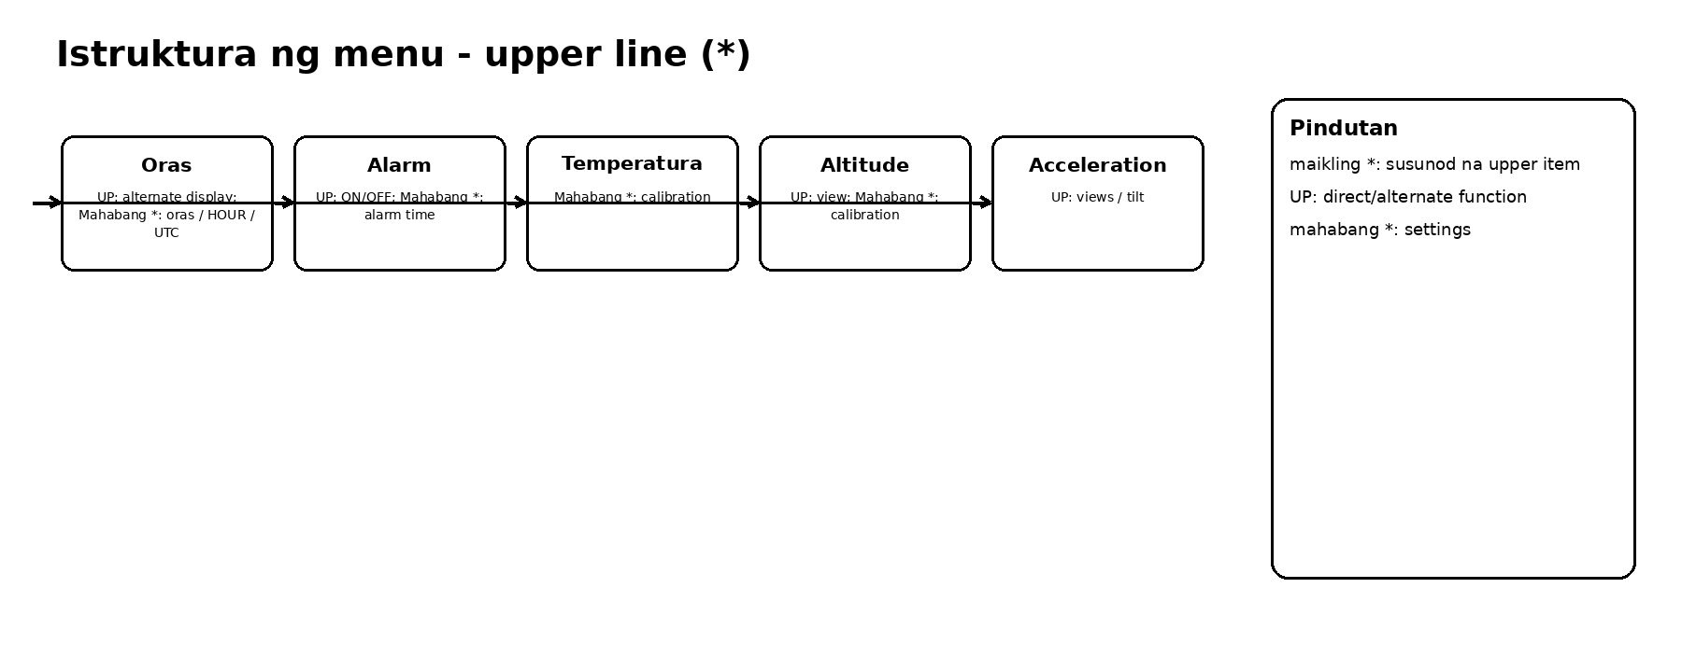
Figure A - Line 1 / *
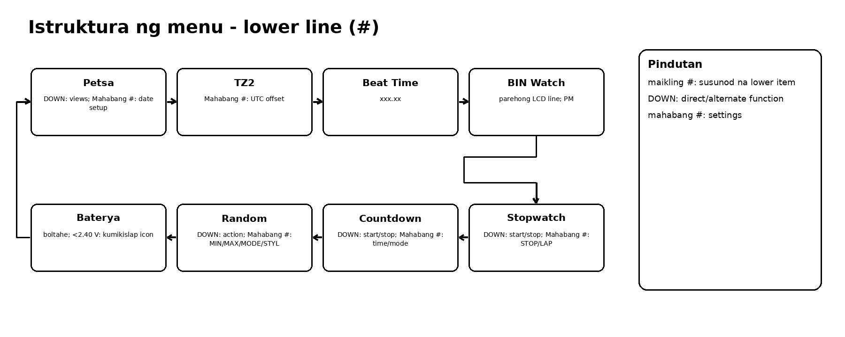
Figure B - Line 2 / #

Funktionen / Functions / Mga Function

Oras
Mahabang * para sa time settings. HOUR ang ON/OFF ng dobleng beep bawat buong oras. UTC ang itinakdang pagitan ng oras sa display at UTC; hiwalay na isinasaalang-alang ang DST.

Alarm
UP para ON/OFF at pansamantalang ipinapakita ang ON/OFF. Mahabang * para itakda ang alarm time.

Temperatura
Internal temperature display; mahabang * para sa kasalukuyang setup/calibration.

Altitude
Altitude/pressure function ng pressure sensor; nananatili ang kasalukuyang direct/setup functions.

Acceleration
Acceleration/tilt display ng accelerometer.

Petsa
Mga date view; mahabang # para sa date settings.

TZ2
Ikalawang time zone. Mahabang # para sa offset. Suportado ang half-hour zones, hal. India +5.5 h. May oras, minuto at segundo.

Swatch Beat Time
Beat display na xxx.xx, kinukuwenta mula sa UTC gamit ang naka-set na UTC relationship at DST.

BIN Watch
Binary watch face gamit ang parehong LCD line; PM ang tanda ng ikalawang kalahati ng araw.

Stopwatch
DOWN para sa direct function; mahabang # para sa STOP/LAP mode setup.

Countdown
Countdown timer na may direct control at settings.

Random
Random generator na may MIN, MAX, MODE at STYL. MIN=1/MAX=6 ay nagbibigay lamang ng 1 hanggang 6.

Baterya
May tunay na ADC measurement sa pagpasok at nagre-refresh habang nakikita. Sa ibaba 2.40 V, kumikislap ang battery icon sa lahat ng menu. Sa beta na ito, gamitin ang boltahe lalo na bilang trend value.

Beta / Technical
Naka-enable ang watchdog. Sadyang naka-disable ang LPM3/sleep dahil ang dating sleep path ay nagdulot ng delayed o maling button behavior matapos ang mahabang paggamit.
Build: make clean && make FREQUENCY=868 SUPPORT_DIR=C:/ti/msp430-gcc/include

