**2022-2023学年于都实验第五中学**

**无生课堂**

**选择性必修三Unit 4 Adversary and Courage 导学案**

**Learning aims:**

In this class, you will

1. read about Shackleton’s Antarctic expedition’s experience.
2. learn to infer something based on the evidence.
3. learn the good qualities of a person, which is to be genuine concern for others and persevere to solve the difficulties.

**Learning procedures:**

**Step1: Lead-in**

Watch a video and conclude what is the video about.

**Step2**: **Pre-reading**

**Task 1**:Read the ad below and answer the questions.

1.What kind of men was Ernest Shackleton looking for?

2.Would you like to join such an expedition? Why or why not?

Task 2: Reading for background information

It is (who)’s diaries about an expedition to (where) on the (how) with Sir (who) in (when).

Task 3: Match the main idea

A.What the crew members’ life was like on Elephant Island

B. How the author joined the Endurance expedition.

C. How Shackleton and his crew abandoned the ship Endurance.

Diary 1

Diary 2

Diary 3

**Step3**: **Pre-reading**

**Task 1: Read Diary 1 and find out how Blackborow came to join the expedition**

**4.Finally**

**2.Then**

**5.Later**

**3.However**

**1.At the very beginning**

**Task 2:Read Diary 2 and fill in the blanks with proper words.**

1.The Endurance became in the ice.

2.The ice around us

3.The ship got by the ice and .

4.Our hearts with the ship.

5.Shackleton calmly us together and us to necessities.

6.We were to take our own belongings.

7.Shackleton all his gold.

8.Hussey was to his *banjo*.

9.We are now on the ice.

10.But the spring is and the ice will soon begin to .

How they abandon the Endurance

**Task 3: Read diary 3 and choose the best answers.**

1.Why didn’t Shackleton take all the members to South Georgia Island to find help ?

A. It is too distant.

B. It was too dangerous and the boat was too small.

C. It had no hope.

D. He wanted to survive alone.

2.What did the crew members do to make sure they could survive?

A. Caught sea animals to eat.

B. Thought of happier things

C. Encouraged each other.

D. all of the above

3. What did the writer spoke highly of Frank and Ernest?

A. Their concern for others.

B. Their resolve.

C. Their perseverance

D. All of the above

**Task 4: Further reading: Infer character traits and emotions**

1. How did Blackborow’s feelings change about being on the expedition?

2. What personal qualities did Shackleton exhibit? Find examples from the text to support your answers.

TIP:Infer character traits and emotions

To infer means to guess something based on the evidence.When inferring character traits(性格特点) and emotions in a story, you need to look at the characters' words and actions. What do these tell us about their personal qualities and feelings?

Example:

1. ...this is the adventure I have been dreaming of. (excited)

2. I was so enthusiastic about the idea...that I hid... (enthusiastic)

More examples:

3. How everyone will envy me when I come back and tell them about the amazing places I have been to!

4. When the ship sank, our hearts sank with it.

5. We have been struggling for days, but things on Elephant Island are going from bad to worse.

6.I feel low. It's cold and windy.

7.Their genuine concern for others, their perseverance, and their resolve fill me with hope.

**What personal qualities did Shackleton exhibit? Find examples from the text to support your answers.**

**a. considerate     b. responsible     c. brave     d. calm**

**e. selfless      f. optimistic  g. experienced   h. adventurous**

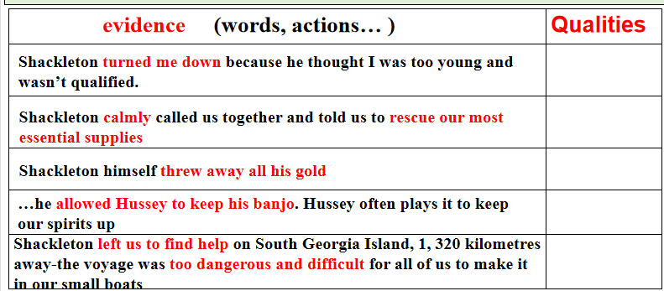

**Step4**: **Post-reading**

**1.How do you understand the title “A SUCCESSFUL FAILURE”?**

1. the Endurance became stuck in the ice, crushed and sank, so they never made it to the South Pole,which made a .
2. Inspired by Shackleton,the crew didn't give up and survived, which was a great .

**2.Discussion:Share your stories of successful failure**

1. What event did you take part in?
2. What difficulty did you meet?
3. What did you learn from the experience?

**3.Read the quote**

“I believe it is in our nature to explore, to reach out into the unknown. The only true failure would be not to explore at all.”

----Ernest Shackleton

**Step5: Homework**

Write a diary about your experience of “a successful failure”