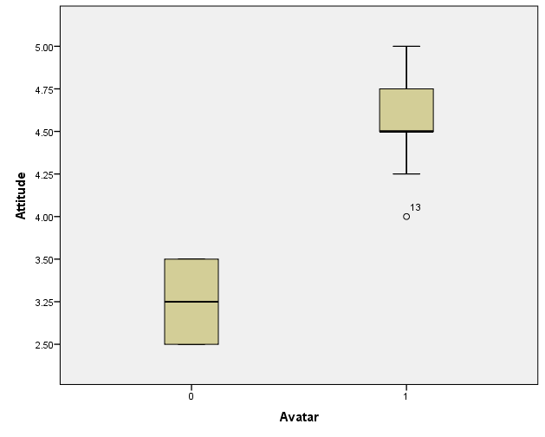

|  |  |  |  |  |  |
| --- | --- | --- | --- | --- | --- |
| **ANOVA** | | | | | |
| Attitude | | | | | |
|  | Sum of Squares | df | Mean Square | F | Sig. |
| Between Groups | 7.661 | 1 | 7.661 | 54.784 | .000 |
| Within Groups | 1.678 | 12 | .140 |  |  |
| Total | 9.339 | 13 |  |  |  |

Participants who used the prototype with the avatar had a significantly better attitude towards the program than participants who did not have the avatar.

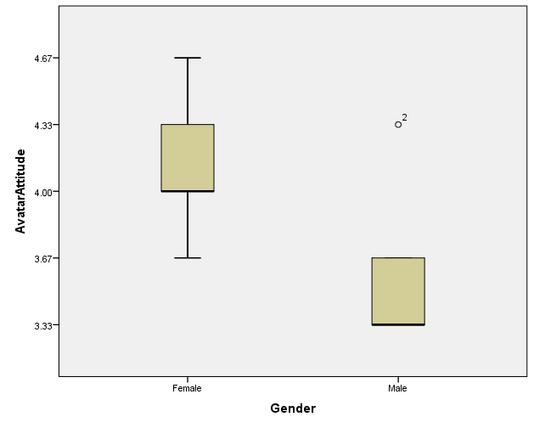

ANOVA with gender as the independent variable and the answers on the questionnaires as dependent variables

|  |  |  |  |  |  |  |
| --- | --- | --- | --- | --- | --- | --- |
| **ANOVA** | | | | | | |
|  | | Sum of Squares | df | Mean Square | F | Sig. |
| Alg1 | Between Groups | .149 | 1 | .149 | .266 | .615 |
| Within Groups | 6.708 | 12 | .559 |  |  |
| Total | 6.857 | 13 |  |  |  |
| Alg2 | Between Groups | .292 | 1 | .292 | .178 | .681 |
| Within Groups | 19.708 | 12 | 1.642 |  |  |
| Total | 20.000 | 13 |  |  |  |
| Alg3 | Between Groups | .292 | 1 | .292 | .161 | .695 |
| Within Groups | 21.708 | 12 | 1.809 |  |  |
| Total | 22.000 | 13 |  |  |  |
| Alg4 | Between Groups | 2.881 | 1 | 2.881 | 2.331 | .153 |
| Within Groups | 14.833 | 12 | 1.236 |  |  |
| Total | 17.714 | 13 |  |  |  |
| Vera1 | Between Groups | 2.500 | 1 | 2.500 | 8.333 | .020 |
| Within Groups | 2.400 | 8 | .300 |  |  |
| Total | 4.900 | 9 |  |  |  |
| Vera2 | Between Groups | 3.600 | 1 | 3.600 | 6.545 | .034 |
| Within Groups | 4.400 | 8 | .550 |  |  |
| Total | 8.000 | 9 |  |  |  |
| Vera3 | Between Groups | .900 | 1 | .900 | 6.000 | .040 |
| Within Groups | 1.200 | 8 | .150 |  |  |
| Total | 2.100 | 9 |  |  |  |

Female participants were significantly ( p < .05) more positive towards the (female) avatar Vera.

We expect boys to give a higher rating for the avatar when it is also male, allowing the boys to identify with the avatar.

**Observations**

Especially for younger children we noticed that the parents can take on the role of “granny”

When working in a group, even if one knew the answer they still searched the internet to check

Some participants got sidetracked and started showing us shark pictures

Almost all participants were able to answer all the questions.

While working in a group seemed to work well, we might need to encourage communication between group members through the avatar.

Hints were sometimes confusing, mostly because the avatar gives them unprovoked.

Open questions on the questionnaire were difficult to answer.

Questions from the avatar were quite straightforward. We feel that more open questions would lead to more curiosity and exploration.

Some participants noted that the program/avatar was too slow. Ideally the speed should be determined by the abilities of the students.

We observed that when working in a group, the “smartest” of the group tended to take control. We should somehow encourage younger group members to be involved more.

Girls were more inclined to explain things to one another while the boys tried to solve all the challenges as fast as possible