/30

Dylan Smith, 20265570

Introduction and instructions

This assignment introduces file input and output operations. You'll learn to create a program that handles text files: reading, interpreting, and formatting their content for both the console and a new text file.

In task 1 we will review a basic input/output program and answer questions about its functionality. We will then explore input/output streams to grasp data handling processes. In task one you will also answer some questions related to software engineering methodology Task 2 involves completing a partially developed program by filling in missing code segments. Task 3 presents a higher-level programming challenge. You'll receive the initial code structure and write a program to solve the given problem.

**For this assignment, you will need to upload:**

* **1 pdf file with your answer to the text related task (Task 1), screenshots of the output of Task 2 and 3.**
* **Two separate files for your code for Task 2 and Task 3.**

# /10 Task 1

In the first part of this task (Q1, Q2) we will read a small program simple_fileIn.cpp and answer some questions to understand what specific parts and lines of code do. In the second part of task 1 (Q3-Q7) you will answer some question related to I/O streams, file I/0 and software engineering methods.

|  |  |  |  |
| --- | --- | --- | --- |
| /1 | 1. | | Line 11 of simple_fileIn.cpp: ifstream inData;    What is being created on line 11? What is its type?  On line 11 an input file stream is being created. It’s type is the ifstream class from the std namespace: std::ifstream. |
| /1 | 2. | | If statement starCng on Line 21: |
| if (!inData) {  cerr << "** Problem: cannot open file_input.txt, ending program."  << endl; return 1;  } | | |

What does the if statement starting on line 21 do?

This if statement checks whether the input filestream ifstream was successfully created and that the file was opened. If it was not, it exits the program with an error code 1.

/1 3. Name and briefly describe two of the stream classes

One stream class is the ifstream, which is an input file stream. This opens a file for input. Another is the ofstream. This is an output file stream, which opens a file for output. There is also istream and ostream.

|  |  |  |
| --- | --- | --- |
| /1 | 4. | In C++ the output file is not written immediately as data is taken into the output filestream object. Data is first saved to the stream buffer then written to disk. which statement in simple_fileIn.cpp saves and writes the output file to the disk?  The statement outData.close() on line 58 saves and writes the output file to the disk. |
| /1 | 5. | What is the difference between a Product Owner and a Scrum Master?   1. The Product Owner needs to be certified in Waterfall, but the ScrumMaster does not. 2. The ScrumMaster needs to be certified in Waterfall, but the Product Owner does not. 3. The Product Owner guides the product direction, and the ScrumMaster guides its implementation. 4. The ScrumMaster guides the product direction, and the Product Owner guides its implementation.   C. |
| /3 | 6. | Suppose that a police department wants to hire you to build a system for keeping track of cases that they are trying to solve. For each case, they will want to track several hundred (or maybe even several thousand) pieces of information about the case’s evidence and suspects.  At present, however, the police department only has a vague idea about exactly which of these pieces of information really need to be part of the system.  It appears that the system will have three parts:   * A web application where detectives can log in, then edit and search the data. * A program that periodically downloads all the evidence data and makes a backup of it. * A program that periodically downloads all the suspect data and publishes it via an XML feed that other law enforcement departments can access.     There probably are several alternatives for designing each of these parts of the system. The police department is extremely eager to have the first part of the system working soon. They can’t wait for the other two parts to be implemented later.    **Would you use a waterfall, spiral, or agile process for building this system, and why?**    I would recommend an agile process for building this system. The reason for this is it allows for rapid and easy changes to the project requirements and planning down the line without serious consequences or costs. The nature of the system required by the police department has uncertainties, such as the “vague idea about exactly which of these pieces of information really need to be part of the system.” Methods like the waterfall require intense planning from the start. If there are any deviations or problems with the plan there can be large time or money costs. The agile methodology would allow for the best flexibility to fit the uncertainties of the project. |
| /2 | 7. | What is the difference between the product backlog and the sprint backlog?  The product backlog represents the overall backlog of all work items for the product. The sprint backlog holds only tasks that have been selected for implementation during a specific sprint. |

# /10 Task 2

For this task, we provide you with a starter program hamletStart.cpp and a text file hamlet.txt. The goal of this task is to implement a program that takes a text file and user provided word, finds the number of occurrences of the word in the text file.

The requirements for matching words are as follows:

1. Ignore case, example if we search **king**, then **KING** and **kiNG** should also match
2. Exact words must match, not subwords. Example, if we search **line**, then **decline** should not match

Use the comments in the code as a guide for implementing the rest of the code.

The following table shows some examples of the word searched, and if it should produce a match or not.

|  |  |  |
| --- | --- | --- |
| **Word Searched** | **Word Found** | **Match** |
| world | world | YES |
| line | decline | NO |
| king | KING | YES |
| to | to-day | YES |
| day | to-day | YES |

Below is an example output that your program may look like.

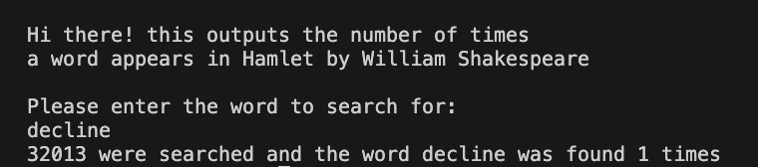

Output screenshot for task 2:

# /10 Task 3

For this task we provide the outline of the program quizMarkerStart.cpp and the text file QuizResponses.txt. Your program will take QuizResponses.txt as input and output a **formatted table** in a **new text file** as shown below:

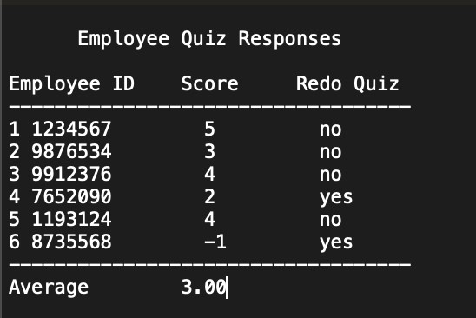

The table requirements are:

1. Title at the top, centered
2. Column headers: **Employee ID**, **Score**, and **Redo Quiz**
3. Line numbers on each printed line with an employee ID and score
4. The columns should be equal width using setw() as seen in lecture
5. Keep track of all employee scores and display the average at the bottom of the table
6. In the score column, print -1 if the response was incomplete. If the response is incomplete, you can automatically assign -1, no need to calculate the score for an incomplete response. (e.g., correct answers are **ABCDE**, the answer given was AAB)
7. In the Redo Quiz column, print **Yes** if the score is less than 3 or if the response is incomplete. The Redo Quiz column indicates that the employee needs to retake the quiz.

The file QuizResponses.txt is in the following format:

* The first line contains the answer key (e.g., ABCDE)
* There is then a pair of employee numbers and their quiz responses separated by newlines.

Output screenshot for task 3:

