**DAR ES SALAAM INSTITUTE OF TECHNOLOGY**



**COU 07504: DATA STRUCTURE AND ALGORITHMS**

**ASSIGNMENT 1**

**NAME: EMMANUEL TARIMO**

**REG NO: 200230228468**

**CLASS: BENG2O – COE1**

1. **Accessing Elements of an Array**

**Code:**

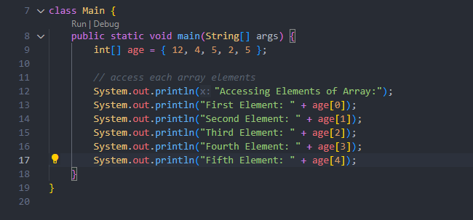

**Output:**

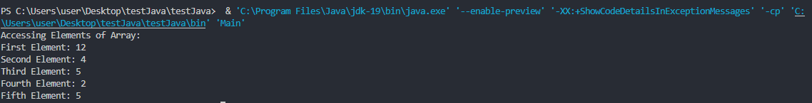

1. **Looping through Array elements**

**Code:**

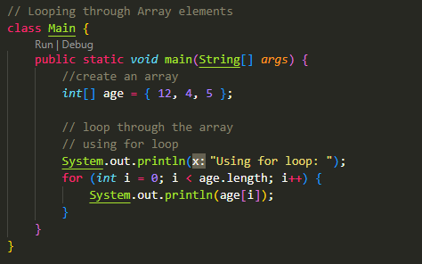

**Output:**

1. 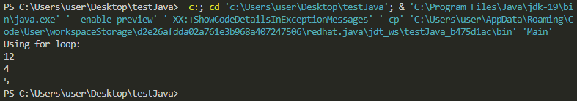
2. **Looping using the for-each loop**

**Code:**

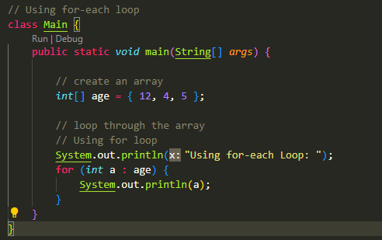

**Output:**

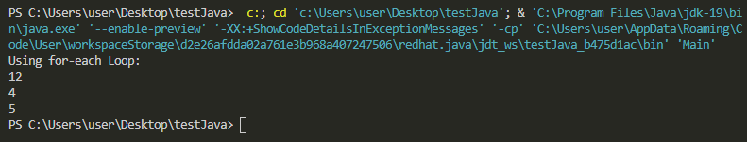

1. **Computing Sum and average of Array**

**Code:**

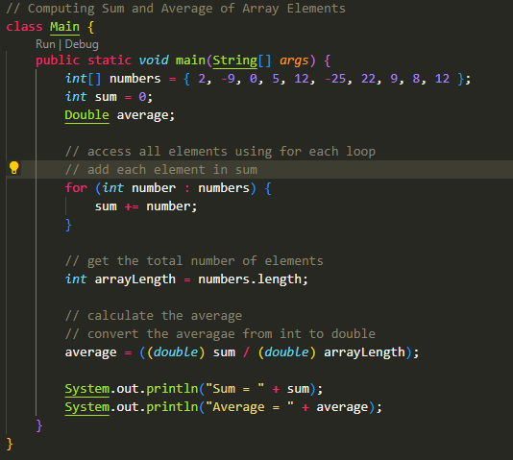

**Output:**

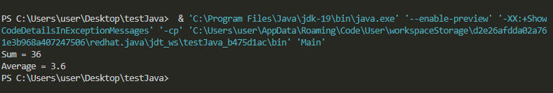

1. **Program to find the sum and the largest/max one**

**Code:**

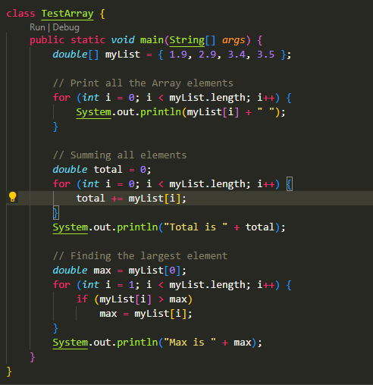

**Output:**

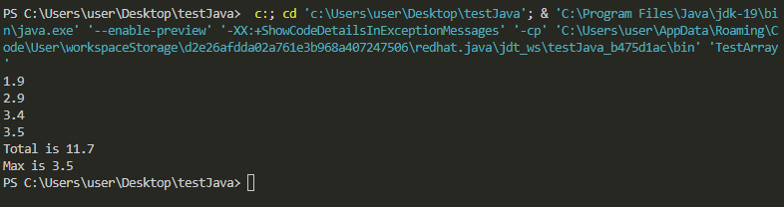

1. **Passing arrays to methods**

**Code:**

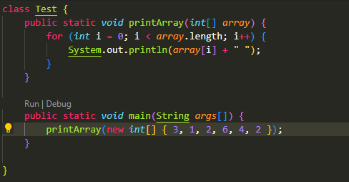

**Output:**

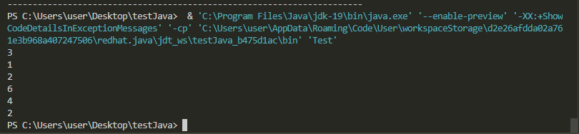

1. **Passing arrays to methods example**

**Code:**

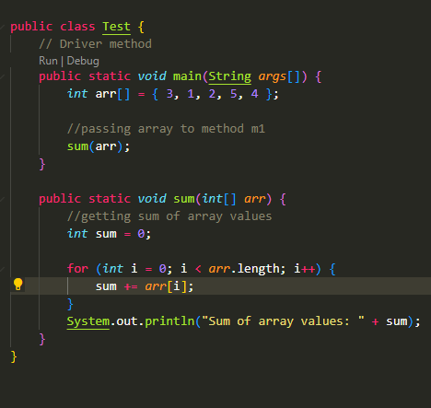

**Output:**

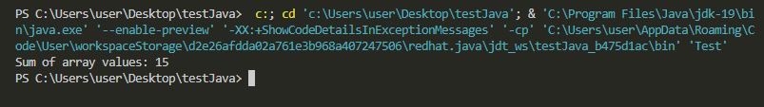

1. **Multidimensional Arrays**

**Code:**

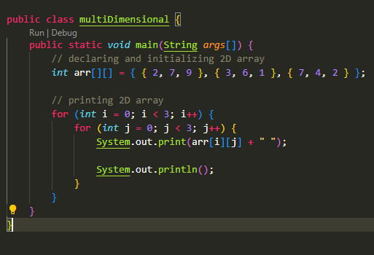

**Output:**

