**DBMS & DATA INTERPRETATION AND LOGICAL REASONING**

**Q-1** Which number should come next in the series 1,2,3,10,__

1. 79
2. 99
3. 89
4. 98

**Q-2** Which number is wrong in the series 2,6,15,31,56,93 ?

1. 6
2. 31
3. 56
4. 93

**Q-3** Which number comes next in the series 1536,384,96,__?

1. 23
2. 24
3. 28
4. 18

**Q-4** What will be the next number in the series 13,17,19,23,29,__?

1. 31
2. 33
3. 35
4. 37

**Q-5** Statement 1 : A is bigger than B but shorter than C

Statement 2 : D is smaller than C and bigger than A

Statement 3 : B is greater than D

If Statement 1 and statement 2 are True, statement 3 will be

1. True
2. False
3. Uncertain
4. NOTA

**Q-6** Introducing a girl, Vishal said, “Her mother is the only daughter of my mother-in-law”. How is

Vishal related to the girl?

(a) Uncle

(b) Husband

© Brother

(d) Father

**Q-7** Introducing a man a woman said, “He is the only son of my mother’s mother”. How is woman

related to the man?

(a) Mother

(b) Aunt

© Niece

(d) Sister

**Q-8** Pointing to a lady, a man said “The son of her only brother is the brother of my wife”. How is the

lady related to the man?

(a) Mother’ssister

(b) Grand mother

(c) Mother-in-law

(d) Sister of father-in-law

**Q-9** Pointing to a person, a man said to a woman, “His mother is the only daughter of your father”.

How was the woman related to the person?

1. Sister
2. Mother

(c) Wife

(d) Daughter

**Q-10** Introducing a man, a woman said, “His wife is the only daughter of my father”. How that man

was related to the woman?

(a) Maternal uncle

(b) Father-in-law

(c) Brother

(d) Husband

**Q-11** Rohit wants to go to the university. He starts from his home which is in the East and comes to a crossing. The road to the left ends in a theatre, straight ahead is the hospital. In which direction is the university?

(a) West

(b) East

(c) North

(d) South

**Q-12** A is 40 m South-West of B. C is 40 m South-East of B. Then C is in which direction of A?

(a) South

(b) North-East

(c) West

(d) East

**Q-13.** A Child is looking for his father. He went 90 metres in the east before turning to his right. He went 20 metres before turning to his right again to look for his father at his uncle’s place 30 metres from this point. His father was not there. From there, he went 100 metres to his north before meeting his father in a street. How far did the son meet his father from starting point?

(a) 180 metres

(b) 100 metres

(c) 140 metres

(d) 120 metres

**Q-14** On playing ground, Dinesh, Kunal, Nitin, Atul and Prashant are standing as described

below facing the North.

(i) Kunal is 40 mts to the right of Atul

(ii) Dinesh is 60 mts to the south of Kunal

(iii) Nitin is 25 mts to the west of Atul

(iv) Prashant is 90 mts to the North of Dinesh

Who is to the North-East of the person who is to the left of Kunal?

(a) Atul

(b) Dinesh

(c) Nitin

(d) None of these

**Q-15** Mahesh ranked 13th from the top and 26th from the bottom among those who have passed the annual examination in a class. If six students have failed in the annual examination, what was the total number of students in that class?

(a) 44

(b) 20

(c) 21

(d) 38

**Q-16** There are five books A, B, C, D, E. C lies above D, E is below A. D is above A, B is below E. Which is the bottom most book?

(a) A

(b) B

(c) E

(d) C

**Q-17** Five bags are lying in a pile one above the other. If A is above B, C is above D but below E and D is above A, which bag is in the middle?

1. A

(b) D

(c) C

(d) B

**Q-18** Prakash is taller than Geetha. Amar is taller than Prabhat but not as tall as Geetha. Prabodh is taller than Prakash. Who among them is the shortest?

(a) Prabhat

(b) Geetha

(c) Amar

(d) Prabodh

**Q-19** There are six students in a class A, B, C, D, E and F. D is taller than E and F. There is only one person between B and C. A is between E and F. There are four persons between C and F.

Who is the tallest in the group?

1. D

(b) A

(c) C

(d) E

**Q-20** Five boys are up on the ladder. A is further up the ladder than B. B is between A and C. D is further up than A. E is on the bottom most. Who is the third from the bottom.

(a) B

(b) C

(c) A

(d) D

**Q-21** P, Q, R, S, and T are sitting in a row. Q is between P and T. To find out who among them is in the middle, which of the following information given in the statements A and B is/are sufficient?

**A.** P is left of Q and right of S

**B**. R is at the right end

(a) Only (B) is sufficient

(b) Only (A) is sufficient

(c) Either (A) or (B) is sufficient

(d) Both (A) and (B) together are needed

**Q-22** Six friends P, Q, R, S, T and U are members of a club and play game of Football, Cricket, Tennis, Basketball, Badminton and Volleyball. T plays Tennis and is taller than P and S. The tallest among them plays Basketball and the shortest Volleyball. Q and S neither plays Volleyball nor Basketball. R plays Volleyball and Q plays Football. T is between Q and P in order of height.

Which of the following is not true?

(a) P is shorter than R

(b) Q is taller than S

(c) S is taller than R

(d) T is taller than R

**Q-23** A cube is coloured blue on all faces. Three cuts are given on each edge to form smaller cubes of equal size. Now, answer the following questions based on this statement.

How many smaller cubes are formed?

(a) 96

(b) 27

(c) 16

(d) 64

**Q-24** 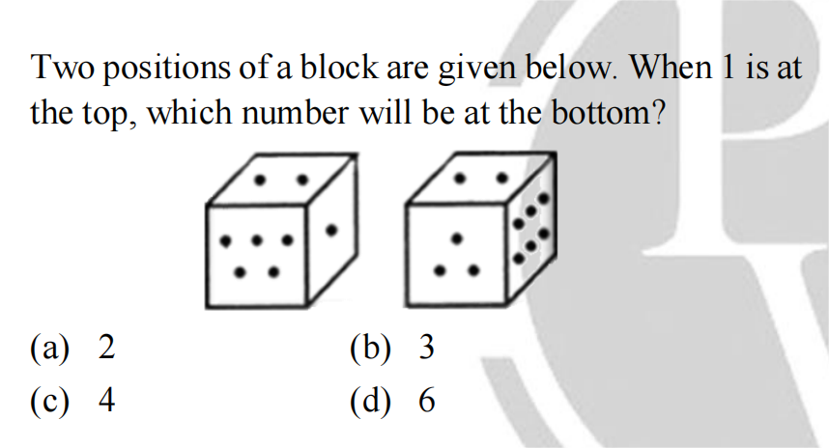

**Q-25**

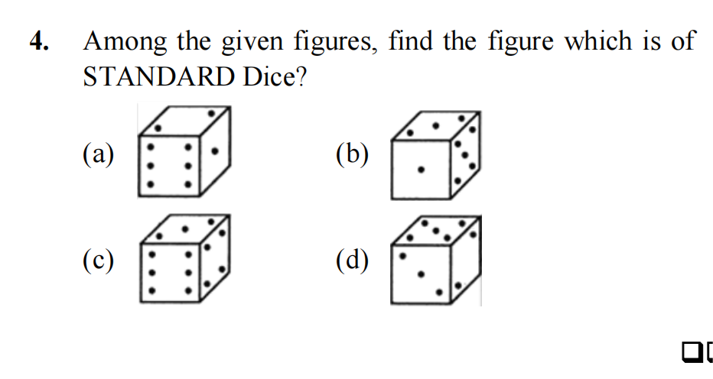

**Q-26** A class of 30 students comprises boys who can play Cricket, Hockey and Football. 3 boys play only cricket, 3 boys play only Hockey and 2 play only football. 4 boys could play all three games, while 11 could play Football and Cricket both, and 10 boys could play Football and Hockey both.

How may boys played Cricket and Hockey both?

(a) 15

(b) 5

(c) 25

(d) 9

**Q-27** A survey was conducted and 300 people were reading among these newspapers: Times of India, Hindustan Times and Indian Express. It is known that 100 people read at least two of these newspapers. 230 people read Times of India or Indian Express. 180 people read exactly one. 80

read neither Times of India nor Hindustan Times. 130 read the Times of India or Hindustan Times but not Indian Express.

How many people read at least one of the other two

newspaper along with Indian Express?

(a) 60

(b) 80

(c) 90

(d) 70

**Q-28** In a class, 70 students passed in Mathematics, 50% of the students passed in English, 25% of the students passed in both and 5% of the students passed in neither Mathematics nor

English.How many students are there in the class?

(a) 100

(b) 200

(c) 105

(d) None

**Q-29** Study the following Time table of Geetanjali Express carefully and answer the question: 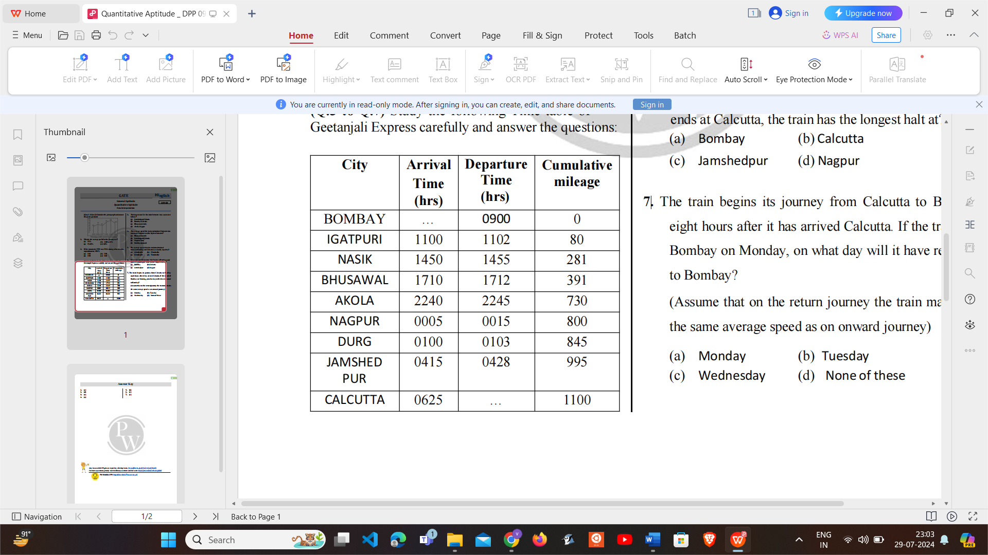

The average speed the train maintained between two successive stations was the highest between?

(a) Bhusawal-Akola

(b) Jamshedpur-Calcutta

(c) Nagpur-Durg

(d) Bombay-Igatpuri

**Q-30** Consider the given graph and answer the given question:

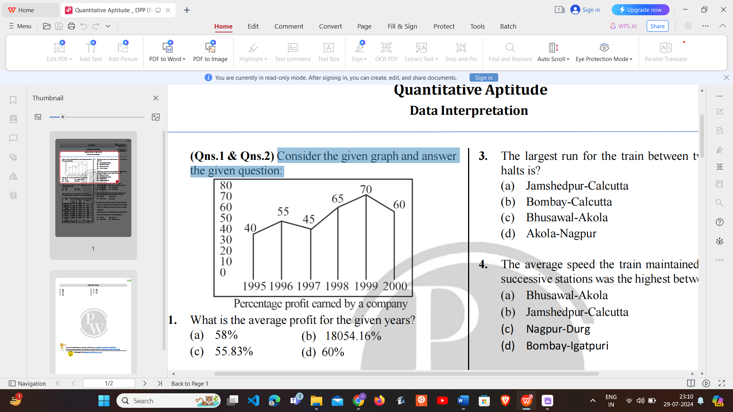

If the income in 1998 was ₹264 crores, what was the expenditure in 1998?.

(a) 240

(b) 180

(c) 150

(d) 160

**PART 2 (DBMS)**

**Q-1** In a schema with attribute X, Y, Z, W, V, the following set of functional dependencies are given:

{Y → X, Y → Z, ZW → V, X → W, V → X}. Which of the following FD is not implied by the above set?

(a) YX → ZW

(b) XV → YZ

(c) ZW → V

(d) XV → XW

**Q-2** Suppose a relation R has 9 attributes, then the

maximum possible number of candidate keys are?

(a) 125

(b) 126

(c) 120

(d) 127

**Q-3** Choose the incorrect statement from the following

(a) All super keys cannot be primary key.

(b) We choose the minimal candidate key to be a

primary key.

(c) The number of super keys are equal to the number

of primary keys for a relation.

(d) None of the above.

**Q-4** Consider the relation R (P, Q, R, S, T) and the set of function dependencies F = {P →Q, QR →T, TS→P}.

Which of the following is not the candidate key of R?

(a) RST

(b) PRS

(c) QRS

(d) PQR

**Q-5** Consider the following statements:

**S1:** Primary key has no duplicate values it has only unique values.

**S2:** Primary key are not necessary to be a single column more than one column can also be a primary key for table.

(a) Only S1 is true.

(b) Only S2 is true.

(c) Both S1 & S2 are true.

(d) Neither S1 nor S2 are true.

**Q-6** Consider a relation with schema R(P, Q, R, S, T) and FD set (PQ→R, R→S, S→P). How many super keys in relation R contains?

(a) 6

(b) 7

(c) 8

(d) 9

**Q-7** Consider the relation R(P, Q, R, S, T, U, V, W) with the following set of functional dependencies: F = {P → QRS, P → T, TUV → W and U → VW}

Which one of the FD in the F is redundant?

(a) P → QRS

(b) PS → T

(c) TUV → W

(d) U → VW

**Q-8** Assume a relation R = (P, Q, R, S) and a set F of functional dependencies:

F = {PR → S, S → P, S → Q, S → R}, Highest normal form satisfied by the relation R is?

(a) 2NF

(b) 3NF

(c) BCNF

(d) 1NF

**Q-9** Consider a relation which contains two different true multivalued dependencies then which of the following normal form is violated automatically.

(a) 2NF

(b) 3NF

(c) BCNF

(d) 4 NF

**Q-10** Consider a table/Relation R has one candidate key, then which of the following is always true?

(a) If R is in 2NF, then it is also in 3NF

(b) If R is in 3NF, then it is also in BCNF

(c) If R is in 2NF, but it is not in 3NF

(d) None of the above.

**Q-11** Assume that a relation is in 3NF under which of the

following conditions R can violate BCNF?

(a) The table consists two candidate keys that share a common attribute.

(b) The table consists of two non-overlapping candidate keys.

(c) The table has a unique candidate key consisting of one attribute.

(d) The table consists of two candidate keys each consisting of one attribute.

**Q-12** Two operations are called conflicting operations, if they satisfy which of the below conditions:

I: They work on same data item.

II: Both the operations belong to different transactions.

III: There exists at most one write operation.

The number of conditions satisfied for conflicting operations is/are

(a) 0

(b) 1

(c) 2

(d) 3

**Q-13** Suppose many concurrent transactions are made to run over the same data set and the 2nd transaction updates the database before the 1st transaction is finished or completed its execution then which one among the following property is violated and the

database is no longer consistent.

(a) Durability

(b) Isolation

(c) Atomicity

(d) Consistency

**Q-14** Consider the following statements

S1: Every view serializable schedule is conflict serializable.

S2: Some view serializable schedules are conflict serializable.

(a) Only S1 is true.

(b) Only S2 is true

(c) Both S1 & S2 are true

(s) Neither S1 nor S2 is true

**Q-15** Consider the following statements:

**P:** Updation of tuples into referenced relation may cause foreign key violation.

**Q:** Updation of tuples into referencing relation may cause foreign key violation.

Which of the following is/are INCORRECT?

(a) P only

(b) Q only

(c) Both P and Q

(d) Neither P nor Q

**Q-16** Consider the two relations R1 and R2 such that they have no attributes in common then

**S1:** R1 ⋈ R2 = R1 × R2

**S2:** R1 ⋈ R2 = φ

Which of the given statement(s) is/are correct?

(a) S1 only

(b) S2 only

(c) Both S1 and S2

(d) Neither S1 nor S2

**Q-17** Consider the following statements. (SQL QUERY)

**S1:** A DELETE statement can remove rows based on a single condition on a table

**S2:** An INSERT statement can add a single row based on multiple condition on a table.

Choose the correct statements

(a) Only S1 is true

(b) Only S2 is true

(c) Both S1 and S2 are true

(d) Both S1 and S2 are false

**Q-18** Consider the following statements

**S1:** An INSERT statement can add multiple rows per execution to a table.

**S2:** An UPDATE Statement can modify multiple rows based on multiple condition on a table.

Choose the correct statements.

(a) Only S1 is true

(b) Only S2 is true

(c) Both S1 is S2 are true

(d) Both S1 and S2 are false

**Q-19** Consider the following keywords.

A. SELECT

B. TOP

C. DISTINCT

D. FROM

E. WHERE

F. GROUP BY

G. HAVING

H. ORDER BY

The above keywords are used in the given SQL query

below.

SELECT TOP NumberOfRows DISTINCT Col1, Col2

FROM TableNameX, TableNameY

GROUP BY ColumnName

HAVING expression

ORDER BY ColumnName;

Which of the following is the correct query execution

order according to SQL Standard?

(a) D E F G A H B C

(b) D E F G A C H B

(c) D E F G A B C H

(d) A D E F G H C B

**Q-20** Consider the following table named Student in a relational database. The primary key of this table is rollNum.

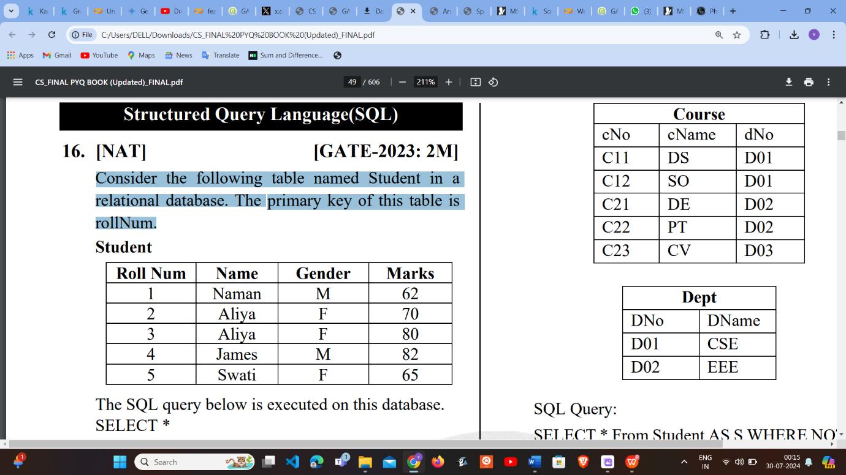

The SQL query below is executed on this database. SELECT * FROM Student WHERE gender = ‘F’ AND marks > 65; The number of rows returned by the query is

(a) 2

(b) 3

(c) 4

(d) 5

**Q-21** The relation scheme given below is used to store information about the employees of a company, where empId is the key and deptId indicates the department to which the employee is assigned. Each employee is assigned to exactly one department.

emp(empId, name, gender, salary, deptId)

Consider the following SQL query:

select deptId, count(*)

from emp

where gender = "female" and salary > (select avg(salary) from emp) group by deptld;

The above query gives, for each department in the company, the number of female employees whose salary is greater than the average salary of

(a) employees in the department.

(b) employees in the company.

(c) female employees in the department.

(d) female employees in the company.

**Q-22** Consider the following database table named top_scorer. Consider the following SQL query:

SELECT ta.player FROM top_scorer AS ta

WHERE ta.goals > ALL (SELECT tb.goals FROM

top_scorer AS tb WHERE tb.country='Spain')

AND ta.goals > ANY (SELECT tc.goals FROM

top_scorer AS tc WHERE tc.country ='Germany')

The number of tuples returned by the above SQL query is

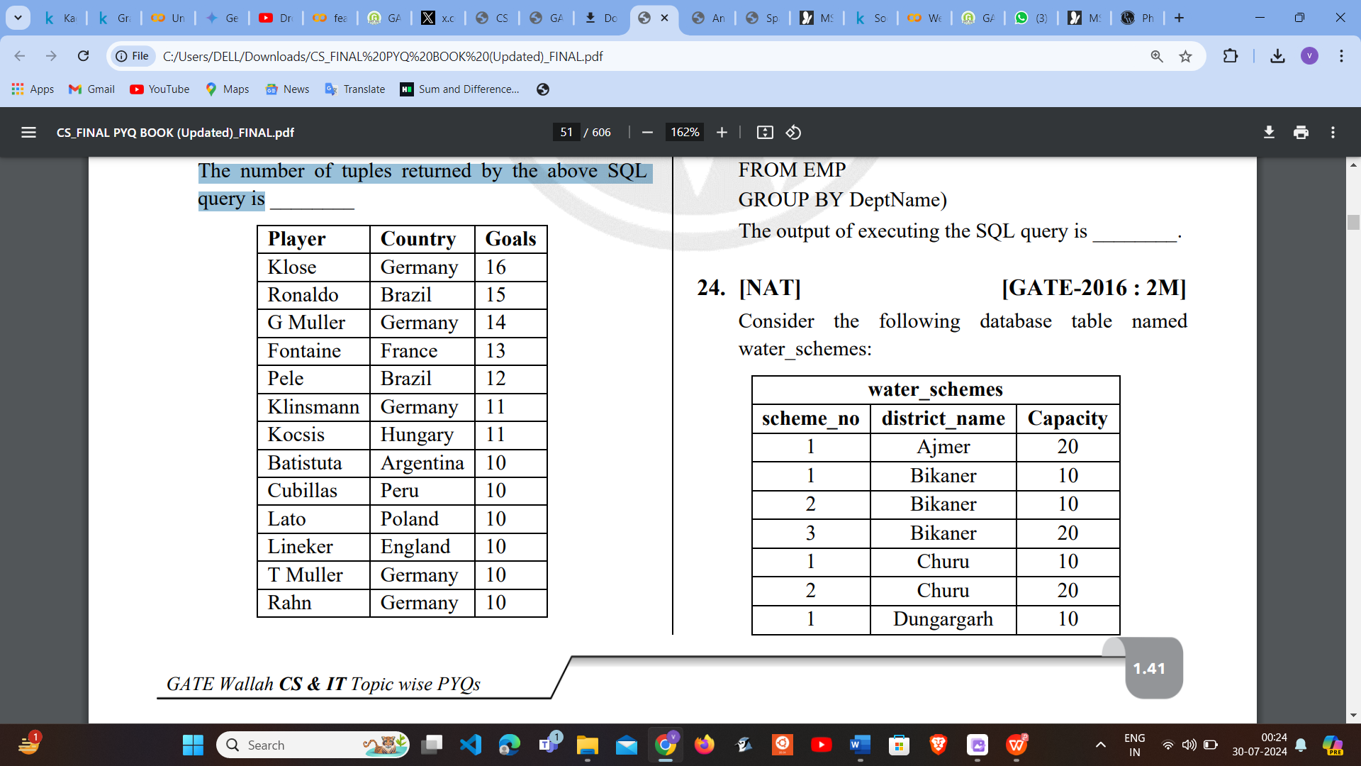

(a) 5

(b) 6

(c) 7

(d) 8

**Q-23**

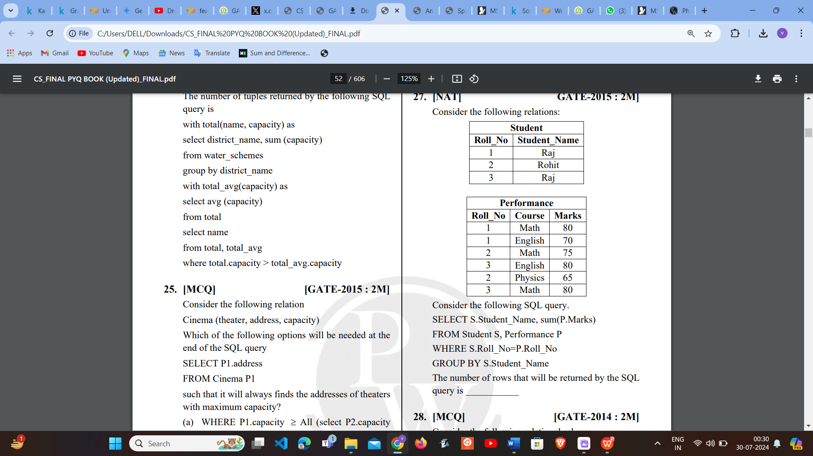

(a) 1

(b) 2

(c) 3

(d) 4

**Q-24** Which of the following statements are TRUE about an SQL query?

P: An SQL query can contain a HAVING clause even if it does not have a GROUP BY clause.

Q: An SQL query can contain a HAVING clause only if it has a GROUP BY clause

R: All attributes used in the GROUP BY clause must appear in the SELECT clause

S: Not all attributes used in the GROUP BY clause need to appear in the SELECT clause

(a) P and R

(b) P and S

(c) Q and R

(d) Q and S

**Q-25**

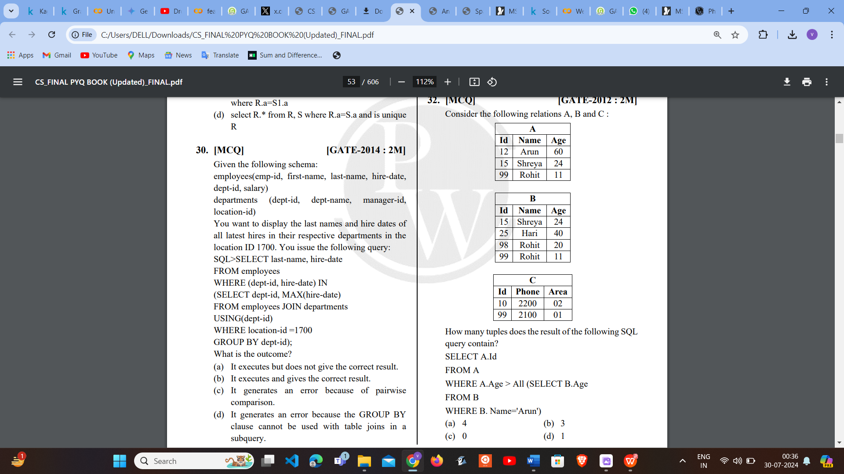

(a) 4

(b) 3

(c) 0

(d) 1