**Course Instructor:**

Name: Dr. Umut TOSUN

Email: utosun@ashesi.edu.gh

Zoom link: https://ashesi.zoom.us/my/umut.tosun

WhatsApp: +90 505 687 45 66

Office Location: Online

Office Phone: TBA

Course Hours: **Tuesday, Thursday 09:45-11:45**

Lab Hour: **Friday 13:55-14:25**

Office hours: **Monday:09:00~11:00, Wednesday: 11:00~13:00** Credit Hours: 4; Ashesi Credit Units: 1

TA: Eugene Daniels

TA email: eugene.daniels@ashesi.edu.gh

**Course Material:**

Principles of Distributed Database Systems 4th ed. 2020 Edition by M. Tamer Özsu (Author), Patrick Valduriez (Author), Springer, ISBN 978-3-030-26252-5

**Required Software:**

MySQL 8.0, MySQL NDB Cluster 8.0, Apache Kafka 2.8.0, MongoDB 4.4, Neo4j Desktop 1.4.9

**Course Overview:**

The Advanced Database Systems course deals with the usage as well as concepts of design and architecture of databases. In covering the concepts, theorems and algorithms, proofs relevant to different aspects (design, architecture, and implementation) are covered. The general approach is to go through conceptual and logical database design, architecture (schema, indexes, tuning and storage), core features (transactions, concurrency), and specialized database usage (data mining & data warehousing). The practical work done in the course goes through usage of some advanced SQL features and the implementation of some algorithms and coding of internals of an actual database system. Students should already know structured query language. Distributed databases, NoSQL (MongoDB, Firebase, etc.) and graph databases will be covered too.

**Prerequisites:**

Database Systems, EITHER Discrete Structures and Theory OR Data Structures and Algorithms

**Learning Outcomes:**

1. To be competent with conceptual and logical database design
2. To be able to setup and configure Enterprise DBMS: transaction processing, concurrency control, database recovery, security & authorization
3. To be able to create and use database objects such as tables, views, stored procedures, functions, indexes, constraints, and triggers
4. To be able to design and develop a holistic and efficient database for any system
5. To be able to modify data with logical query processing
6. To be able to troubleshoot and optimize database using tools to analyze query performance 7. To be competent in the use of non-relational databases

**Ashesi Learning Outcomes Addressed:**

1. Technological Competence

Students will learn cutting edge and bleeding edge technologies in databases which will help them to be pioneers in ICT jobs and database research.

1. Leadership & Teamwork

Students will gain the skills of leadership and teamwork through lab assignments every week. They will form study groups for hands-on practices. They will improve mentioned skills as they help and guide each other.

1. Curiosity & Skill

Some of the course assignments and discussions are open ended, therefore students will spend more time on them to sharpen their skills. This course is not only a hands-on course but also a first course for guided database research.

1. Critical Thinking Open or Close

This course is a design course which teaches students to design distributed databases and queries in an efficient way. This will require critical thinking for solving problems like query optimisation, data allocation and distributed database design.

**Course outline (Tentative):**

**Modules in this outline might be subject to change depending on student interests and recent innovations in database technology.**

|  |  |
| --- | --- |
| **Topic** | **Chapter** |
| Overview of Relational Databases | Module 1 |
| Tuple Relational Calculus | Module 2 |
| Domain Relational Calculus | Module 3 |
| Stored Procedures | Module 4 |
| Triggers and Views in SQL | Module 5 |
| Introduction to Distributed Database Systems | Module 6 |
| **Study Break** |  |
| **Midterm Exam** |  |
| Distributed and Parallel Database Design | Module 7 |
| Distributed Data Access Control | Module 8 |
| MySQL Cluster Database Technology | Module 9 |
| Distributed Query Processing | Module 10 |
| NoSQL, Graph Databases | Module 11 |
| Distributed Transaction Processing | Module 12 |
| **Final Exam** |  |

**Grading:**

Your participation is **expected** and **required** since there will be a hands-on lab session every week. This lab session will constitute **20 %** of overall grade. An extra **10 %** will be given for attendance, preparedness and contribution to the class discussion. Missing more than 6 classes will result in **direct failure** from this class with a letter grade **"F"**. All students are encouraged to participate to class discussions. **Please let me know if there is a genuine reason to prevent you from attending the class.**

You can notify me through my email in advance for any issues.

The grades in the course will be based on the following categories:

|  |  |
| --- | --- |
| **Category** | **Grade** |
| Quizzes, Lab sessions, Assignments & Attendance  10 15 / 6 5 | 30 percent |
| Midterm | 30 percent |
| Final exam (assignment part) | 20 percent |
| Final exam (exam part) | 20 percent |
| **Total** | **100 percent** |

**Assignments:**

The best way to learn advanced database management is to program it yourself and tune it. Therefore, the lab assignments will generally involve implementing distributed database design problems and experimentation to test your solutions on some data. You will be asked to summarize your work, and analyse the results, in brief (1-2 page) write ups. The implementations will be done in several database systems including MySQL, SQL Server 2019 and MongoDB. We will also use Kafka which uses distributed data management principles to understand streaming. There will be an **assignment** for **each module**. These assignments will be **solved in lab or they will be due the start of the next class hour**. Please spend enough time on the course material. This is a **hands-on course** therefore **it may take some time to get the skills**. Do not give up if you don’t get the idea behind something at first. You should consistently show progress to be a database expert. **Late assignments and lab work** will not be accepted unless there is a serious excuse.

**Exams:**

**Midterm and final exams** will be **take home project assignments**. **Late submissions for midterm and final exams will not be accepted !** You are free to discuss midterm and final exams with your friends. **However, you should answer all the questions yourself ! Collaboration is not allowed. You are responsible from your own work.**

**Plagiarism is an extremely serious offense. Copying material from your classmates or internet without citation, cheating in the exams or assignments will result in a failed grade. You will need the skills gained in this course as a database expert. Therefore, I trust everyone will put all the effort to understand concepts of the course without a doubt.**

According to the ASHESI grading system, letter grades will be assigned based on the following ranges:

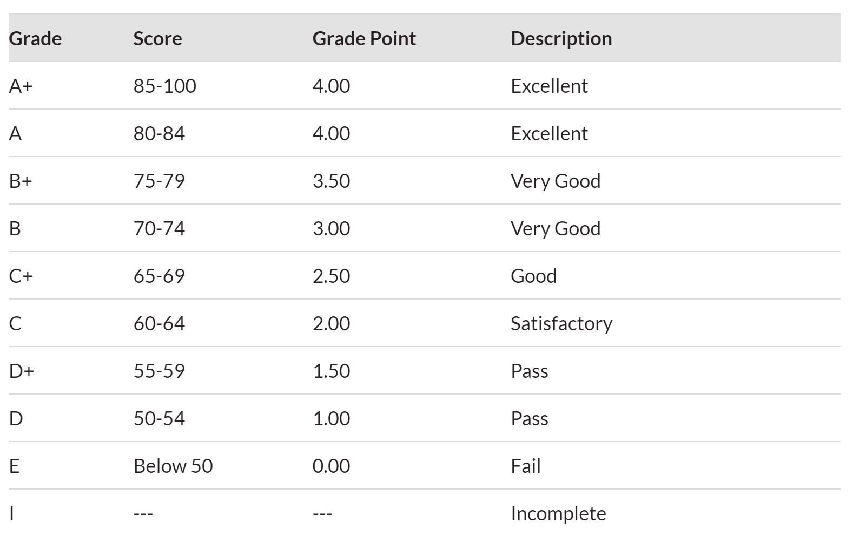

*A 'D' grade does not count towards credits in a major area of study, nor does it count towards prerequisites for other courses.*

# NETIQUETTE GUIDE FOR ONLINE COURSES

It is important to recognize that the online classroom is in fact a classroom, and certain behaviors are expected when you communicate with both your peers and me. These guidelines for online behavior and interaction are known as netiquette.

**SECURITY** Remember that your password is the only thing protecting you from pranks or more serious harm.

* Don't share your password with anyone .
* Change your password if you think someone else might know it.
* Always log out when you are finished using the system.

**GENERAL GUIDELINES** When communicating online, you should always:

* Treat your instructor and classmates with respect in email or any other communication.
* Always use your professors’ proper title: Dr. or Prof., or if in doubt use Mr. or Ms.
* Unless specifically invited, don’t refer to me by first name.
* Use clear and concise language.
* Remember that all college level communication should have correct spelling and grammar (this includes discussion boards).
* Avoid slang terms such as “wassup?” and texting abbreviations such as “u” instead of “you.”
* Use standard fonts such as Ariel, Calibri or Times new Roman and use a size 10 or 12 pt. font • Avoid using the caps lock feature AS IT CAN BE INTERPRETTED AS YELLING. • Limit and possibly avoid the use of emoticons like :) or ☺. • Be cautious when using humor or sarcasm as tone is sometimes lost in an email or discussion post and your message might be taken seriously or sound offensive. • Be careful with personal information (both yours and other’s).
* Do not send confidential information via e-mail.

**EMAIL NETIQUETTE** When you send an email to your instructor, teaching assistant, or classmates, you should:

* Use a descriptive subject line.
* Be brief. • Avoid attachments unless you are sure your recipients can open them.
* Avoid HTML in favor of plain text.
* Sign your message with your name and return e-mail address.
* Think before you send the e-mail to more than one person. Does everyone really need to see your message?
* Be sure you REALLY want everyone to receive your response when you click, “reply all.” • Be sure that the message author intended for the information to be passed along before you click the “forward” button.

**MESSAGE BOARD NETIQUETTE AND GUIDELINES** When posting on the Discussion Board in your online class, you should:

* Make posts that are on topic and within the scope of the course material.
* Take your posts seriously and review and edit your posts before sending.
* Be as brief as possible while still making a thorough comment.
* Always give proper credit when referencing or quoting another source.
* Be sure to read all messages in a thread before replying. • Don’t repeat someone else’s post without adding something of your own to it.
* Avoid short, generic replies such as, “I agree.” You should include why you agree or add to the previous point.
* Always be respectful of others’ opinions even when they differ from your own.
* When you disagree with someone, you should express your differing opinion in a respectful, non-critical way.
* Do not make personal or insulting remarks. • Be open-minded.

Netiquette Rules are taken from https://www.utep.edu/extendeduniversity/cid/_Files/docs/facultyresources/student-orientation/NetiquetteGuideforOnlineCourses.pdf